**IST 412 Team 5**

Sprint Document 2

**Project: Work Hour Tracker**

**Client: Jim Clarke**

**Developers: Dennis Smith**

**Sai Nithisha Guntamadugu**

**Ricky Zhao**

**Jackson Penning**

**Bijal Patel**

**Sprint Summary Metrics** **3**

User Story Summary 3

**Deliverables** **5**

Add Content to About.cshtml Page 5

Create the “Create a Project” Page 5

“Assign a Project” 10

**Retrospective** **20**

**Product Backlog Summary (Kanban board)** **21**

# Sprint Summary Metrics

Burn down chart showing the team’s work throughout the week.

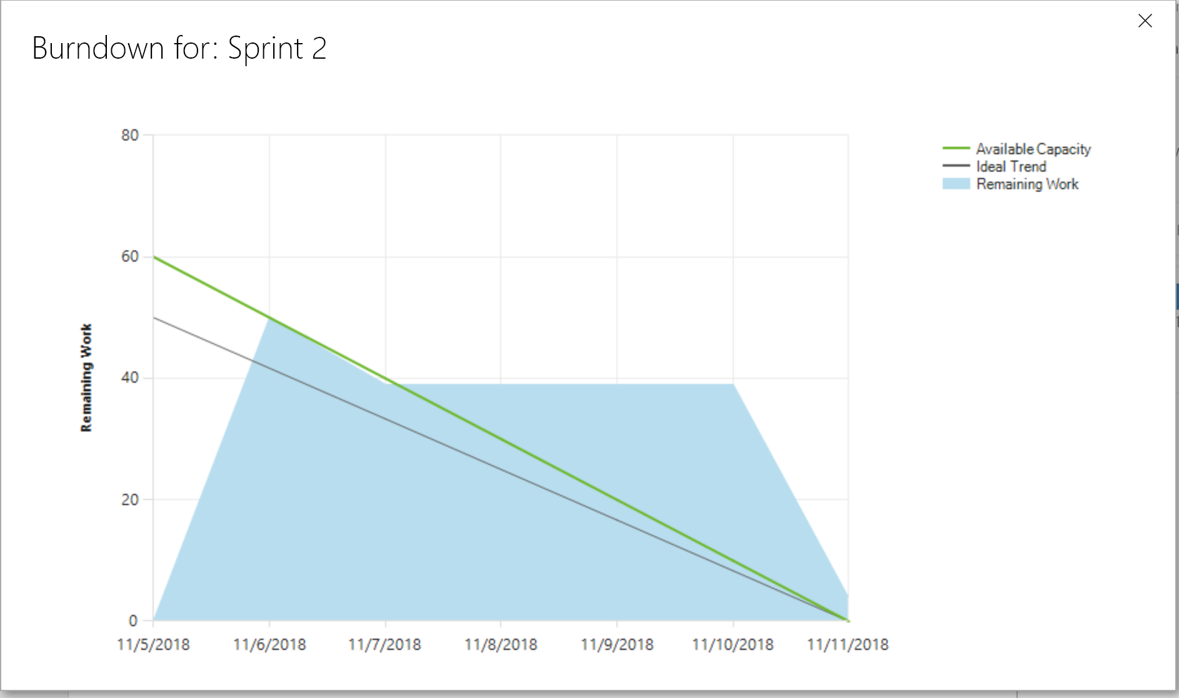

## User Story Summary

User Stories Completed:

* Tech Story - Get all members to Clone Git Repo and Push a small change
* Add Content to About Page
* “Assign a Project” Page
* “Create a Project” Page

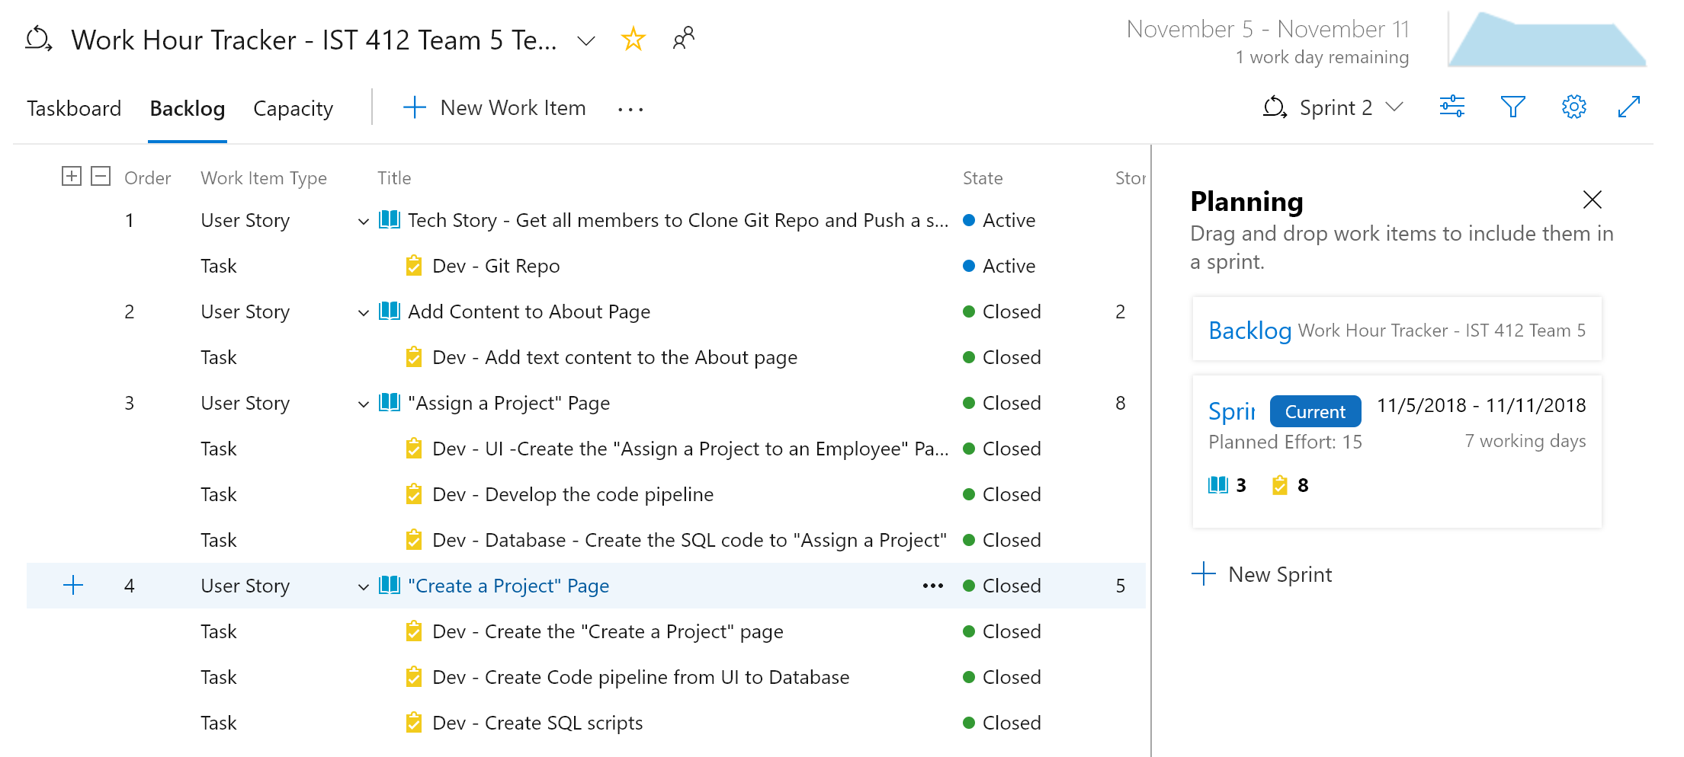

Number of Story Points Completed: 15 (the Tech Story did not have story points associated with it)

# Deliverables

## Add Content to About.cshtml Page

Added content to the About.cshtml page: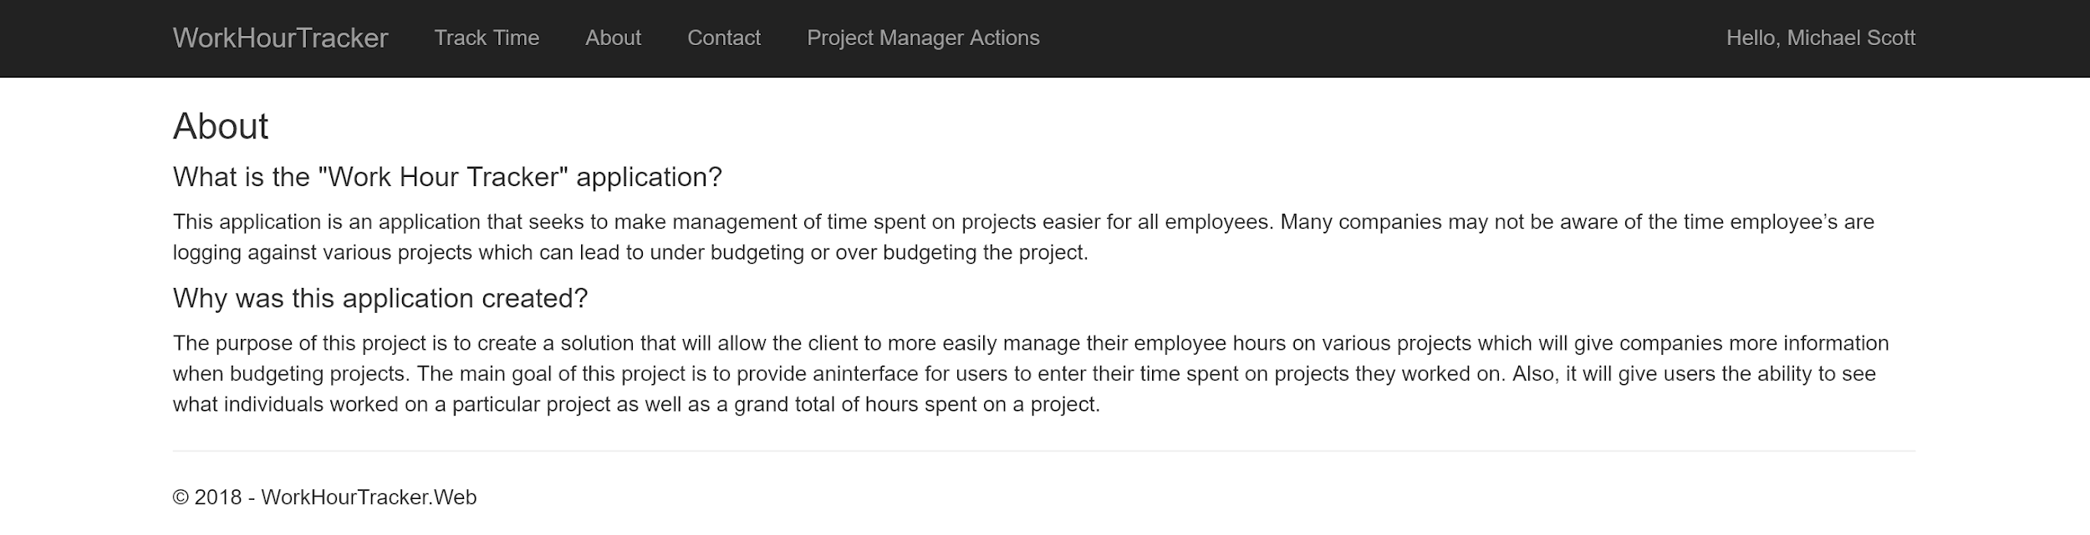

## Create the “Create a Project” Page

Created an interface for a Project Manager / Manager to create a new project: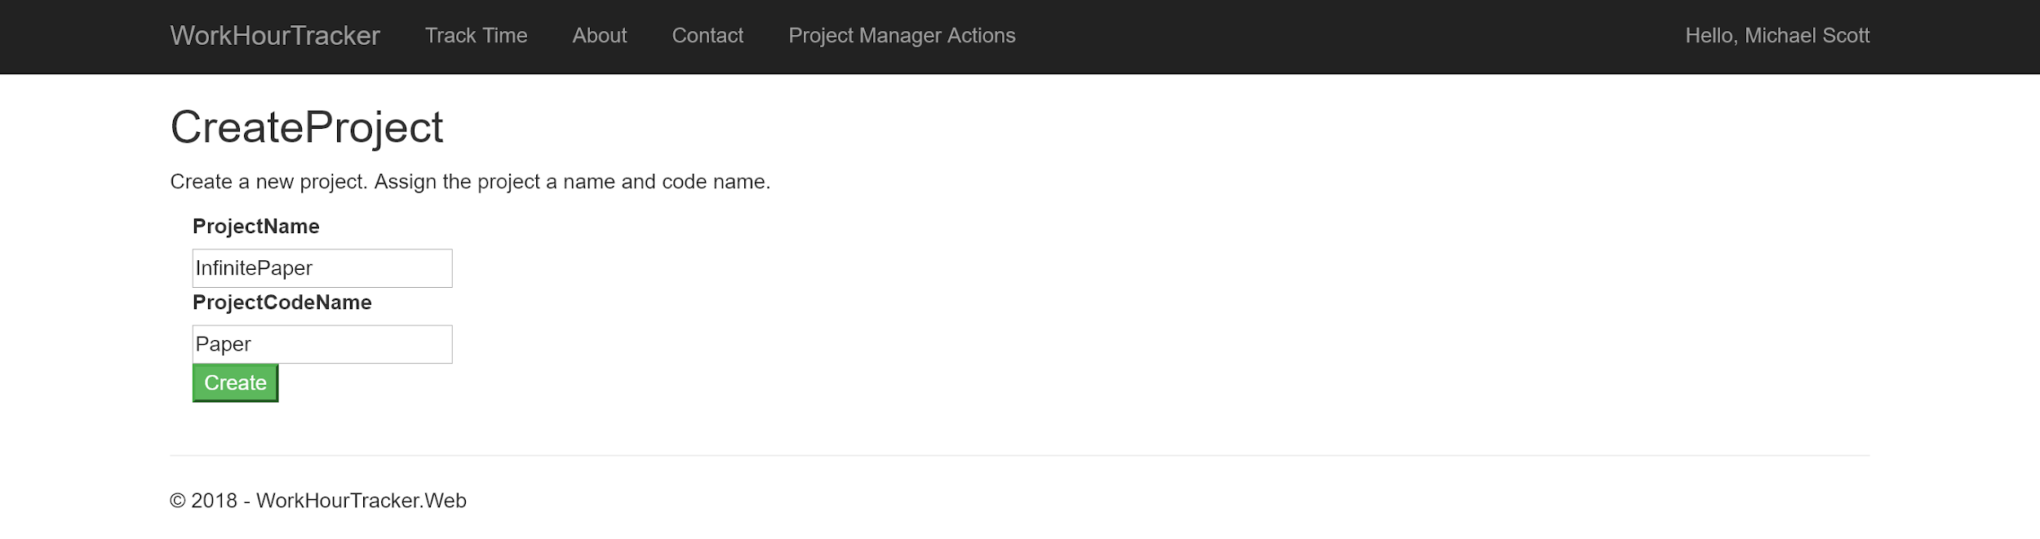

Success message the user will see. The team will continue to make updates to this: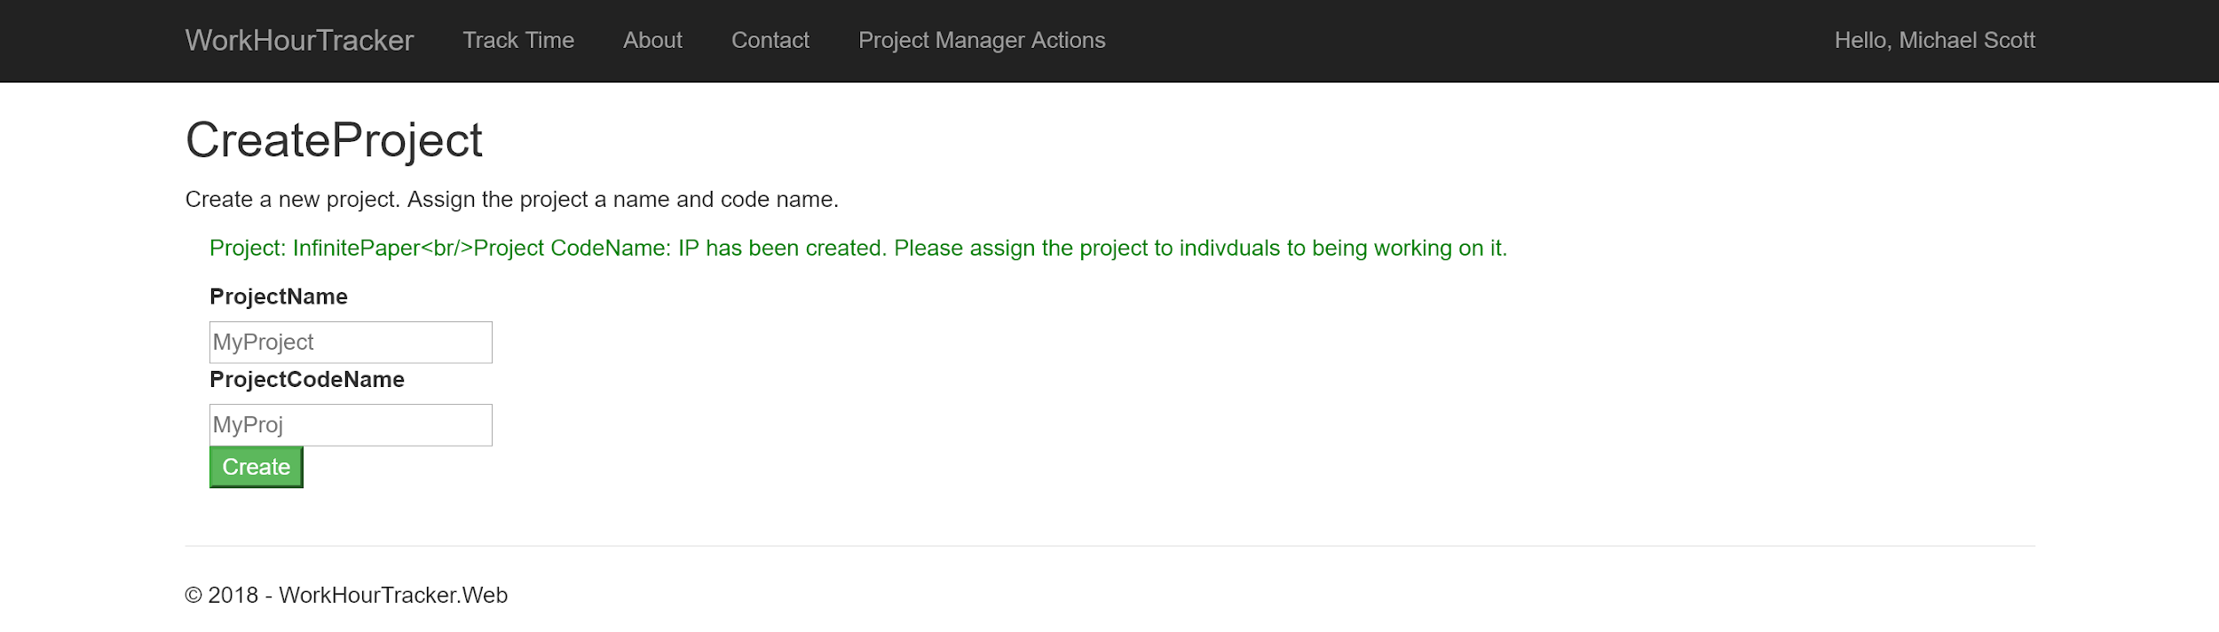

Created Validation on the “ViewModel” to reject bad input from the user:



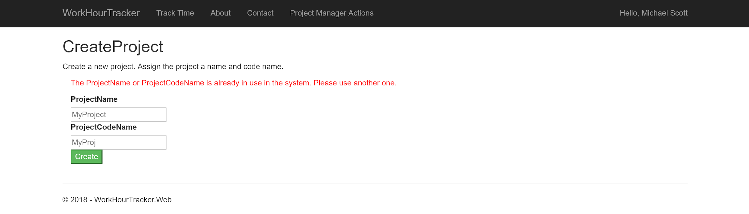

Code behind for this story. This is the MVC Controller code.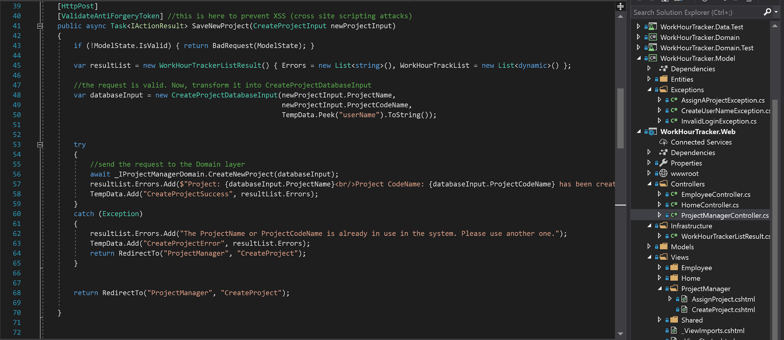

Domain code: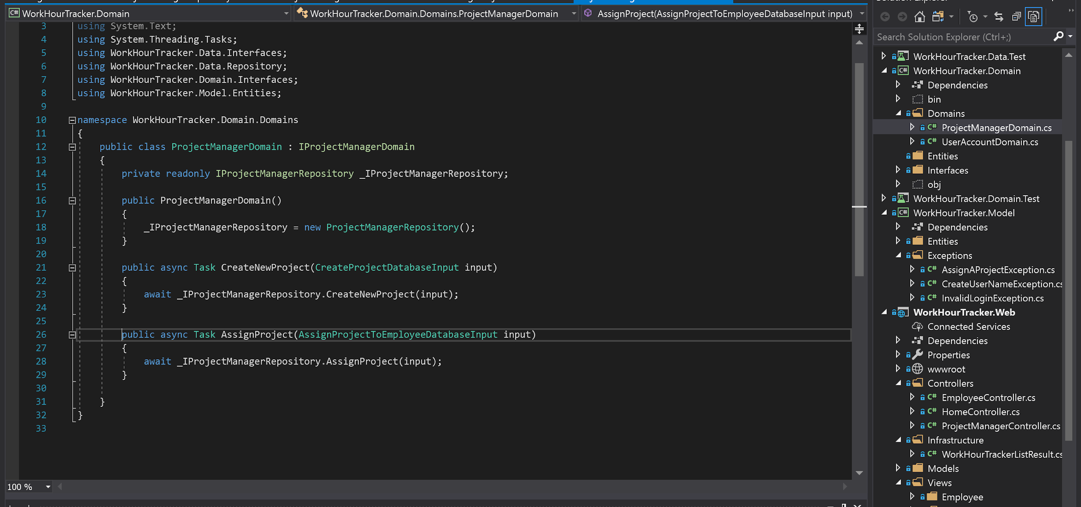

Domain Interface: 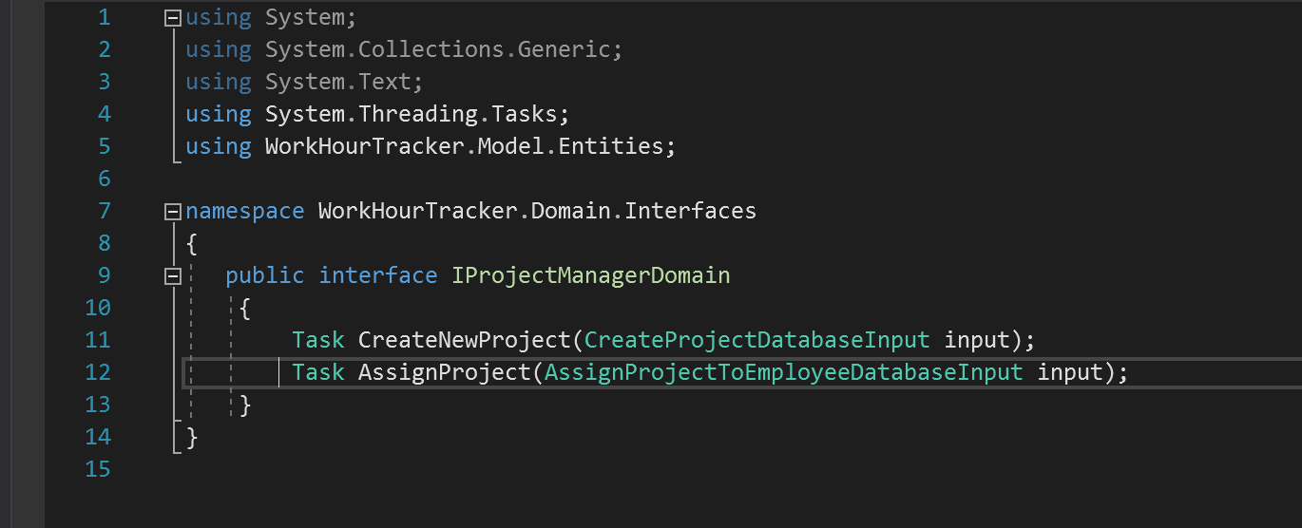

Data layer code:

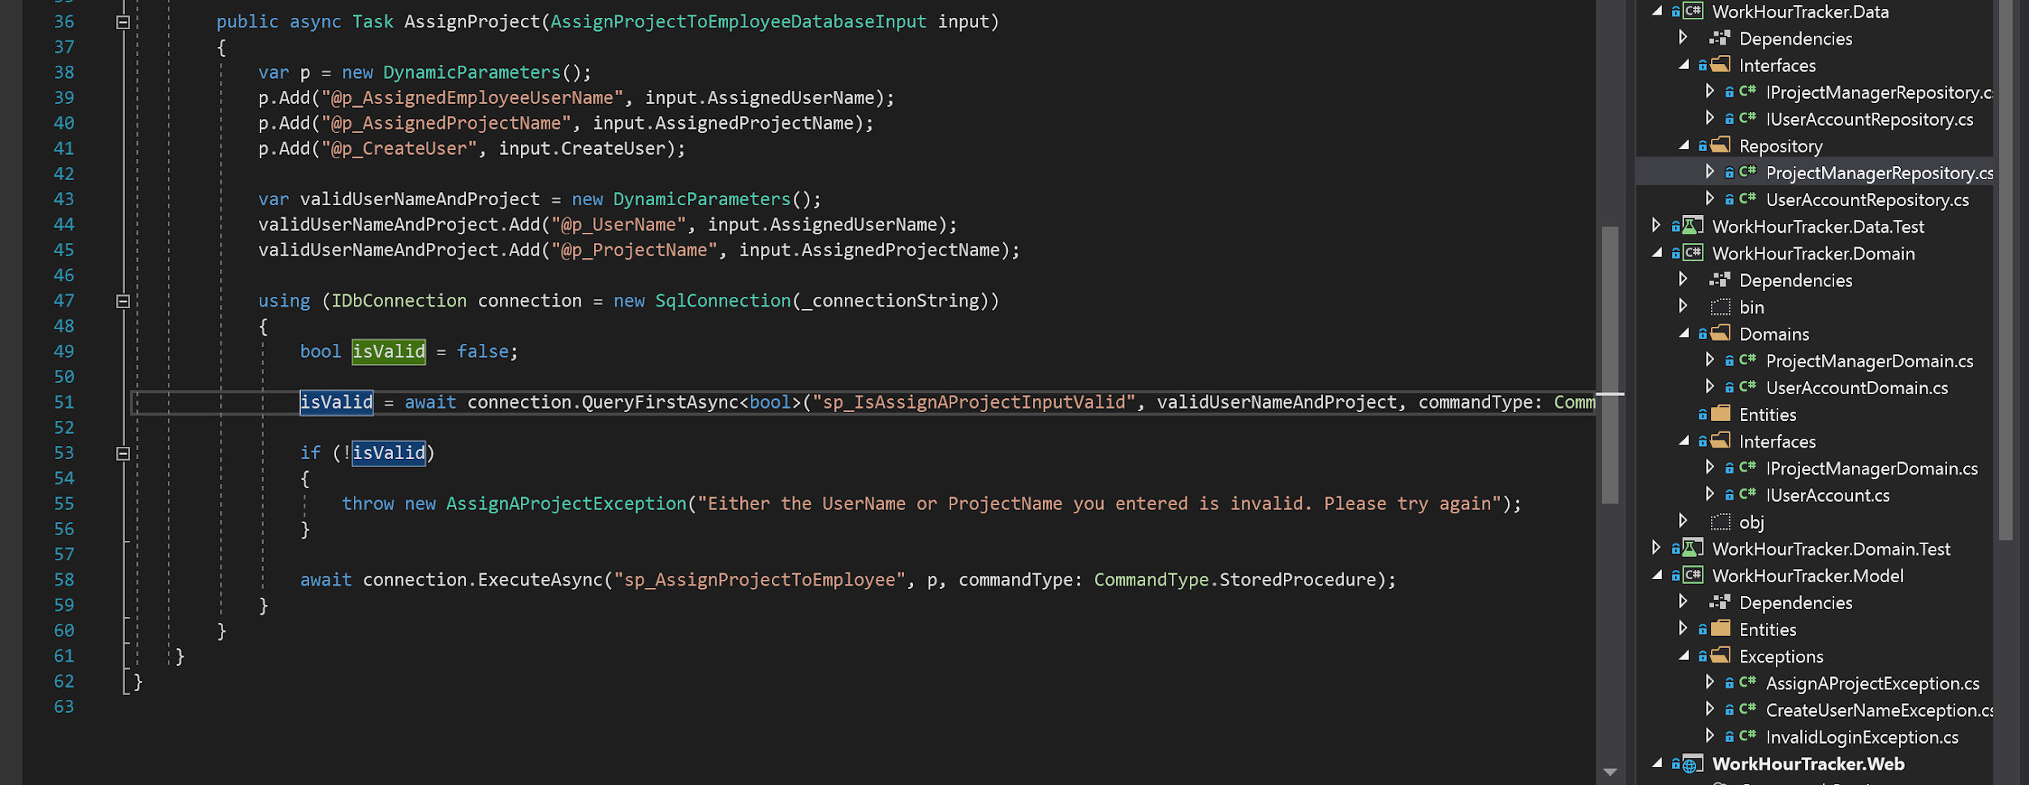

Data layer interface:

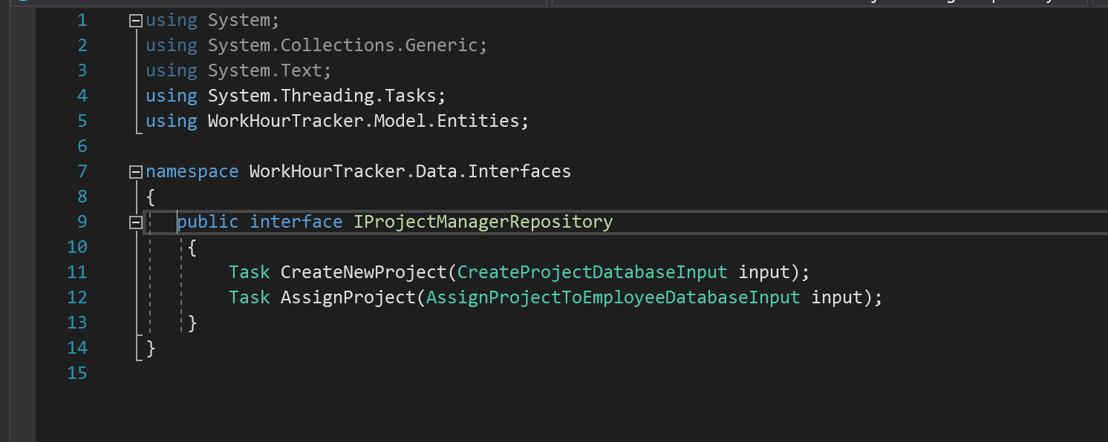

Stored Procedure sp_CreateProject

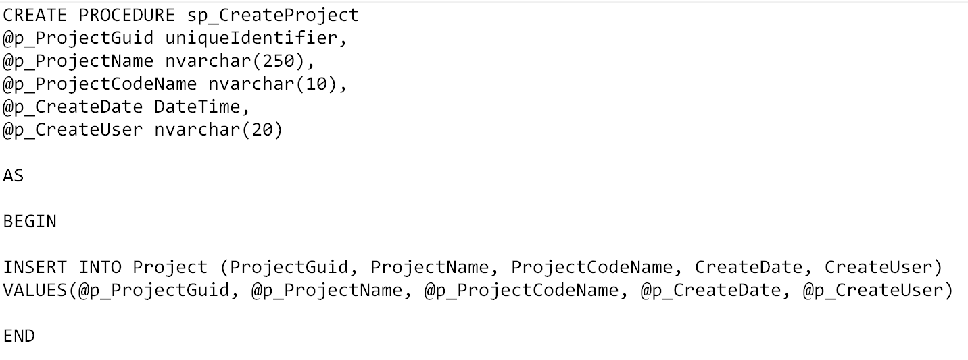

What the data looks like in the Database:

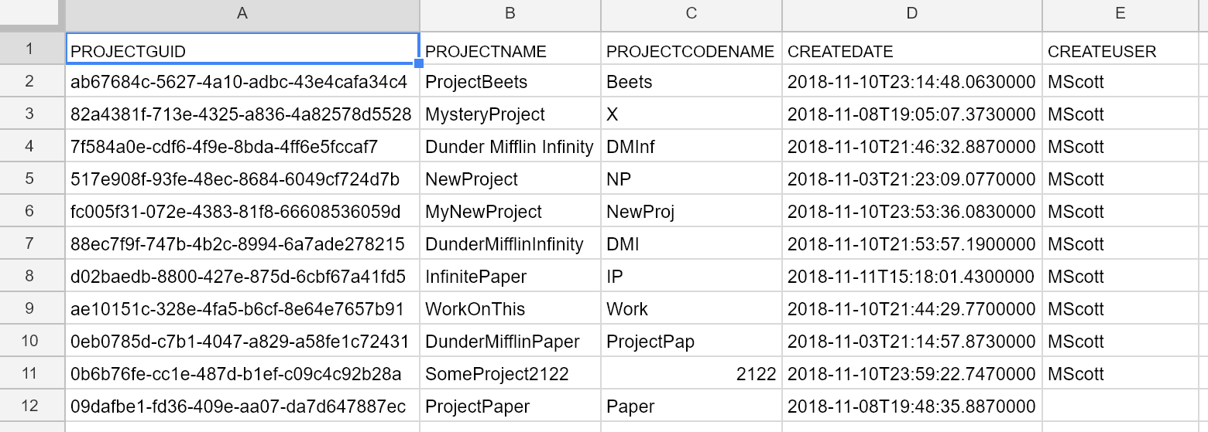

# 

# 

## “Assign a Project”

Provide an interface for the Project Manager / Manager to assign work to an employee by the employee’s UserName.

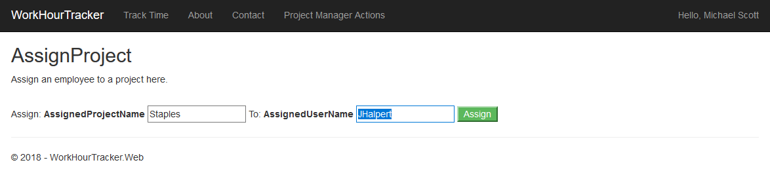

Validation on the ViewModel:

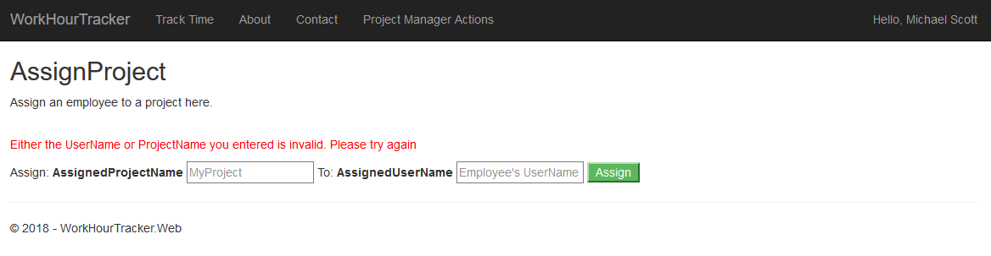

The user is entering valid data:

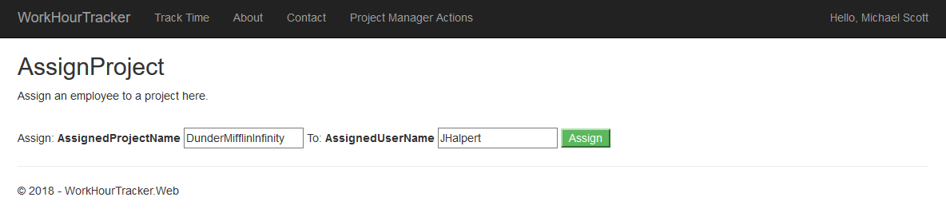

Success:

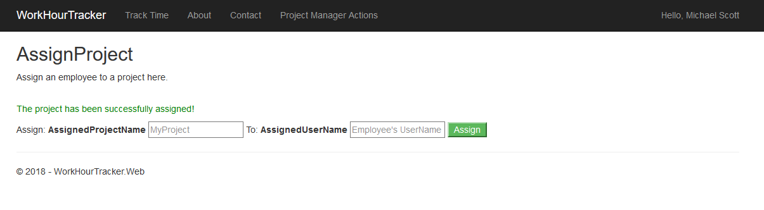

ViewModel for the user’s input:

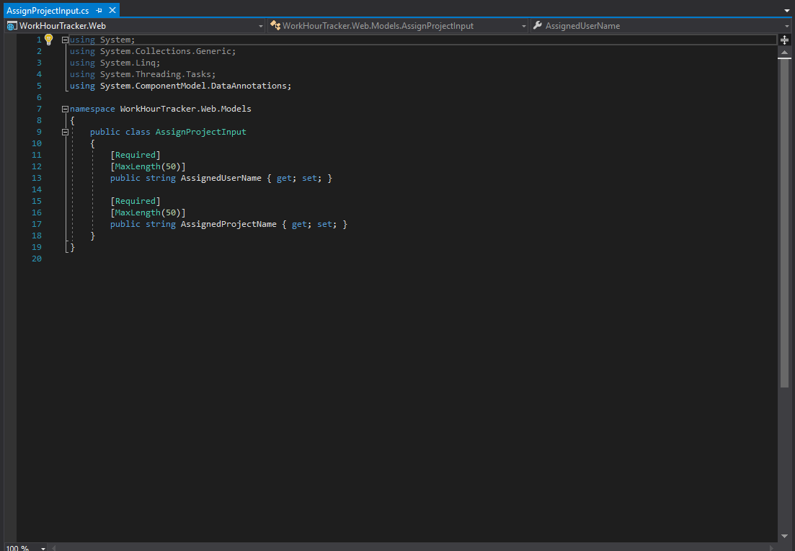

Here is the View where the user will interact with the application:

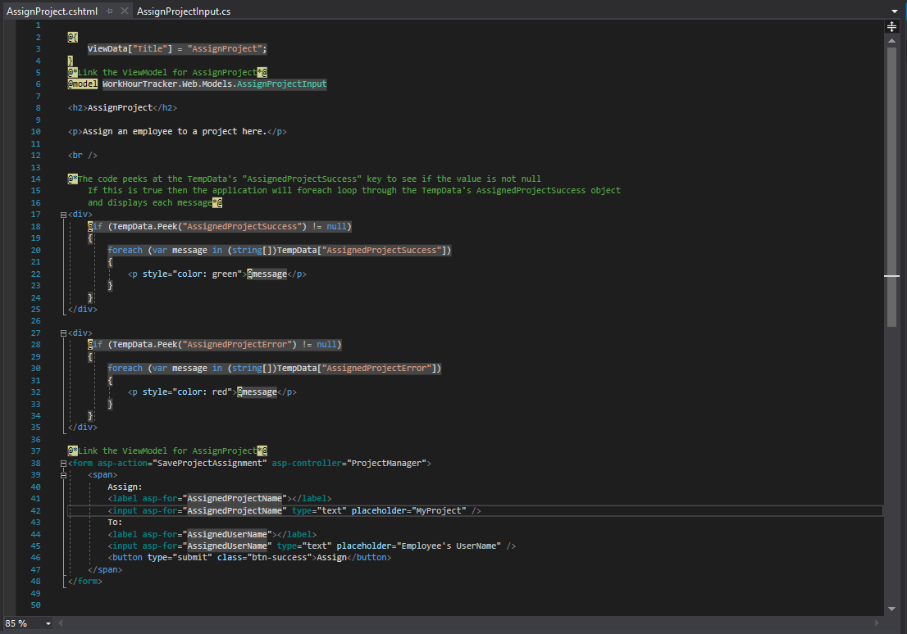

Screenshot of the DTO that will be passed through the application layers: AssignProjectToEmployeeDatabaseInput

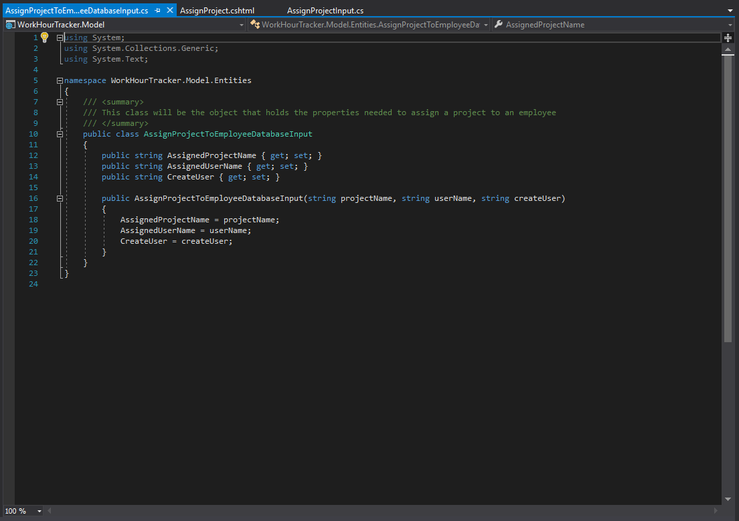

Screenshot of ProjectManagerController method to handle saving project assignment.

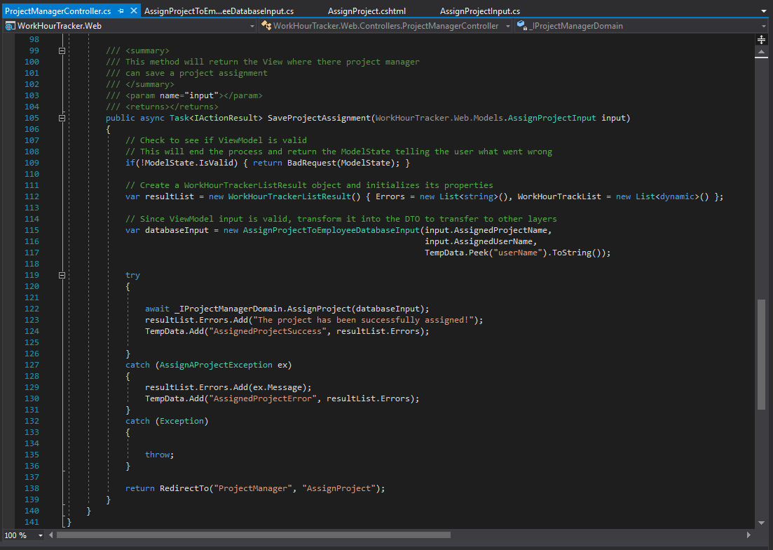

Screenshot of AssignProject method added to IProjectManagerDomain interface

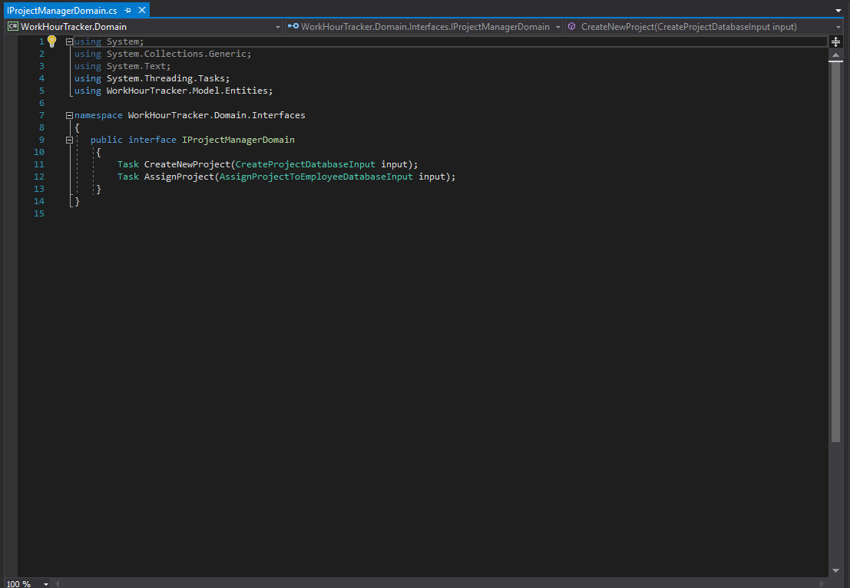

Screenshot of AssignProject interface member being implemented in ProjectManagerDomain

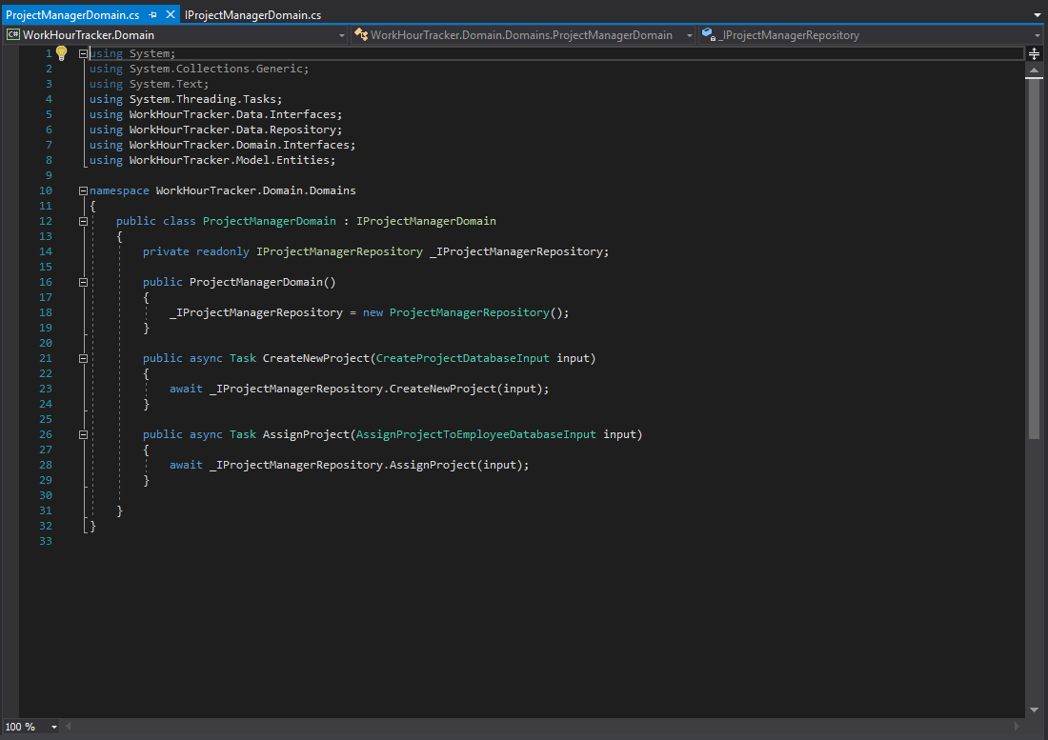

Screenshot of AssignProject method added to IProjectManagerRepository interface

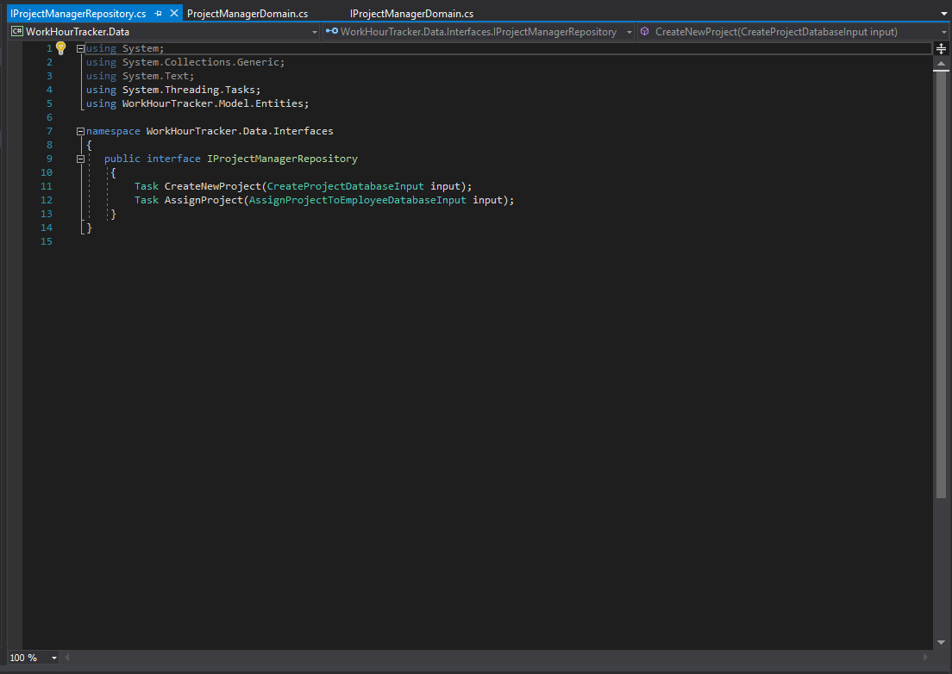

Screenshot of AssignProject interface member defined in ProjectManagerRepository

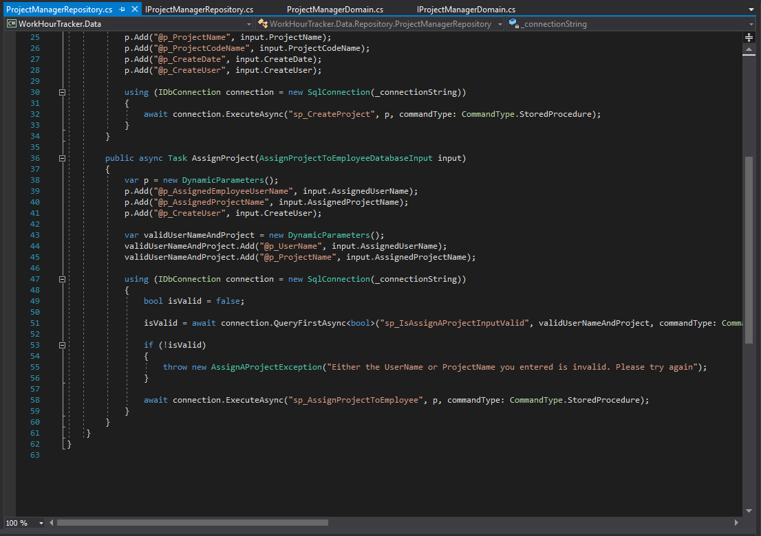

Stored Procedure sp_AssignProjectToEmployee:

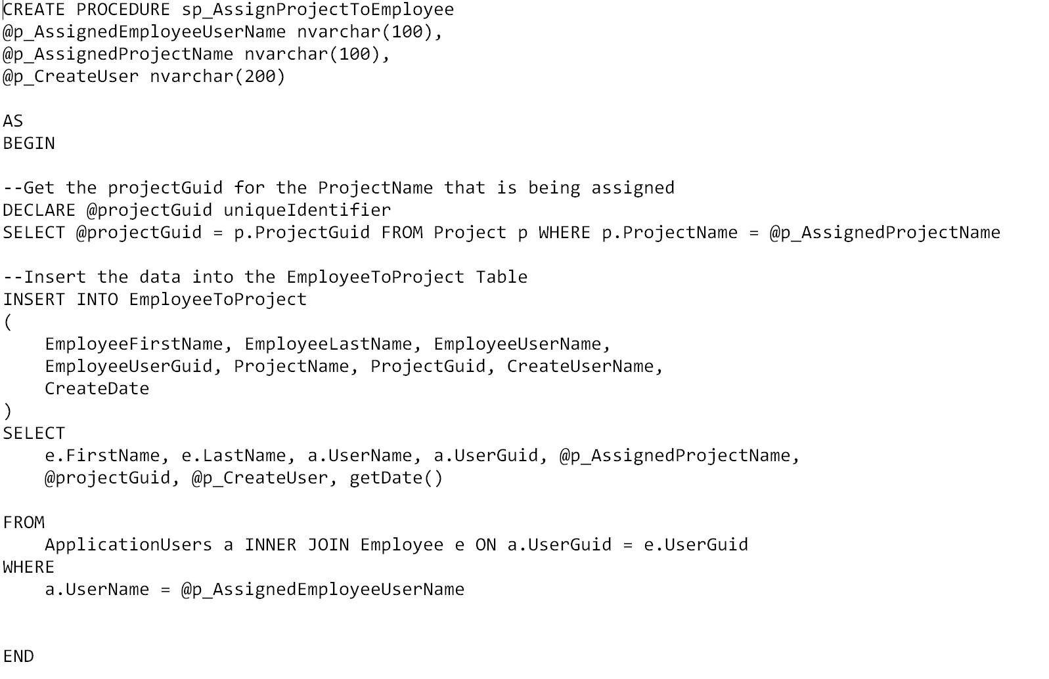

What the data looks like in the Database:

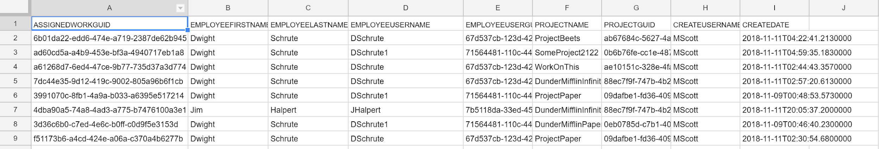

# **Retrospective**

What did the team do really well with?

The team did well cloning the Git Repo to their local machines. The team communicated problems they had to the team leader early and we were able to solve them in a timely manner. The team discussed design choices such as validation on the ViewModel. Some members gave a time that they had set aside to work on the project and followed through on that.

What could the team improve upon in the next sprint?

Each member of the team needs to be checking the current Sprint in order to see what work is pending instead of waiting for someone to answer the question. Three more team members to provide their IP addresses that way they can access the Azure SQL database (an exception has to be made inside the Azure SQL Database in order to allow the client in.)

# **Product Backlog Summary (Kanban board)**

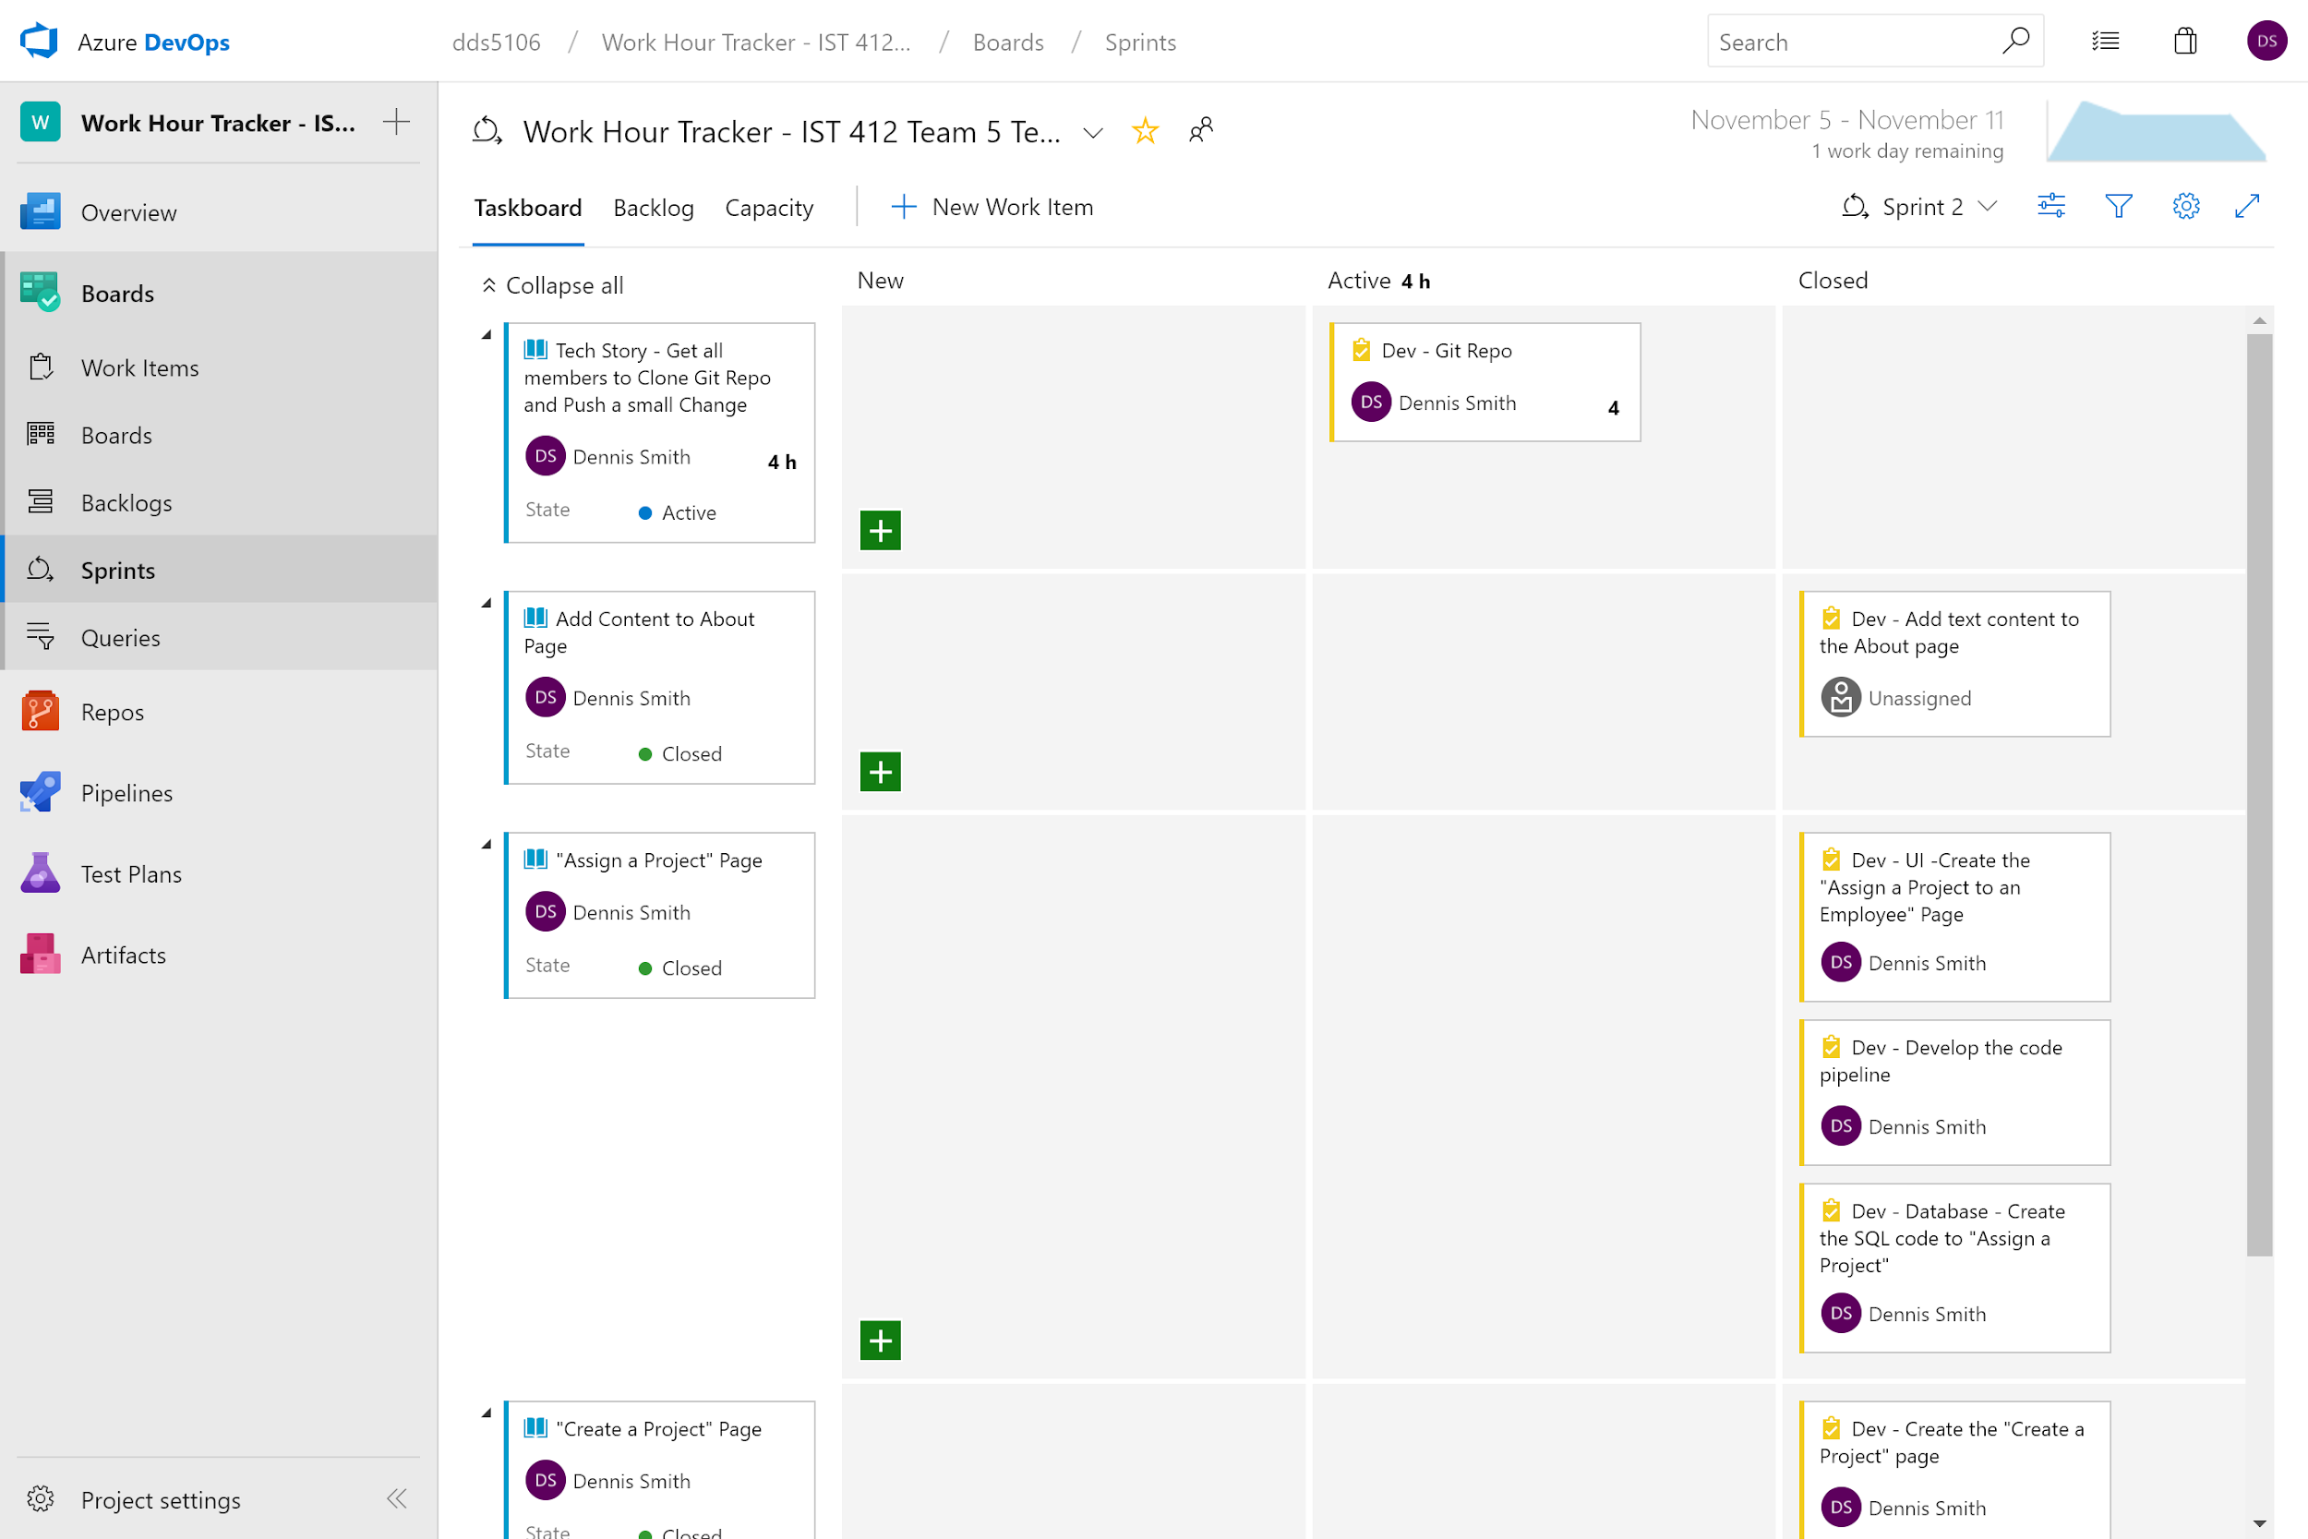

Continued: