**IST 412 Team 5**

Sprint Document 3

**Project: Work Hour Tracker**

**Client: Jim Clarke**

**Developers: Dennis Smith**

**Sai Nithisha Guntamadugu**

**Ricky Zhao**

**Jackson Penning**

**Bijal Patel**

**Sprint Summary Metrics** **3**

User Story Summary 3

**Deliverables** **5**

Update “Assign a Project” Page 5

Add enum to the “Create an Account” Page 5

“Time Entry” Page 7

“Employee Search” Page and Graphical Representation 11

“Project Search” Page and Graphical Representation 14

**Retrospective** **17**

**Product Backlog Summary (Kanban board)** **18**

# Sprint Summary Metrics

Burn down chart showing the team’s work throughout the week.

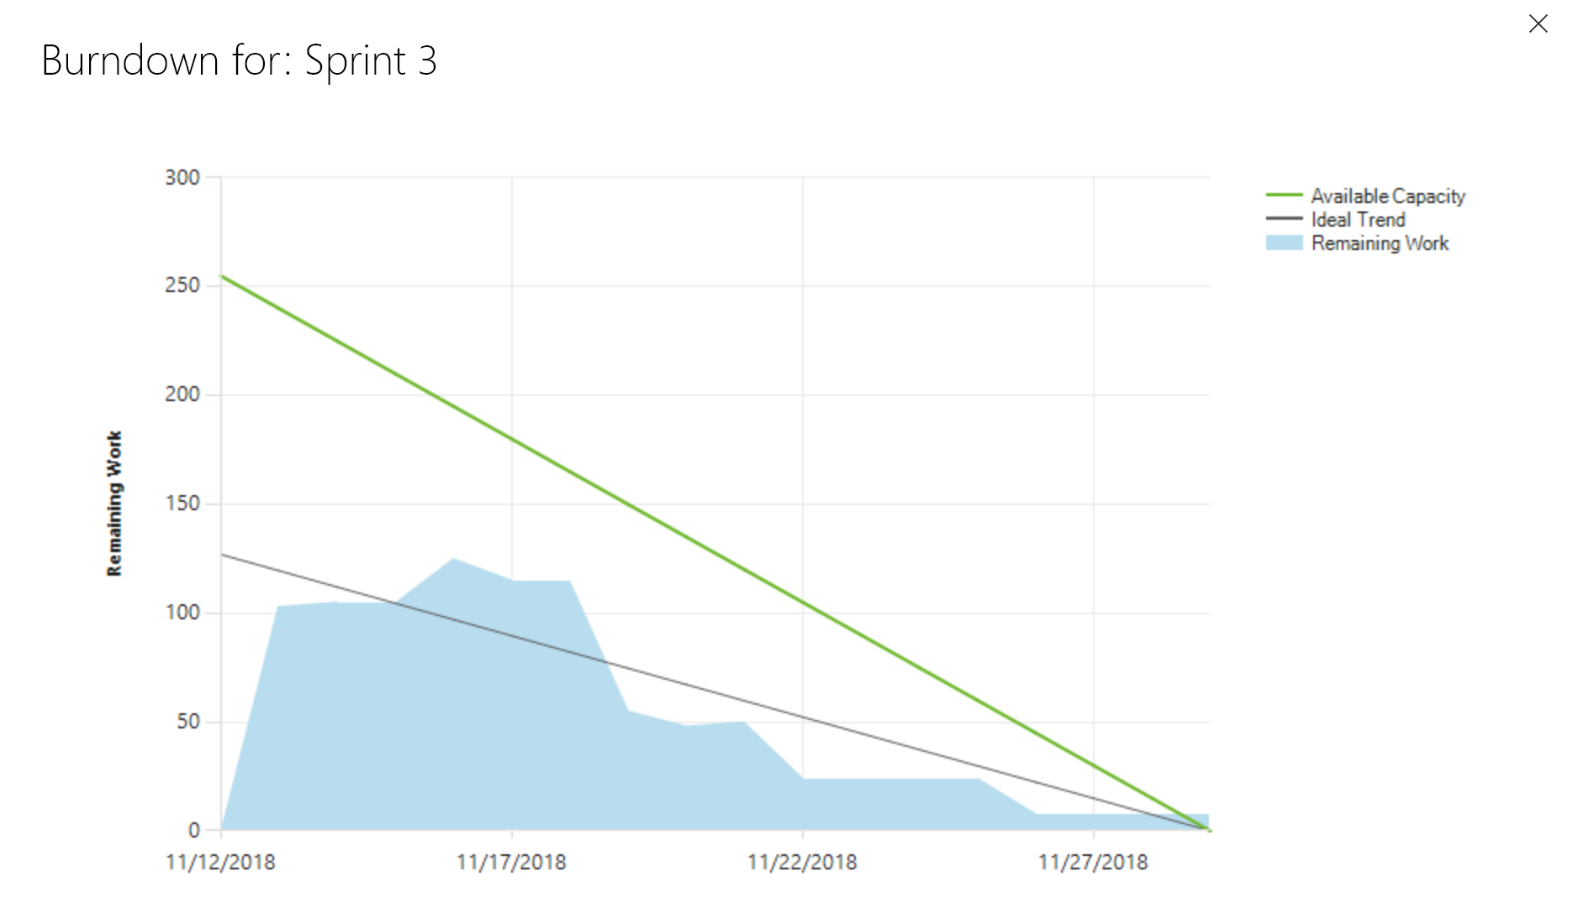

## User Story Summary

User Stories Completed:

* Tech Story - Get all members to Clone Git Repo and Push a small change
* Update “Assign a Project”
* Add enum and drop-down list to “Create an Account” page
* “Time Entry” Page
* “Employee Search” Page
* “Project Search” Page
* Create “View Past Track Time” feature
* Presentation Preparation
* Add graphical representations to “Employee Search” and “Project Search” pages

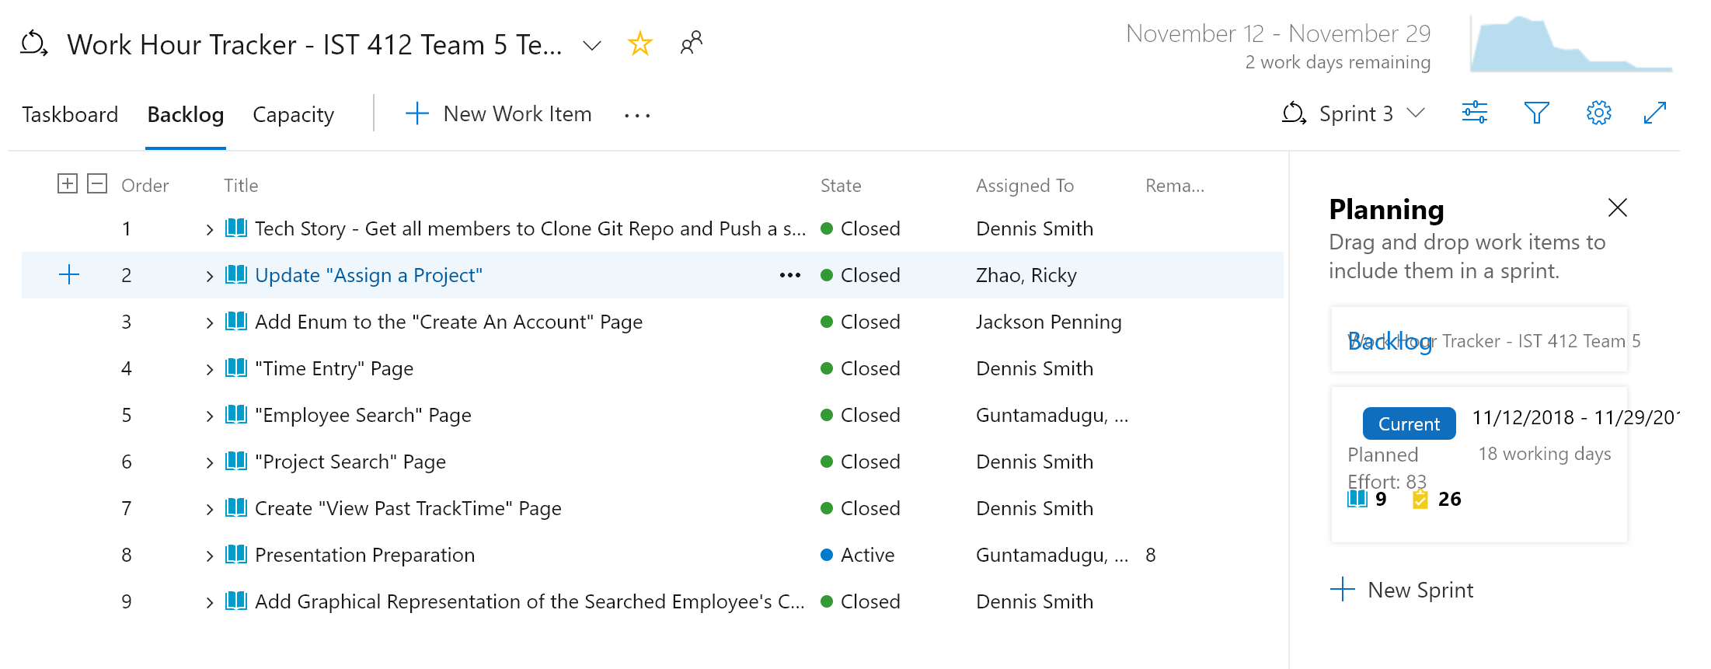

Number of Story Points Completed: 83 (for some reason the story points are now displaying in the screenshot above)

# Deliverables

## Update “Assign a Project” Page

Added a field for the ProjectManager / Manager to supply a capacity for the employee to dedicate to the project: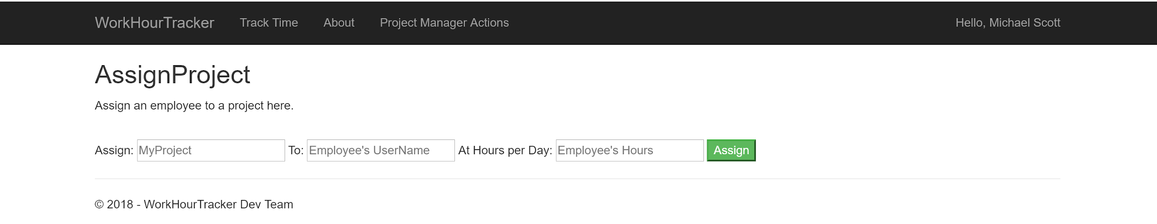

## Add enum to the “Create an Account” Page

Created enum for a dropdown menu on the “Create an Account” page in order to ensure integrity in the application:

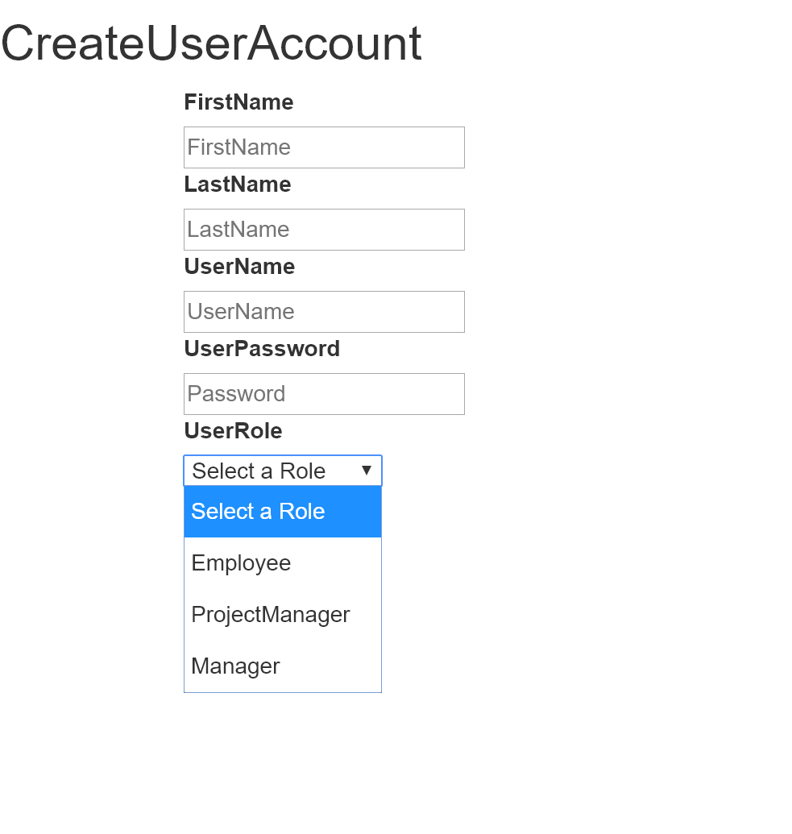

Some of the code behind: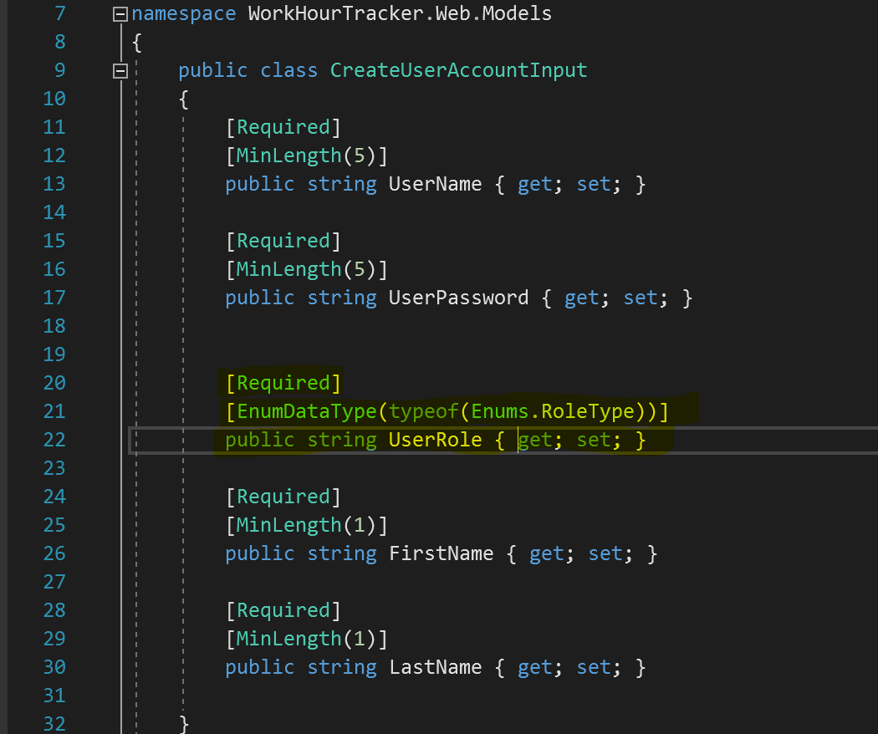

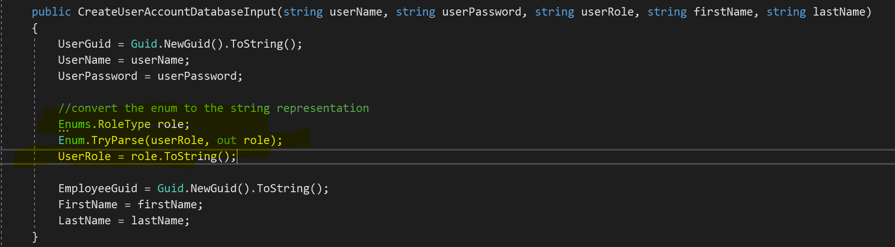

## “Time Entry” Page

Create an interface for a user to log their time worked by project:

The screenshot below shows all of the record Dwight currently has and by clicking he can view / update them

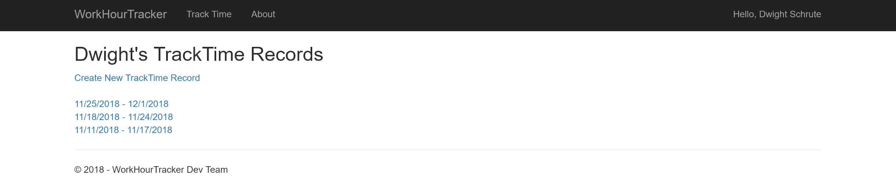

The user has successfully saved their TrackTime information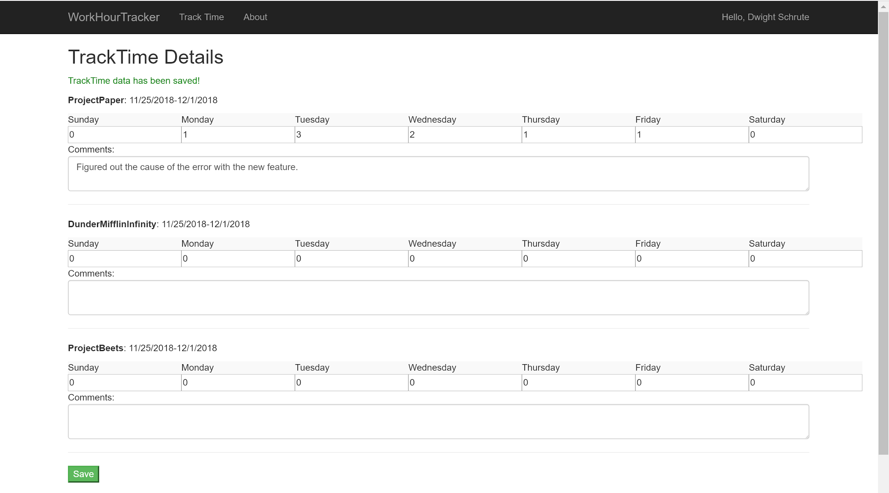

The user cannot edit any records that are not for the current week: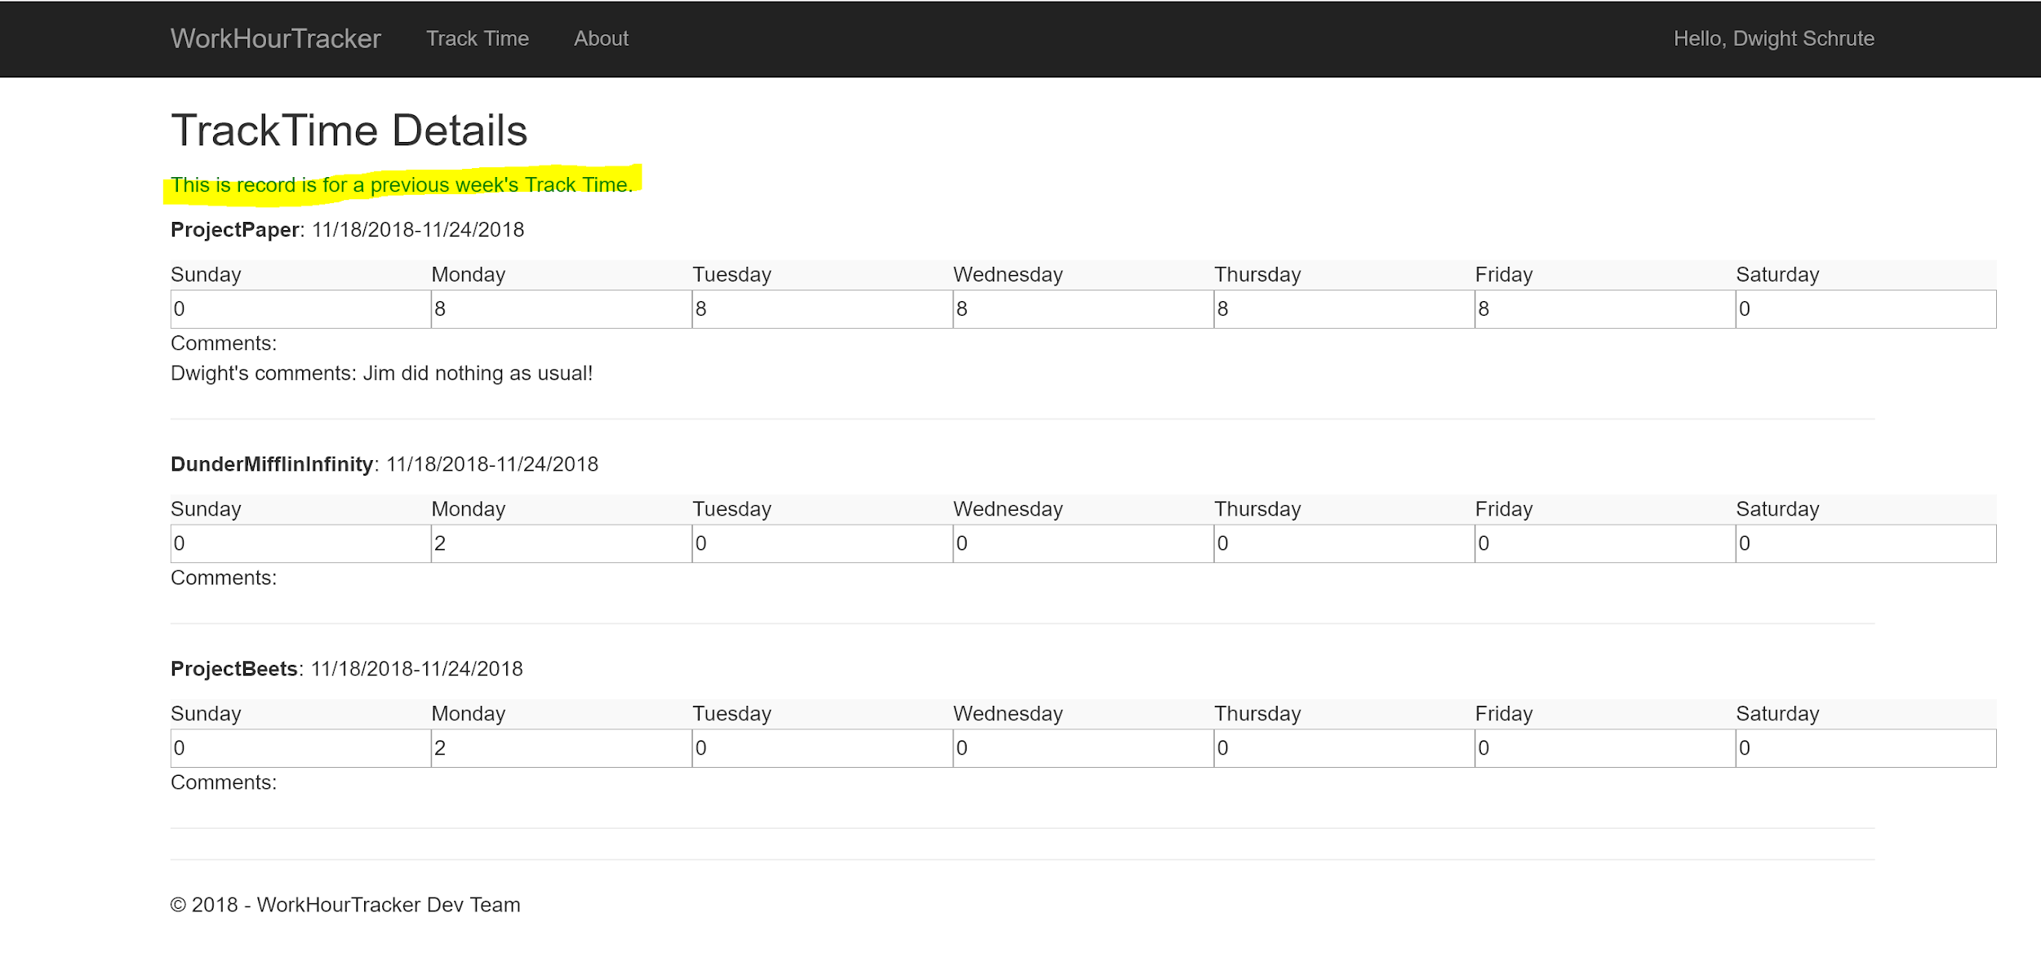

The user cannot create a record for the same week: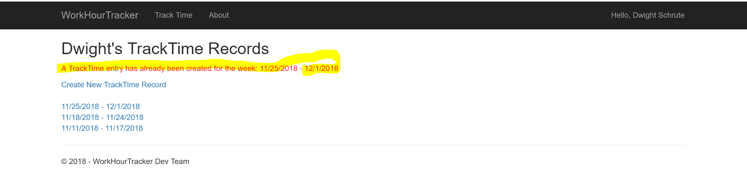

Example of some of the stored procedure needed to achieve this feature:

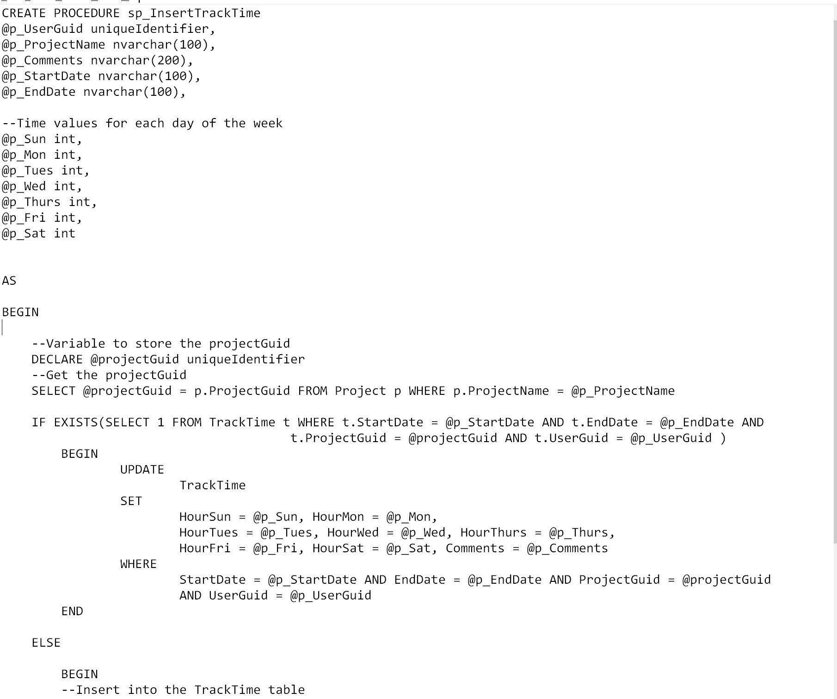

This procedure is used to insert track time information into the database. Also, if the record already exists that means the user is trying to update it so an UPDATE statement was used.

This procedure is used to get the track time data for UI display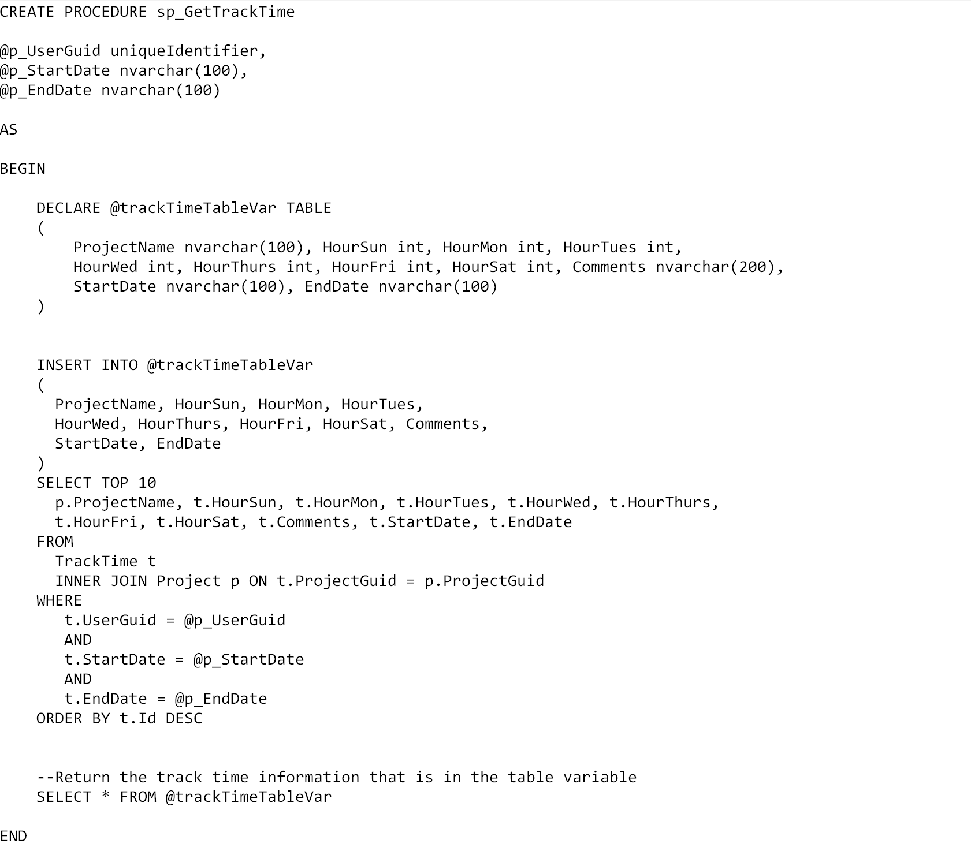

## “Employee Search” Page and Graphical Representation

Create an interface where a ProjectManager / Manager can search for an employee (by employee username) and see information on the projects they are working on as well as a graphical representation of their capacity by project

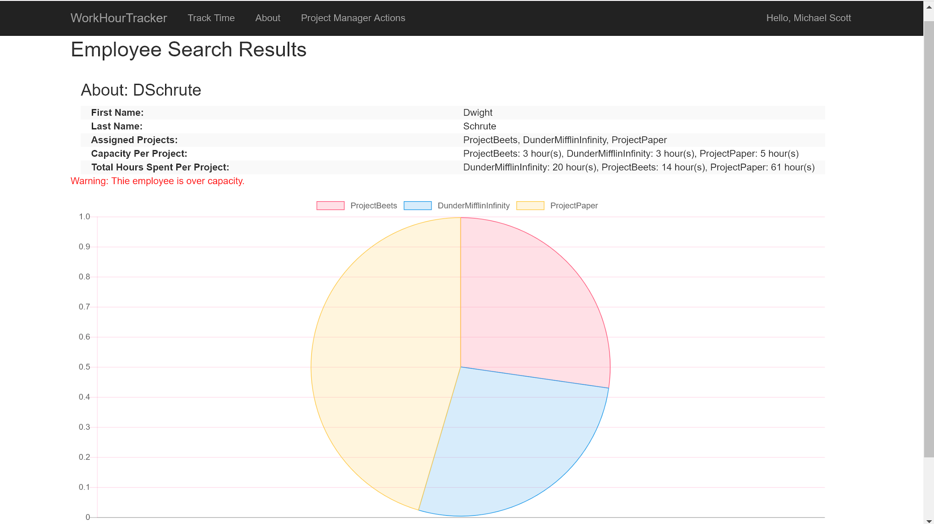

This screenshot shows information about DSchrute - his first name, last name, a list of the projects he is assigned, his capacity per project, total hours spent per project, and shows a pie chart of Dwight’s capacity per project. A warning is being displayed to the user telling them that Dwight is over capacity since his capacity is 11 hours per day. As of right now, there is no feature to deallocate hours. **Would this be a feature you would like?**

Here is an example of a user is not over capacity. Note: you can hover over a pie slice to see the value. These charts were created using a free javascript library called chart.js

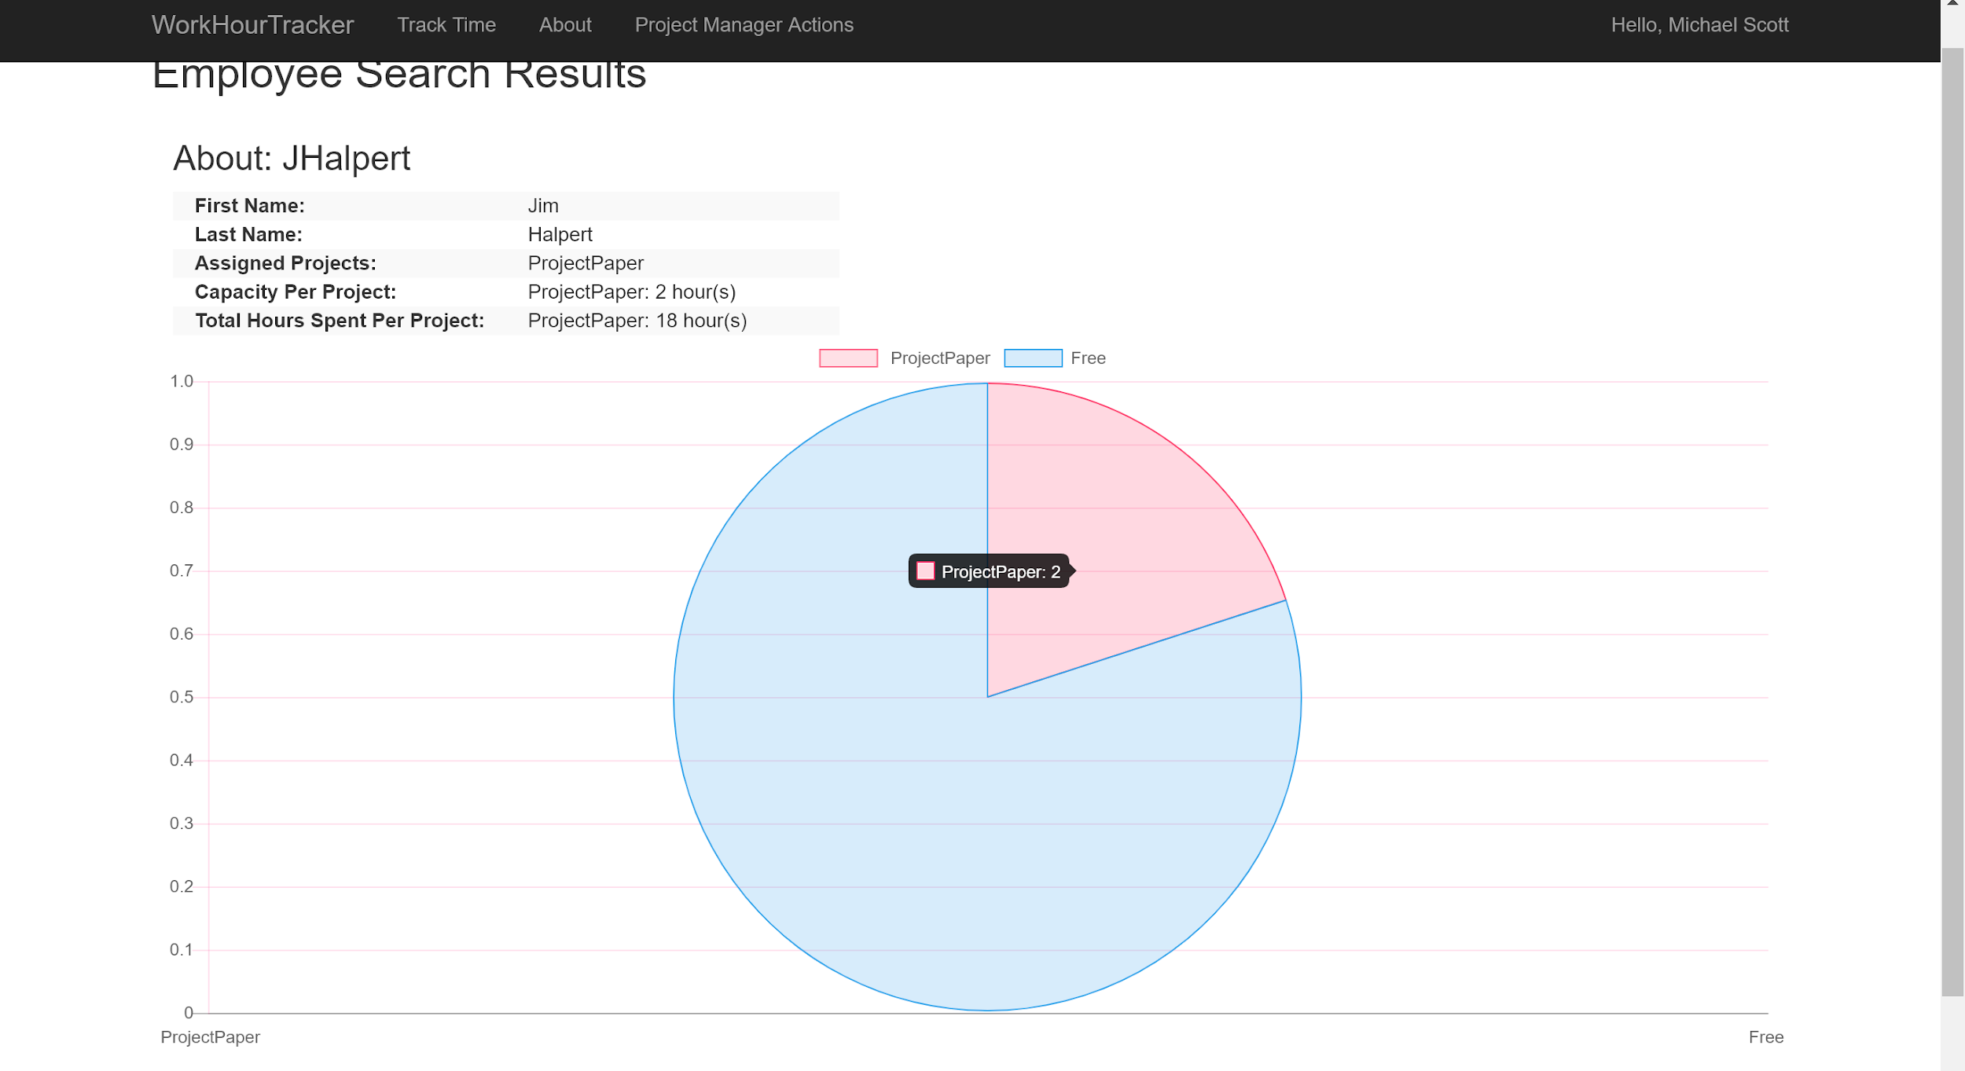

Here’s a look at the code behind. The main goal was to take the CSV string of Capacity per Project and split it at the semi colon then split it again at the comma in order to create a EmployeeCapacity object which requires ProjectName and Capacity. Once the object is created we add it to the chartData object which is a List<EmployeeCapacity>. 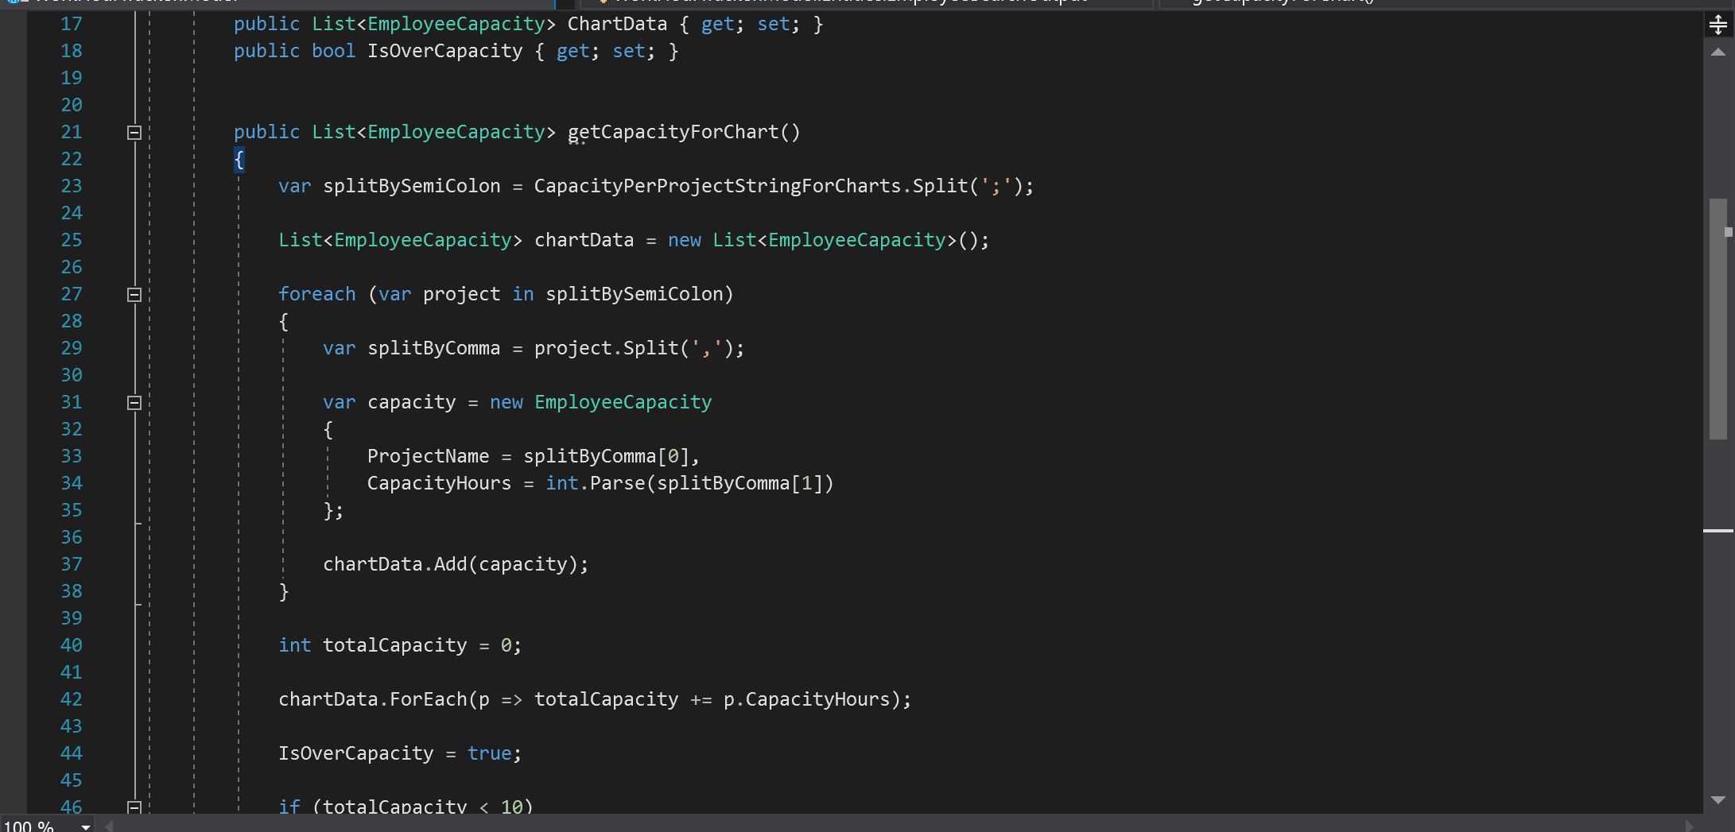

Here’s some of the stored procedure used to achieve this feature:

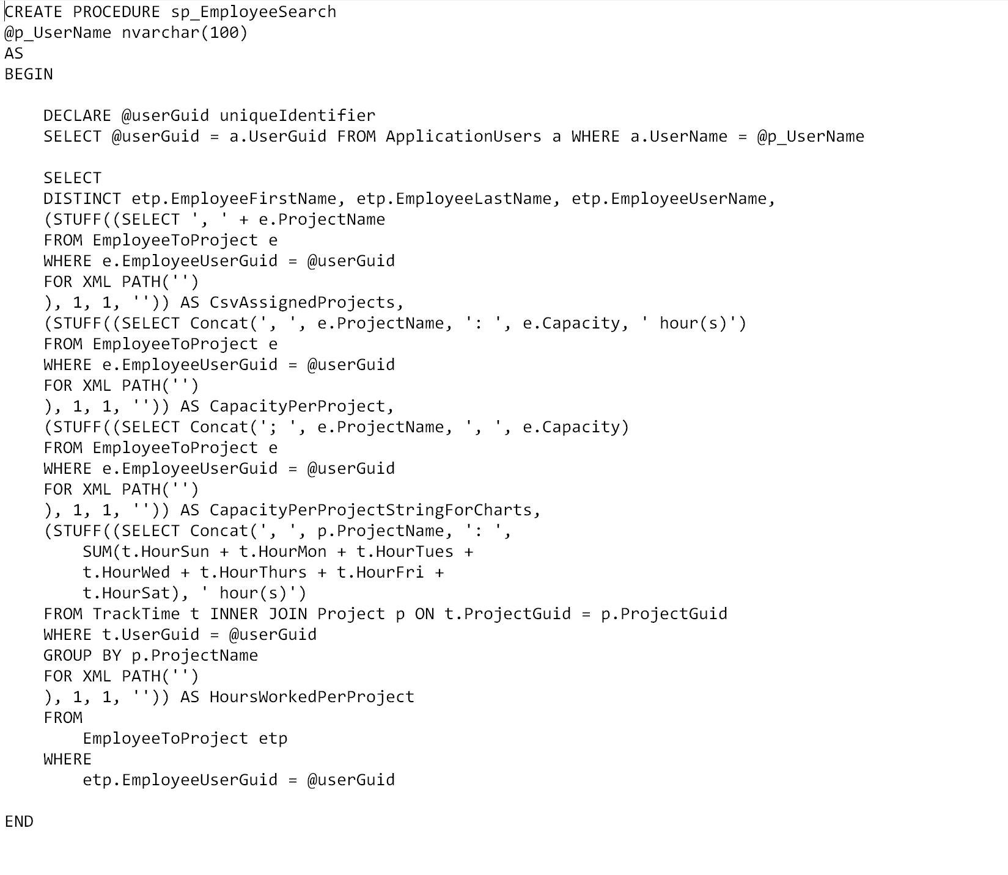

## “Project Search” Page and Graphical Representation

Provide the ProjectManager / Manager an interface where they can view project level information such as: the project’s name, code name, a list of individuals assigned to it and their capacity on it, grand total hours spent across employees, the user who created the project, when it was created, and a bar chart showing each assigned user’s total hours spent:

The user can search for a project by the project’s name or code name.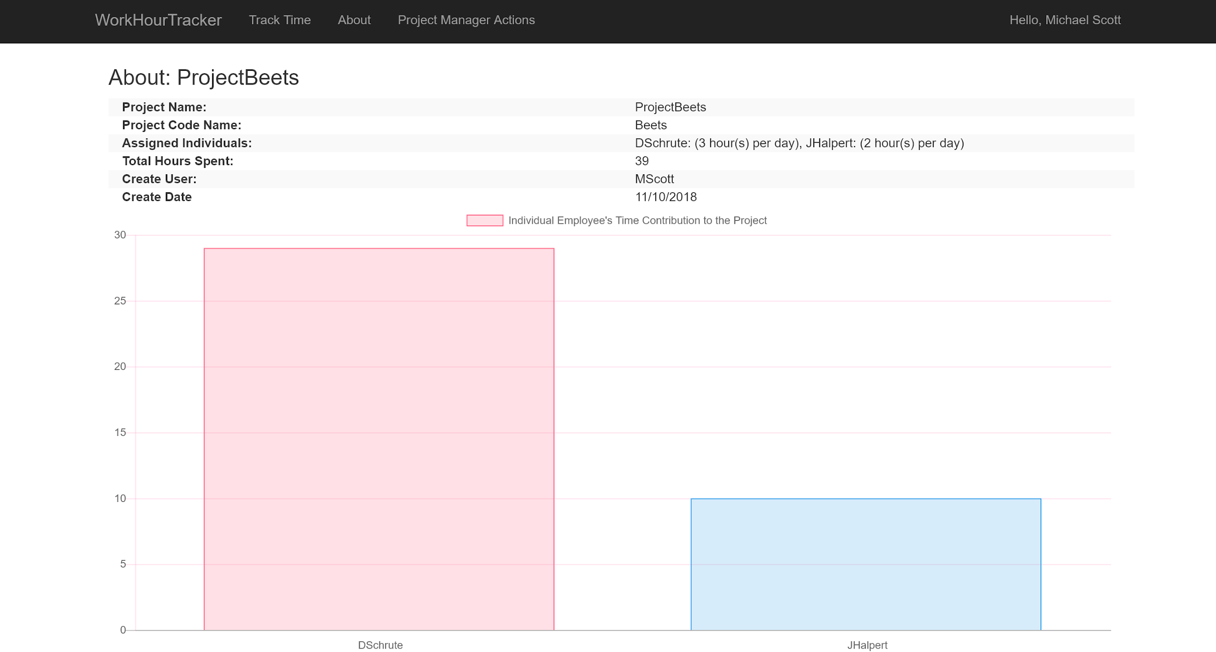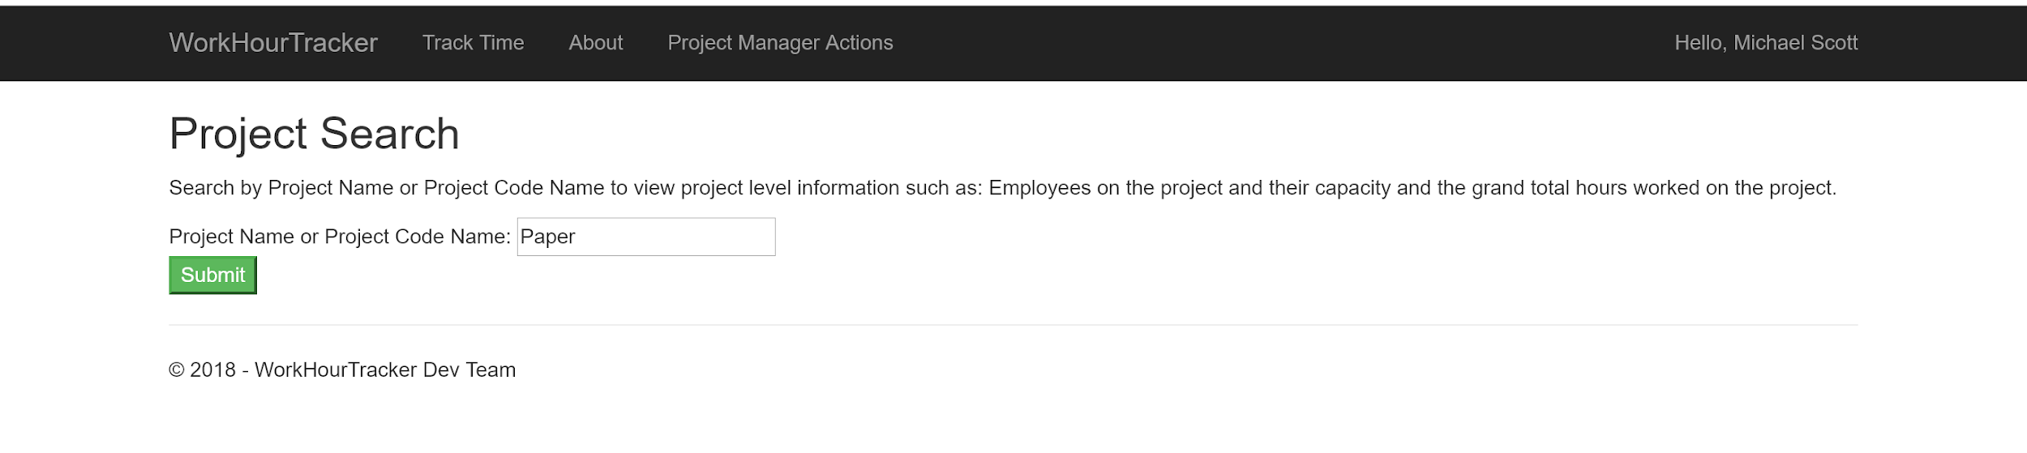

This screenshot shows the Project Search page displaying project level information as well as a bar chart show the hours each employee contributed towards the current total.

Here’s some of the stored procedure that were used to achieve this: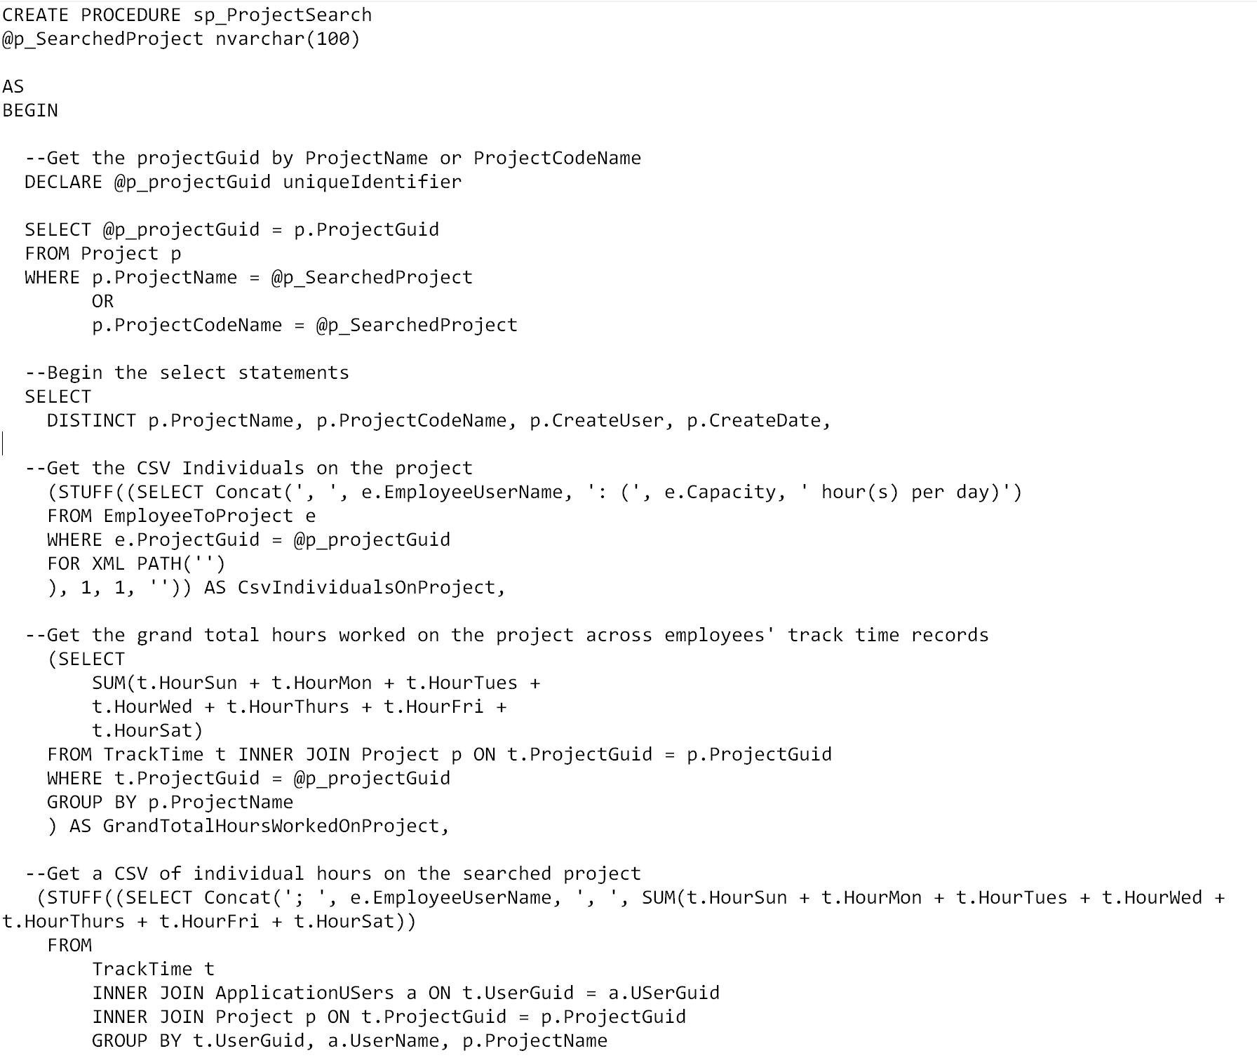

# **Retrospective**

What did the team do really well with?

The team did well keep eachother up-to-date with how their task was going. Also, everyone did a good job pushing their code to the Git Repo in a timely manner..

What could the team improve upon in the next sprint?

The team members should get into the habit of ‘burning of their hours’ in the Azure Board so that we can look at the sprint board and see how much longer until a story or task is completed.

# 

# **Product Backlog Summary (Kanban board)**

Continued: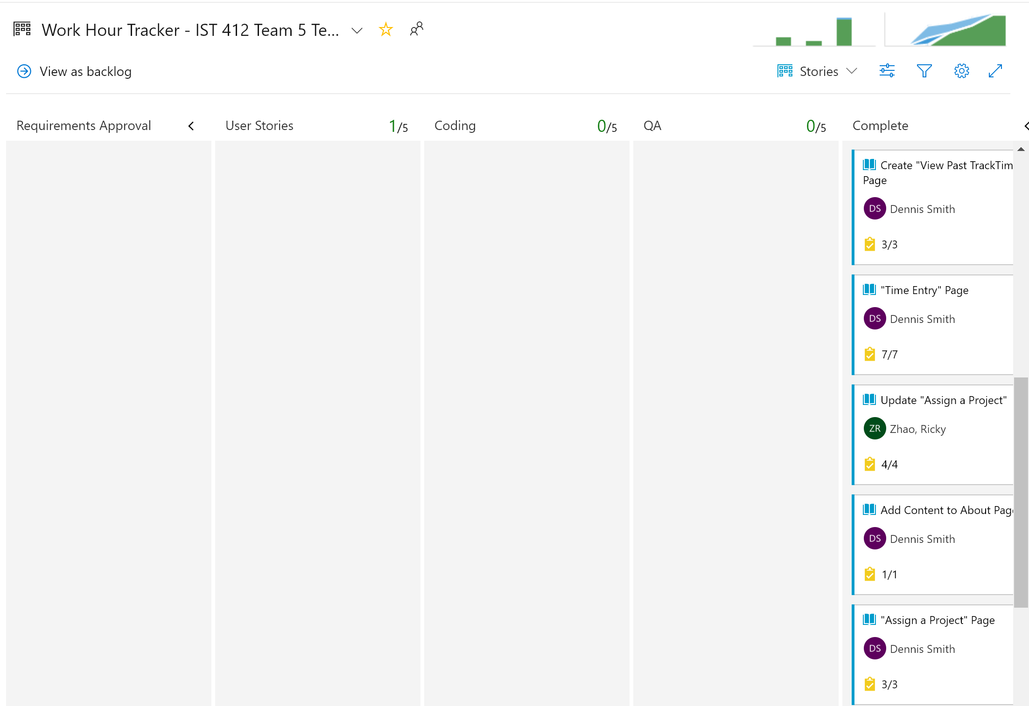

Continued: