**IST 412 Team 5**

Sprint Document 4

**Project: Work Hour Tracker**

**Client: Jim Clarke**

**Developers: Dennis Smith**

**Sai Nithisha Guntamadugu**

**Ricky Zhao**

**Jackson Penning**

**Bijal Patel**

**Sprint Summary Metrics** **3**

User Story Summary 3

**Deliverables** **5**

Project Preparation 5

Create video of a demo of the app 5

Account Restrictions 5

Prevent “URL Hacking” 6

Style ‘User Login’ and ‘Create an Account’ pages 7

Fine Tune Error Handling 9

**Show the user the same project name cannot be used** **10**

**Retrospective** **11**

**Product Backlog Summary (Kanban board)** **12**

# Sprint Summary Metrics

Burn down chart showing the team’s work throughout the week.

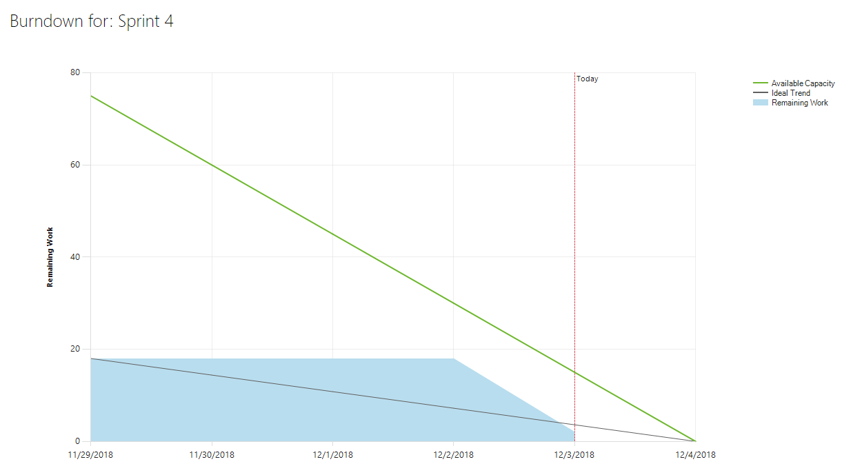

## User Story Summary

User Stories Completed:

* Presentation Preparation
* Account Restrictions
* Prevent “URL Hacking”
* Style Login and Create An Account pages
* Fine Tune Error Handling

Number of Story Points Completed: 31

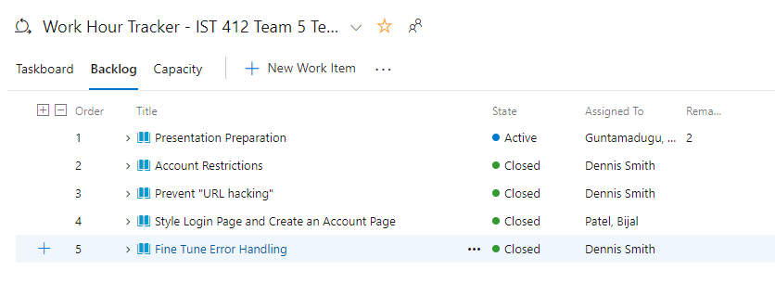

# 

# Deliverables

## Project Preparation

Create the presentation framework and add content (Professor Clarke has access to this link)

<https://docs.google.com/presentation/d/1W_uz43dasXP102lY-Xu8n7-i0EjhlyEJraceOSAp3ZA/edit#slide=id.p>

## Create video of a demo of the app

Create a video of a demo of the app so that the client can get an overview of the application’s functions. This video has been shared with the client through Google Drive.

## Account Restrictions

Restrict access to pages by user role. ‘Employee’ level user are not allowed to access the “Project Manager Actions” group of links.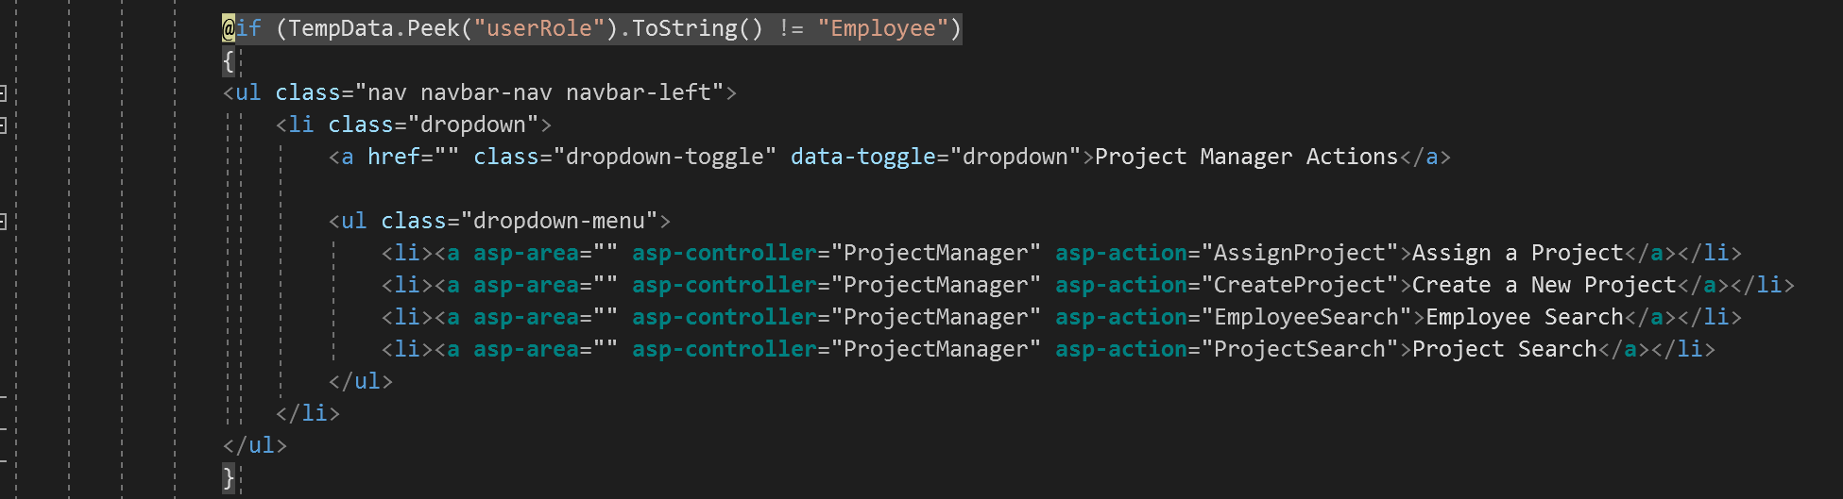

This screenshot shows that an ‘Employee’ level user, DSchrute, cannot access the “Project Manager Actions” link group:

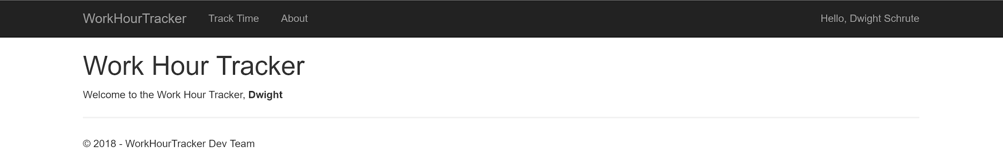

This screenshot shows that a ‘Manager’ level user, MScott, has access to the ‘Project Manager Actions’ link group:

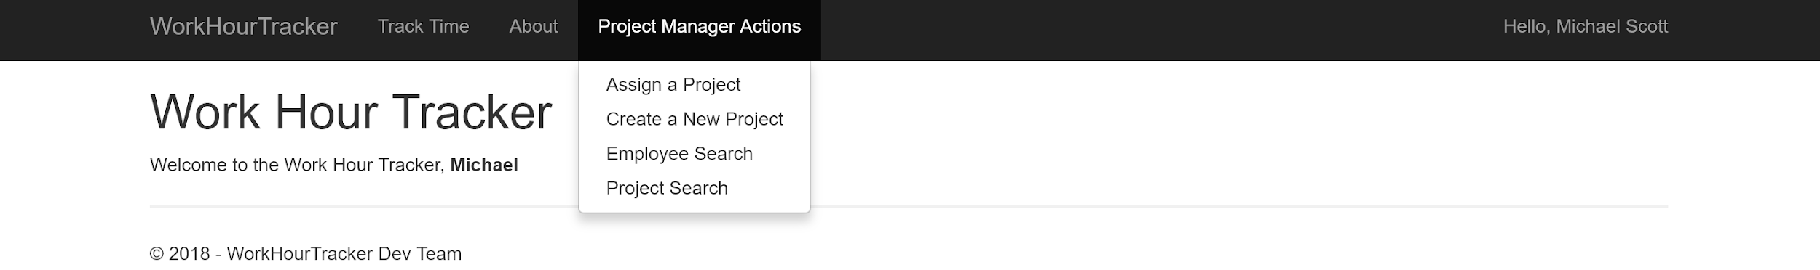

## Prevent “URL Hacking”

Add functionality that will not allow a user to enter the URL of a controller and action method they are not allowed to view. For example, an Employee level user could type ProjectManager/EmployeeSearch into the URL and be brought to that page even if they do not have a physical link to take them to that page.

This screenshot shows DSchrute trying to manually enter the Controller/ActionName that will take him to the EmployeeSearch View (that View is not for Employee level users):

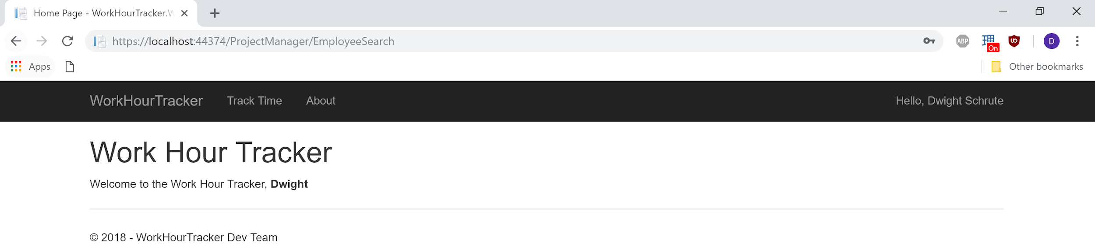

This screenshot shows the error after hitting enter (the user is brought back to the Index):

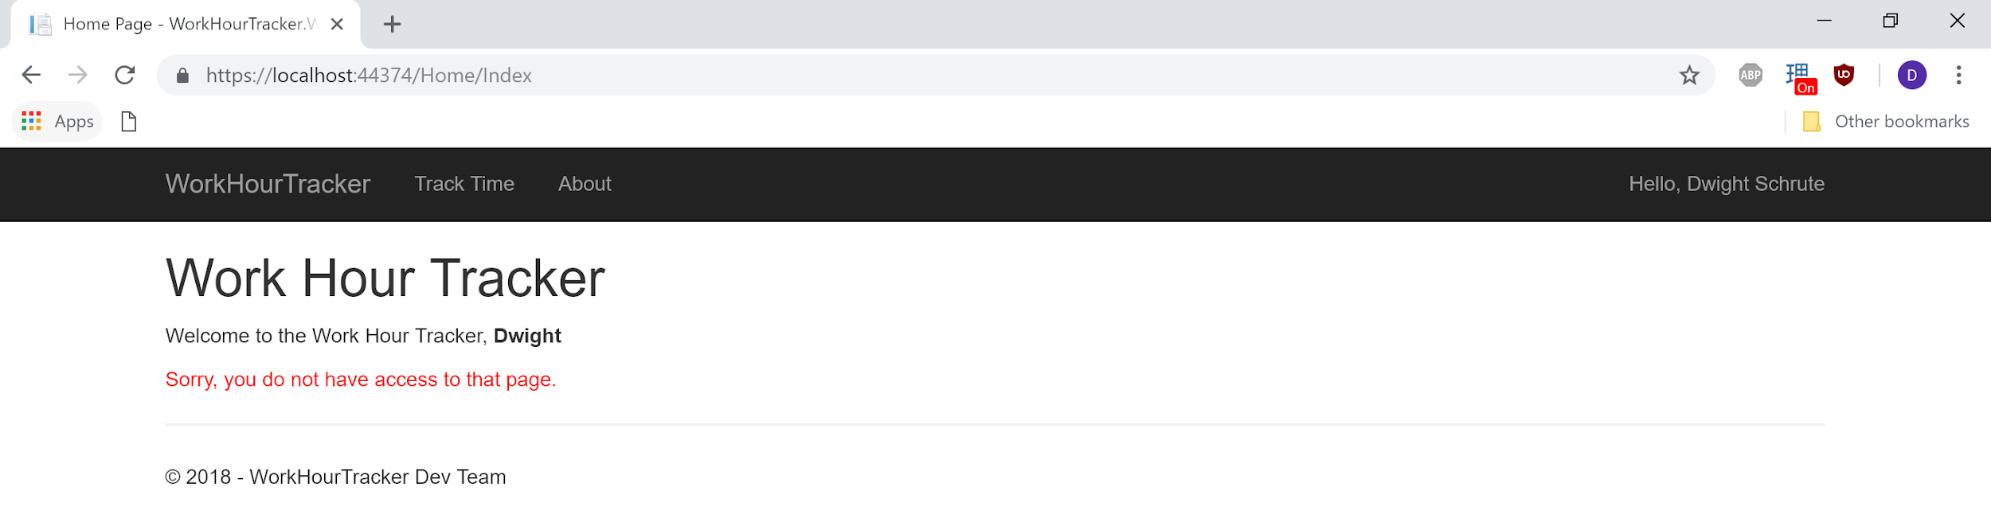

## Style ‘User Login’ and ‘Create an Account’ pages

Style the above two pages so that they are appealing to the user.

The login screen:

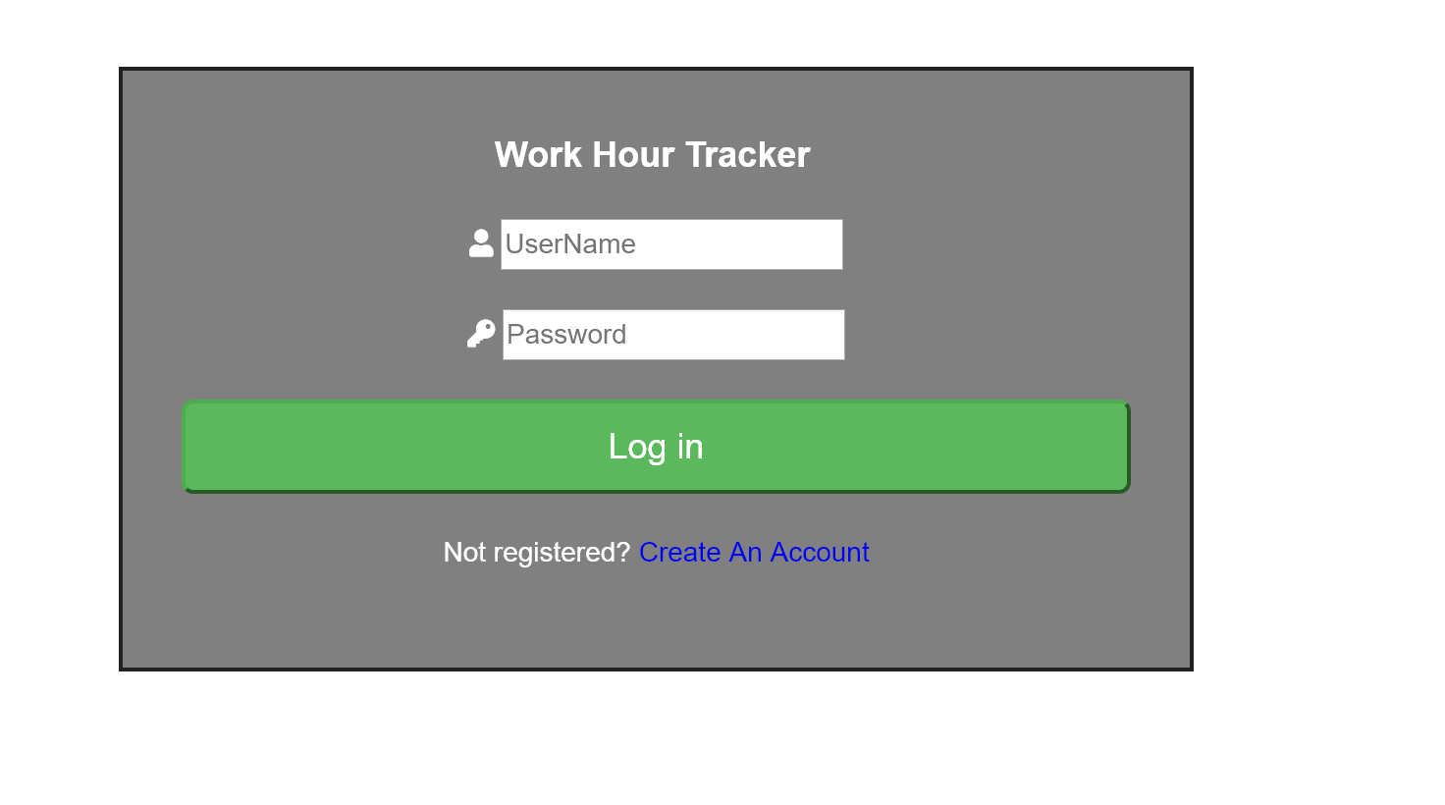

Create an Account page:

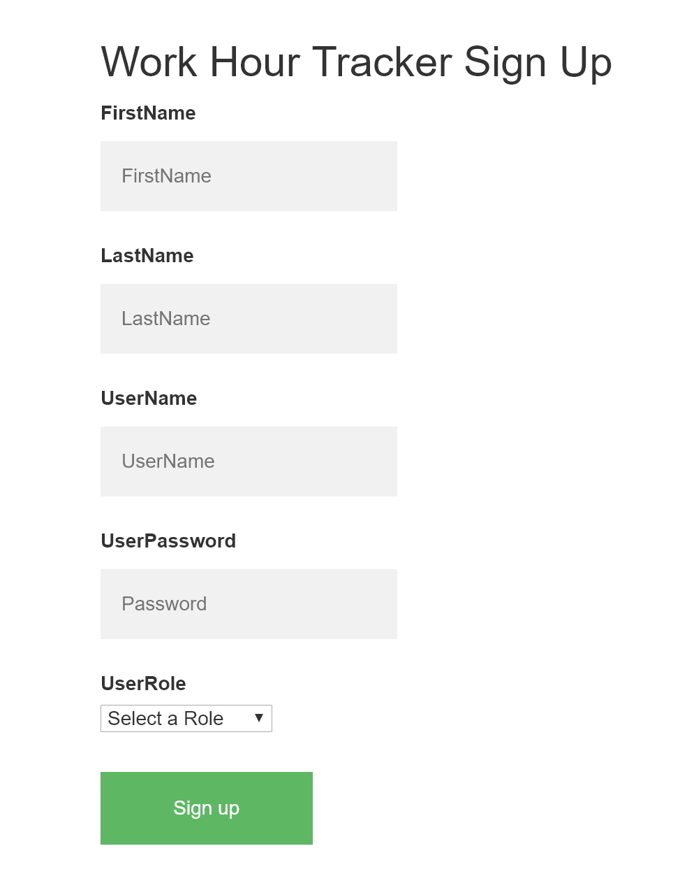

## Fine Tune Error Handling

Fine tune the error handling so that in the event of an error the user is shown what they did wrong

# Show the user the same project name cannot be used

# 

Show the user that the user name they entered was invalid:

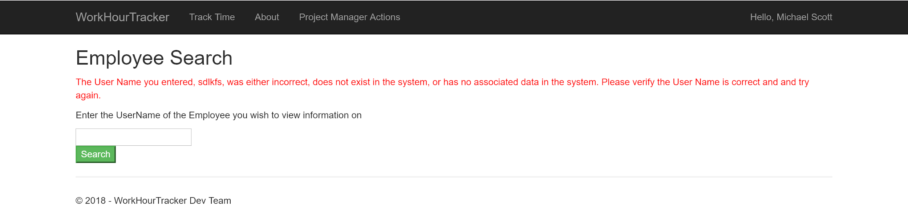

# **Retrospective**

What did the team do really well with?

The team did well dividing up the slides for the powerpoint and creating informative slides. The demo we created was a good way to bring it all together and show the client the application’s functions.

What could the team improve upon in the next sprint?

The team should have gotten into contact with the client more frequently. We were under the impression that the Sprint Documents were a good enough way to keep the client involved in the process, and that was our mistake.

# **Product Backlog Summary (Kanban board)**