Cover Page

Team Name

Team Number

Team members that contributed to the product

Table of Contents

Sprint Summary Metrics:

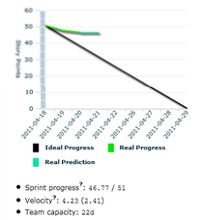

Also summarize # of User Stories started, # of User Stories completed, # of Stories carried into the next sprint, # of Hours completed, # story points completed, etc.

If you are unsure of these terms, go back to your Project Management lectures (or google) ☺

Deliverables:

What artifacts did you successfully complete? Include links to these articles and/or copy/paste contents here. Be creative with how you package this area. How would you “deliver” code? Think of github/TFS online.

What if you had a box.psu.edu folder that had a folder for each Sprint deliverable containing a PDF file of Specifications (User Stories, Workflows, Wireframes, Diagrams, etc.), ZIP archive with the code baseline to date,

Retrospective:

What did the team do really well with?

What could the team improve upon for the next Sprint?

What Lessons did you learn/observe over the last two weeks?

Product Backlog summary by sprint:

\*NOTE\* if you are using Visual Studio online, Trello or some other Agile Planning tools, there is probably a pre-canned report that you can leverage to establish these outputs.

The following is strictly giving you an idea of what you can incorporate here.

