# Github Repository

“gh repo clone rizahmad/Road2Sat”

## Directory structure

The repository contains 3 main folders:

### Dataset

This folder contains all the raw data:

#### Frames:

Contains all the frames of the video being used.

#### rs_frames:

contains the segmented lane image for each given frame.

#### roadref:

contains the initial reference frame of the ground video.

#### satref:

contains the initial reference frame for the satellite image.

### gen

this contains all the generated data and .json files containing all the interframe homographies and the initial satellite image to 1st frame homography.

### Resources

Contains the required models like superglue and YOLOP being used to generate the top-view image and the scripts folder which contains all the scripts being utilized in our image generation.

# Scripts

## Road2sat.py

Command



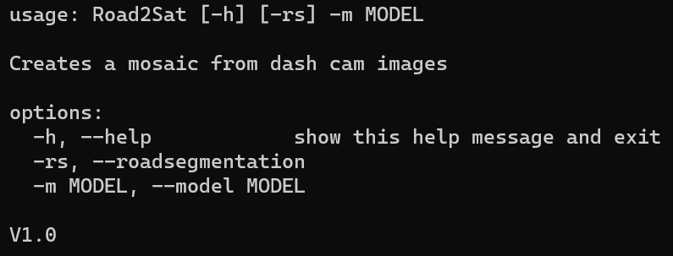

### Design

Calculates inter-frame homography and generates projection images and mosaic.

## Video2frame.py

### Command

### Design

The task of this script is to store the individual frames of a video in a folder so they can be utilized later.

### Sample outputs

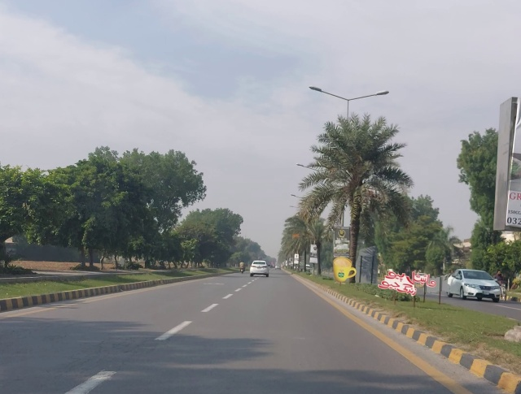

## roadSegmentation.py

### Command



### Design

The file utilizes the YOLOP lane segmentation to provide the final lanes(after being segmented) which are multiplied with their mask and only the lane remains.

### Sample outputs

## numpyArrayEncoder.py

### Command

N/A – internal script

### Design

Utility script that converts any desired numpy array into json file

### Sample outputs

Not applicable

## selectedPointsHomography.py

### Command

### Design

We use this file to hand annotate the corresponding points between the satellite image and 1st frame and compute the homography using cv2.

### Sample outputs (computed homography)

