**Klasifikasi tingkat Buah Manggis dengan menggunakan deep learning**

Pada saat ini, penulis mengambil referensi dari karya AL-diphi et all yang berjudul **Decision Support System for In Situ Melon’s Fruit Harvesting Time Based on Fuzzy Logic and Single Shot Detector (SSD).** Alasan penulis memilih ini dikarenakan ada kesamaan topik dan ada kesamaan tujuan, hanya saja berbeda buah dan tingkatan kematangan. Dan ini mungkin bisa dijadikan acuan dalam *preprocessing data* *image* pada buah manggis.

**Abstract—Melon has a large variety in horticultural and is widely used in scientific research such as biology and geneticist’s developments. This study aims to develop a system for detecting the correct harvest time. The farmers currently harvest melons based on their experience, and melon cannot maintain their quality after harvesting. Thus, the melon needs to be harvested at the right time. Melon harvesting is a daily task; Melon is not mature on the same day even though the melon plant was planted in the same period due to genetics and environment. Therefore, the decision support system should detect and classify the ripeness level of the fruit on the tree. The system will categorize the maturity level into three categories: Ripe, About to Ripe, or Under Ripe (within a rate from 0 to 10 obtained from fuzzy inference system result). The ripeness levels are confirmed by the expert, depending on the skin color of the fruit. As a result, we get 100% accuracy in classifying each category using phone camera images and video. Furthermore, this decision support system can be implemented in melon’s harvesting robot. The melon used in this study is honeydew Cucumis melo L, var. Alisha F1.**

Penulis pula mengambil referensi dari karya Wang et all yang berjudul **YOLOv7: Trainable bag-of-freebies sets new state-of-the-art for real-time object detectors .** Alasan penulis memilih ini dikarenakan memiliki akurasi tertinggi dan memiliki kecepatan tertinggi untuk algoritma pendeteksian objek . berarti penulis menggunakan algoritma YOLOv7 berdasarkan artikel ini .

Abstraksi

**YOLOv7 surpasses all known object detectors in both speed and accuracy in the range from 5 FPS to 160 FPS and has the highest accuracy 56.8% AP among all known real-time object detectors with 30 FPS or higher on GPU V100. YOLOv7-E6 object detector (56 FPS V100, 55.9% AP) outperforms both transformer-based detector SWINL Cascade-Mask R-CNN (9.2 FPS A100, 53.9% AP) by 509% in speed and 2% in accuracy, and convolutionalbased detector ConvNeXt-XL Cascade-Mask R-CNN (8.6 FPS A100, 55.2% AP) by 551% in speed and 0.7% AP in accuracy, as well as YOLOv7 outperforms: YOLOR, YOLOX, Scaled-YOLOv4, YOLOv5, DETR, Deformable DETR, DINO-5scale-R50, ViT-Adapter-B and many other object detectors in speed and accuracy. Moreover, we train YOLOv7 only on MS COCO dataset from scratch without using any other datasets or pre-trained weights. Source code is released in https:// github.com/WongKinYiu/yolov7**

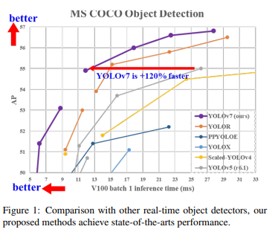

Teknologi Budidaya Manggis dari badan litbang pertanian

Jurnal ini direkomendasikan oleh dosen pembimbing saya, selain itu mengapa saya menggunakan rujukan ini juga, itu dikarenakan dosen pembimbing saya bermitra dengan kementerian pertanian, maka dari itu. Penulis ini menggunakan ini