Windows User

1. If you already install Virtual Environment, Open cmd and type ‘workon NoteApp’ to activate the environment and move into your root project folder.

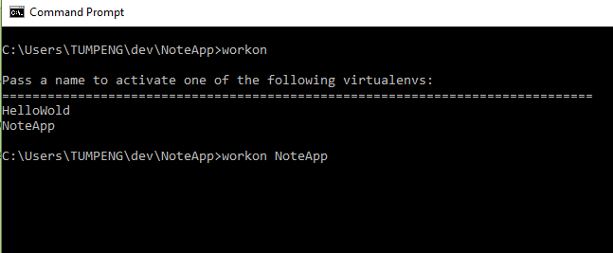

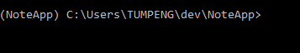

1. Start your MongoDB service on cmd(administrator).

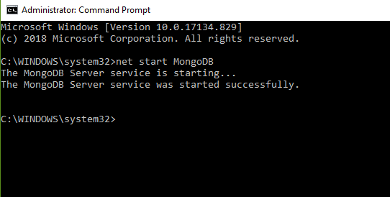

1. Go to your MongoDB directory. Click mongod.exe, then mongo.exe

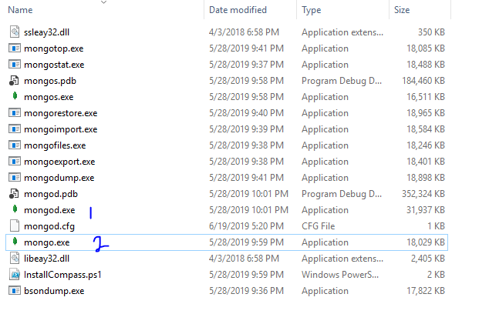

1. Back to your project folder and run your python backend

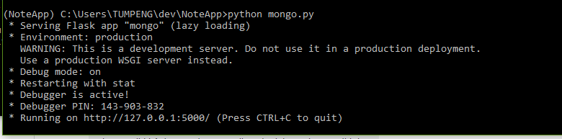

1. Now Open your Front End folder. I am using angular for the front end, so if you do not have node_modules, you must install first “ng new NoteAppFE”. Here is my FE directory

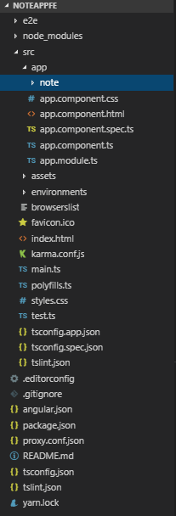

1. And then type npm start. If complete open localhost:4200 in your browser

