Nama : Rizal Fathur Rahman  
NPM : 140810170009  
A

KURSKAL

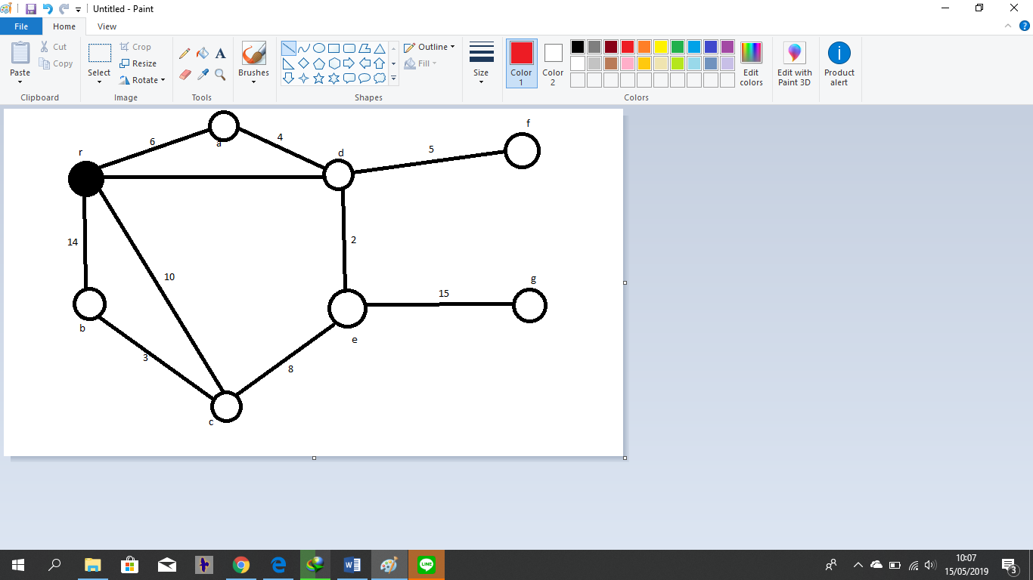

|  |  |  |
| --- | --- | --- |
| Steps | Edges | weight |
| 1 | d-e | 2 |
| 2 | b-c | 3 |
| 3 | a-d | 4 |
| 4 | d-r | 5 |
| 5 | c-e | 8 |
| 6 | d-f | 9 |
| 7 | e-g | 15 |

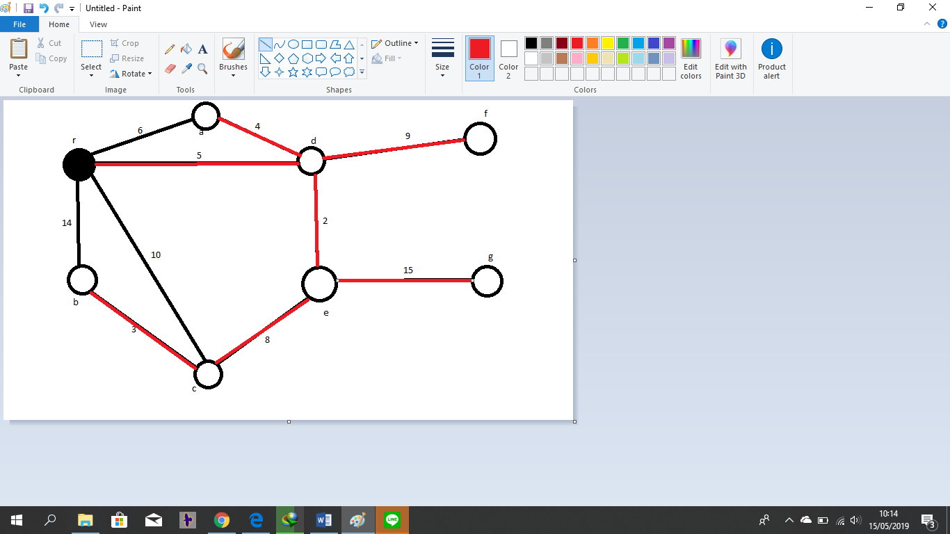

PRIM



|  |  |  |
| --- | --- | --- |
| Steps | Edges | Weight |
| 1 | r-d | 5 |
| 2 | d-e | 2 |
| 3 | a-d | 4 |
| 4 | e-c | 3 |
| 5 | c-b | 3 |
| 6 | d-f | 9 |
| 7 | e-g | 15 |

