MODUL PRAKTIKUM 4
ANALISIS ALGORITMA



Disusun oleh :
Rizal Fathur Rahman 140810170009

PROGRAM STUDI S1 TEKNIK INFORMATIKA
FAKULTAS MATEMATIKA DAN ILMU PENGETAHUAN ALAM
UNIVERSITAS PADJADJARAN
2019
- Merge Sort
Source code:
/****
Nama Program : mengurutkan elemen menggunakan merge sort
Nama : Rizal Fathur Rahman
NPM : 140810170009
***/

#include <iostream>
#include<stdlib.h>
#include<stdio.h>
using namespace std;

void merge(int arr[], int left, int middle, int right)
{
int i, j, k;
int n1 = middle - left + 1;
int n2 = right - middle;

int kiri[n1], kanan[n2];

for (i = 0; i < n1; i++)
kiri[i] = arr[left + i];
for (j = 0; j < n2; j++)
kanan[j] = arr[middle + 1+ j];

i = 0;
j = 0;
k = left;
while (i < n1 && j < n2)
{
if (kiri[i] <= kanan[j])
{
arr[k] = kiri[i];
i++;
}
else
{
arr[k] = kanan[j];
j++;
}
k++;
}

while (i < n1)
{
arr[k] = kiri[i];
i++;
k++;
}

while (j < n2)
{
arr[k] = kanan[j];
j++;
k++;
}
}

void mergeSort(int arr[], int left, int right)
{
if (left < right)
{
int middle = left+(right-left)/2;

mergeSort(arr, left, middle);
mergeSort(arr, middle+1, right);

merge(arr, left, middle, right);
}
}

void printArray(int arr[], int size)
{
for (int i=0; i < size; i++)
cout<<arr[i]<<" ";
cout<<"\n";
}

int main()
{
cout<<"=============================\n";
cout<<"Merge Sort";
int arr[] = {12,10,18,20,16,133};
int arr_size = sizeof(arr)/sizeof(arr[0]);

cout<<"Array nya \n";
printArray(arr, arr_size);

mergeSort(arr, 0, arr_size - 1);

cout<<"\nArray Setelah disorting \n";
printArray(arr, arr_size);
cout<<"=============================\n";
return 0;
}

Screenshot:
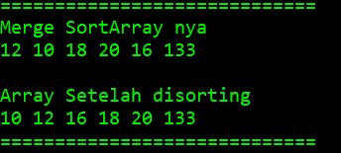
Kompleksitas Algoritma merge sort adalah O(n lg n).
- Selection Sort
Source code:
/**************

Nama Program : Selection sort

Nama : Rizal Fathur Rahman

NPM : 140810170009

**************/
#include <iostream>
#include<conio.h>

using namespace std;

int data[100],data2[100];
int n;

void tukar(int a, int b)
{
int t;
t = data[b];
data[b] = data[a];
data[a] = t;
}
void selection_sort()
{
int pos,i,j;
for(i=1;i<=n-1;i++)
{
pos = i;
for(j = i+1;j<=n;j++)
{
if(data[j] < data[pos]) pos = j;
}
if(pos != i) tukar(pos,i);
}
}

int main()
{
cout << "\n=====================================";
cout<<"\nMasukkan Jumlah Data : ";cin>>n;
cout << "\n-------------------------------------" << endl;
for(int i=1;i<=n;i++)
{
cout<<"Masukkan data ke-"<<i<<" : ";
cin>>data[i];
data2[i]=data[i];
}

selection_sort();
cout << "\n-------------------------------------" << endl;
cout<<"Data Setelah di Sort : ";
for(int i=1; i<=n; i++)
{
cout<<" "<<data[i];
}

cout << "\n=====================================\n";
getch();
}

Screenshot:
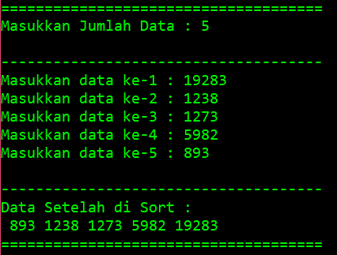
Menentukan T(n):
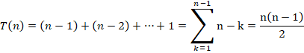
Oleh Karena itu:

Karena ,Maka

- Insertion Sort
Source code:
/**************

Nama Program : Insertion sort

Nama : Rizal Fathur Rahman

NPM : 140810170009

**************/

#include <iostream>
#include <conio.h>

using namespace std;

int data[100],data2[100],n;

void insertion_sort()
{
int temp,i,j;
for(i=1;i<=n;i++){
temp = data[i];
j = i -1;
while(data[j]>temp && j>=0){
data[j+1] = data[j];
j--;
}
data[j+1] = temp;
}
}
int main()
{
cout << "\n=================================="<<endl;
cout<<"Masukkan Jumlah Data : "; cin>>n;
cout<<endl;
cout << "\n----------------------------------" << endl;
for(int i=1;i<=n;i++)
{
cout<<"Masukkan data ke-"<<i<<" : ";
cin>>data[i];
data2[i]=data[i];
}
cout << "\n----------------------------------" << endl;
insertion_sort();
cout<<"\nData Setelah di Sort : "<<endl;
for(int i=1; i<=n; i++)
{
cout<<data[i]<<" ";
}
cout << "\n=================================="<<endl;
getch();
}

Screenshot:
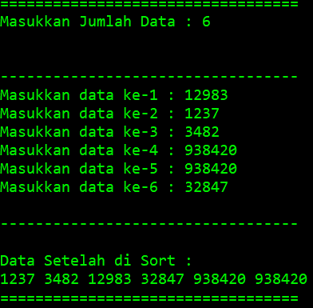
Menentukan T(n):
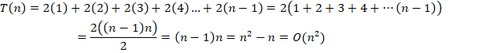
T(n) =

- Bubble sort
Source code:
/**************

Nama Program : Insertion sort

Nama : Rizal Fathur Rahman

NPM : 140810170009

**************/

#include <iostream>
#include <conio.h>

using namespace std;

int main(){
int arr[100],n,temp;
cout << "\n================================================"<<endl;
cout<<"Massukan banyak elemen yang akan diinputkan : ";cin>>n;
cout << "\n------------------------------------------------" << endl;

for(int i=0;i<n;++i){
cout<<"Masukkan Elemen ke-"<<i+1<<" : ";cin>>arr[i];
}

for(int i=1;i<n;i++){
for(int j=0;j<(n-1);j++){
if(arr[j]>arr[j+1]){
temp=arr[j];
arr[j]=arr[j+1];
arr[j+1]=temp;
}
}
}
cout << "------------------------------------------------" << endl;
cout<<"\nHasil dari Bubble Sort : "<<endl;
for(int i=0;i<n;i++){
cout<<" "<<arr[i];
}
cout << "\n================================================"<<endl;
}

Screenshot:
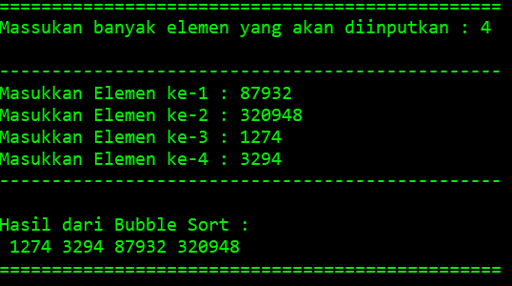
Menentukan T(n):

