# Week-1 and Week-2

# **Part1:**

1. File name: 1perimeter.py

**Description:**

The program calculates the perimeter of the rectangle of length 9 and width 6.

The perimeter of rectangle is calculated by the formula:

***Perimeter = 2 * (length + width)***

Using formula, the perimeter should be 30 if length and width are 9 and 6 respectively.

Test is carried out.

**Test:**

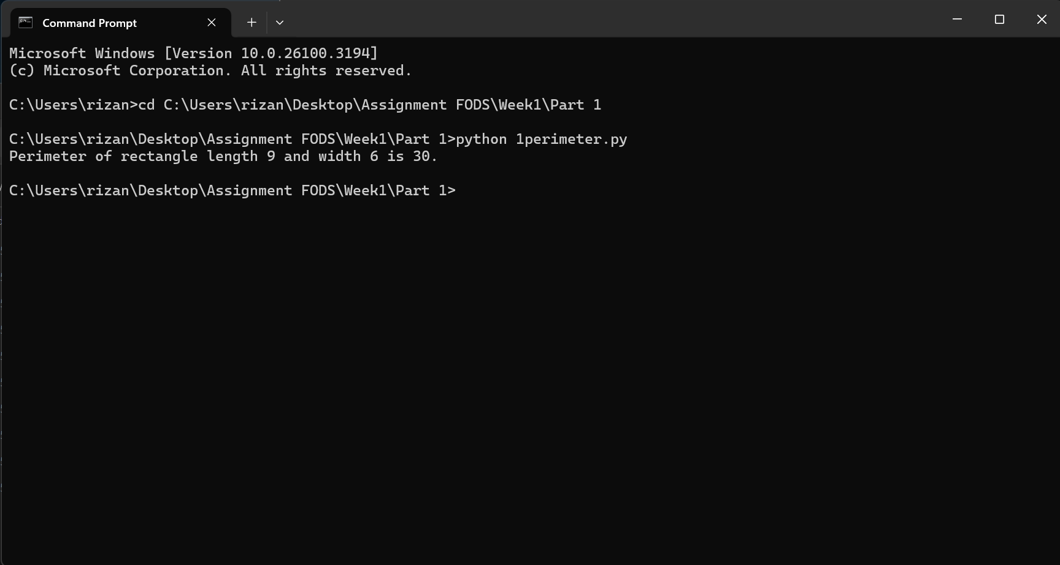

Based on the test, it is found that the program works properly.

1. File name: 2print.py

**Description:**

The program prints the message “Python is great, it’s wild!”.

**Test:**

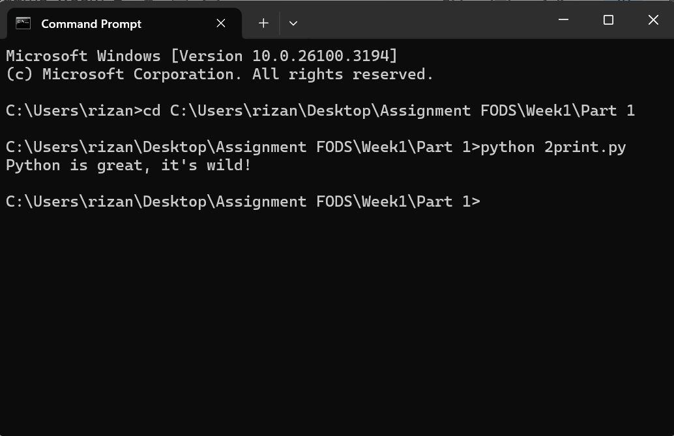

Based on the test, the program works properly.

1. File name: 3power.py

**Description:**

The program calculates when 2 is raised to the power 10.

In python, ** is an arithmetic operator used to calculate when the first operand is raised to the second operand. It is represented by a ** b.

**Test**:

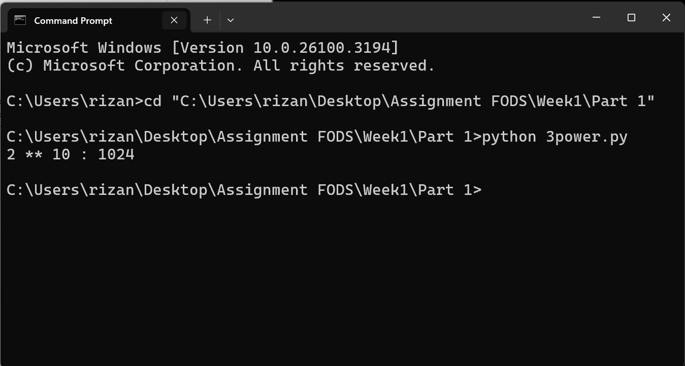

Based on the test, the program works properly.

1. File name: 4factorial.py

**Description:**

The program calculates the difference of 7 factorial and 5 factorial.

For that, python has a module called math which has a method called factorial, which calculates the factorial of the number passed in the function. Using these modules helps in writing this program.

The difference between 7 factorial and 5 factorial is 4920. Test is carried out.

**Test:**

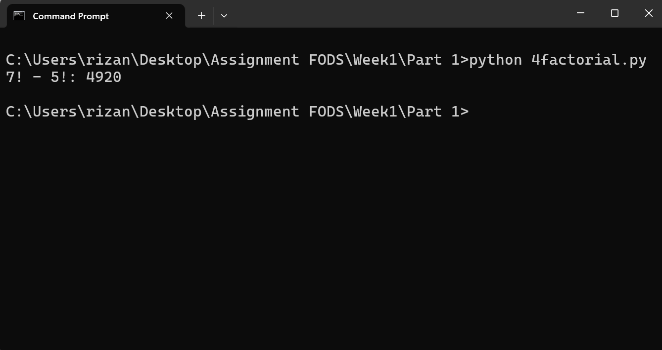

Based on the test, the program works properly.

1. File name: 5forenamemul.py

**Description:**

The program prints when my forename is multiplied by 5.

My forename is Rizan. Based on that, when the forename is multiplied by 5, the output should be “RizanRizanRizanRizanRizan”.

Test is carried out.

**Test:**

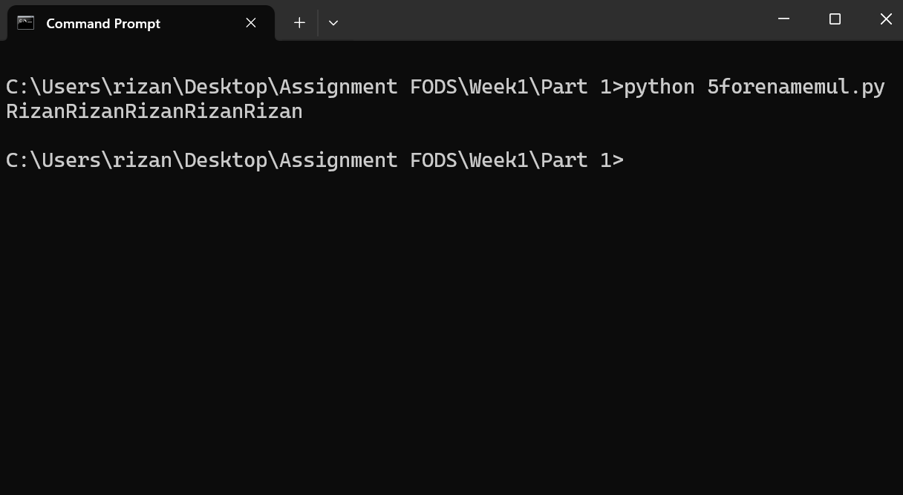

Based on the test, the program works properly.

1. File name: 6justified.py

**Description:**

The program prints my name left justified 15 spaces.

**Test:**

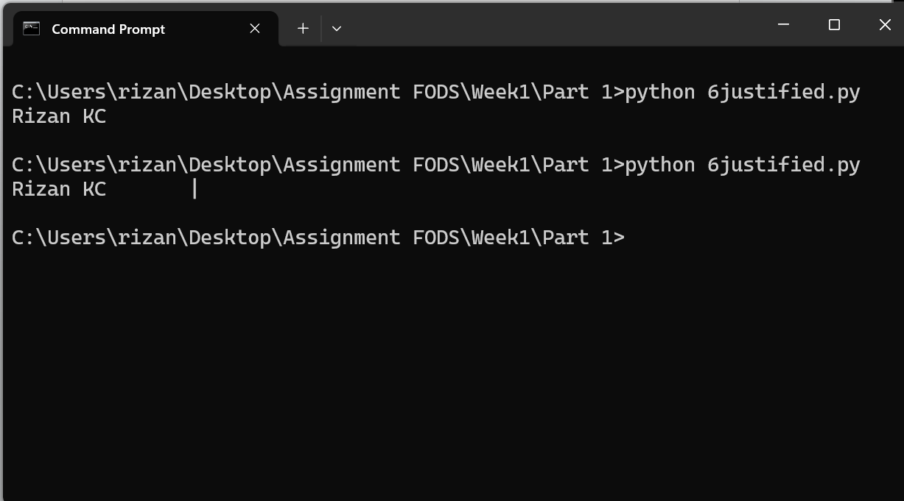

The first test works fine but the spaces are not visible making it harder to distinguish. The second test is carried where after formatting a character ‘|’ is added to make it distinguishable. Based on the test, the program works fine.

1. File name: 7decimal.py

**Description:**

The program prints the value of PI to 5 decimal places.

In the math module, the math.pi returns the value of PI which is 3.141592653589793.

Alongside, the value of PI should be to 5 decimal places which can be obtained by using the format function. So, the value should be 3.14159.

**Test:**

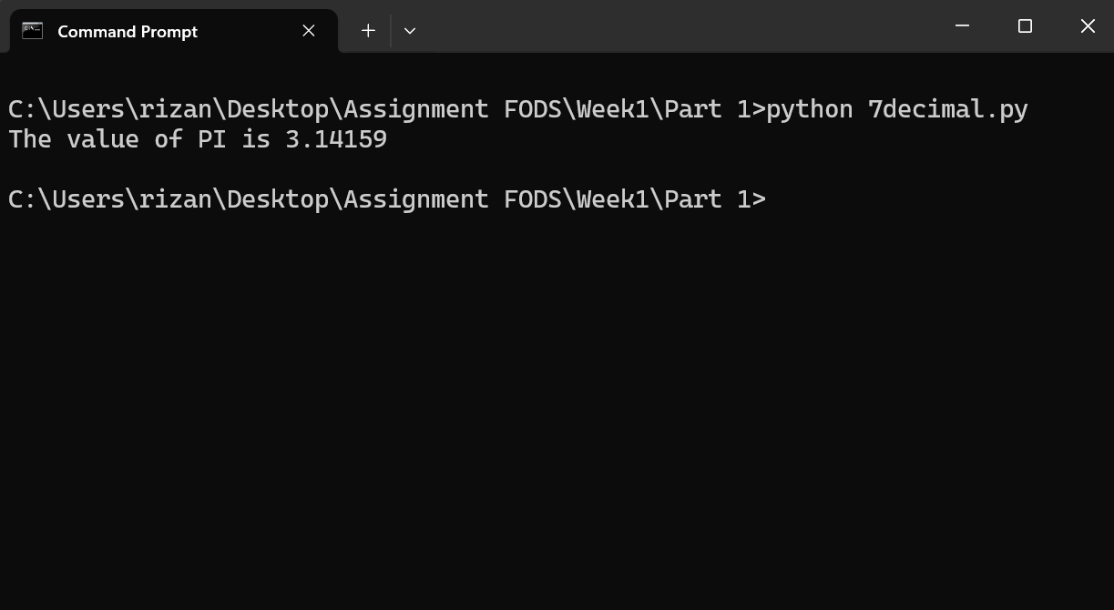

1. File name: 8modulus.py

**Description:**

The program calculates 200 modulus 12.

In python, % is used to calculate the remainder when the first operand is divided by the second operand.

The remainder when 200 is divided by 12 is 8. Based on this, a test is carried out.

**Test:**

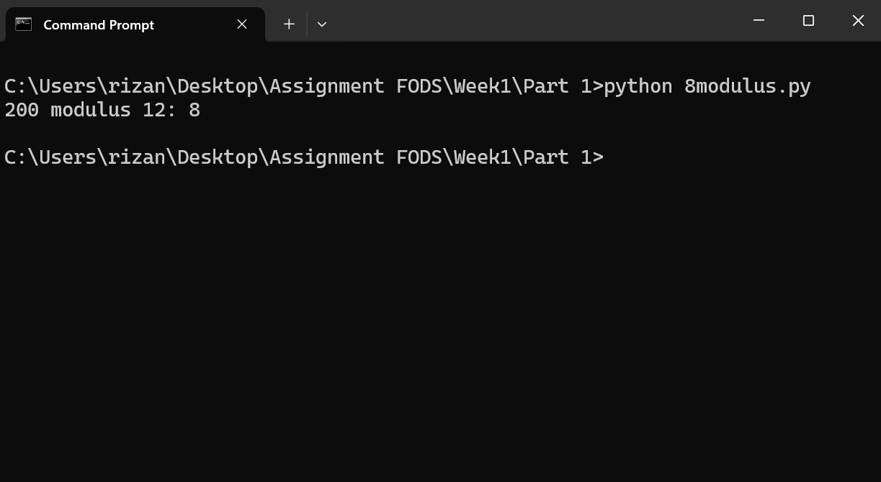

Based on the test, the program works properly.

1. File name: 9float_as_int.py

**Description:**

The program prints 7.2 a floating number as an integer value.

For that, the number 7.2 should be type casted from float to integer.

The result should be 7. Based on this, a test is carried out.

**Test:**

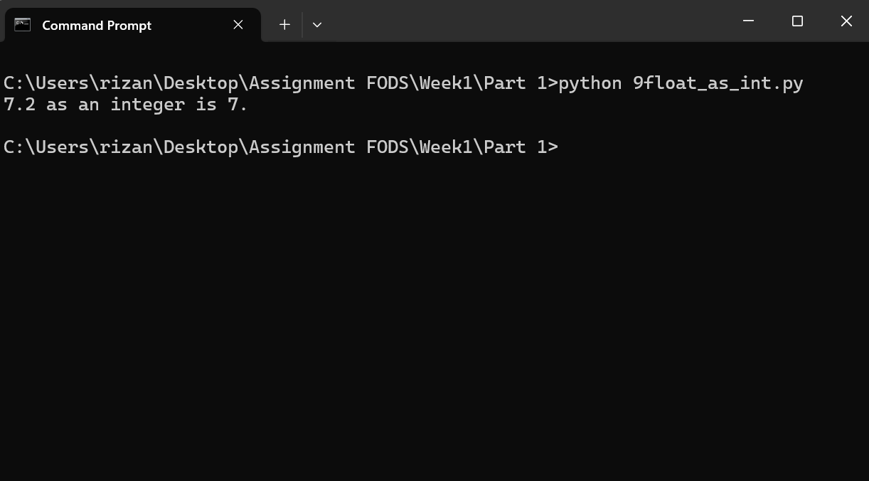

Based on the test, the program works properly.

1. File name: 10unicode.py

**Description:**

The program prints the unicode encoding for my name.

The unicode encoding can be obtained using the ord() method.

**Test:**

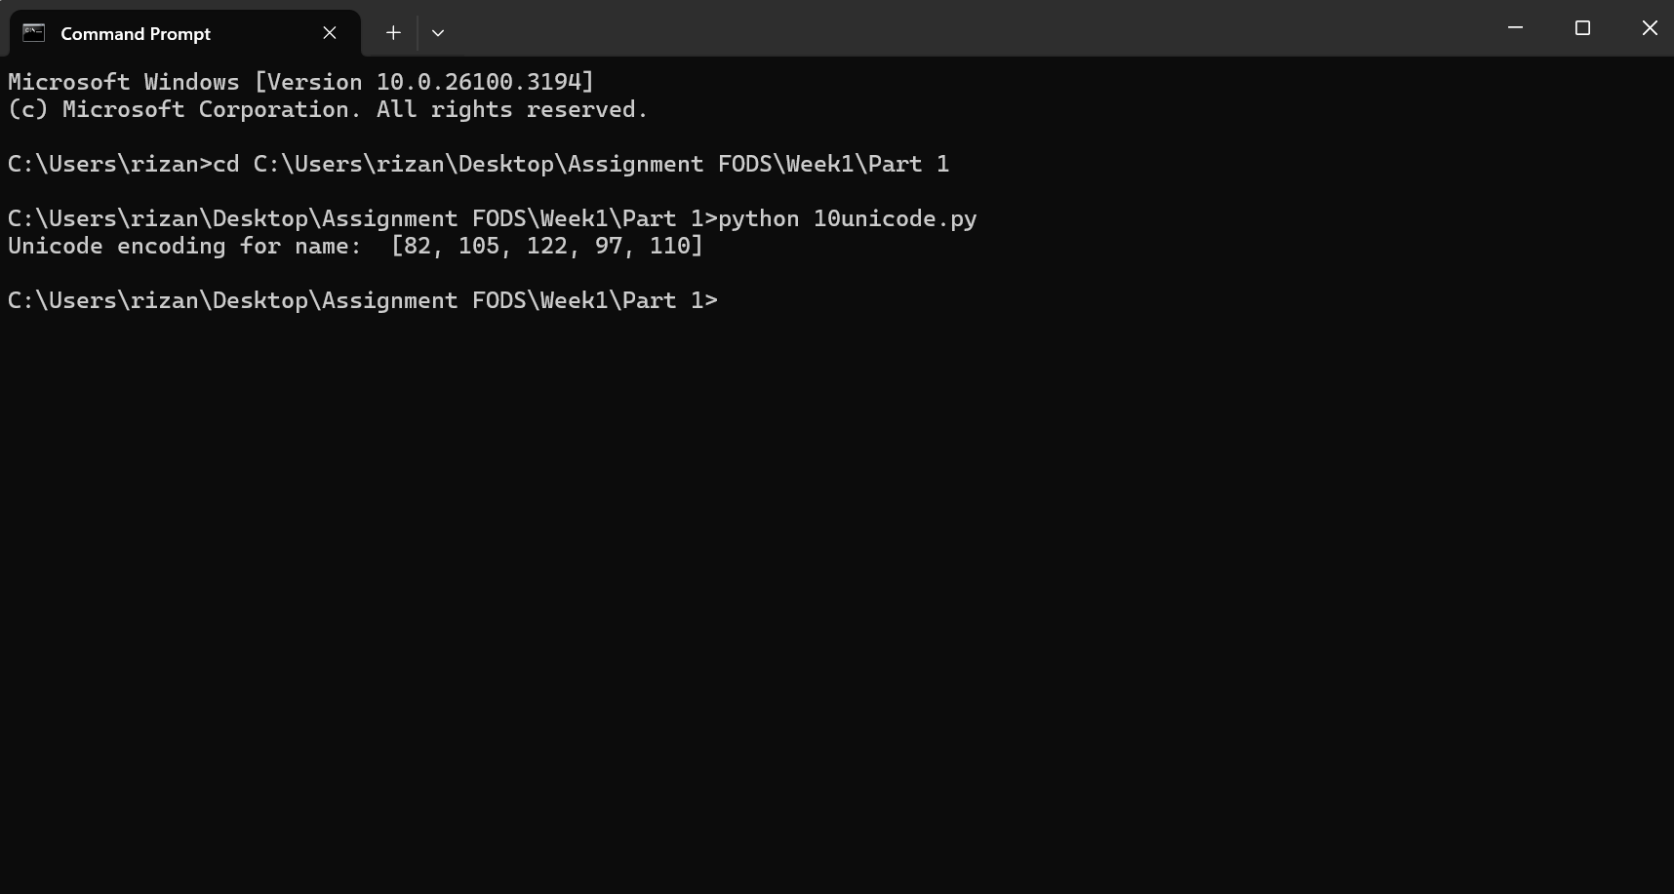

Based on the test, the program works properly.

# **Part2**:

1. File name: 1evenodd.py

**Description:**

The program takes a number from the user and displays whether the number is even or odd.

The number is even if the number is divisible by 2. To check divisibility the remainder must be equal to 0 which can be obtained by num % 2.

If the remainder is 0, the condition of even satisfies.

For that 2 tests are carried out, in the first test, number is 8 and in the second test, number is 5.

**Test1:**

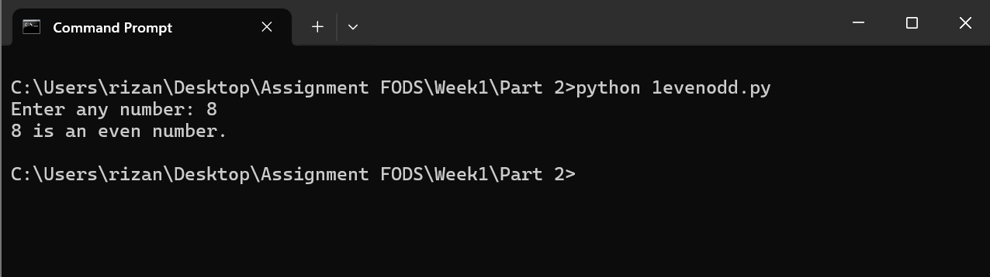

**Test2:**

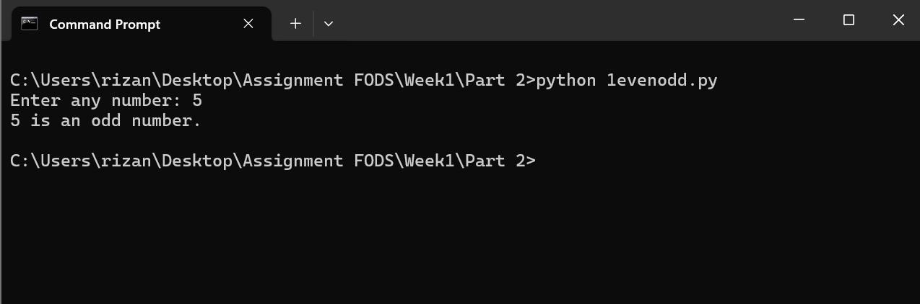

Based on the test, the program works properly.

1. File name: 2formatdivision.py

**Description:**

The program asks the user for two integer values and displays the results of the first number divided by the second, with exactly two decimal places displayed.

The result of division can be obtained by using ‘/’ operator. And for two decimal places, a format function is used.

Alongside, error handling is done using if else, if the second number is 0 then “Error” message is displayed.

**Test1:**

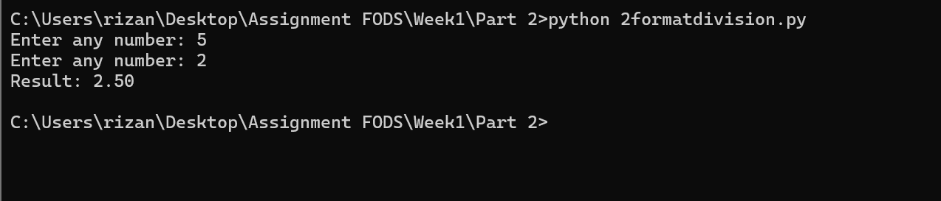

**Test2:**

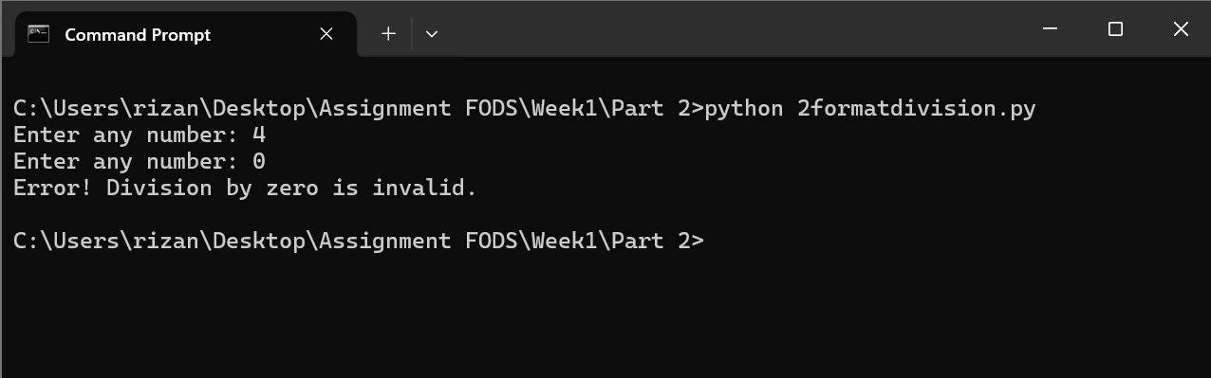

Based on the test, the program works properly.

1. File name: 3CtoF.py

**Description:**

The program prompts the user to enter the temperature in Celsius and converts the temperature in Celsius to Fahrenheit.

The formula to convert the temperature from Celsius to Fahrenheit is:

***F = (C * 1.8) + 32***

Using this formula, the temperature can be converted from Celsius to Fahrenheit.

The 40 degree Celsius in Fahrenheit scale is 104. Based on this, a test is carried out.

**Test:**

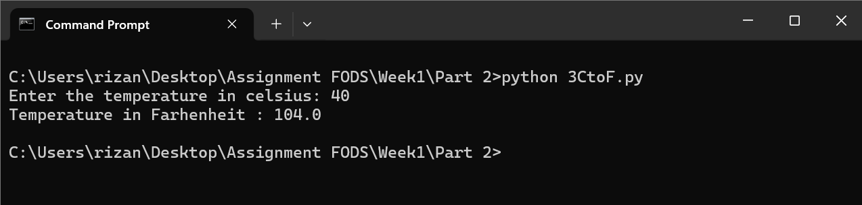

1. File name: 4euclideandist.py

**Description:**

The program prompts the user to enter both the coordinates and calculates the euclidean distance between two coordinates.

The euclidean distance can be calculated by the formula:

***Distance = ((x2-x1)^2 + (y2-y1)^2)^½***

If (x1, y1) = (5, 2) and (x2, y2) = (2, 6) then the euclidean distance is 5 units.

Based on this, a test is carried out.

**Test:**

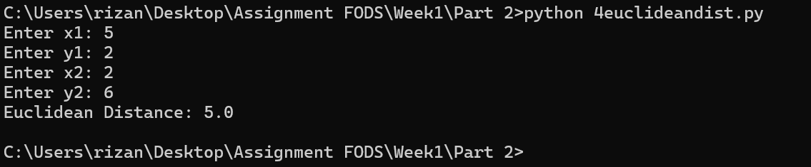

1. File name: 5simpleinterest.py

**Description:**

The program prompts the user to enter Principle, Rate of Interest, Time Period and calculates the Simple Interest.

The Simple Interest can be calculated using the formula:

***S.I. = (P * T * R) / 100***

**Test:**

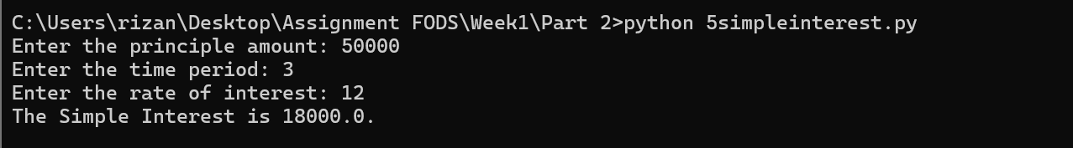

Based on the test, the program works fine.

1. File name: 6divisibility.py

**Description:**

The program prints the number which is divisible by 7 and multiple of 5, between 1500 and 2000(both included).

For this program, a for loop and range function is used.

**Test:**

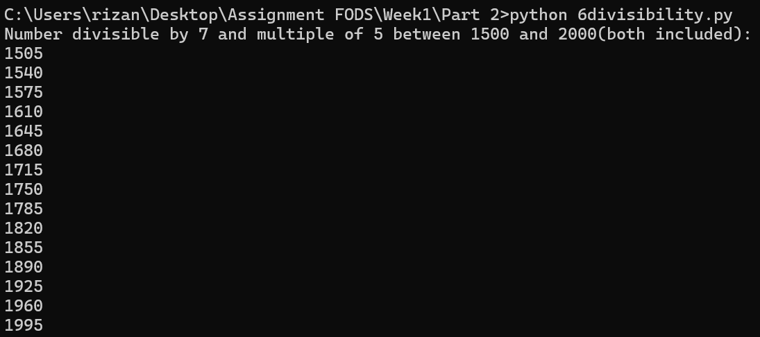

Based on the test, the program works fine.

1. File name: 7noofletanddig.py

**Description:**

The program accepts a string and calculates the number of digits and letters.

For this program, a for loop, .isalpha, .isdigit method is used to count the number of digits and letters.

**Test1:**

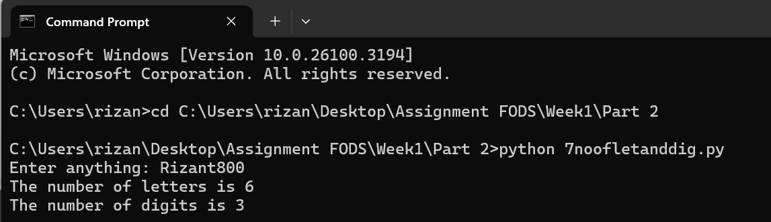

**Test2:**

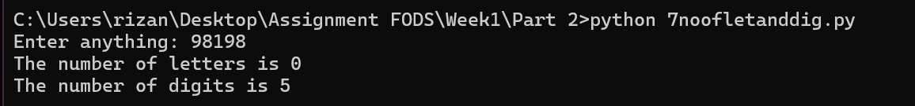

**Test3:**

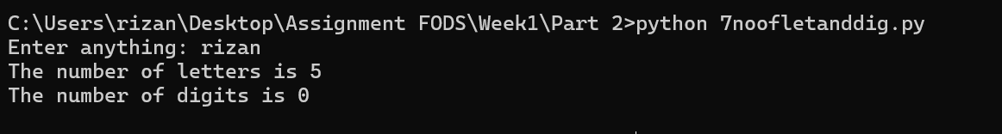

Based on the test, the program works fine.

1. File name: 8game.py

**Description:**

This program generates a random number between 1 and 100 and the user has to guess it in 5 attempts. After each guess, the program provides feedback:

"Too high" if the guess is greater than the target number.

"Too low" if the guess is smaller than the target number.

"Correct number" if the guess is right.

If the user cannot guess the number correctly in 5 attempts, the program prints "Game Over" along with the correct answer.

For this program, a for loop, if…elif…else, random module and a range method is used.

**Test1:**

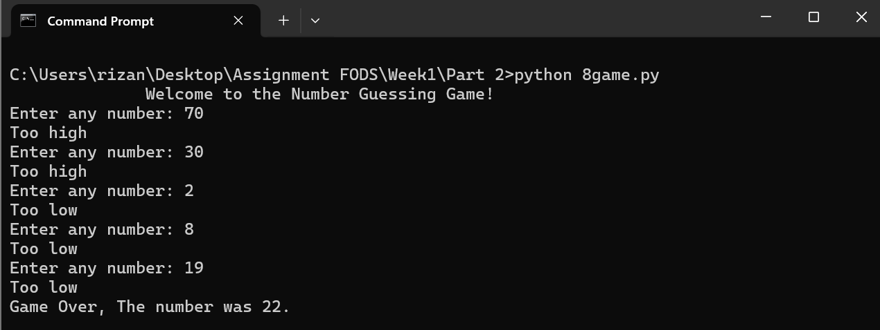

**Test2:**

