Week-7 and Week-8

- File name: null_vector.py
Description:
The program creates a null vector of size 10 where the fifth value is 1.

The program uses numpy module to create a vector where every elements are 0s and the value at the position 5 which is index 4 is change to 1 as per the requirement.

Test :
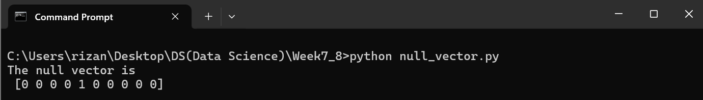Based on the test, the program works properly.

- File name: random_shape.py
Description:
The program prompts the user to input two numbers a and b. And generates an array containing random elements where shape is made as per the input a and b.
The program prints the array and average of the array elements.

Test 1:
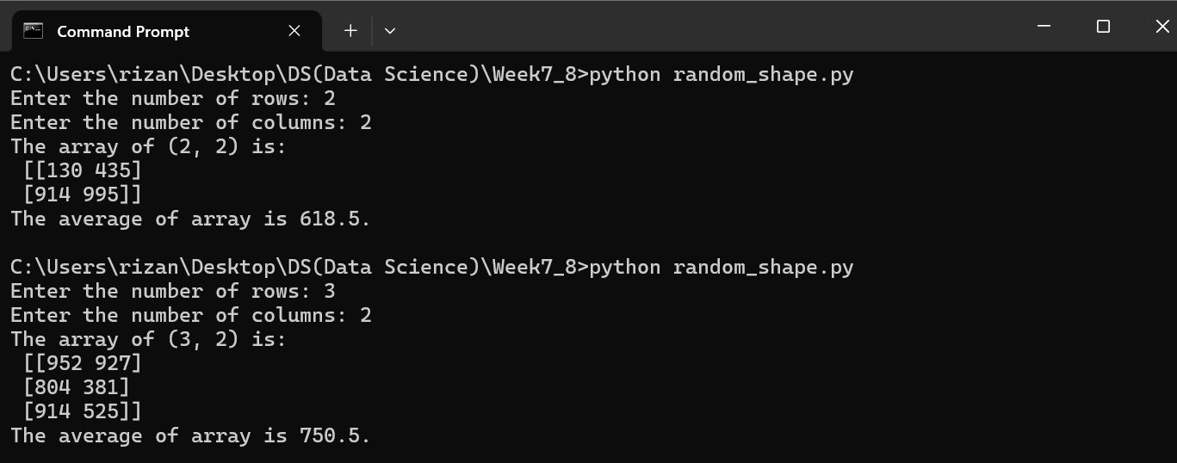Based on the test, the program works properly.

- File name: excluded.py
Description:
The program creates an array of size 10 where elements ranges from 0 to 1 while 0 and 1 are excluded from the array.
The program uses numpy module to create the array using linspace() function.

Test is carried out.
Test:
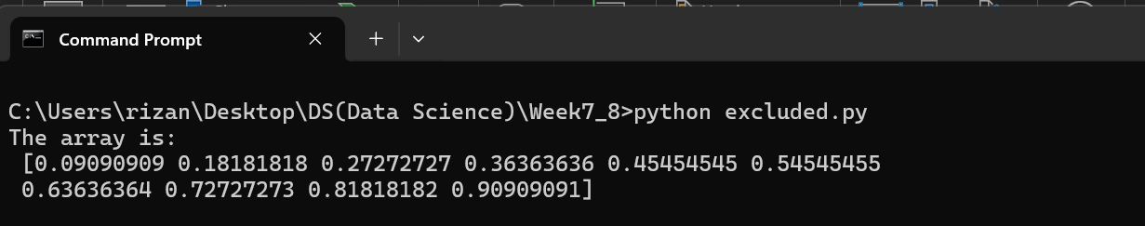

Based on the test, the program works properly.

- File name: identity.py
Description:
The program creates an identity matrix of shape (3,4).
Test:
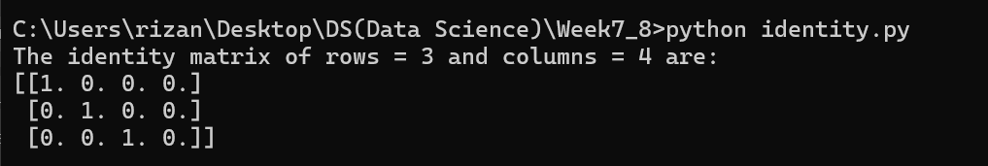

Based on the test, the program works properly.

- File name: fivexfive.py
Description:
The program creates a 5 * 5 matrix where values ranges from 0 to 4.
This is done by creating a 1d array of which contains 5 elements ranging from 0 to 4. Then the tile() method is used to construct an array of 5 * 5 by repeating the existing array of 5 elements.

Test is carried out.
Test:
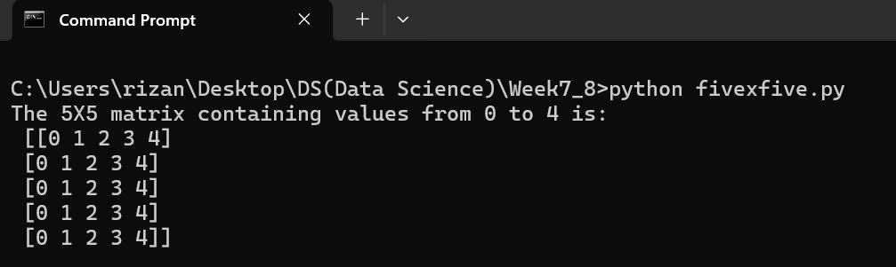

Based on the test, the program works properly.

- File name: array_slicing.py
Description:
The program creates an array from user input list, sort them and performs the slicing operation to get the elements between indexes such as 2 to 5, 5 to 8, 2 to 9.
The program uses .append() method to add elements in a list. For sorting, the program uses .sort() method from numpy module to sort the array.

Test:
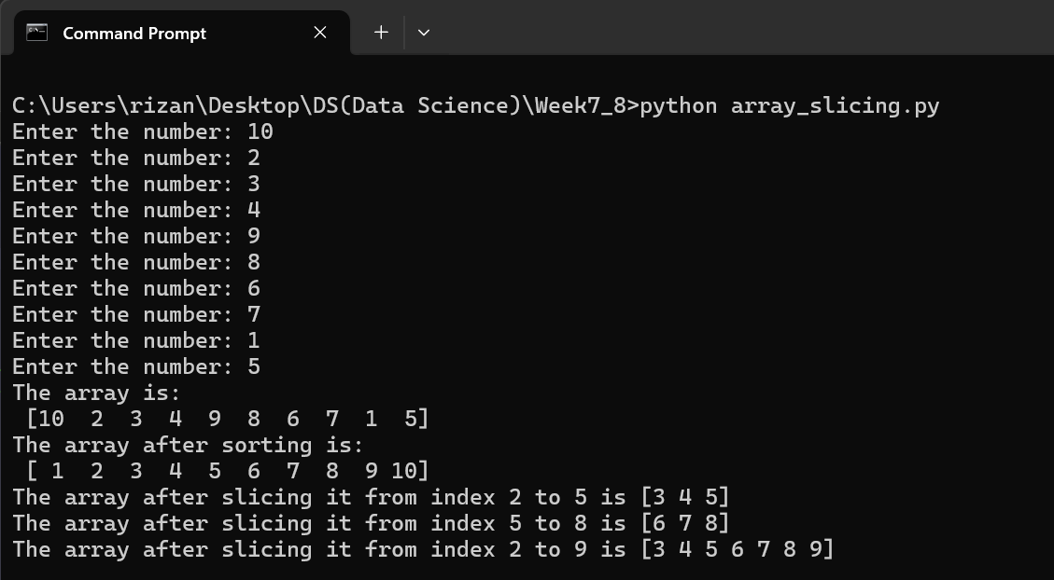

- File name: random_arrayreshape.py
Description:
The program creates an array 1 row and 10 columns i.e 1d array, containing random integers number, then it sorts the array. The array is reshaped into different dimension 5 * 2 and 2 * 5.
These dimensions are only possible as the original array has only 10 elements. The array are sorted using .sort() from numpy module and for reshaping .reshape() is used.

Test:
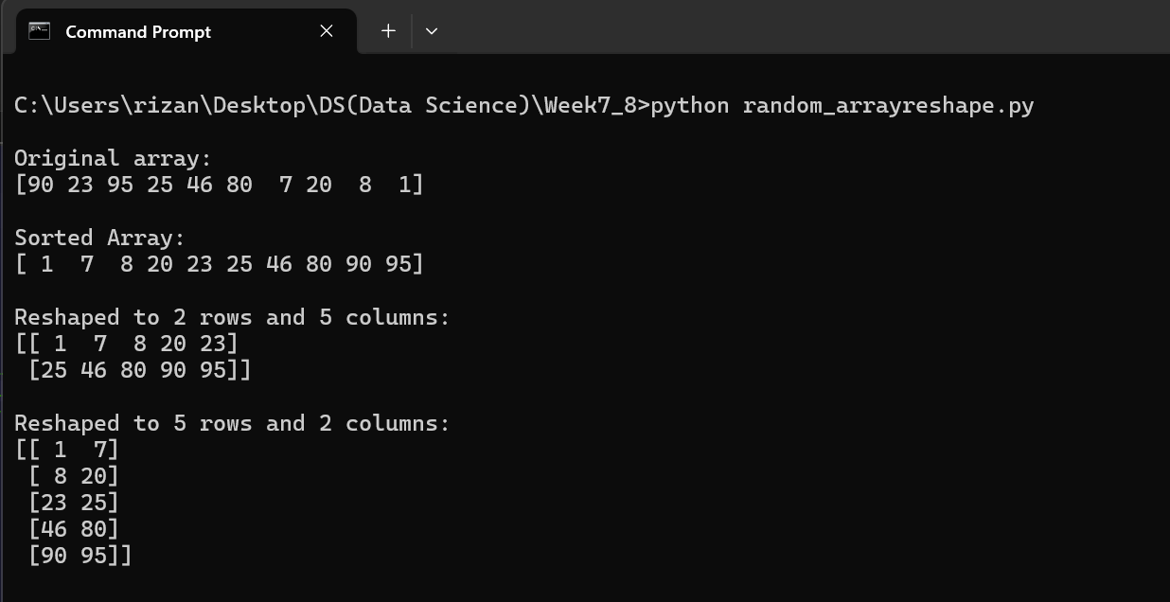
Based on the test, the program works properly.

- File name: pandas_arithmetic.py
Description:
The program adds, subtracts, multiplication and division over two pandas series.
The program use pandas module to create a panda series.

Test:
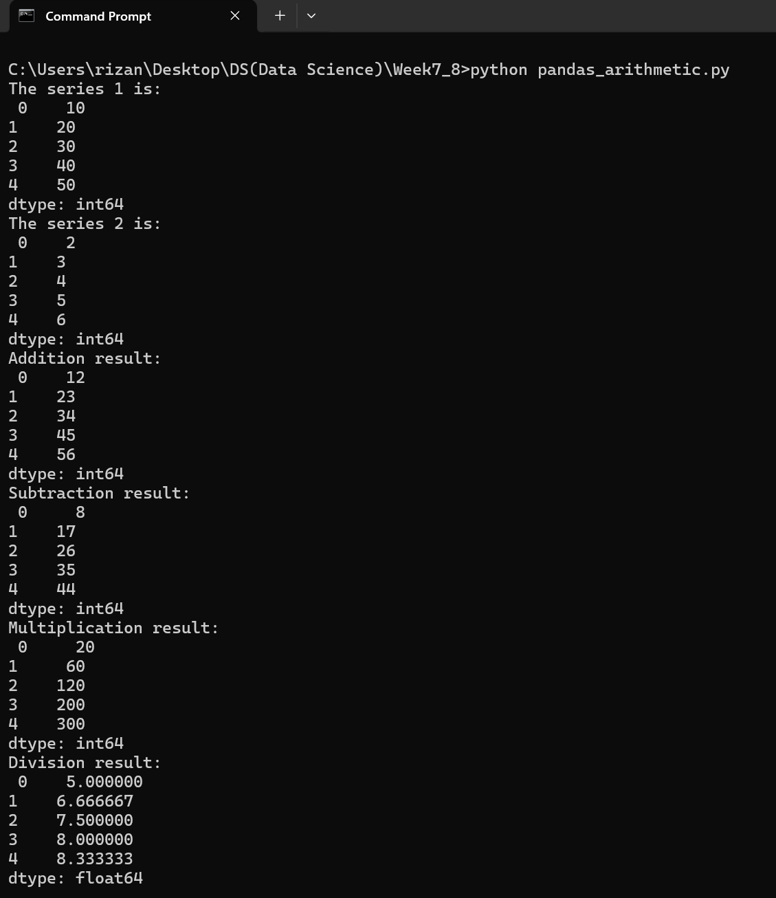

Based on the test input, the program works fine.

- File name: table_panda.py and tabledf.csv
Description:
The program reads a csv file named tabledf.csv which contains the information of Employee from ID, Name, Department, Age, Salary, JoinDate, ExperienceYears.

The program displays the Name and Salary columns only, filter out all the employees from the “IT” Department, average salary in each department, counts the employee in each department, add a new column “Bonus” and “Salary Category”, replaces occurences of “HR” with Human Resources, employee with longest time spent in the office, check duplicate IDs if found and median of age of all employees.

For all this operation, pandas is used for manipulation of data.

Test:
CSV FILE:
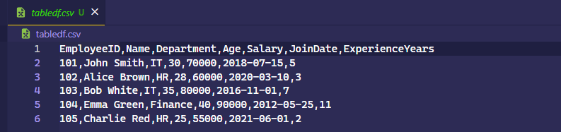

Program Output:
