## 

## 

## 

## 

## 

## **Name: Rizan K.C.**

## **Student No: 24071142**

## **Assignment: Internet Technologies (Wireframe and Mockup)**

## 

## 

## 

## 

Task 1-

Getting started with moqups.com account setup and tools overview.

Image:

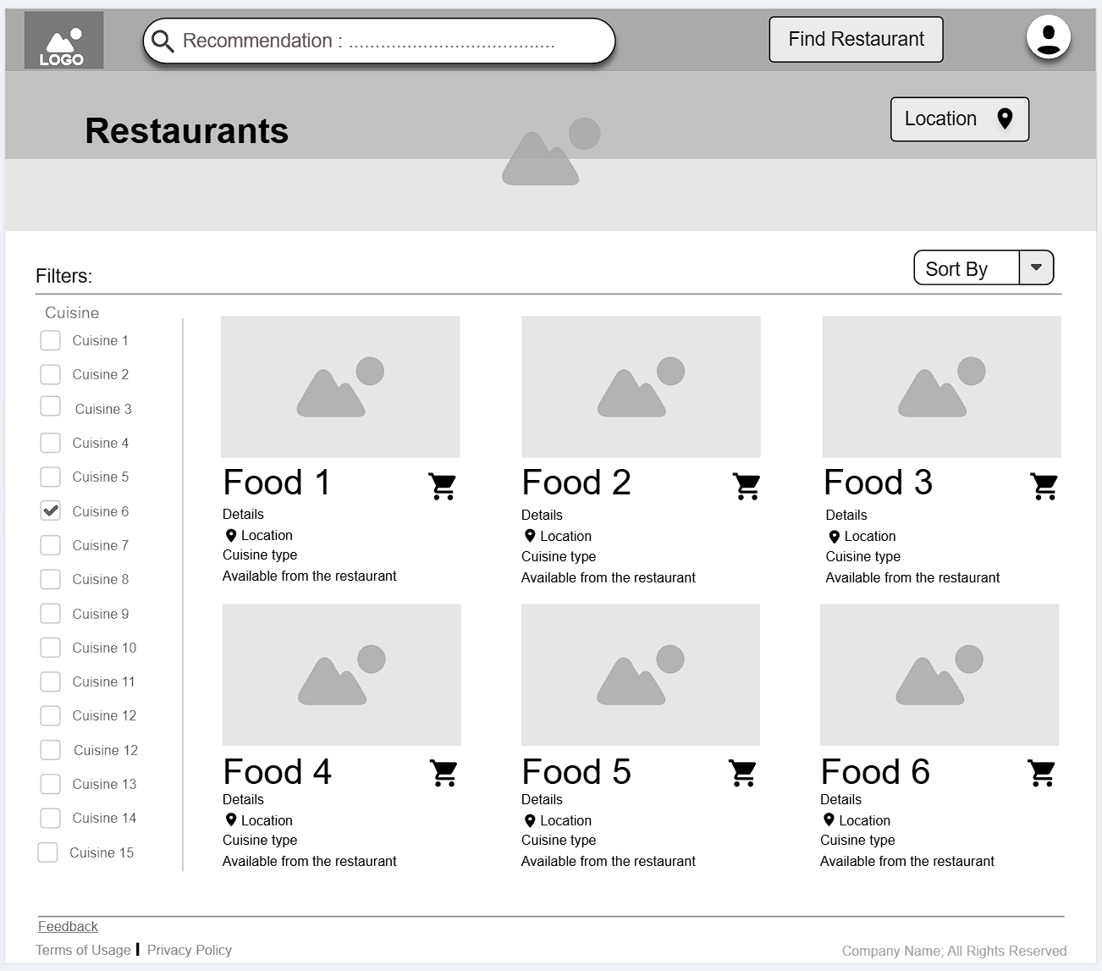

Link: <https://app.moqups.com/PaXQJHK4C3rbRGSvvAv8bQ6dLmC721Ke/view/page/ad64222d5>

Task 2-

Design the below like wireframe structure. Use your own creativity.

Image:

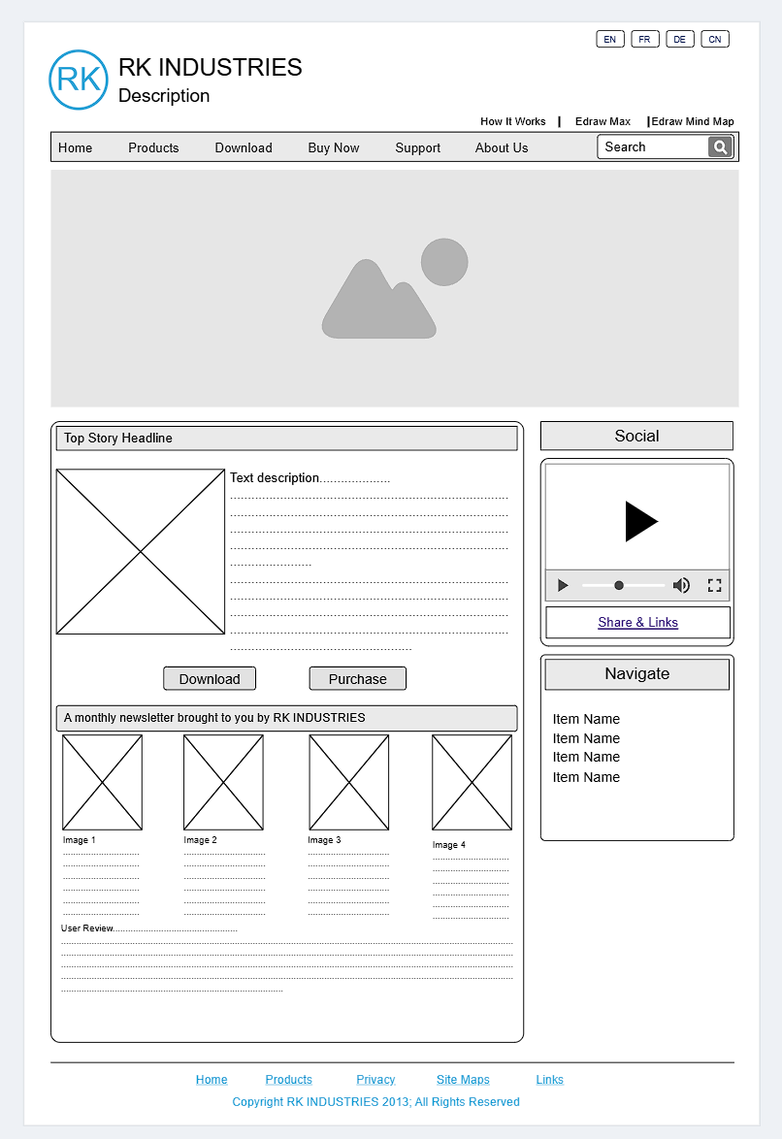

Link: <https://app.moqups.com/ScVBlxasFdxW3wKlUvYppgpQr1q1B0qI/view/page/ad64222d5>

Task 3-

Create a mockup design like your college website’s contact us page. Use your own creativity for this design.

Image:

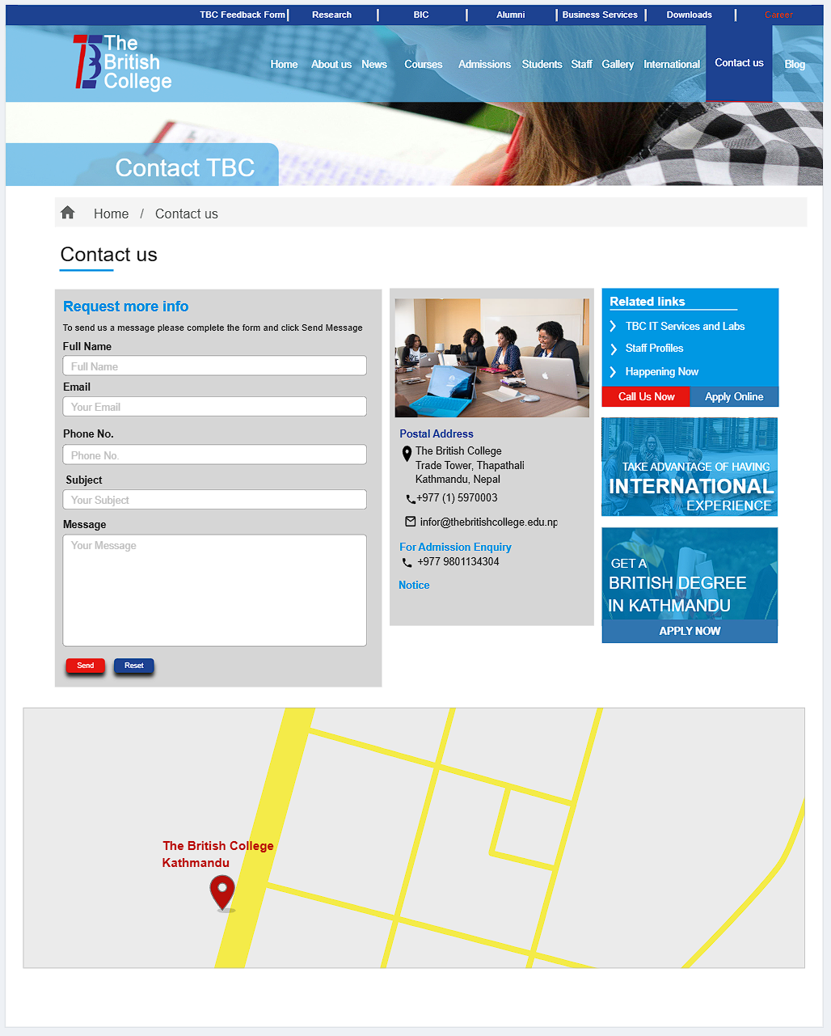

Link: <https://app.moqups.com/bGy0vqBW2QclfvDeIOGz0navYEU2Vo7H/view/page/ad64222d5>