**HOSPITAL APPOINTMENT SYSTEM**

A Mini Project Report

Submitted in partial fulfillment of the requirements for the course  
Object Oriented programming

**Submitted by**

Nafeesath Riza (Roll No: 41)

Asma Rizanath (Roll No: 15)

Ayshath Shameema B A (Roll No: 18)

Naja Fathima (Roll No: 43)

Under the Guidance of

Prof. Sajina K

Department of Computer Science & Engineering

LBS College of Engineering, Kasaragod

Date of Submission: October 2025

# 1. Cover Page

Project Title: HOSPITAL APPOINTMENT SYSTEM

Department of Computer Science

LBS College of Engineering Kasaragod

Guide: Prof. Sajina K.

Team Members:

• Nafeesath Riza (Roll No: 41)  
• Asma Rizanath (Roll No: 15)  
• Ayshath Shameema B A (Roll No: 18)  
• Naja Fathima (Roll No: 43)

Date of Submission: 06-10-2025

# 2. Certificate

This is to certify that the project entitled “Hospital Appointment System” has been carried out by  
Nafeesath Riza , Asma Rizanath, Ayshath Shameema B A, and Naja Fathima   
under the guidance of Prof. Sajina K., Department of Computer Science, LBS College of Engineering Kasaragod,  
as part of the partial fulfillment for the subject during the academic year 2025–26.

Signature of Guide:  
(Prof. Sajina K.)

Date: 06-10-2025

# 3. Acknowledgment

We would like to express our sincere thanks to Prof. Sajina K., Department of Computer Science,   
LBS College of Engineering Kasaragod, for officially guiding our project, “Hospital Appointment System.”   
We are also thankful to our teammates for their cooperation, support, and contribution throughout the completion of this project.

# 4. Abstract

The Hospital Appointment System is a Java-based desktop application developed using Swing for the user interface and MySQL for database management.   
It provides a digital platform to manage patient information, doctor details, and appointment bookings efficiently. The project aims to reduce manual paperwork, minimize scheduling errors,   
and improve communication between patients and hospital staff. The system enables hospital administration to manage operations effectively through a user-friendly interface.

# 5. Table of Contents

1. Cover Page

2. Certificate

3. Acknowledgment

4. Abstract

5. Table of Contents

6. Introduction

7. Problem Definition

8. Objectives

9. Scope of the Project

10. Literature Review / Existing System

11. Proposed System

12. System Design

13. Implementation Details

14. Testing

15. Cost Estimation / Budget

16. Project Schedule

17. Outcome / Results

18. Conclusion and Future Scope

19. References

20. Appendices

# 6. Introduction

In many hospitals, appointments are still managed manually, leading to confusion and inefficiency.   
This project automates the process using Java and MySQL, allowing patient registration, doctor management, and appointment booking.

# 7. Problem Definition

Manual appointment management causes data loss, double booking, and time delays.   
This system addresses these issues through a computerized platform.

# 8. Objectives

• Automate appointment booking.  
• Securely store patient and doctor data.  
• Generate unique IDs for tracking.  
• Allow quick viewing of appointments.

# 9. Scope of the Project

The system serves hospitals, clinics, and healthcare centers. It includes patient, doctor, and admin modules but excludes billing and report generation.

# 10. Literature Review / Existing System

Existing systems often lack integration or usability. Many hospitals still rely on manual systems.   
Our solution provides a lightweight, desktop-based Java application for offline use.

# 11. Proposed System

The system allows patient registration, doctor addition, and appointment booking. It ensures better organization, faster access, and less human error.

# 12. System Design

• Architecture Diagram ┌────────────────────────────────────┐

│ Hospital Appointment │

│ System GUI │

│ (Java Swing Application in VSCode)│

└────────────────────────────────────┘

│

│ JDBC (MySQL Connector)

▼

┌──────────────────────────────┐

│ MySQL Database │

│ (Patients, Doctors, │

│ Appointments Tables) │

└──────────────────────────────┘

• Data Flow Diagram

[Patient]

↓

[Book Appointment Form]

↓

[Database - Appointments Table]

↓

[Doctor Schedule / View Appointment Module]

• ER Diagram

patients (patient_id, name, age, gender, contact, email)

doctors (doctor_id, name, specialization, contact)

appointments (appt_id, patient_id, doctor_id, date, time, status)

These diagrams represent the system workflow, data storage, and communication between modules.

# 13. Implementation Details

Language: Java  
IDE: Visual Studio Code  
Database: MySQL  
Connector: MySQL Connector JAR  
  
Modules Implemented:  
• Add Doctor  
• Register Patient  
• Book Appointment  
• View Appointment  
  
screenshots:  
Add Patient

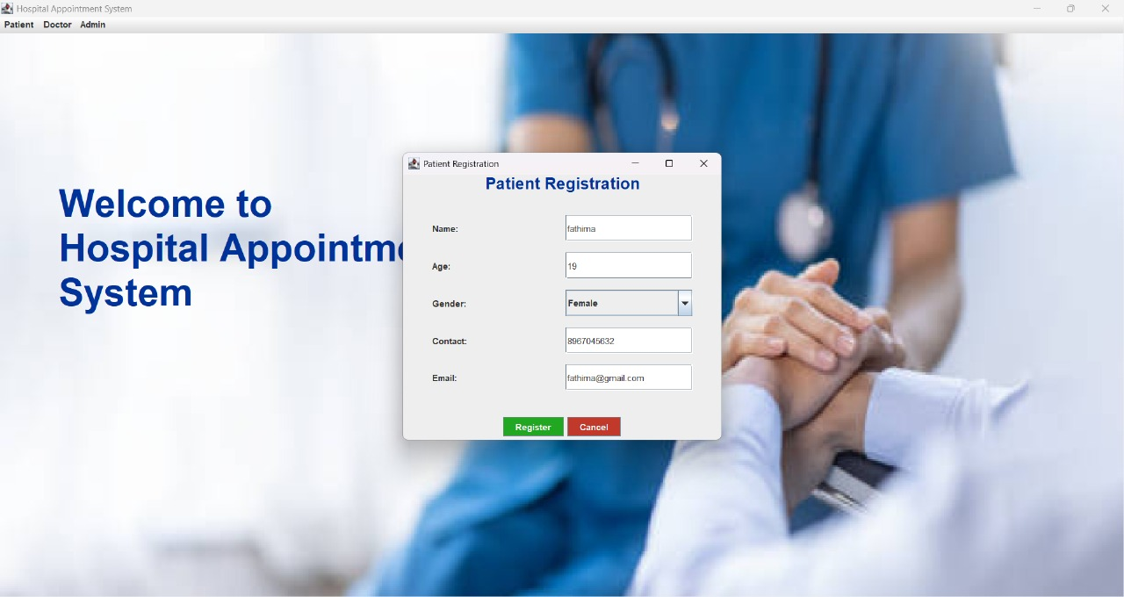  
Add Doctor

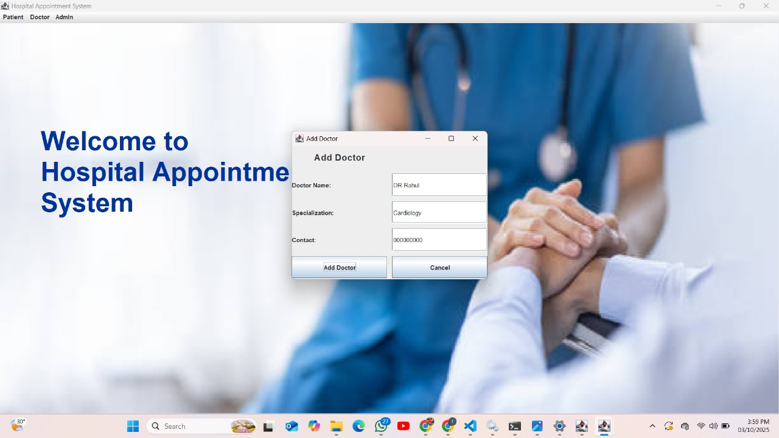  
 Book Appointment

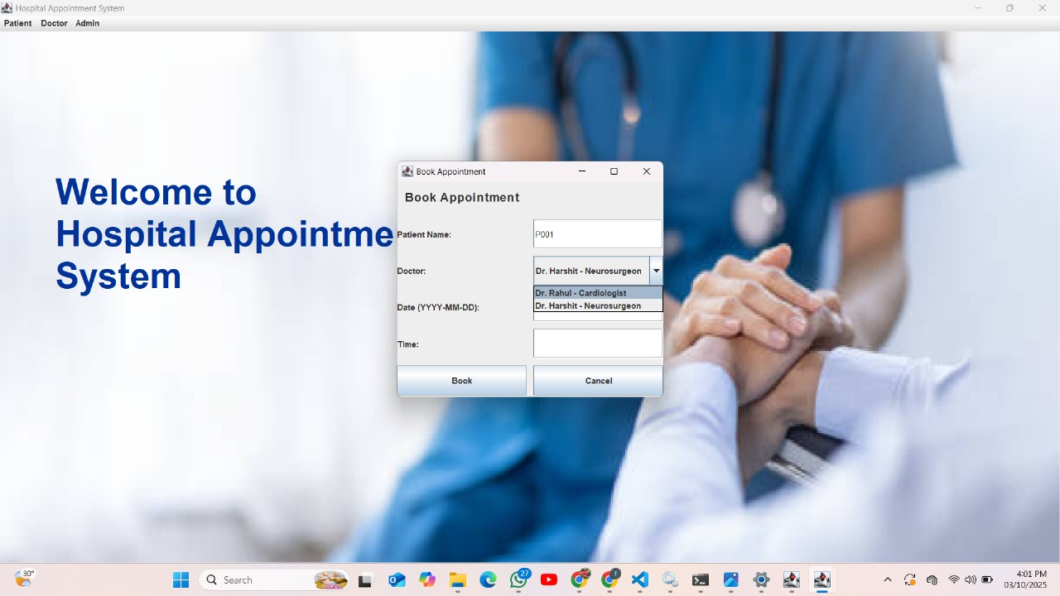  
 View Appointment

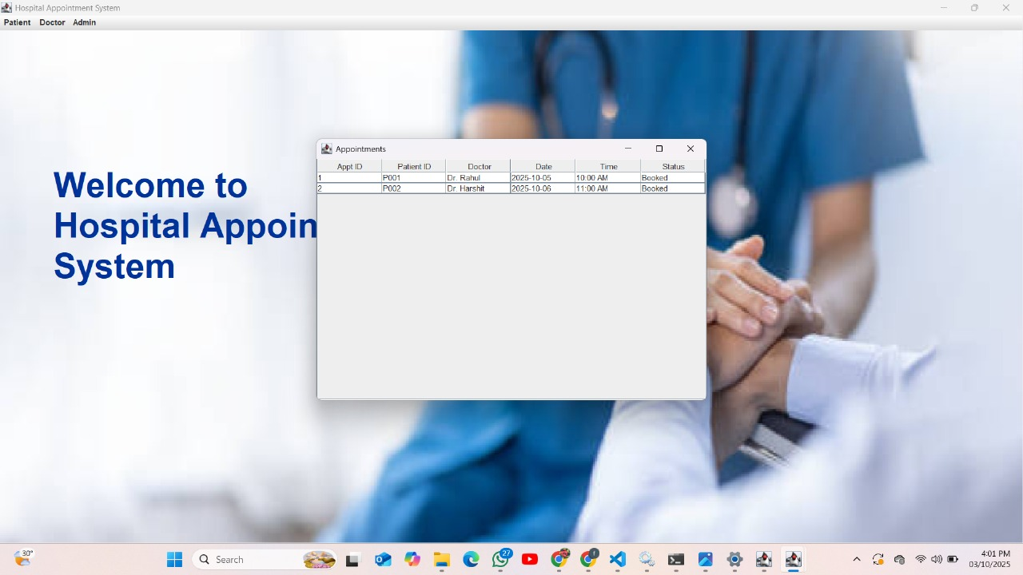  
Admin Page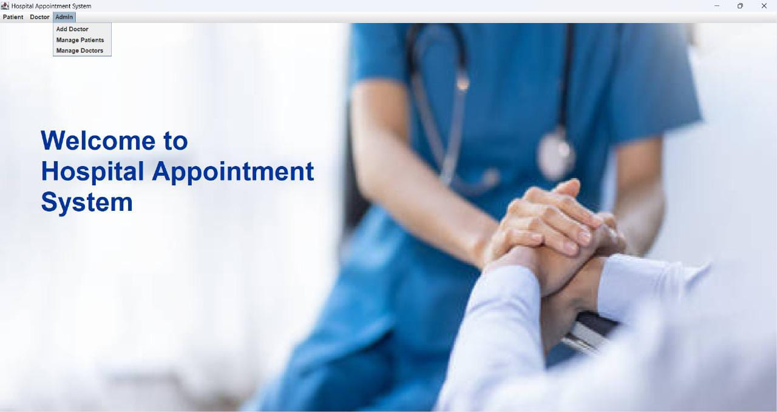

# 14. Source Code Development

We developed the Hospital Appointment System using Java and MySQL.

The project structure is as follows:

src/

├── HospitalAppointmentSystem.java // Main GUI and Menu

├── DBConnection.java // Handles database connectivity

├── Doctor.java // Doctor data model

├── Patient.java // Patient data model

└── hospital_bg.jpg // Background image for the interface

Technologies Used:

Java Swing (for GUI)

MySQL (for database)

JDBC Connector (for MySQL integration)

VS Code (IDE used for development)

# 14. Testing

The system was tested using unit and integration testing. All modules passed database connectivity and GUI interaction tests successfully.

# 15. Cost Estimation / Budget

Hardware: Existing PC - ₹0  
Software: Open Source Tools - ₹0  
Miscellaneous: Internet, electricity - ₹100  
Total Estimated Cost: ₹100

# 16. Project Schedule

System Design: 1 Week  
Development: 2 Weeks  
Testing: 1 Week  
Documentation: 1 Week  
Total Duration: 5 Weeks

# 17. Outcome / Results

The system simplifies hospital appointment management by automating patient registration, doctor management, and appointment booking.

# 18. Conclusion and Future Scope

The Hospital Appointment System successfully meets its objectives.   
Future versions could include login authentication, patient history tracking, and SMS/email notifications.

# 19. References

1. MySQL Documentation (https://dev.mysql.com/doc/)  
2. Oracle Java Tutorials (https://docs.oracle.com/javase/tutorial/)  
3. ChatGPT assistance for structuring and project documentation.

# 20. Appendices

Attach source code files, additional screenshots, or data samples here.

Database stored in MySQL

