- Bibliografie
[1] https://www.udemy.com/course/python-and-flask-bootcamp-create-websites-using-flask
[2] https://docs.docker.com/develop/develop-images/dockerfile_best-practices/
[3] https://werkzeug.palletsprojects.com/en/2.0.x/utils/
- Anexe
  - Baza de date
Baza de date este formata din doua tabele, “useri” si “produse”. Ambele tabele folosesc ca cheie primara un ID, care este incrementat automat la adaugarea unei noi intrari in cadrul tabelei.
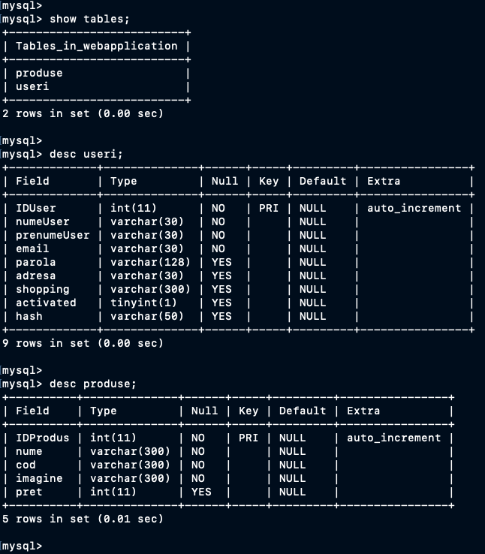
Fig. 9

  - Docker compose
Pentru deploy-ul aplicatiei am folosit docker-compose pentru o mai usoara gestiune a containerelor. Stackul actual este format din doua servicii, si anume baza de date (care ruleaza si ea in Docker) si aplicatia. Pentru ambele servicii am configurat implicit volume cu nume, deoarece durata spatiului de stocare in docker este efemera (la oprirea containerului, datele nesalvate intr-un volum sunt pierdute).
version: '3.2'
services:
# mysql -u root -p webapplication
mysql:
image: mysql:5.7
environment:
MYSQL_DATABASE: 'webapplication'
MYSQL_ROOT_PASSWORD: 'mypassword'
deploy:
replicas: 1
restart_policy:
condition: on-failure
volumes:
- /Users/eusebiu.rizescu/dizertatie/mysql:/var/lib/mysql
- /Users/eusebiu.rizescu/dizertatie/mysql-conf/mycustom.cnf:/etc/mysql/conf.d/mycustom.cnf
networks:
- webnet
flask:
image: webapplication
container_name: flask
deploy:
replicas: 1
restart_policy:
condition: on-failure
ports:
- '80:5000'
depends_on:
- mysql
volumes:
- /Users/eusebiu.rizescu/dizertatie/flask:/app
networks:
- webnet
networks:
webnet:
driver: overlay
internal: false

  - Scriptul de deploy
Pentru o mai usoara dezvoltare a codului, si pentru un deploy rapid dupa o modificare, am folosit un script bash. Acest script bash, cand este executat cu parametrul “start” (sau fara parametru, “start” fiind cel default), codul sursa este copiat in volume, iar containerele sunt restartate.
#! /bin/bash
if [ "$1" == "help" ]; then
echo "./build.sh help <- help"
echo "./build.sh start <- start docker compose"
echo "./build.sh stop <- stop docker compose"
echo "./build.sh populate <- populate database tables"
exit
fi
if [ "$1" == "populate" ]; then
docker exec $(docker ps | grep flask | cut -d " " -f1 | head -1) python3 populateTables.py
exit
fi
echo Exit Docker Swarm
sudo docker swarm leave --force
sleep 1
if [ "$1" != "stop" ]; then
echo Init Docker Swarm
sudo docker swarm init
fi
sleep 1
if [ "$1" != "stop" ]; then
echo "Removing /Users/eusebiu.rizescu/dizertatie/flask/*"
sudo rm -rf /Users/eusebiu.rizescu/dizertatie/flask/*
echo "Removing /Users/eusebiu.rizescu/dizertatie/mysql-conf/*"
sudo rm -rf /Users/eusebiu.rizescu/dizertatie/mysql-conf/*
echo "Copying to /Users/eusebiu.rizescu/dizertatie/flask/*"
sudo cp -R ./WebApplicationCode/* /Users/eusebiu.rizescu/dizertatie/flask/
echo "Copying to /Users/eusebiu.rizescu/dizertatie/mysql-conf/*"
sudo cp -R ./MySQL/* /Users/eusebiu.rizescu/dizertatie/mysql-conf/
sleep 1
sudo docker stack deploy -c docker-compose.yml webapplication
fi
if [ "$1" == "stop" ]; then
# delete all containers
echo "Delete all containers"
sudo docker rm -f $(docker ps -a -q)
fi

