Report

Project name: Increaseing House Comfort by Reducing Heat

Authors: Everybody

Situation Assessment
Large windows to use natural light, combined with wooden flooring generates excesive and incomfortable heat in summer.

Challenge | Maria --- "We want the impossible"  Have Light,  Keep the Area Cool  Prevent Solar Heating  Save energy related cost  Customer: Family

Objectives | Ideal Vision:  A perfectly illuminated area with a temperature of 22 degrees centigrade.  Energy costs to be zero (use of natural resources)

Constraints | - •Αϖοιδ χονσυμπτιον οφ ενεργψ βψ υσε οφ ΑΧ  - •Ινφραστρυχτυρε ισ αλρεαδψ φινισηεδ (Αϖοιδ Χηανγε ιν ιτ)  - •Βυδγετ οφ νο μορε τηαν 100 ΥΣΔ

Scope | Th scope of the system is the landscape, including the rooms, furniture, garden, windows.

Idea: Yousef--- USe double glased windows

Idea: Shade over the window

Idea: Yousef and John--- Reflective film

Idea: Yousef---- Use heavy curtains

Idea: Yousef --- Ventilate better

Idea: Yousef.. Grow a high Tree

Idea: Yousef --- Close the curtain, there is no need to be in the room by day

Idea: Yousef---Minimize the size of the window

Idea: Yousef --- Ventilation can be added

Idea: Sukumar... Use of Blinds (persianas) orientable with fixed angle

Evaluate Ideas:

Type | Impact | Ease | Ideas | Used
Resource | High | Difficult | Yousef--- USe double glased windows
Resource | High | Easy | Shade over the window | Used
Resource | Medium | Easy | Yousef and John--- Reflective film
Resource | High | Easy | Yousef---- Use heavy curtains | Used
Function | High | Difficult | Yousef --- Ventilate better
Resource | Medium | Difficult | Yousef.. Grow a high Tree
Vision | High | Easy | Yousef --- Close the curtain, there is no need to be in the room by day | Used
Resource | High | Difficult | Yousef---Minimize the size of the window
Function | High | Medium | Yousef --- Ventilation can be added | Used
Resource | Medium | Easy | Sukumar... Use of Blinds (persianas) orientable with fixed angle | Used

Structured Innovation
Diagramm: Function Model for the Heat Problem
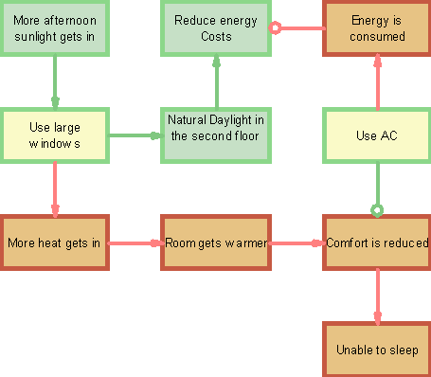

Opportunity: Resolve the contradiction: "Use large windows" should produce "Natural Daylight in the second floor " and should counteract "More heat gets in" .
Concept development
Type | Impact | Ease | Ideas | Used
Resource | High | Difficult | Yousef--- USe double glased windows
Resource | High | Easy | Shade over the window | Used
Resource | Medium | Easy | Yousef and John--- Reflective film
Resource | High | Easy | Yousef---- Use heavy curtains | Used
Function | High | Difficult | Yousef --- Ventilate better
Resource | Medium | Difficult | Yousef.. Grow a high Tree
Vision | High | Easy | Yousef --- Close the curtain, there is no need to be in the room by day | Used
Resource | High | Difficult | Yousef---Minimize the size of the window
Function | High | Medium | Yousef --- Ventilation can be added | Used
Resource | Medium | Easy | Sukumar... Use of Blinds (persianas) orientable with fixed angle | Used

Concept: :

Concept: Shades
Idea:
Shade over the window
Yousef --- Ventilation can be added

Concept: :

Concept: Blinds with Open Window
Idea:
Yousef --- Ventilation can be added
Idea:
Sukumar... Use of Blinds (persianas) orientable with fixed angle

Concept: :

Concept: Housekeeping Discipline
Idea:
Yousef --- Close the curtain, there is no need to be in the room by day
Idea:
Yousef---- Use heavy curtains

Action plan:

Action plan
Concept: Housekeeping Discipline
Idea:
Yousef --- Close the curtain, there is no need to be in the room by day
Idea:
Yousef---- Use heavy curtains
5W 2H

