Please submit your responses by RFP deadline. Please answer all applicable questions. A negative answer will not necessarily disqualify your company.
We look forward to working with you. Thanks in advance for your cooperation.

- Name & position of person completing this form:
_______________________________________________________________

- Name of Company:________________________________________________

- How many years in business:________________________

- How are you going to perform the staging of this project and is this included? ________________________________________________________________

- What is the specific warranty information on the materials and labor for project? ________________________________________________________________

- What is the timeframe to complete the work? ____________________________

- Are you the Qualifying Agent? ____ If not, who is? _______________________

- Are you licensed, bonded and insured? ________________________________

- What is the cost and procedure for change orders? (N/A) __________________

- What are the payment terms? (N/A)____________________________________

- What other cost items not specified in the RFP should we consider? ________________________________________________________________

- How many crew members and supervisors will be used for this project? _______

- How many crew members are temporary crews (subcontracted)? ____________

- Does the supervisor speak English? _______

- Will the supervisor remain on the job for the duration? _______

- What are your Cleanup Procedures (provide dumpster, daily cleanup, storage for materials and equipment, etc.?___________________________________________________________

- What remedies will you provide for nonperforming or substantially delayed work? _______________________________________________________________

- Are your workers certified to meet all OSHA standards? ________

- Are your workers tested to be Drug Free? _________

- Working Hours are from: Monday-Friday 8am-5pm. Can you meet this requirement? _________

- Who is responsible for pulling the permits - and will that be included in the contract? ________________________________________________________

*I acknowledge that all answers to these questions are truthful and that this document will be attached as an addendum to the formal contract.

*_________________________, Legal Company Representative for RFP.

_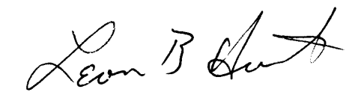_, President, for Sheffield D COA, Century Village, WPB

