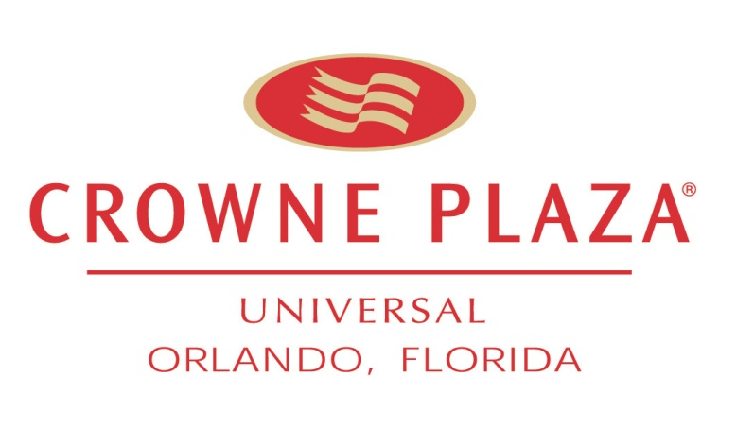

September 12, 2011

To Whom It May Concern,

PROScape, Inc was hired in 2011 as the exterior plant and landscaping company here at the Crowne Plaza Orlando Universal. PROscape has done an outstanding job in ensuring the entire hotel looks first class all the time. They are very professional and display a very high level of pride in everything they do. There is a marked change in the health of our plants and the overall eye appeal of the hotel exterior since they took over. The Business Development Manager, Jason Beaty, was influential in getting me to sign with PROscape. Once I did, he did not disappear, he still makes contact often to ensure we are 100% satisfied. Our Account Manager Robert Warren has been instrumental in working with my team to make recommendations to ensure that we are doing our part to assist in the process. Robert is extremely knowledgeable and hands on in this process. We have found PROscape very responsive to our needs and requests. They always do an excellent job of working around our guests to ensure no negative guest impact.

One example of a truly amazing service story was a short time ago we had a wedding that was being held in our Courtyard with 200 guests. The mother of the bride requested that the hanging baskets be changed to plants that have orange and pink flowers to match her daughter’s colors. Not only did they change them, but they had their new interior division upgrade them and they were over the top! Our client was truly impressed!

I would highly recommend PROscape, Inc for your interior or exterior plant and landscaping needs. If you have any further questions, please feel free to contact me directly at 407-781-2100.

Best Regards,

Scott A. Tripoli

General Manager

Crowne Plaza Orlando Universal