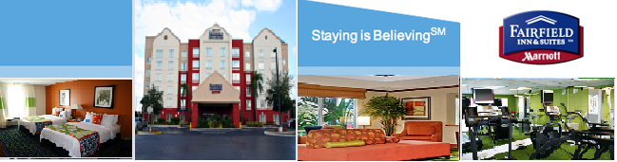

January 31, 2011

To whom it may concern:

I am writing this letter to strongly recommend choosing Proscape for landscaping needs. On September 2010, we chose to look at several companies to bid out our landscaping services. Jason Beaty, our sales person at Proscape, took the time out to meet with me during the proposal phase. During this meeting, he described what our property was lacking and what his company could do to increase the curb appeal at a minimal cost. Jason and his entire operations crew not only completed the task described, they also went above and beyond to upgrade the look of the landscaping. The entire team at Proscape continues to communicate on a weekly basis and makes the team aware of the services completed. The consistency of delivering the scope of services promised at the decision making phase is exceeding the delivery of services provided as their recent customer. I feel this has been a great benefit to our hotel. Thank you.

Sincerely,

Angela M. Bell

Angela M. Bell

General Manager

Fairfield Inn & Suites Orlando near Universal