Please submit your responses by RFP deadline. Please answer all applicable questions. A negative answer will not necessarily disqualify your company.

We look forward to working with you. Thanks in advance for your cooperation.

1. Name & position of person completing this form:

_______________________________________________________________

1. Name of Company:________________________________________________
2. How many years in business:________________________
3. How are you going to perform the staging of this project and is this included? ________________________________________________________________
4. What is the specific warranty information on the materials and labor for project? ________________________________________________________________
5. What is the timeframe to complete the work? ____________________________
6. Are you the Qualifying Agent? ____ If not, who is? _______________________
7. Are you licensed, bonded and insured? ________________________________
8. What is the cost and procedure for change orders? (N/A) __________________
9. What are the payment terms? (N/A)____________________________________
10. What other cost items not specified in the RFP should we consider? ________________________________________________________________
11. How many crew members and supervisors will be used for this project? _______
12. How many crew members are temporary crews (subcontracted)? ____________
13. Does the supervisor speak English? _______
14. Will the supervisor remain on the job for the duration? _______
15. What are your Cleanup Procedures (provide dumpster, daily cleanup, storage for materials and equipment, etc.?___________________________________________________________
16. What remedies will you provide for nonperforming or substantially delayed work? _______________________________________________________________
17. Are your workers certified to meet all OSHA standards? ________
18. Are your workers tested to be Drug Free? _________
19. Working Hours are from: Monday-Friday 8am-5pm. Can you meet this requirement? _________
20. Who is responsible for pulling the permits - and will that be included in the contract? ________________________________________________________

*I acknowledge that all answers to these questions are truthful and that this document will be attached as an addendum to the formal contract.

*_________________________, Legal Company Representative for RFP.

_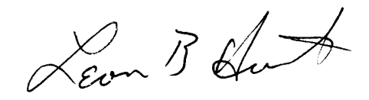_, President, for Sheffield D COA, Century Village, WPB