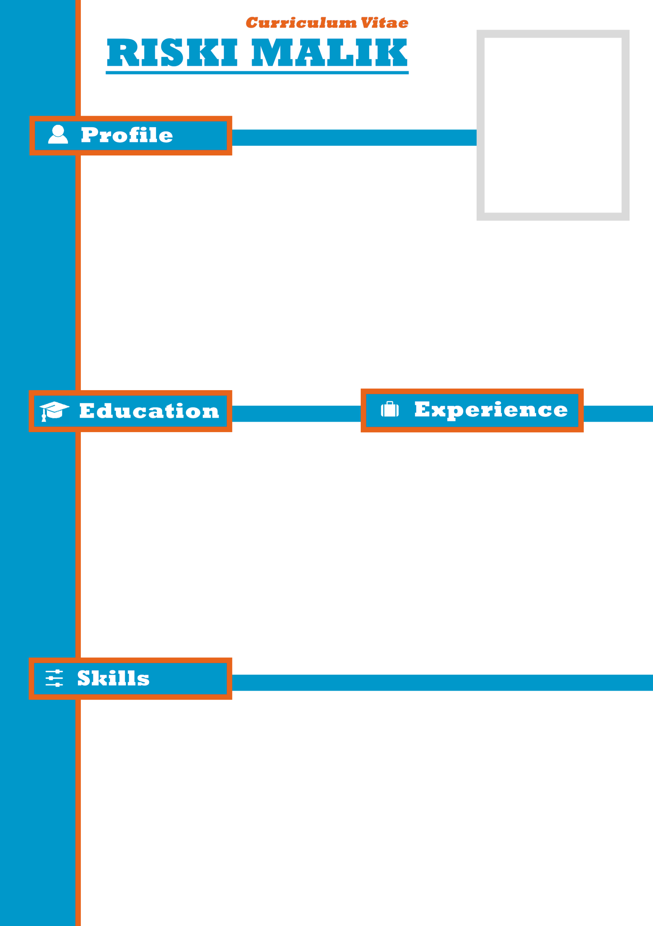

* **Programming :**

**Programming :**

**- HTML - JQuery**

**- PHP - NodeJS**

**- JavaScript - JSON**

* **Programming :Dase :**

**Database : Template :**

**-MySql -Bootstrap**

**-SQLServer -Extjs**

**Place Of Birth : Jakarta**

**Date Of Birth : December, 26th 1994**

**Gender : Male**

**Address : Jl. Rambutan 01 RT 04/06 No.29**

**Pejaten Barat, Pasar Minggu, Jakarta Selatan**

**Religion : Islam**

**Marital Status : Single**

**HP / Whatsapp : 085889088095**

**Email : rizkimalik94@gmail.com**

* **Framework** :

### **Oct 2015 – Nov 2018**

## PT Bintang Karya Perdana

## **(Web Programmer)**

### **Dec 2018 – NOW**

## PT Invision Astrindo Pratama

## **(Frontend - UI/UX)**

### **2013 - 2016**

## Politeknik LP3I Jakarta / Jakarta

**Jurusan : Informatika Komputer (D3)**

### **2010 - 2013**

## SMK Bunda Kandung / **Jakarta**

**Jurusan : Teknik Electronika**