Mata Kuliah : Pemrograman Web
Pertemuan : 1
NIM : A11.2016.09493
Nama : Rizki Mufti Ilmawan

Hasil Program :

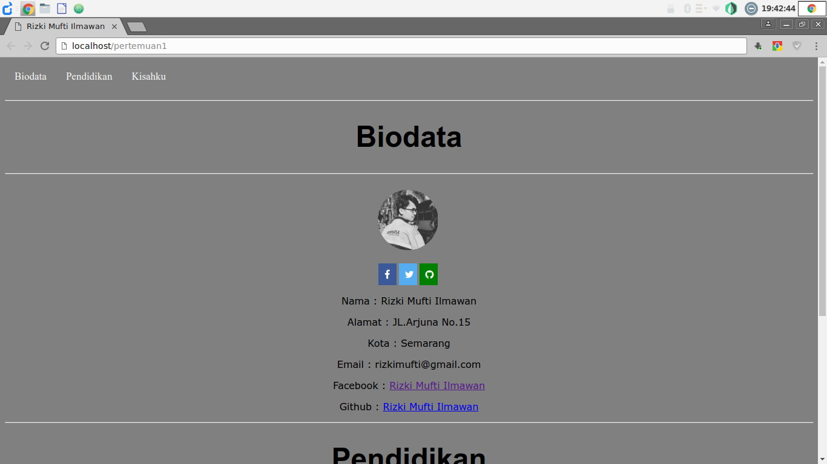
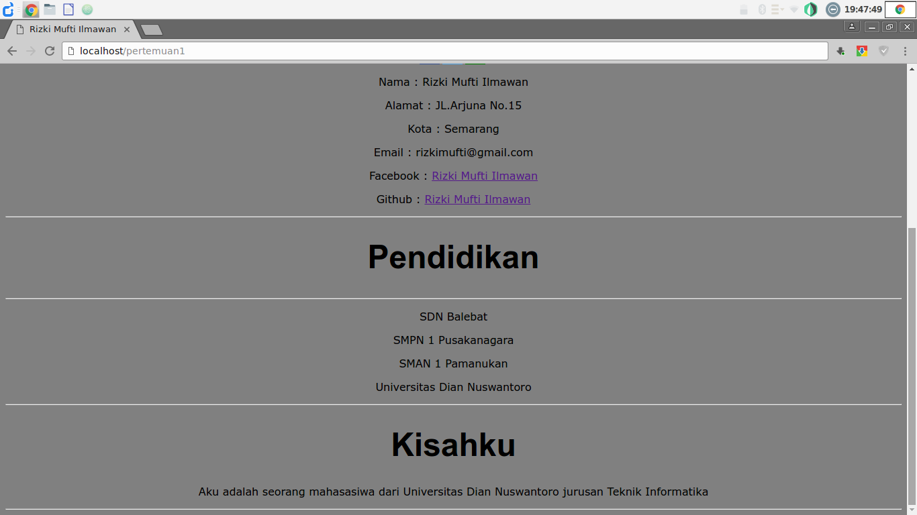

Code Program :

<html>
<title>Rizki Mufti Ilmawan</title>

<style>

body
{
background-color: gray;
text-align: center;
}

h1
{
font-family: arial;
font-size: 300%;
}

p{
font-family: verdana;
}

img{
border-radius: 50%;
}

/* Navigasi Bar */
.navatas a {
float: left;
display: block;
color: #f2f2f2;
text-align: center;
padding: 14px 16px;
text-decoration: none;
font-size: 17px;
}

.navatas a:hover {
background-color: #ddd;
color: black;
}

.navatas a.active {
background-color: #4CAF50;
color: white;
}

.fa {
padding: 10px;
font-size: 30px;
width: 10px;
text-align: center;
text-decoration: none;
}

.fa:hover {
opacity: 0.7;
}

/* Facebook */
.fa-facebook {
background: #3B5998;
color: white;
}

/* Twitter */
.fa-twitter {
background: #55ACEE;
color: white;
}

.fa-github
{
background : green;
color : white;

}

</style>

<body>

<div class="navatas" id="topnav">
<a href="#biodata">Biodata</a>
<a href="#pendidikan">Pendidikan</a>
<a href="#kisahku">Kisahku</a>

</div>
<br><br>
<br><hr>
<div id="biodata">
<h1>Biodata</h1>
<hr>
<br>

<img src="https://avatars0.githubusercontent.com/u/26708690?v=4&s=460" height="100px" width="100px">
<br><br>
<!-- sumber icon -->
<link rel="stylesheet" href="https://cdnjs.cloudflare.com/ajax/libs/font-awesome/4.7.0/css/font-awesome.min.css">

<a href="http://facebook.com/rizki.mufti" class="fa fa-facebook"></a>
<a href="http://twitter.com/" class="fa fa-twitter"></a>
<a href="http://github.com/rizkimufti" class="fa fa-github"></a>

<br>
<p>Nama : Rizki Mufti Ilmawan</p>
<p>Alamat : JL.Arjuna No.15 </p>
<p>Kota : Semarang </p>
<p>Email : rizkimufti@gmail.com</p>
<p>
Facebook : <a href="http://facebook.com/rizki.mufti">Rizki Mufti Ilmawan</a>
</p>
<p>
Github : <a href="http://github.com/rizkimufti">Rizki Mufti Ilmawan</a>
</p>
</div>

<div id="pendidikan">
<hr></hr>
<h1>Pendidikan</h1>
<hr>
<p>SDN Balebat</p>
<p>SMPN 1 Pusakanagara</p>
<p>SMAN 1 Pamanukan</p>
<p>Universitas Dian Nuswantoro</p>
<div>
<hr>
<h1>Kisahku</h1>
<div id="kisahku">
<p>Aku adalah seorang mahasasiwa dari Universitas Dian Nuswantoro jurusan Teknik Informatika</p>

</div>
<hr>
</body>
</html>

code program versi gambar :

