1. **ERD (Entity Relationship Diagram)**

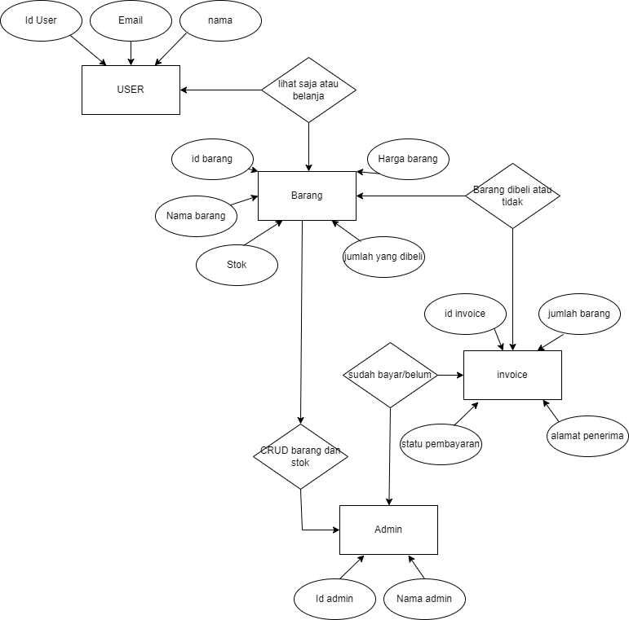

1. **Activity Diagram user**

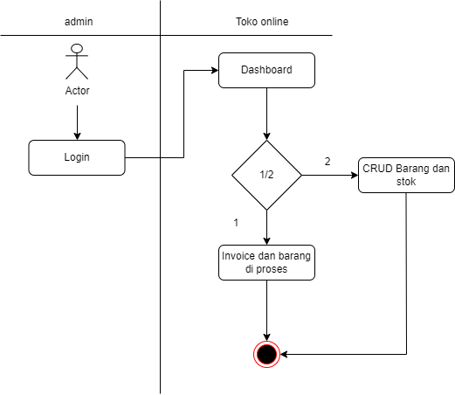

1. **Activity Diagram Admin**

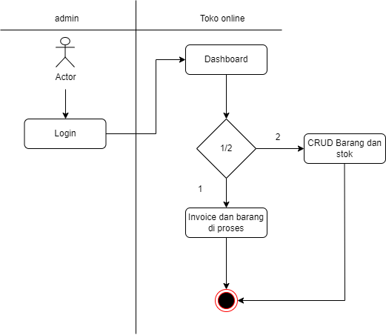

1. **Use Case Diagram**

