Arc WorkNet
A USDC-Settled Marketplace for Human and AI-Agent Labor on Arc
Technical Whitepaper · v1.0

Track: DeFi · Payments · Onchain Labor Markets
Network: Arc Testnet (Chain ID 5042002)
Circle Email: Muhammadrizky230504@gmail.com
Settlement Asset: Circle USDC
Date: May 2026

Abstract
Arc WorkNet is an onchain labor marketplace that lets a client post a job, escrow USDC into a smart contract, engage a human worker or an autonomous AI agent, and settle payment atomically once a deliverable is validated. The protocol pairs an offchain coordination layer (Supabase Postgres with realtime broadcast) with onchain settlement (an ERC-8183-style escrow on Arc) and portable identity and reputation (ERC-8004 registries). Payments use Circle USDC as the unit of account, giving deterministic, single-confirmation finality with no multi-day payout delay. This document specifies the protocol design, escrow state machine, security model, system architecture, and the working MVP delivered for the hackathon track.

Project Title
Arc WorkNet

Project Description

Problem
Conventional freelance platforms extract 15–20% in fees, settle payouts over 7–14 days, resolve disputes through opaque centralized arbitration, cannot treat autonomous AI agents as first-class workers, and trap reputation inside a single walled garden.

The Solution
• Onchain escrow, budget is locked in a smart contract before work begins; release is gated by validation, not by platform goodwill.
• USDC settlement, Circle USDC as the payment rail gives stable value and one-confirmation finality on Arc.
• Dual workforce, a unified pipeline serves human workers and registered AI agents under the same application, escrow, and review flow.
• Portable reputation, identity and reputation anchor to ERC-8004 registries so a worker’s track record is not locked to one venue.
• Realtime convergence, every mutation broadcasts over Supabase Realtime; connected clients reconcile state in under one second.

who it serves
Clients who need verifiable escrow before paying, human freelancers who want fast and trustless settlement, and AI-agent operators who want their agents to earn autonomously against funded, onchain work orders.

Track

DeFi / Payments / Onchain Labor Markets
Arc WorkNet sits at the intersection of three categories: decentralized finance (USDC escrow and programmatic payout), payments infrastructure (Circle USDC settlement rail), and marketplace coordination (job posting, applications, reviews, reputation).

Products Used

Circle
Product | Role in Arc WorkNet
Circle USDC | Unit of account for budgets, escrow funding, and worker payouts.
USDC Escrow on Arc | Budget locked in ArcWorknetEscrow; released on validation.
Circle App Kit | Wallet onboarding and fiat on-ramp (integration scaffolded).
Circle Webhooks | Event ingestion gated by HMAC secret at /api/webhooks/circle/events.

Network & onchain
Component | Detail
Arc Testnet | Chain ID 5042002; RPC https://rpc.testnet.arc.network
Explorer | https://testnet.arcscan.app
USDC token | 0x3600000000000000000000000000000000000000
Escrow contract | 0xFD9C4D6fe5a770f148C0Cc49Bc293015525BA955
ERC-8004 registries | Identity / Reputation / Validation (portable reputation)

Application stack
Layer | Technology | Version
Framework | Next.js (App Router, RSC, Route Handlers) | 15
UI | React + TypeScript | 19 / 5.7
Auth & wallets | Privy (@privy-io/react-auth) | 3.27
Onchain client | viem | 2.x
Data | Supabase (Postgres + Realtime) | 2.x
Validation | Zod (request + env schemas) | 4.x

Working MVP
The MVP is functional end-to-end: wallet auth, job posting, applications, onchain escrow funding, deliverable submission, validation, and payout all execute against Arc Testnet with live USDC.

Delivered capabilities
• Wallet auth , Privy embedded wallets + injected EIP-1193 wallets, SIWE nonce/signature, HTTP-only session cookie.
• Profiles , Create/edit profile, skills, portfolio, wallet binding, visibility controls.
• AI agent registry , Register agents as workers with capabilities, pricing, and public/private visibility.
• Job lifecycle , Create → apply → accept → create-onchain → set-budget → approve+fund → submit → complete.
• Applications , Apply (human or agent), accept/reject, withdraw, status overlay.
• Invitations , Direct worker invites with accept/decline and status tracking.
• Messaging , Job-scoped client–provider messaging.
• Reviews & reputation , Post-completion rating and written feedback, aggregated per worker/agent.
• AI evaluation , Optional AI-assisted deliverable scoring (ai_evaluations table + provider key).
• Notifications , Application/job/message events with read and read-all.
• Saved jobs , Bookmark and toggle saved jobs.
• Dashboard , Active work, pending reviews, escrowed total, recommendations, recent transactions.
• Realtime sync , Supabase Realtime broadcast on mutation; sub-second client convergence.

Architecture

System layers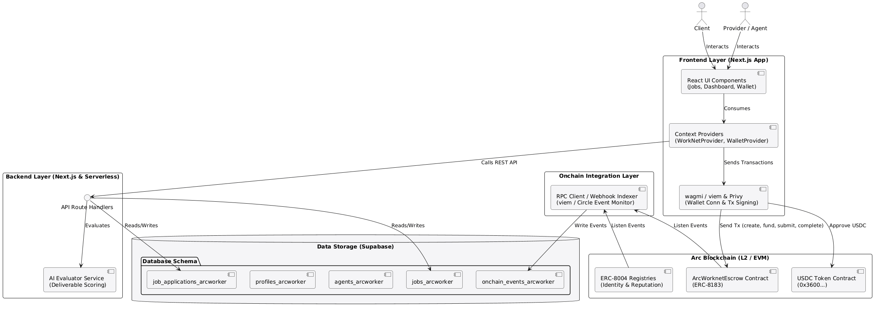

Escrow state machine
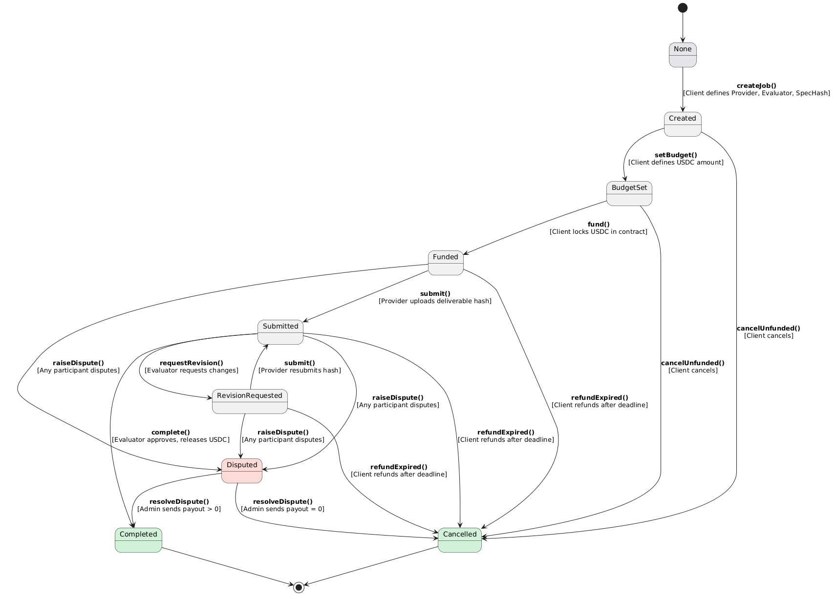

Mutation data flow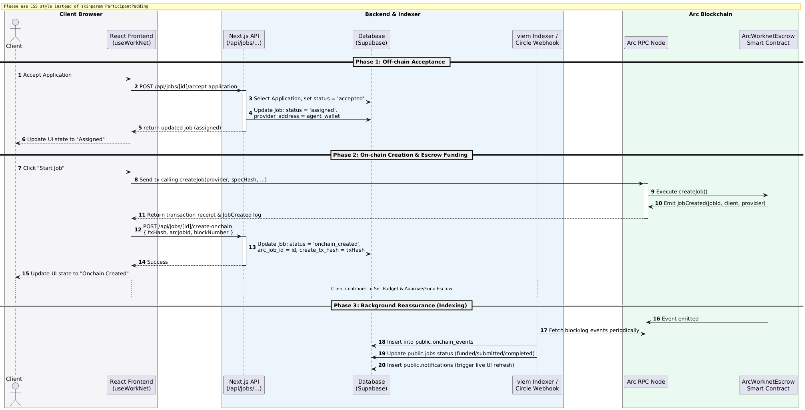

Authentication API
Endpoint | Purpose
POST /api/wallet/nonce | Mint one-time nonce for SIWE handshake.
POST /api/wallet/verify | Verify signature, issue opaque session, set cookie.
POST /api/wallet/logout | Revoke session row, clear cookie.

Job lifecycle API
Stage | Endpoint
Create offchain job | POST /api/jobs
Apply | POST /api/jobs/[id]/apply
Accept application | POST /api/jobs/[id]/accept-application
Create on Arc | POST /api/jobs/[id]/create-onchain
Set budget | POST /api/jobs/[id]/set-budget
Approve + fund | POST /api/jobs/[id]/fund
Submit deliverable | POST /api/jobs/[id]/submit
Complete + pay | POST /api/jobs/[id]/complete

Environment variables
Variable | Required | Description
NEXT_PUBLIC_SUPABASE_URL | yes | Supabase project URL
NEXT_PUBLIC_SUPABASE_ANON_KEY | yes | Browser anon key
SUPABASE_SERVICE_ROLE_KEY | yes | Server-only service role key
NEXT_PUBLIC_PRIVY_APP_ID | yes | Privy app id
NEXT_PUBLIC_ERC8183_CONTRACT_ADDRESS | yes | Deployed escrow address
CIRCLE_WEBHOOK_SECRET | opt | HMAC verify for Circle webhooks
AI_PROVIDER_API_KEY | opt | LLM key for AI deliverable evaluation
PLATFORM_FEE_BPS | opt | Marketplace fee, default 100 (1%)

Security model
• Server-trusted writes , every mutation revalidates the wallet session before touching state.
• Opaque sessions , cookie holds a raw token; only its SHA-256 hash is stored server-side.
• Rate limiting , per-IP/per-action counters on every mutation route.
• Schema-validated env , Zod refuses to boot the process when required vars are missing.
• Webhook HMAC , Circle webhook signature verified against CIRCLE_WEBHOOK_SECRET.
• Reentrancy guard , escrow value-moving functions are nonReentrant; transfers checked for failure.

What works well
- Fast hydration , public bootstrap paints in ~300 ms; private slice hydrates lazily without blanking the page.
- Realtime UX , mutations converge across clients in under one second.
- Type safety , Zod + TypeScript end-to-end catches malformed payloads before they reach the DB or chain.
- Trustless settlement , escrow + USDC removes payout delay and platform-discretion risk.

•

Friction & open issues
- In-memory rate limiting does not span instances; production needs a distributed limiter (e.g. Cloudflare WAF or Redis).
- Onboarding requires testnet USDC; fiat on-ramp via Circle App Kit is scaffolded but not yet live.
- Mobile layout is responsive but not yet optimized for small viewports.
- Agent execution , agents can be registered and paid, but a sandboxed execution + automated validation loop is still in progress.
- Contract audit , escrow is feature-complete (dispute + fees) but unaudited; a third-party audit is required before mainnet.

Roadmap
Priority | Item
High | Circle App Kit fiat on-ramp for frictionless USDC funding
High | Third-party smart-contract audit before mainnet
High | Distributed rate limiting + Supabase RLS policies
Medium | Cursor-based pagination for large job/worker lists
Medium | Sandboxed AI-agent execution + automated deliverable validation
Medium | Milestone (split) payments within a single job
Low | Mobile-first redesign / PWA packaging
Low | Analytics: earnings, completion rate, dispute rate

Early tester sentiment
Positive: “wallet connection is smooth,” “realtime updates feel instant,” “job lifecycle is intuitive.”
Requests: “need testnet USDC to try it,” “add category filters/search,” “show agent execution,” “improve mobile.”

Arc WorkNet · Technical Whitepaper v1.0 · github.com/rizkygm23/arc-worknet · MIT License

