**1st Case Name :** SQL Query Creation

**Case Objective :** Write an SQL query to get the top 10 customers by net total spending in the last 6 months

**Task and Constraints:** The expected output should include:

* Customer_id
* Customer_name
* Country
* Total_spent
* Unique_products_purchase
* Unique_total_orders
* Filtered only “completed” orders

**My approach to solve this case:**

1. Build PostgreSQL in a dockerized environment, through docker-compose.yaml

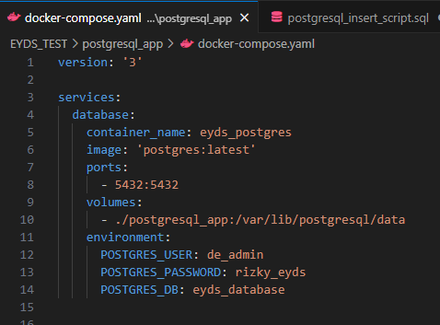

Figure - docker-compose.yaml syntax

1. Create database connections through DBeaver app

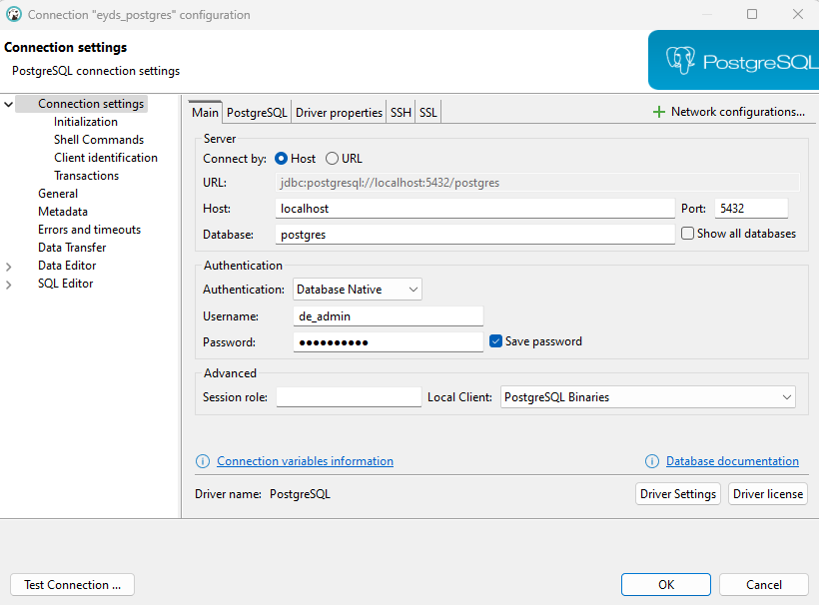

Figure Create connection in DBeaver

1. Create tables in PostgreSQL database using SQL DDL commands:
   * Create customers table:

**create** **table** customers (

customer_id **INT** **primary** **key**,

name **VARCHAR**(50),

email **VARCHAR**(100),

country **VARCHAR**(50),

created_at **TIMESTAMP**

);

* + Create products table:

**create** **table** products (

product_id **INT** **primary** **key**,

name **varchar**(50),

category **varchar**(50),

base_price **INT**

);

* + Create orders table:

**create** **table** orders (

order_id **INT** **primary** **key**,

customer_id **INT**,

order_date **TIMESTAMP**,

status **VARCHAR**(255) **not** **null**,

**foreign** **key** (customer_id) **references** customers(customer_id)

);

* + Create order_items table:

**create** **table** order_items (

order_item_id **INT** **primary** **key**,

order_id **INT**,

product_id **INT**,

quantity **INT**,

price **INT**,

discount **INT**,

TAX **INT**,

**foreign** **key** (order_id) **references** orders(order_id),

**foreign** **key**(product_id) **references** products(product_id)

);

1. Generate sample data using AI
2. Convert generated data into DML commands and insert to table in PostgreSQL

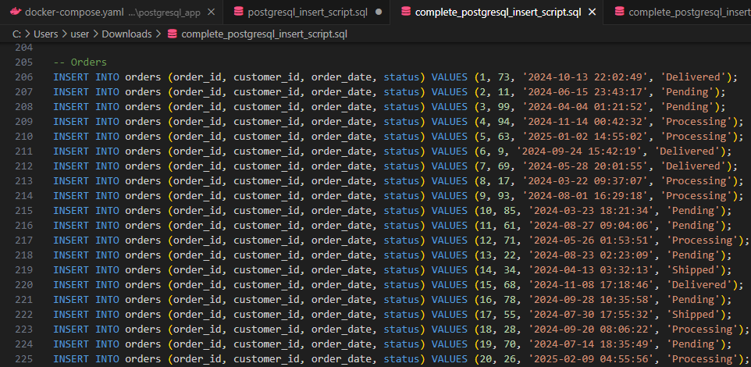

Figure - DML commands sample

1. Perform Query using Common Table Expression (CTE) in SQL

-- query top 10 customers by total_spending in the last 6 months and delivered status only

**with** recent_order **AS**(

**select**

*o*.order_id,

*o*.customer_id,

*o*.order_date,

*o*.status,

*oi*.product_id,

*oi*.quantity,

*oi*.price,

*oi*.discount,

*oi*.tax

**from** orders *o*

**left** **join** order_items *oi*

**on** *o*.order_id = *oi*.order_id

**where** order_date >= '2024-09-20' **and** status = 'Delivered'

**order** **by** order_date **desc**

),

customer_spending **AS**(

**select**

customer_id,

**count**(**distinct** product_id) **as** total_unique_products_purchased,

**count**(**distinct** order_id) **as** total_unique_orders,

**SUM** (quantity * price) - **SUM**(discount) + **SUM**(tax) **as** total_cust_spending

**from** recent_order

**group** **by** customer_id

**order** **by** total_unique_orders **desc**

)

**select**

*c*.customer_id,

*c*.name **as** *cust_name*,

*c*.country,

*cs*.total_unique_orders,

*cs*.total_unique_products_purchased,

*cs*.total_cust_spending

**from** customers *c*

**join** customer_spending *cs*

**on** *c*.customer_id = *cs*.customer_id

**order** **by** total_cust_spending **desc**

**limit** 10

1. Query Results

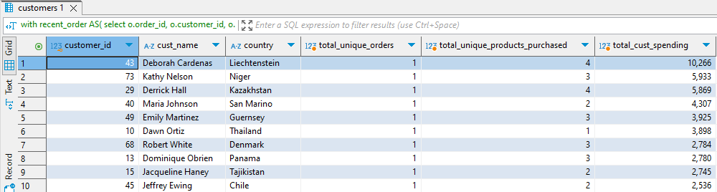

Figure - Query Results