1. Query:

select employee_id, first_name,last_name,salary,extract(year from age(now(),hire_date)) masa_kerja,

case when extract(year from age(now(),hire_date)) >= 20

then salary * 5

else salary * 3

end bonus

from employees

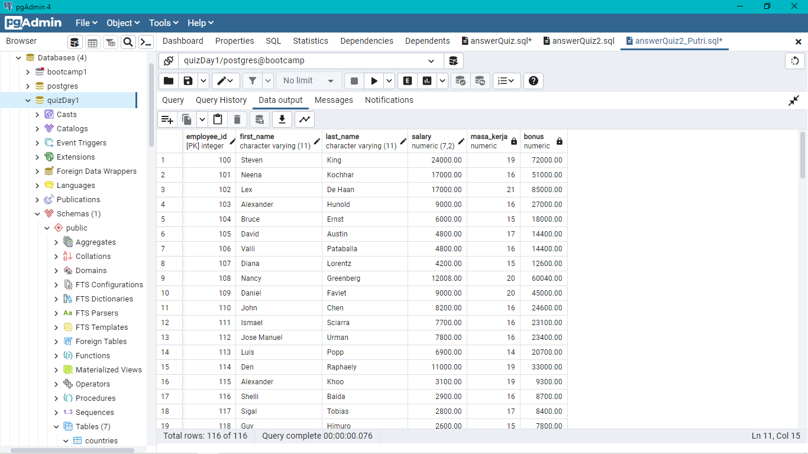

1. Query:

select extract(year

from age(now(),hire_date)) masa_kerja,

sum (case when extract(year from age(now(),hire_date)) >= 20

then salary * 5

else salary * 3

end) bonus

from employees

group by masa_kerja

order by masa_kerja asc

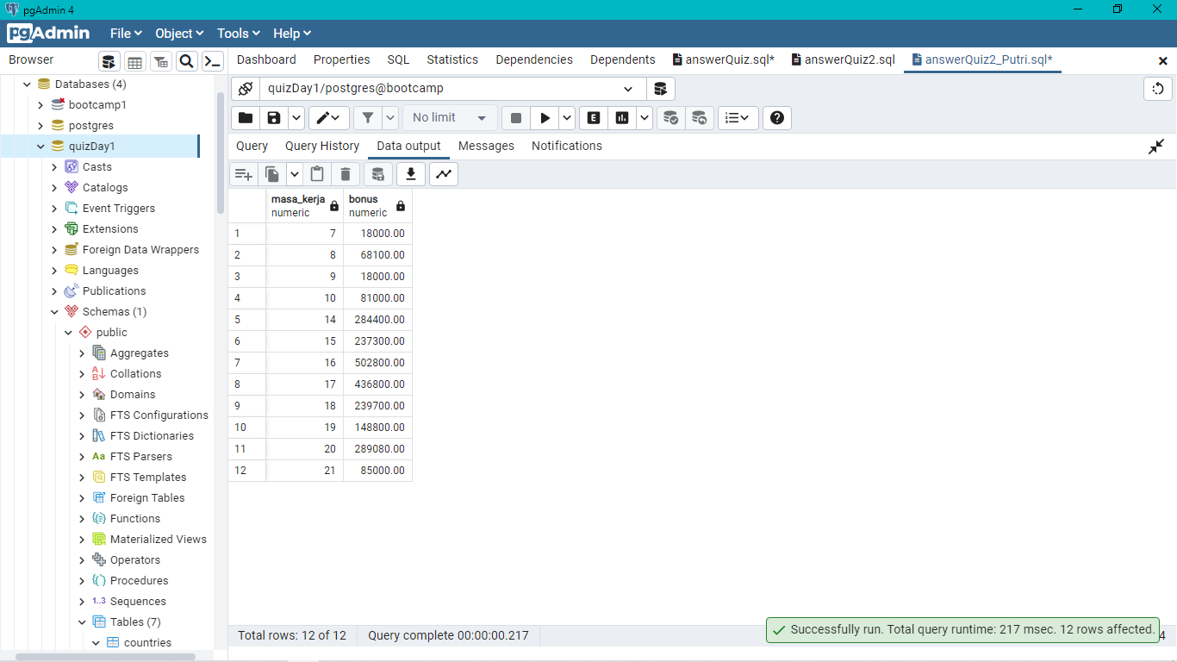

1. Query:

select extract(year from age(now(),hire_date)) masa_kerja,

case when extract(year from age(now(),hire_date)) >=20

then count (employee_id)

end jumlah_pegawai,

case when extract(year from age(now(),hire_date)) <=20

then count (employee_id)

end jumlah_pegawai_2

from employees

group by masa_kerja

order by masa_kerja

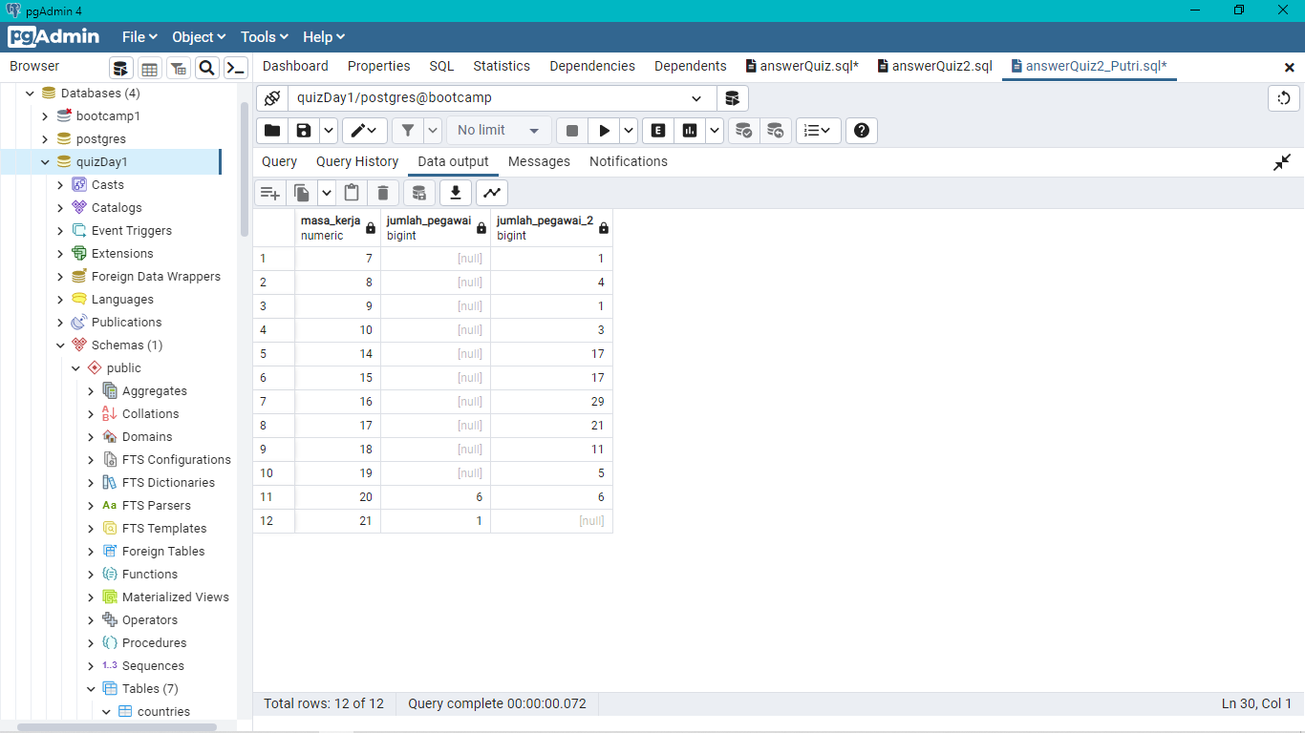

1. Query:

select department_id,extract(year from age(now(),hire_date)) masa_kerja,

case when extract(year from age(now(),hire_date)) >=20

then count (employee_id)

end jumlah_pegawai,

case when extract(year from age(now(),hire_date)) <=20

then count (employee_id)

end jumlah_pegawai_2

from employees

group by department_id,masa_kerja

order by masa_kerja

