Contents

Task 1: Define basic algorithms to carry out an operation and outline the process of programming an application (LO1) 2

1.1 Define what an algorithm is and outline the characteristics of a good algorithm. Develop algorithms for linear search and binary search using Pseudo code 2

1.2 Describe the steps involve in the process of writing and executing a program. Take an array of 10 or more elements and dry run the above two algorithms. Show the outputs at the end of each iteration and the final output . 7

# Task 1: Define basic algorithms to carry out an operation and outline the process of programming an application (LO1)

## Define what an algorithm is and outline the characteristics of a good algorithm. Develop algorithms for linear search and binary search using Pseudo code

**Algorithm**

An algorithm is a well-defined procedure that allows a computer to solve a problem. Another way to describe an algorithm is a sequence of unambiguous instructions. The use of the term 'unambiguous' indicates that there is no room for subjective interpretation. Every time you ask your computer to carry out the same algorithm, it will do it in exactly the same manner with the exact same result. (study.com, 2018)

**Characteristics of a good Algorithm**

Not all procedures can be called an algorithm. An algorithm should have the following characteristics.

* Precision - the steps are precisely stated.
* Input- the algorithm receives input.
* Output- the algorithm produces output.
* Feasibility- should be feasible with the available resources.

Flow diagrams and pseudo code are two ways to represent algorithms….

**Flow Diagrams**

Flow diagram algorithm use labeled shapes to represent the instructions in the program and arrows to show the order of the instructions. It is a guide to what your program will do and how it will do it.

Some examples of the standard shapes used in the flow diagram shown below.

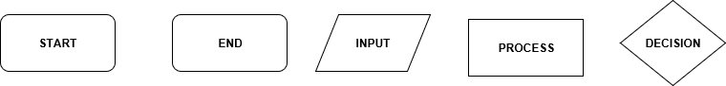

Figure 1 some of the common symbols used in flow diagrams (author developed using starumi)

**Pseudocode**

Pseudocode is a simple way of writing programming code in English. Pseudocode is not an actual programming language. It uses short phrases to write code for programs before you actually create it in a specific language. Once you know what the program is about and how it will function, then you can use pseudo code to create statements to accomplish the required outcomes for your program.

Some examples of keyword operations used in pseudo code

1. While/End While-the algorithm repeats a block of instructions until the condition is tested at the start of the block is false.
2. IF/Then/Else/End If -used to select various instructions based on the result of TRUE/FALSE.
3. FOR/ENDFOR-used for repeating the block of instructions a specified number of times
4. Output, Print, Display-used to output data.
5. Input, Read, Obtain-used to input data.

Here is an example of programming with pseudocode and using flow diagram to calculate weekly wages when gross pay depends on the hourly rate and the number of hours worked per week. If 35 hours are worked, half a time is paid for the extra hours:

This algorithm uses the sequential instruction: **INPUT** and **OUTPUT** and the conditional control operations **IF/THEN/ELSE/ENDIF**

**Pseudocode:**

INPUT hours worked

INPUT hourly rate

IF hours worked<=40

Gross wage= hours worked * hourly rate

Else

Gross wage=hours worked * hourly rate + hours worked – 40 * hourly rate * 1.5

End IF

OUTPUT hourly rate

END

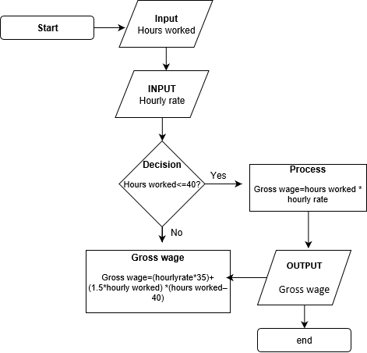**Flow Diagram**

Figure 2: author developed using staruml

**Linear Search Algorithm**

A linear search looks down at list, one item at a time, without jumping. In complexity terms this an 0(n) search – the time taken to search the list gets bigger at the same rate as the list does. (stackoverflow.com, 2018)

**Pseudo code for linear array**

Start

Declare integer array A=[1,2,3,4,5,6,7,8,9,10]

Function linear_search(search_key)

X=0

While x<=5

If search_key = A[x]

Return x

Else

x=x+1

End if

End while

Return -1

End function

// main program

Print “Search”

Input key

Index=linear_search(key)

If index>=0

Print “search item found”

Else

Print “search item not found”

End if

End main program

**Binary Search**

A binary search is when you start with the middle of sorted list, and see whether that’s greater than or less than the values you’re looking for, which determines whether the value is in first or second half of the list. Jump to the half way through sub list, and compare again etc. in complexity terms this an O(log n) search- the number of search operations grows more slowly than the list does, because you’re having the search space with each operation (stackoverflow.com, 2018)

**For more understanding of binary search and linear search:** think of it as two different ways of finding your way in a phonebook. A linear search is starting at the beginning, reading every name until you find what you’re looking for. A binary search, on the other hand, is when you open the book, look at the name on top of the page, and decide if the name you’re looking for is bigger or smaller than the one you’re looking for. If the name you’re looking for is bigger, then you continue searching the upper part of the book in this very fashion.

## Describe the steps involve in the process of writing and executing a program. Take an array of 10 or more elements and dry run the above two algorithms. Show the outputs at the end of each iteration and the final output .

**Programming Process**

Developing a program involves steps similar to any problem-solving task. There are 5 main steps in the programming process:

A five step programming p

1. Defining the problem
2. Planning the solution
3. Coding the program
4. Testing the program
5. Documenting the program

**Defining the problem**

**Planning the solution**

There are 2 common ways of planning the solution to a problem are to draw a flowchart and to write pseudocode, or possibly both. Essentially, a flowchart is a pictorial representation of a st