Student Activities Proposal Evaluation System Planning Using Barcode Scanner Technology

Rizqi Chandra Pramana¹
Department of Informatics
UPN Veteran Jawa Timur
Surabaya, Indonesia
rizqicp@gmail.com

Abstract—Student Creativity Program (PKM) is an activity formed by Ministry of Research and Technology of the Republic of Indonesia. This activity was formed to facilitate the various potentials possessed by students to apply and develop the knowledge gained in lectures to the wider community. PKM Center is the agency that manages student creativity program proposals in Universitas Pembangunan Nasional “Veteran” Jawa Timur enviroment. However, the management of student proposal data carried out by the PKM Center is still done manually. So it is difficult to evaluate the history of student proposals. Because of these problems, information systems need to be developed to ensure that these problems can be resolved. So that the management of student proposal data can be carried out properly. Making a student proposal evaluation system has several stages that are carried out, such as a literature study to get a reference to the features used in the proposal evaluation system. After that, it is continued with business process design to application design. Barcode scanners as supporting technology are used in the system to improve data accuracy. The final result of this research is a web-based system for evaluating proposals that have been submitted by the proposing students, so that the proposal data can be used by the center in determining which proposals can qualify for the next stage.

Keywords— System, Proposal, PKM, Barcode, QuaggaJS
- Introduction
PKM (Student Creativity Program) is an activity formed by Ministry of Research and Technology of the Republic of Indonesia. This program was formed as a forum to facilitate the various potentials possessed by students in Indonesia. The potential that is owned can come from various fields and backgrounds, then channeled through the Student Creativity Program in the form of a research proposal. That way students can study, develop, and apply the knowledge and technology they have learned in lectures for the benefit of the wider community.
UPN “Veteran” Jawa Timur is one of the universities that participates in the Student Creativity Program every period. UPN “Veteran” Jawa Timur student submitting the proposal to the PKM Center, which acts as the management agency for student activity proposals. However, the process of managing PKM proposals at UPN "Veteran" Jawa Timur is still done manually. Over time, the number of student proposal data will increase. So it is difficult to evaluate student PKM proposal data.
The information system is one solution to the problem of processing PKM proposal data at UPN ”Veteran” Jawa Timur. This system can also provide information about student activities to its users. By using a computer-based system, data processing can be done more quickly and can reduce the possibility of human errors. According to [9](Putra & Alit, 2019) Higher education institutions that do not develop information technology properly will be increasingly left behind.
Every UPN ”Veteran” Jawa Timur student has a KTM (Student Identity Card). At each KTM there is a Barcode that contains information about the student. Barcode is a code with a black line on a white background that can insert personal information in an ID card or ID card [10](Saepulloh & Adeyadi, 2019). Barcodes are usually used to store specific data such as production codes, identity numbers, and others so that computer systems can identify easily. The application of Barcode Scanner technology to the computer-based PKM registration system can ensure that PKM applicants are still active in lectures, and can speed up the process of inputting student data into the system.
Based on these problems, the authors make a web-based information system design using barcode scanner technology that can be used to manage PKM proposal data at UPN ”Veteran” Jawa Timur.
- Literature Review
- Previous Research
As a basis for this research, the author refers to previous research from several journals, among others :
[9](Putra & Alit, 2019), Information System for Assessment of Litdimas Proposals at Lppm UPN "Veteran" Jawa Timur. The results of research in scientific journals are in the form of systems used to manage information from Verification and Assessment activities on research and community service at Lppm UPN "Veteran" Jawa Timur. This system allows each user to get access rights as specified. User lecturer proposing has access rights to submit and upload Litdimas documents, User reviewers have access rights to assess the prescribed litdimas proposals, and Lppm as manager users who have administrative access rights to document inspection and access rights to plot reviewers for litdimas proposals proposed by the lecturer who proposed.
[8](Nugraha, Arifin, & Harjanto, 2020), Design of Management Information System for Student Affairs Proposals. This scientific journal states that the student organization at a university is one of the units that manages many student activities. Each of these activities requires documentation of various stages of activity in the form of proposals. The large number of proposals for student activity proposals requires the development of an information system that will help manage student proposals. The results of research in this scientific journal are a system that can be used for the management of the process of submitting proposals for student activities which include the data collection process for various types of student activities, registration of proposals, approval of supervisors, evaluation of proposals and reports on the results of proposals for student activity proposals.
[6](Junadhi, 2019), E-Proposal Information System for Student Activities. This scientific journal states that the proposal is a condition that must be met in making an activity. To start an activity, the organizer must first submit a proposal, and the activity cannot run if the proposal is not approved or without a proposal. Therefore, the number of proposals will continue to increase along with the number of activities, so the effectiveness of proposal management greatly affects the running of an activity. If the acceptance of proposals is still manual, namely binding and delivery to the recipient's room, and examination of old proposals, it will hamper the implementation of an activity. Therefore, making a proposal management system better, more effective, and efficient will help the activity itself.
[10](Saepulloh & Adeyadi, 2019), Android Based Scanner Application To Display Id Card Data Using Barcodes. This scientific journal discusses barcode technology which can help to store personal information or ID cards which are always used by members of an organization or employee members in an agency, by raising the issue, namely the use of barcodes which require users to have a Barcode Scanner and PC so they can see what information. which can be scanned on the ID Card. This journal states that we can view the information on the barcode by using an android barcode scanner application, so as to minimize the budget so as not to buy a PC and scanner. The final result of research in this scientific journal is a barcode scanner application on Android to see the information contained in the ID Card.
[4](Handayani, 2018), Barcode Card Parking System Design. This scientific journal discusses the problems of parking management at the University of Semarang. The journal writer gave an idea to make a parking card equipped with a barcode containing information about motor vehicle owners. This card will be read by the parking system with barcode scanners and automatic parking latches. The final result of research in this scientific journal is in the form of a barcode card parking system, this system will read the barcode on the card and the parking door latch will automatically open or close after the scanner has successfully read the barcode. This system was built using the PHP programming language and the database used was MySQL.

- Definition of System
According to [9](Putra & Alit, 2019), A system is a network of interconnected procedures, gathered together to carry out an activity or to complete a specific goal. The Big Indonesian Dictionary defines that the system is a set of elements that are regularly interrelated to form a totality.
According to the Wikipedia site, Information Systems is a combination of information technology and the activities of people who use that technology to support operations and management. In a very broad sense, the term information systems is often used to refer to the interactions between people, algorithmic processes, data and technology. In this sense, the term is used to refer not only to the organization's use of information and communication technology, but also to the way in which people interact with these technologies in support of business processes.

- Definition of Evaluation
According to [7](Lazwardi, 2017), Evaluation is an activity of gathering information that is useful for making decisions and as a measure of how far goals can be achieved. Literally, evaluation is defined as an assessment. According to the Big Indonesian Dictionary, Evaluation is an effort to assess technically and economically on a deposit of minerals for the possibility of carrying out its mining. Or another meaning is to give an assessment, or judge.
The conclusion according to the Wikipedia site is that evaluation is the process of determining a value for a thing or object based on certain references to determine certain goals. Within the company, evaluation can be interpreted as a process of measuring the effectiveness of the strategies used in achieving company goals. The data obtained from the measurement results will be used as a situation analysis for the next program.

- Definition of Proposal
According to [6](Junadhi, 2019), Proposals are plans that are drawn up to carry out certain activities that are made systematically and logically. According to The Big Indonesian Dictionary, a proposal is a plan that is set out in the form of a work plan, planning systematically, carefully and thoroughly made by researchers before carrying out research, both field research and research in the library.
Meanwhile, in the context of research, according to Wikipedia, a research proposal is a document in proposing a research project, generally in the field of science or academia, and is usually a request to sponsor that research. From the above understanding, it can be concluded that a proposal is an activity plan that is structured systematically and logically to propose an activity or research.

- Student Creativity Program (PKM)
Student Creativity Program (PKM) is an activity formed by Ministry of Research and Technology of the Republic of Indonesia. This activity was formed to facilitate the various potentials possessed by students to apply and develop the knowledge gained in lectures to the wider community .
PKM is the successor of the Student Alternative Work Program activity which was formed in 1997, then changed to the Student Creativity Program or PKM in 2001 until now. Through this activity students can apply their knowledge as a form of community service, which is one of the goals of the Tri Dharma of University.
- Definition of Barcode
According to [10](Saepulloh & Adeyadi, 2019), A barcode is a machine-readable set of optical data. Barcode collects data in line width and parallel line spacing and can be referred to as a linear or 1 dimensional barcode or symbology. But it also has squares, dots, hexagons and other geometric shapes in the image called matrix code or 2-dimensional symbology. Barcodes were originally used to automate self-service inspection systems, but as technology has developed, the use of barcodes has spread to other uses, such as identity cards. From the above understanding, it can be concluded that Barcode is an optical data in the form of lines or bars to store information that can be read by machines.

- Business Use Case Diagram
The Business Use Case diagram is a business model that represents the interaction between external entities outside an organization and entities within the organization, these external entities can be people or other organizations that interact using a business process to achieve business goals..

- Use Case Diagram
Use Case diagrams included in business modeling are representations of user interactions with the system that show how users can interact with the system and the relationship between users and a business process based on the perspective of the system user.

- Database
According to [13](Swara & Pebriadi, 2016), Database is a collection of information that is compiled and constitutes a complete unit that is systematically stored in hardware (computer) so that it can be processed using software.
Data is an object in the form of notes that represent facts from the real world. By using a database or commonly called a database, a person can store information such as student data, employee data, or products into electronic storage media. Databases are important because they can avoid duplication of data and unclear relationships between data.
The process of entering and retrieving data to and from data storage requires a software called a Database Management System (DBMS). DBMS is software that allows users of a database to access and manage data practically and efficiently.
To create an efficient database structure, a good database design is needed. Conceptual Data Model (CDM) and Physical Data Model (PDM) are forms of database modeling that are commonly used in the development of an information system.

- Conceptual Data Model (CDM)
CDM is a database modeling based on the understanding that the real world consists of a collection of basic objects called entities, and relationships between these entities. CDM is usually represented in the form of an Entity Relationship Diagram (ERD), which is modeling conceptual which describes the relationship between data from entities that are stored in the database.

- Physical Data Model (PDM)
PDM is a physical description of the database created based on a predetermined design and is ready to be implemented. PDM shows all table structures and, including column names, data types, primary keys, foreign keys, and relationships between tables.

- Definition of Website
According to [5](Hasugian, 2018), Web is an application that contains multimedia documents (text, images, sound, animation, video) in it that uses the HTTP protocol (hypertext transfer protocol) and for access using software called a browser. According to Wikipedia, a website is a set of interconnected web pages that are generally on the same program or device containing a collection of information provided by individuals, groups, or organizations.
Websites are usually placed on a server that can be accessed via a network such as the internet or a local network through an internet address known as a URL. This combination of all publicly accessible sites on the Internet is also known as the World Wide Web or better known as WWW.
The website was invented by Sir Tim Berners-Lee in 1991. The purpose of the Team designing the website was to make it easier to exchange and update information with fellow researchers where he worked. Then since 1993 the Website was announced that it could be used free of charge by the public. This makes a website easily accessible to anyone with an internet network.

- QuaggaJS
QuaggaJS is a barcode scanner written by Christoph Oberhofer in 2015. QuaggaJS is written entirely in the JavaScript programming language that supports real-time scanning and decoding of various types of barcodes such as EAN, CODE 128, CODE 39, EAN 8 , UPC-A, UPC-C, I2of5, 2of5, CODE 93 and CODABAR. This library is also capable of using the getUserMedia function to get direct access to the user's camera. Although the code relies on heavy image processing, the latest hardware is capable of extracting information from barcodes or barcodes in real-time..
- Methodology
- Data Collection Method
There are 3 (three) steps used in completing the making of the Proposal Evaluation System Using Barcode Technology, namely:

- Observation
Observation activities are carried out to obtain the required data, such as the flow of the process for submitting proposals for student activities, and other information that supports the running of this program..

- Literature Review
Literature review is carried out by reading the literature in books or on the internet related to the manufacture of this system. The goal is as supporting data and problem solving for the manufacture of this system.

- Design
This design activity aims to create a Proposal Evaluation System in accordance with the system specifications and flowcharts previously described. This design includes designing business processes and designing applications made using the Unified Modeling Language or UML.

In developing this Student Activity Proposal Evaluation System requires data, including:

- Student Data

- Lecturer Data

- Administrator Data

- Faculty Data

- Departement Data

- Grant Type Data

- Proposal Category Data

- Results and Discussion
The results of this design produce information about business process design to database design and application interface mockups.

- Business Process Design
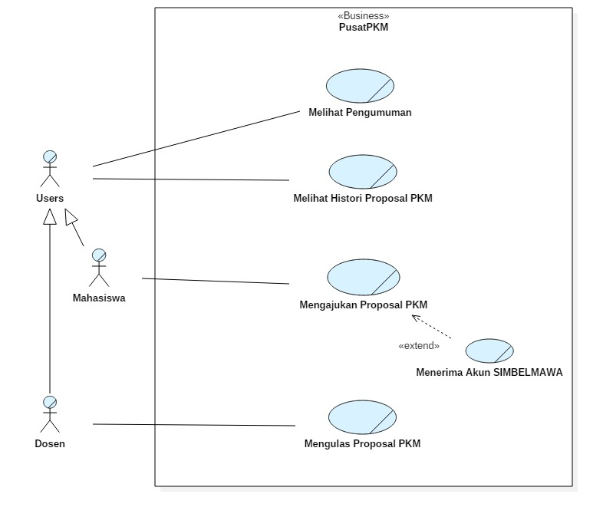
Figure 1. Business Use Case Diagram
The diagram above is a business process design in the form of a Use Case Diagram. This diagram illustrates how external actors interact with the organization to achieve business goals. External actors in this case are lecturers and students who interact with the PKM Center organization with actions described as use cases.

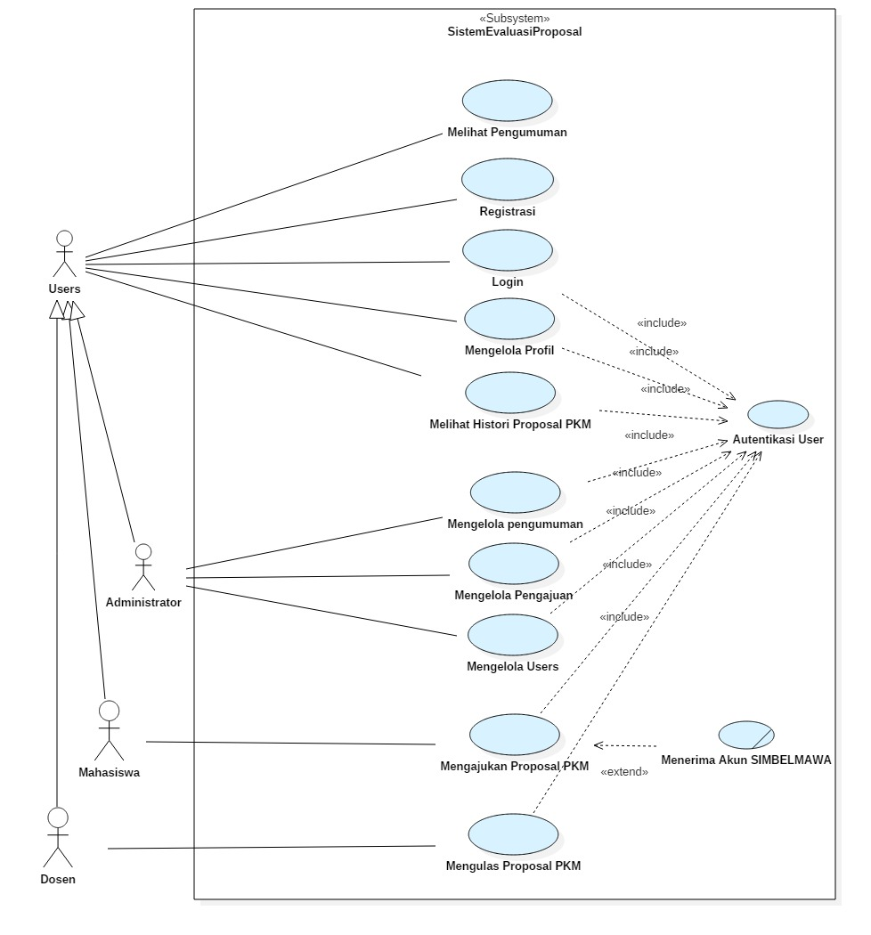
Figure 2. Use Case Diagram
The diagram above is a system business process design in the form of a Use Case Diagram. This diagram illustrates how external and internal actors in the organization interact with the system. Actors in this case are people who use the system, including students, lecturers, and administrators. All those who are not part of the system become external actors in the Use Case Diagram, such as Administrators who are internal to the organization, will be considered as external actors in the Use Case Diagram because they are not part of the system.

- Database Design
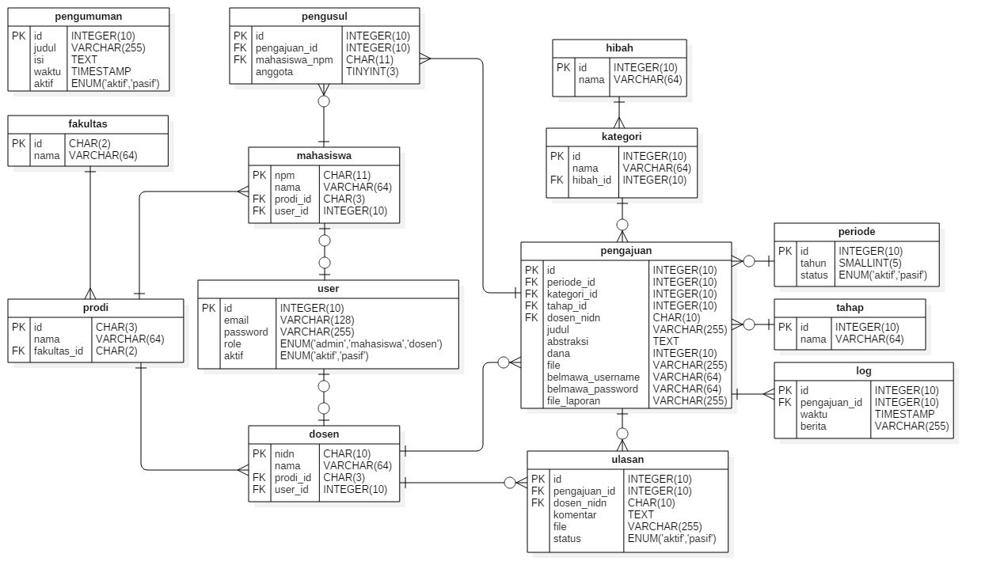
Figure 3. Conceptual Data Model
The Conceptual Data Model in Figure 3 is designed based on system requirements. This diagram describes all the entities contained in a database consisting of 14 entities. Each entity has a relationship to one or more entities, or has no relationship at all. This relationship is depicted by a line of cardinality, which is the maximum number of entities that can relate to entities on the set of other entities. In addition, the attributes and data types that exist in each entity are also described in this diagram. This attribute is data that will be stored in each table with a certain data type. The data type is selected based on what data will be stored and how much ideal memory allocation is needed to store that data. That way, the data stored in the database can be used properly and efficiently.
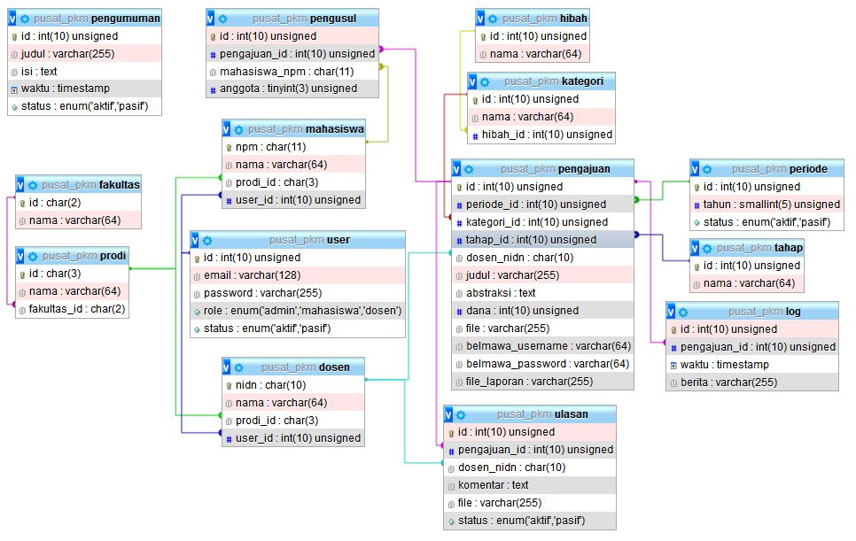
Figure 4. Physical Data Model
The physical data model in Figure 4 is a physical description of the database concept that was designed in the previous section. In this diagram, it is illustrated that each entity has become a table, and the line of cardinality now describes the relationship between table attributes which are primary and foreign keys. These related attributes will make it easier to process data, which in the event of a change in data in a table, the data in other tables will be automatically updated as well..

- Interface Design
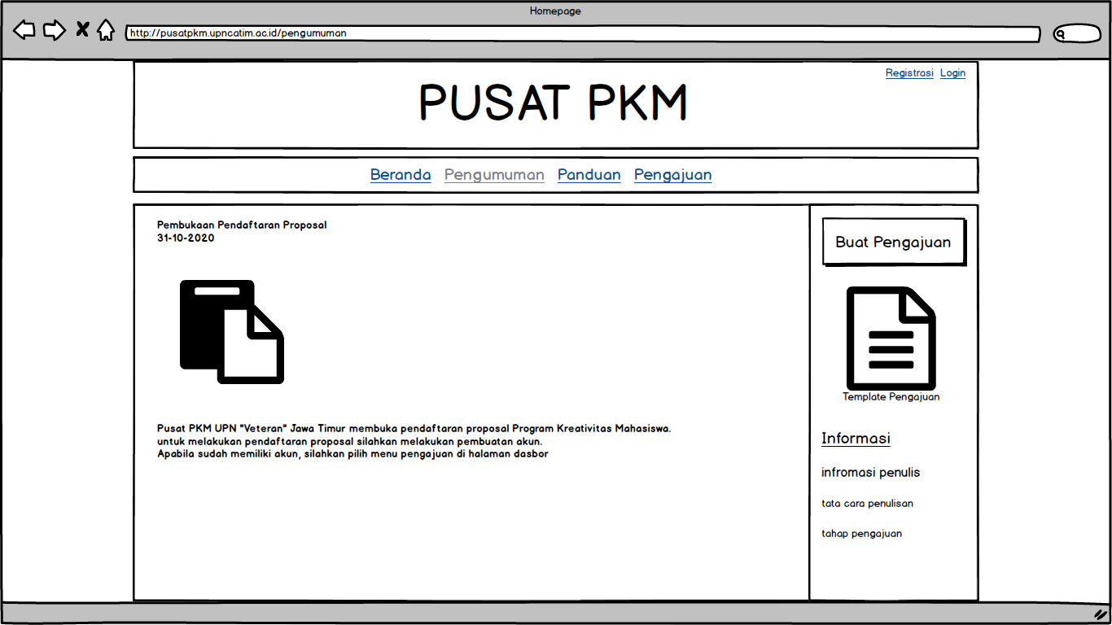
Figure 5. Hompage Mockup
Figure 5 is the main page design of the system, with an open announcement menu. Here users can access announcements, login and registration menus, and other information such as submission guides.
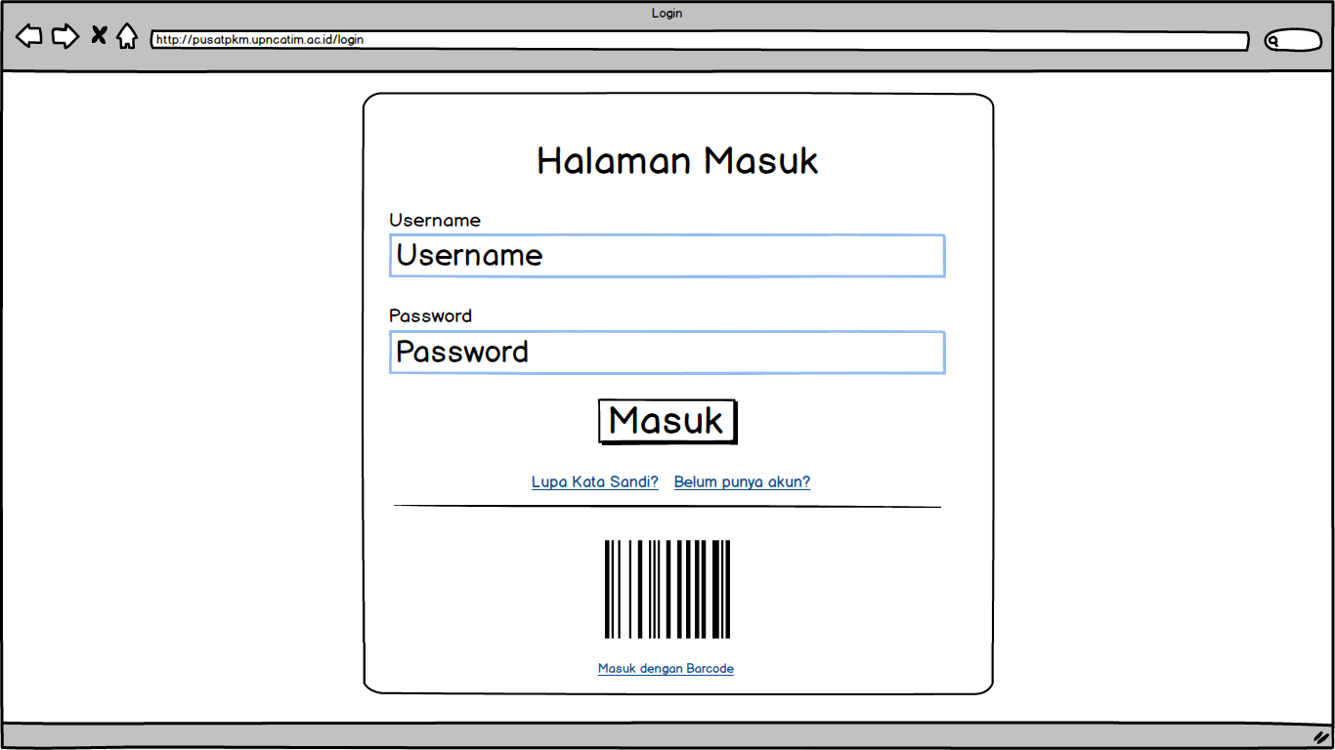
Figure 6. Login Mockup
Figure 6 is the login page design of the system, through this page the user can enter the system using user account data or using the barcode on the student ID card. Users are also provided with a link to reset the password if they forget account information, and there is a link to direct the user to the registration page if the user does not have an account..
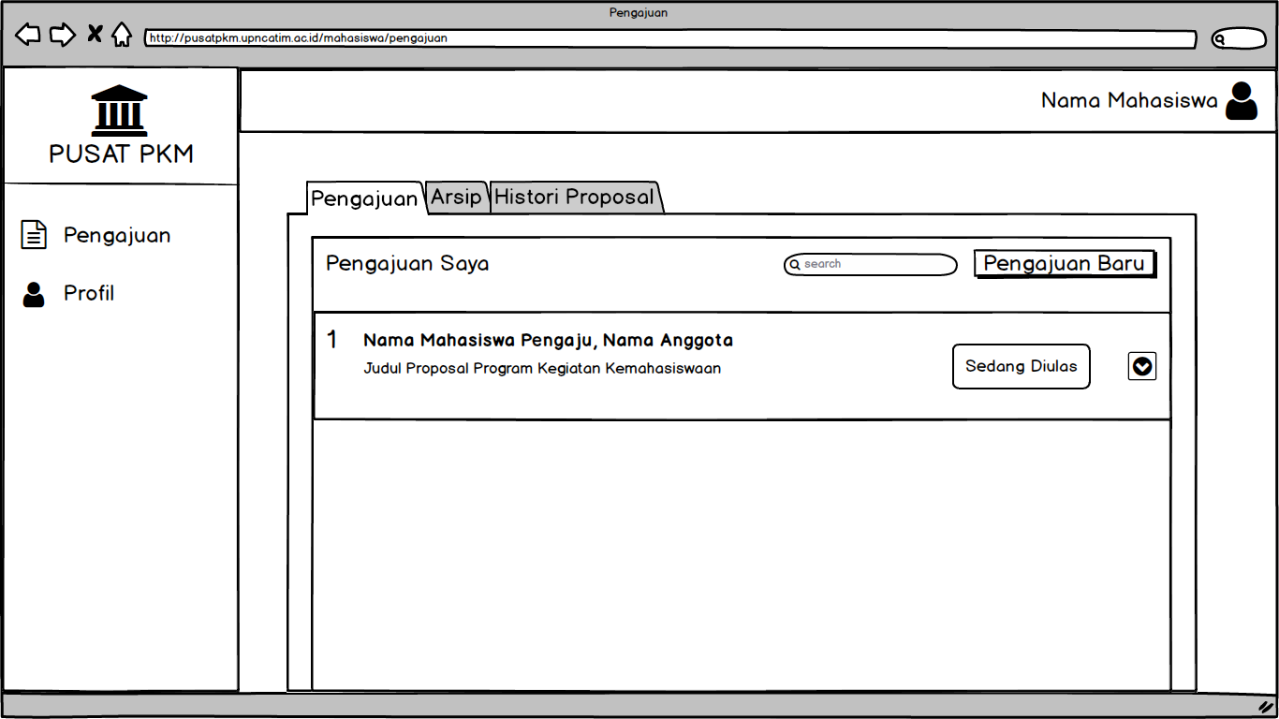
Figure 7. Student Dasboard Mockup
Figure 7 is a student dashboard page design, with an open submission menu. On the dashboard page, students can access the profile menu to edit the profile, and can access the submission menu to manage submissions, namely making new submissions or editing old ones.
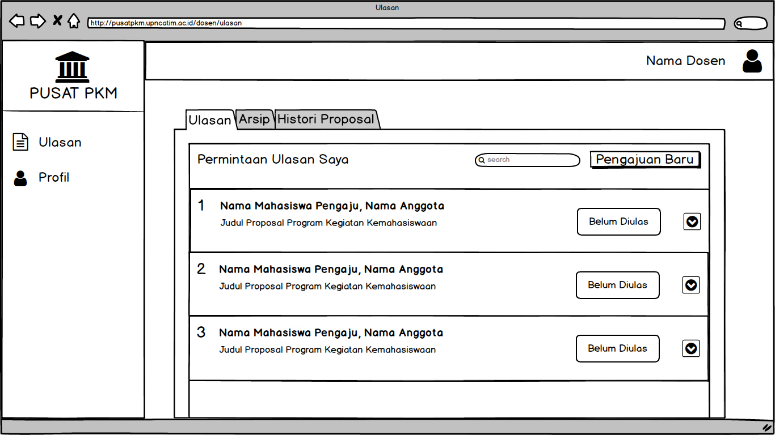
Figure 8. Lecturer Dasboard Mockup
Figure 8 is the design of the lecturer dashboard page, with an open review menu. On the dashboard page, lecturers can access the profile menu to edit the profile, and can access the review menu to manage student proposal review requests sent by administrators. Lecturers accept to review proposals or reject requests for proposal reviews if they are not in accordance with the lecturer's field of expertise.
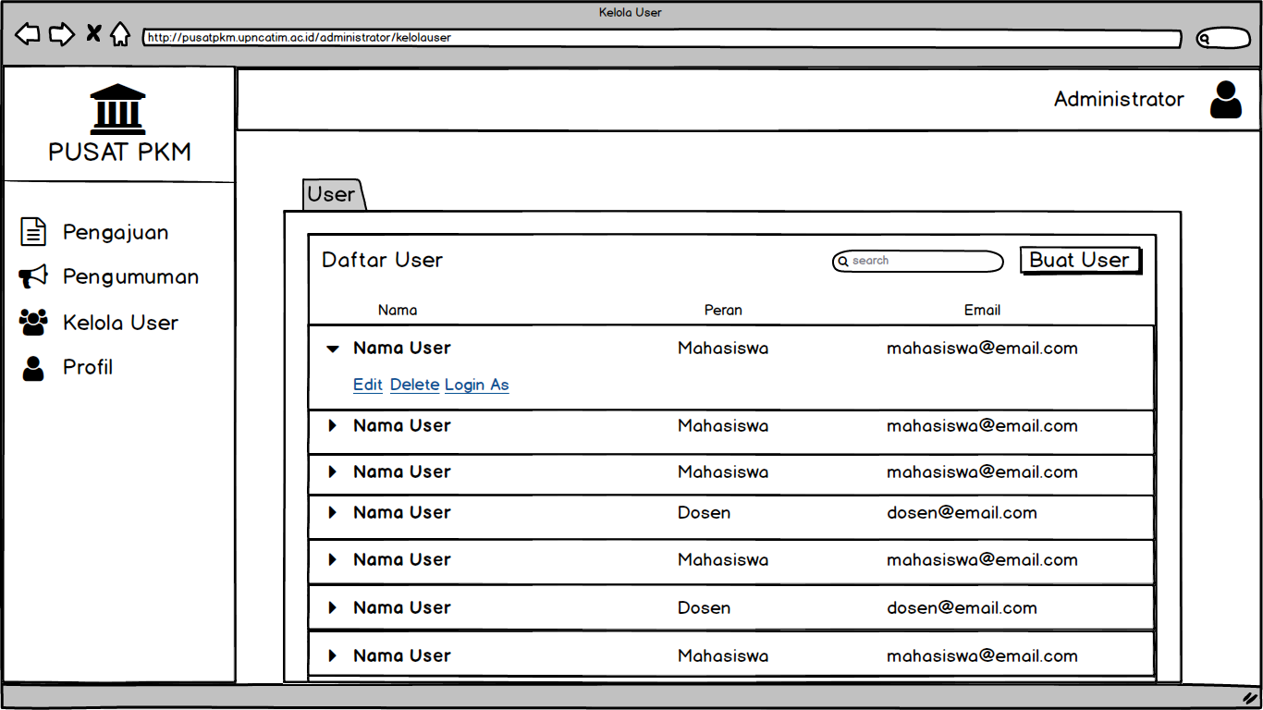
Figure 9. Administrator Dashboard Mockup
Figure 9 is a dashboard page design from the administrator, with the open user manage menu. On the dashboard page, the admin can access the profile menu to edit the profile, access the announcement menu to manage announcements, access submissions to manage submissions, submissions from students will go to the administrator first, then the admin will select a lecturer to review student proposals according to their area of expertise. Admin can also access the manage user menu, the admin can delete users, create new users, or log in as the selected user.

- Conclusion
Based on the results of the analysis and design of the Proposal Evaluation System from the previous chapter, the following conclusions can be drawn:

- In the design of the Proposal Evaluation System, there are 3 users who have different access rights, other users cannot access the menu outside their access rights except the administrator, who can log in as the selected user through the user manage menu.

- With the Proposal Evaluation System as a medium for managing student proposals, it can help manage proposal data more efficiently.
- Students can enter the system without having to use a username and password, if the data is forgotten.
References
- Afandi, F. N., & Yulianis, M. (2018). Implementasi Genetic Algoritms Untuk Penjadwalan Mata Kuliah Berbasis Website. Jurnal Sistem Informasi Dan Telematika, 9(1), 45–52. https://doi.org/10.36448/jsit.v9i1.1031
- Destiningrum, M., & Adrian, Q. J. (2017). Sistem Informasi Penjadwalan Dokter Berbassis Web Dengan Menggunakan Framework Codeigniter (Studi Kasus: Rumah Sakit Yukum Medical Centre). TEKNOINFO, 11(2), 30–37.
- Firman, A., Wowor, H. F., & Najoan, X. (2016). Sistem Informasi Perpustakaan Online Berbasis Web. E-Journal Teknik Elektro Dan Komputer, 5(2), 29–36.
- Handayani, S. (2018). Rancang Bangun Sistem Parkir Dengan Kartu Barcode. INFOKAM, 2(14), 147–157.
- Hasugian, P. S. (2018). Perancangan Website Sebagai Media Promosi Dan Informasi. Journal Of Informatic Pelita Nusantara, 3(1), 82–86.
- Junadhi. (2019). Sistem Informasi E-Proposal Kegiatan Kemahasiswaan ( Studi Kasus : STMIK Amik Riau ). Riau Journal of Computer Science, 05(01), 48–57.
- Lazwardi, D. (2017). Implementasi Evaluasi Program Pendidikan di Tingkat Sekolah Dasar Dan Menengah. Al-Idarah: Jurnal Kependidikan Islam VII, 7(2), 142–156.
- Nugraha, F., Arifin, M., & Harjanto, A. (2020). Rancang Bangun Sistem Informasi Manajemen Proposal Kemahasiswaan. Jurnal Sistem Informasi & Manajemen Basis Data, 03(01), 51–59.
- Putra, C. A., & Alit, R. (2019). Sistem Informasi Penilaian Proposal Litdimas Pada Lppm Upn “Veteran” Jawa Timur. Jurnal Ilmiah Teknologi Informasi Dan Robotika, 1(1), 29–33. https://doi.org/10.33005/jifti.v1i1.10
- Saepulloh, A., & Adeyadi, M. (2019). Aplikasi Scanner Berbasis Android Untuk Menampilkan Data Id Card Menggunakan Barcode. Jumantaka, 03(01), 101–110.
- Safitri, R. (2018). Simple Crud Buku Tamu Perpustakaan Berbasis Php Dan Mysql :Langkah-Langkah Pembuatan. Tibanndaru : Jurnal Ilmu Perpustakaan Dan Informasi, 2(2), 40. https://doi.org/10.30742/tb.v2i2.553
- Suendri. (2018). Implementasi Diagram UML (Unified Modelling Language) Pada Perancangan Sistem Informasi Remunerasi Dosen Dengan Database Oracle (Studi Kasus: UIN Sumatera Utara Medan). Jurnal Ilmu Komputer Dan Informatika, 3(1), 1–9. Retrieved from http://jurnal.uinsu.ac.id/index.php/algoritma/article/download/3148/1871
- Swara, G. Y., & Pebriadi, Y. (2016). Rekayasa Perangkat Lunak Pemesanan Tiket Bioskop Berbasis Web. Jurnal TEKNOIF, 4(2), 27–39.

