Profile Matching Based Business Incubator Tenant Acceptance System

Sugiarto¹
Department of Informatics
UPN Veteran Jawa Timur
Surabaya, Indonesia
sugiarto.if@upnjatim.ac.id
Pratama Wirya Atmaja²
Department of Informatics
UPN Veteran Jawa Timur
Surabaya, Indonesia
pratama_wirya.fik@upnjatim.ac.id

Abstract — Business incubator is an institution that is currently more needed to improve all types of entrepreneurs and startups. Tenant is the name of the fostered partners in the Business Incubator, the performance of the Business Incubator is improved, so the tenants who enter the registration in the Business Incubator also increase. The criteria to be a tenant has many variables, so it takes a long time during the calculation process, with the matching profile that can be customized with several variables needed in this business incubator, it becomes a shorter process and provides a recommendation value for the business incubator director in deciding whether the tenant is accepted or rejected. In table 2 in this paper it is explained that the validity test value of the tenant registration information system using the profile matching algorithm gets values above 0.6 of 1, so that the matching profile matching with the case study registration can be applied to the determination of technopark business incubator fostered tenants.
Keywords — profile matching, business incubator, validity test;

Introduction (Heading 1)
Utilization of information systems can result in improved overall information service performance processes and can provide needed information quickly, precisely and accurately. There are numerous examples of successful incubation mechanisms, such as technology incubators, accelerators, and science parks, which have contributed to developing sustainable regional eco-systems with the concentration of innovative entrepreneurial activities, generating intense interest in policy circles [8]. At present the company cannot rely solely on the resources it has in achieving its competitive advantage. The company must conduct business partnerships with various parties, both with suppliers, distributors and even with consumers. This condition is especially faced by companies who want to expand their activities into international or global markets. Understanding how a user behaves is an important task for many applications such as the generation of recommendations, candidate assessment by HR departments or even for the analysis of further developing for social media itself. With entrepreneurial universities increasingly viewed as engines of knowledge-oriented regional economic growth through technology transfer and commercialization of research results, a regionally integrated technology incubation mechanism has the potential to be the principal vehicle for nurturing and growing such enterprises [12]. In determining partners manually will result in less effective data and on target. Then we need a system solution that is intended to support managerial decision makers in a decision situation. Conceptually, incubators help connect science, technology, education, knowledge, entrepreneurial talent, and capital [13][9]. To overcome the problems that exist in the Technopark Business Incubator related from Tenant who many want to join the Business Incubator, then you can use the decision-making method that will be used to determine the best partner is the profile matching method. There needs to be a change in ways and methods as an alternative to the selection of leaders according to needs. In this study, the Profile Matching method was chosen to provide assessment and evaluation of employee performance to be promoted to become a Leader [10]. Hypothesized to act as conduits for developing entrepreneurial capital within a region [2], their regional role in promoting technology-based economic development and contributing towards the enhancement of the image of location [7]. With entrepreneurial universities increasingly

literature review

Profile Matching
Profile Matching is a decision-making mechanism to assume that there is an ideal level of predictor variables that must be fulfilled by the parameters, instead of the static criteria. In a profile matching process, an outline of the process of comparing the individual's competence into the aspects that can be known differences in competence called gap[4][5]. Sequencing data is defined as a process to reconstitute the set of objects using certain rules[3].

Workshop Design
Result systems can be improved upon by using back-up policies and audit trails. Although his solution was built with java and MySql database, it did not establish any evidence for processing results batched in files to increase data integrity and mitigate fraud. The research could not also [14] In UML specification, requirements analysis and design are usually done using diagrams [1]. One particular diagram (a use-case diagram) is used to specify requirements of the system. In a use-case diagram, two important factors are used to describe the requirements of a system. They are actors and use cases. Actors are external entities that interact with the system and use cases are the behaviour (or the functionalities) of a system [11] The use cases are used to define the requirements of the system. These use cases represent the functionalities of the system. Most often, each use case is then converted into a function representing the task of the system. Most often, use cases represent the functional requirements of a system. If the requirements are gathered correctly, then a good use-case diagram can be formed. In UML, sequence diagrams are usually used to manually record the behaviour of a system by viewing the interaction between the system and its environment [6].

methodology
In this paper using the Profile matching method, where profile matching is a decision making mechanism by assuming that there is an ideal level of predictor variables that must be met by the subjects studied, not the minimum level that must be met or passed.
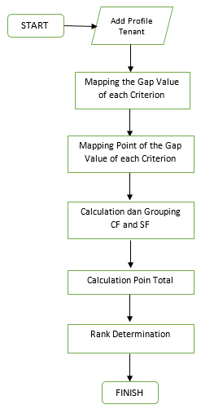
Fig 1. Flowchart Profile Matching Algorithm

In Fig 1 above what is done is to take data of each partner who has joined, then do a mapping of the gap values of each criterion, then weighting the gap values that have been obtained, which is then continued by calculating the core factor (CF) and secondary factor (SF), where the results are cf and sf calculations will continue to calculate the total value, and then determining the ranking of the total value.
In the conditions table below, it has 9 points that must be met to create a condition for compliance with the profile matching algorithm. The following in table 1 below is an attachment of urgency or sequence for points from several recruitment requirements and / or accepting tenants / partners based on the priority scale as follows:
- table syarat
No | Information / Terms | Point
No | Information / Terms | 1 | 2 | 3
1 | Has a business in the focus areas including: Food, Health and Medicine, Energy, Transportation, Information and Communication Technology, Defense and Security, Raw Materials, and Advanced Materials. | √
2 | Having Product Production from the business focus area |  | √
3 | Have a place or office for the business |  |  | √
4 | Have Legal Entity |  |  | √
5 | Have an Organizational Structure |  | √
6 | Have a branding reinforcement of the product to be incubated |  | √
7 | Have a food product permit, and certification (PIRT, SNI, etc.) |  |  | √
8 | Able to occupy the existing Inwall in the UPN Veteran Jawa Timur Technopark Technology Business Incubator | √
9 | Able to follow all the rules the UPN Veteran Jawa Timur Technopark Technology Business Incubator | √
Information :
1 = Already Have (p) 3 = Do not have (b)
2 = Have a concept (k)

In figure 2 the business use case below illustrates some of the business processes that exist in UPN Veteran Jawa Timur Business Incubator. The activity begins with prospective tenants registering with the Business Incubator and waiting for acceptance as tenans. After registering the Business Incubator will place tenans in the group then tenans will get activities from the PIC, the activity will be designed by PIC as supervisor of the tenan. After receiving the activity, the tenant will provide a report on each activity, so that it can be seen by the pic and the leader of the Technopark Business Incubator of UPN Veteran Jawa Timur. The 5 actors in Figure 2 below, explain the registration information system using profile matching has a different scope, and has points and access rights that can be done from each actor. the lead actor, can only check based on the report that has been processed by the profile matching algorithm, so that the leader will be able to make decisions from the calculation of each tenant candidate who will join to be incubated

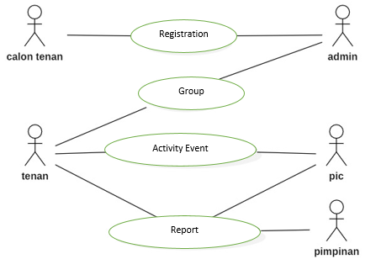
Fig 2. Business Use Case Diagram

Use case diagrams present interactions between use cases and actors. Where actors can be people, equipment or other systems that interact with the system being built. Use cases describe functionality with or requirements that must be met by the system from the user's perspective. In this usecase design there are 4 user use cases created, the first use case is the admin user where the admin has 9 use cases namely Use case managing user data, managing data groups, managing prospective tenancy data, managing aspect data, managing sub aspect data, managing poin data, manage tenan prospective value data, manage calculation results. The second use case is a lead user that has 3 use cases, namely, use case, see user, see group, view report. The third use case is a user pic that has 4 use cases, namely Use case, viewing tenants, managing projects, managing rab, managing reports. The needs of this information system will be utilized in many future times. use case diagram will make it easier in the future if there are improvements that can be said to be urgent or only a slight change in the system, from the Business Use Case diagram, can be passed on to the Use Case diagram, the two most basic diagrams are needed to conceptualize object oriented programming, and the last use case is the tenant user who has 1 use case, namely the Use case managing activities. Following is the use case diagram along with an explanation of this research :
In Fig 3 is a use case diagram of the information system run by the admin user. Use cases owned by the admin include:
1. Use case to manage user data.
2. Use case manage data groups.
3. Use case manage tenan prospective data.
4. Use case manage data aspects.
5. Use case manage data sub aspects.
6. Use case manage data weights,
7. Use case to manage data on prospective tenure.
8. Use case manage calculation results.
9. Use case manage question data.
More details can be seen in Figure 3 below :
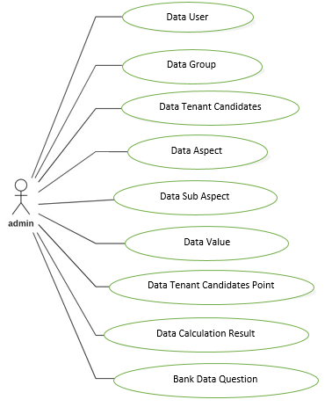
Fig 3. Use Case Diagram

In designing the database, stages will be carried out to identify entities, attributes, determine primary keys and foreign keys, relationships, and relationships between entities. These stages will be poured into the database modeling in the form of a CDM diagram and PDM diagram along with the details of filling the database to clarify the contents of each existing database attribute.
In Figure 4 the PDM (Physical Data Model) below explains the relationship or relations between tables where those who have relations with other tables will have a new field called the foreing key. Where this foreign key comes from the parent table primary key. Following relations that occur in this system :
- In the group table there are foreign keys from the PIC table and the member table.
- In the project table there are foreign keys from the PIC table, the member table, and the group table.
- In the rab table there is a foreign key from the PIC table and the project table.
- In the result table there is a foreign key from the registration table and the question table.
- In the question table there is a foreign key from the sub-aspect table.
- In the sub-aspect table there is a foreign key from the aspect table.
After the PDM is formed, it will be explained about each attribute in each table. The elaboration will explain the description and function of each attribute or field used along with examples of the filling data. Additionally, it will specify the data type that is used to store data from the field.
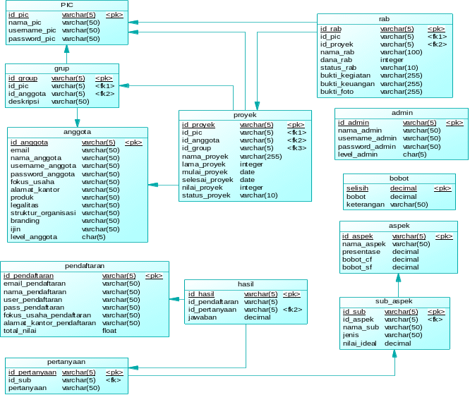
Fig 4. Phisycal Data Model

result
In this section, we present the system that we implemented to validate our approach. We also explain the results of a set of experiments conducted to test and prove the relevance of incubator business technopark.
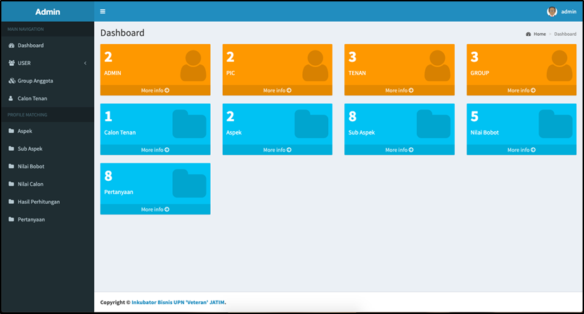
Fig 5. Dashboard Information System using Profile Matching
In Figure 5, the admin's main display consists of the user menu, group members, prospective tenants, aspects, sub aspects, weight values, candidate values, calculation results, and questions. This view can only be accessed by users who have admin authority on the system.
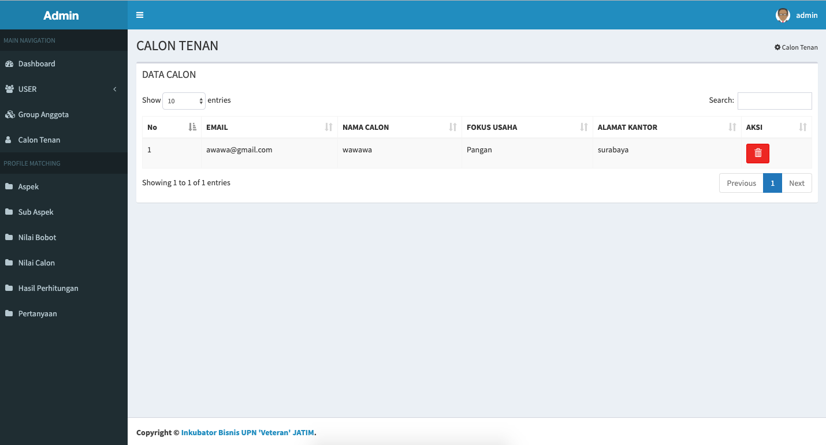
Fig 6. Data Tenant
In figure 6 is a display of management of prospective tenans. There are several fields that fill in the table, namely e-mail, name of candidate, business focus, office address and action in the form of erasing data. In this data the beginning of the calculation of all points in profile matching.
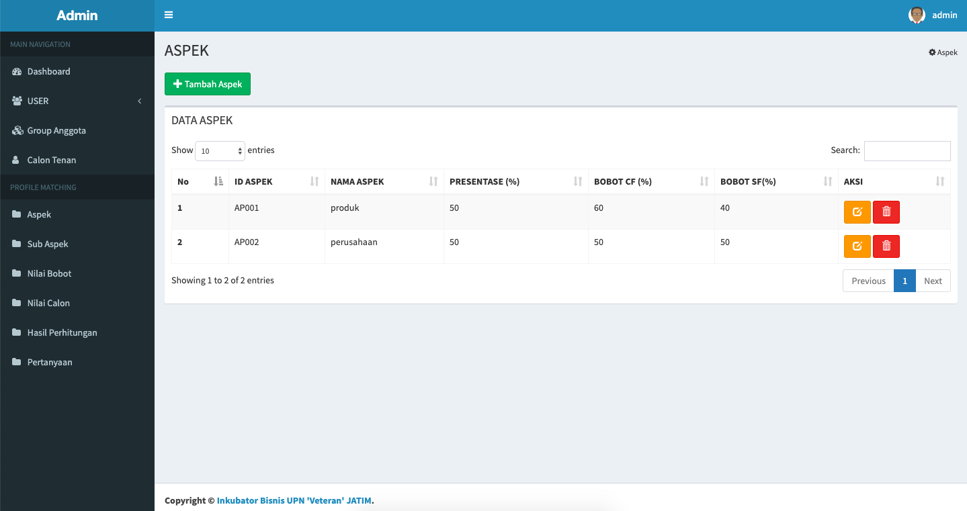
Fig 7. Data Aspect
In figure 7 is a display of managing data aspects. There is a table that contains several fields namely aspect id, aspect name, percentage, cf weight, sf weight and action in the form of edit and delete data. There is also a function added aspect above the table.
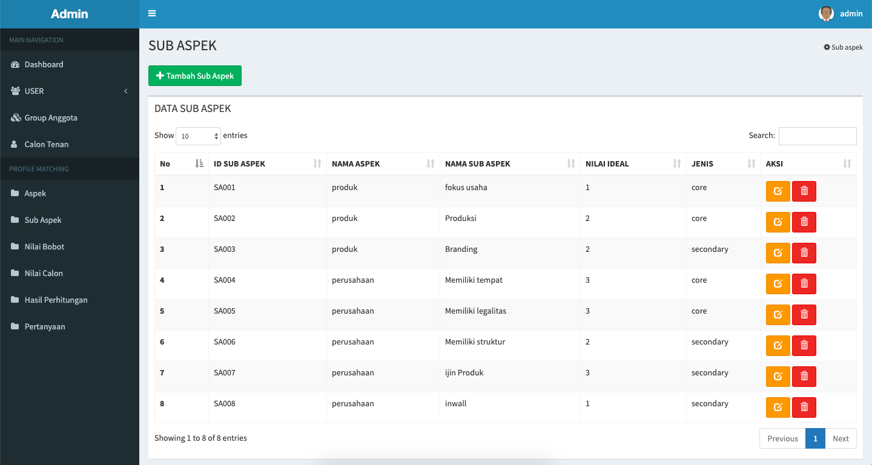
Fig 8. Data Sub Aspect
In figure 8 is a display of managing data aspects. There is a table that contains several fields, namely sub-aspect id, aspect name, sub-aspect name, ideal value, type and action in the form of editing and deleting data. There are also functions added sub aspects above the table.
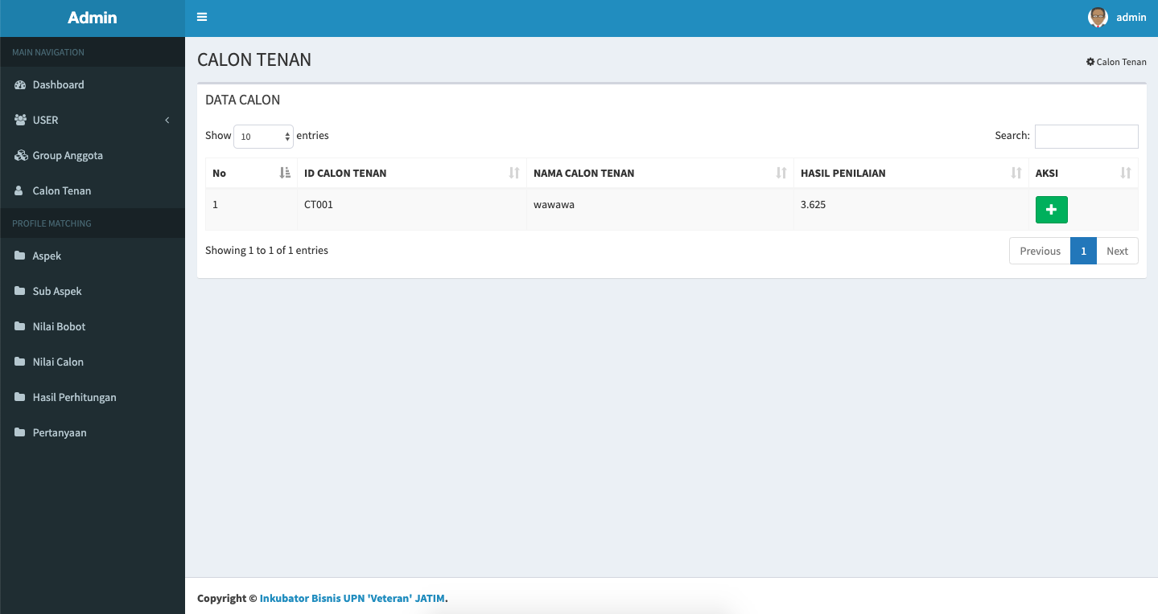
Fig 9. Data Result Tenant Using Profile Matching Calculation
In Figure 9 is a display of managing the calculated data. There is a table that contains several fields, namely the candidate's tenure, tenant's name, assessment results and action in the form of adding data that serves to add the tenant candidate with the best value.

conclusion
Implement Profile Matching method which is used to find the best tenant candidates based on predetermined criteria. That way it will be easy to select prospective tenants and the admin will also get tenan recommendations from this method.
The value in the number_poin or scor column is then compared with the value in table R according to n, which is 30. But in this case, the R table used uses the formula n-2. Thus, n = 28. The value of table R with n = 28 with a significant level of 5% is 0.3061. Following are the results of the validity test recapitulation shown in the following table:
- table Uji Validitas
Nomor Soal | r_{xy} | rtabel 5% (28) | Keterangan
1 | 0.412 | 0.3061 | VALID
2 | 0.561 | 0.3061 | VALID
3 | 0.452 | 0.3061 | VALID
4 | 0.360 | 0.3061 | VALID
5 | 0.358 | 0.3061 | VALID
6 | 0.561 | 0.3061 | VALID
7 | 0.615 | 0.3061 | VALID
8 | 0.465 | 0.3061 | VALID
9 | 0.634 | 0.3061 | VALID

References
- A. Bahrami Object oriented systems development : using the unified modeling language, Mc-Graw Hill, Singapore. (1999).
- Audretsch, D. B. (2007). The entrepreneurial society. New York: Oxford University Press.
- D. J. Power, Decision Support Systems : Concepts and Resources For Managers, USA: Greenwood, 2002.
- D. J. Power, "Evaluation: From Precision, Recall and F-Measure to ROC, Informedness, Markedness & Correlation," Journal of Machine Learning Technologies, pp. 37-63, 2011.
- E. Turban, Decission Support Systems and Intelligent Systems, New Jersey: Pearson Education, 2005.
- J. Gutierez, Escalona M.J. and Torres M.M. An Approach to Generate Test Cases from Use Cases, Proceedings of the 6th International Conference on Web Engineering. pp. 113-114 (2006).
- Link, A., & Siegel, D. S. (2007). Innovation, entrepreneurship, and technological change. Oxford: Oxford University Press.
- Mian, S., Fayolle, A., & Lamine, W. (2012). Building sustainable regional platforms for incubating science and technology businesses: Evidence from US and French science and technology parks. International Journal of Entrepreneurship and Innovation, 13(4), 235–247.
- Mian, S., Lamine, W., & Fayolle, A. (2016). Technology business incubation: An overview of the state of knowledge. Technovation, 50–51, 1–12.
- Purwanto, H. (2017). Penerapan Metode Profile Matching Dalam Sistem Pendukung Keputusan Penilaian Kinerja Karyawan Pada Pt. Hyundai Mobil Indonesia Cabang Kalimalang. Jurnal Techno Nusa Mandiri, 14(1), 15–20.
- Rational. (2003). Mastering Requirements Management with Use Cases, Rational Software, IBM.
- Smith, D. J., & Zhang, M. (2012). ). Introduction: The evolution of the incubator concept. Special Issue: technology incubators—promoting science businesses? International Journal of Entrepreneurship and Innovation, 13(4), 227–234.
- Smilor, R. W., & Gill, M. D., Jr. (1986). The new business incubator: Linking talent, technology, capital, and know-how. Toronto: Lexington Books.
- Ukem, E. et al. (2012). A software application for university students results processing. Journal of Theoretical and Applied Information Technology, Vol. 35 No.l:10.

