Planning Of Solar Power Plant With On-Grid System At The Fourth Building University Of PGRI Semarang

Adhi Kusmantoro
department of electrical engineering
University Of PGRI Semarang
Semarang, Indonesia
adhiteknik@gmail.com

Abstract—The on-grid system is a system that is used by PLTS directly connected to an existing electricity grid (PLN). Therefore, the on-grid system does not use a battery storage system or supercapacitor. By using this on-grid system, the community has helped the government in reducing PLN's electricity burden. The main objective in this study was to plan an on-grid system using photovoltaics in the four buildings of the University of PGRI Semarang. The research method carried out in the study was collecting data as supporting research including hourly electric load identification data and on-grid system inverter and photovoltaic specifications used, determining the amount of power to be generated in the on-grid system, calculating the number of solar panels will be used, determine the arrangement of solar panels. Based on the load data of Building four, it can be planned to have a capacity of 200 Wp solarland monocrystaline solar panels 166 units of PV modules. In the installation of PV modules there are connected in series or parallel and depending on the size of the on-grid inverter input voltage used. Based on the Sunny Tripower 60 inverter specifications, the inverter input voltage is 685 V to 800 V DC. Based on the calculation of the PV area, a value of 254.19 m² was obtained. If the strings are arranged then the total power generated by the PV area is 33.15 KWP. The choice of location is based on the consideration that the solar panel faces north with a slope angle of 17.45⁰ and is close to the building installation room.
Keywords— PV Area, On-Grid Inverter, System, PV Slope

Introduction
The position of the sun can be known by the observer's knowledge of latitude and longitude, besides the time and date of observation. The difference in latitude and longitude of an area will affect the potential of solar energy in the area, therefore to obtain optimal solar energy there are two things that must be considered, namely the elevation angle and the azimuth angle.[6] Electricity in residential homes is on average supplied by PLN electricity so that electricity in residential homes can have mandri electricity so a renewable alternative power source is needed to help supply electricity. The potential for developing solar energy in Indonesia is very promising in view of Indonesia's geographical location on the equator. Java island has solar energy potential of 4.47 kW / m² / day.
The use of renewable energy sources for electricity generation has increased in line with the increase in electricity consumption. With the reduction of non-renewable energy sources and maintaining the continuity of future energy sources, the use of renewable energy sources for the electrical energy system is a concern. Among the various types of renewable energy sources, solar PV systems are very suitable for a system of electrical energy sources and connected to the grid. [8] With the increase in the use of electricity and with the reduction in fossil fuel resources, the cost of electricity will be increased and the use of fossil fuels will cause negative impacts on the environment. Renewable Energy Sources (RES), solar energy is the best choice for reducing dependence on fossil fuels to produce electricity because they are clean and environmentally friendly. Solar energy sources have disadvantages because they cannot meet the demand for the load that is needed at any time because it changes with changes in solar irradiance. [5] Much research has been done in the field of power converter design to produce semiconductor circuits and fewer passive elements, thereby reducing the overall cost of the circuit. In a study, to produce AC output two separate inverters were used. The inverter is connected in parallel to two loads. However, the weakness of this method is that it requires a lot of interfaces and a lack of control over each load. [10,12]
Renewable energy as an alternative to overcome the shortage of fossil fuels. Renewable energy sources, solar energy, are converted into electrical energy using Photovoltaic (PV) panels. Many solar panels are installed for use in homes. DC power generated from solar panels is not always the same every time. A DC-DC converter or DC-AC is needed before the solar panel provides a source to the load or is connected to the electricity network. Energy storage is needed to save more power on the network and can be burdened during the time there is solar radiation. A design converter model has been developed for multilevel converters that work in parallel. This converter can be used for off-grid systems. Some studies have combined different converters to improve system performance.[7,13] A study developed an inverter system to meet energy needs in a region. This is done by collecting solar radiation; turn it into electrical energy which is a new source of electrical energy for load use. [1,11].

Photovoltaic
An increase in PV temperature higher than normal temperature will reduce the open circuit voltage (V_{oc}). Each increase in temperature of PV 1 ⁰C from 25 ⁰C will cause a reduction in power of about 0.5% of the total power produced. [9] PV power which decreases when the temperature of a solar panel increases t ⁰C from its normal temperature can be calculated using equation 1:
P_{on the diff t ⁰C} = [(0.5%/⁰C) x P_{mpp} x t ⁰C (1)
The maximum output power of solar panels when the temperature rises to t ⁰C from the standard temperature is calculated by the equation:
P_{mpp on the diff t ⁰C} = P_{mpp} – P_{on the diff t ⁰C} (2)
Installation of solar panels is very easy and requires little cost.[2] The slope angle in a location based on the angle of the sun altitude at a location in a time can be searched by the equation:
β_{N} = 90⁰ - L+/-δ (3)
Tlit = 90⁰ - β_{N} (4)
The size of the tilt angle is generally located between the maximum tilt angle during the winter solstice (δ = 23 ⁰) dan summer solstice (δ = -23 ⁰). Fix tilt angle can be calculated based on the average tilt angle value during winter solstice and summer solstice, as follows:
Fix Tlit angel (TA) = (TA _{winter} – TA _{summer}) : 2 (5)
Based on the exposure of the factors that influence the energy generated by solar panels, the capacity of solar panels is needed in a plan
P(WP) = E_{L} : PGF (6)
PGF = CE x Avrg Solar Panel
Furthermore, based on the magnitude of the panel power requirements to be generated (P Wp), the number of solar panels needed can be calculated by equation 8:[3]
Number of Solar Panels = P_{WP} / P_{mpp} (7)
The amount of energy in a PV array depends not only on the energy emitted by sunlight, but also on the position of mounting a PV array. When PV arrays are perpendicular to sunlight, the maximum power density will be on the surface of the PV array, so that two PV arrays are mounted on the roof of the house with a 45⁰ position in different directions to obtain maximum sunlight power density at two different times of the day . The first PV array is at position 45⁰ facing east (PV-E) and the second PV array is at position 45⁰ facing west (PV-W) as shown in Figure.4. The relationship between the amount of solar radiation on the surface of PV and solar radiation on a horizontal surface, the maximum solar radiation measured perpendicular (Sincident), shown in figure 1.[4] The value of Shorizontal, SPV and Sincident can be calculated by (8) and (9) :
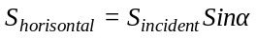 (8)
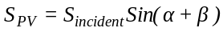 (9)
Where α is the sun elevation angle and β is the tilt angle of the PV array measured from the horizontal plane.

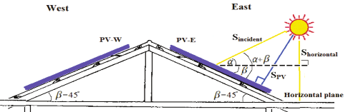

Fig. 1. The two PV arrays installed on a gable house roof of a PV array tilt angle β= 45.

Research Methods
- Collecting data as a supporter of research that includes data on identifying electrical loads in a span of three months.
- Determine the amount of power that will be generated by PLTS by calculating the string area and calculating the amount of electricity used in the building.
- Calculating the number of solar panels to be used, choosing the type of solar panel products and calculating the number of solar panels based on specifications.
- Determine the capacity of the inverter used by calculating the Pmpp value and choosing the type of inverter product.
- Establish the arrangement of solar panels, review the location of the solar panels, calculate the maximum value of the sun and determine the slope of the PV module.
The process of designing and building an alternative power plant provider system to help supply electricity to the University building in PGRI Semarang can be explained through a flow diagram in figure 2.
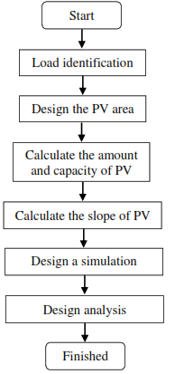
Fig. 2. System design flow chart.

Results And Discussion
Based on the measurement results of the four building electricity at the University of PGRI Semarang in a span of 3 months, from 1 August 2018 to 31 October 2018, it shows that the highest electricity consumption in the building on 13 September 2018 is 140,812 KWh, this data shows the actual peak load in the building.

Calculation Of PV Capacity
Indonesia is a tropical country that has considerable solar energy potential. Based on the intensity data of solar radiation in Indonesia, data were obtained with distribution in the Indonesian Western Region (KBI) of around 4.5 kWh / m² / day and in Eastern Indonesia (KTI) around 5.1 kWh / m² / day. Thus, the potential intensity of average solar radiation in Indonesia is 4.47 kWh / m² / day. The results of calculating the PV area are used to calculate the string area and calculate the electrical energy to be obtained, by performing the following calculations:
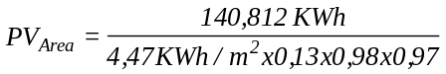
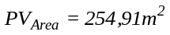
Based on the calculation of the PV area, a value of 254,91 m² is obtained, the value of which is the area of PV needed to generate electrical energy needs. The area of PV is sufficient to be installed at a location of 643,04 m². Therefore the power to be generated based on the calculation of the PV area is calculated as follows.
P_{Watt Peak} = 254,91 m² x 1000 W/m² x 0,13
P_{Watt Peak} = 33,138 KWP
Based on the calculation of the PV area, solar panels with a capacity of 200 WP of Solarland monocrystaline will be used. The need for the number of solar panels can be determined as follows.
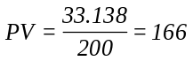
The number of solar panels needed is 166 which will be divided into 3 strings with each string having 55 solar panels which will be arranged in series and parallel. Each planned string will produce power of 11,05 KWP, if 3 strings are arranged then the total power generated by the PV area is 33,15 KWP.

Calculation Of Panel Slope
In the PV installation process the area requires precision in determining the slope angle of the solar panel, this is needed so that the solar panels get optimal sunlight for the four buildings of the University of PGRI Semarang. The slope of the solar panel at the location in building four (6°58'58.1"S 110°26'55.1"E) is as follows :
α = 90⁰ + lat – δ
= 90⁰ + 06⁰ - 23,45⁰
= 72.55⁰
β = 90⁰ - α
= 90⁰ - 72,55⁰
= 17,45⁰
So the maximum solar panel slope is 17,45⁰. The choice of location is based on the consideration that the solar panel faces north with a slope angle of 17,45⁰ and is close to the building installation room. The location of this solar panel placement plan covers the needs of a large area of PV area of 254.91 m².

Fig. 3. Location of planning for solar panel placement.

On-Grid Simulation Model
After the planning calculation, a simulation model can be carried out to determine the performance of the system to be built. The simulation model uses the simulink Matlab shown in figure 4.
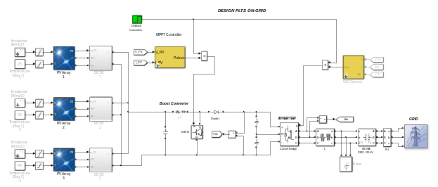
Fig. 4. On-grid system simulation model.
The number of strings and the number of solar panels used in accordance with the planning, the intensity of solar radiation used is 1000 W / m² with different temperatures for each string. In the simulation model multiple DC converters are used.
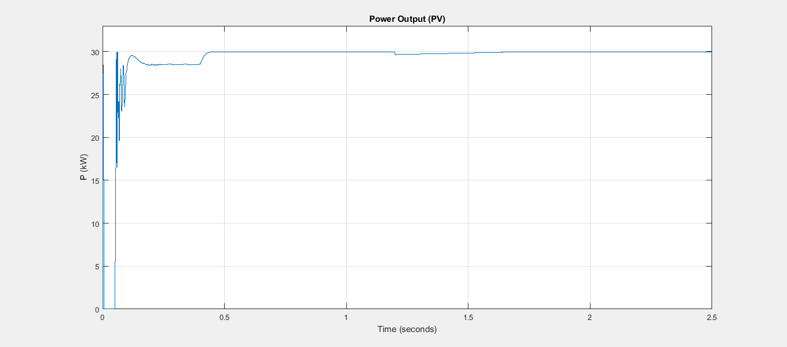
Fig. 5. PV output power (1000 W / m², 25 ⁰C).
Figure 5 shows the test results of PV power output with an irradiance of 1000 W / m² and a temperature of 25 ⁰C resulting in a power output according to the plan. While Figure 6 shows if irradiance is lowered at 700 W / m² it will affect the amount of PV output power.
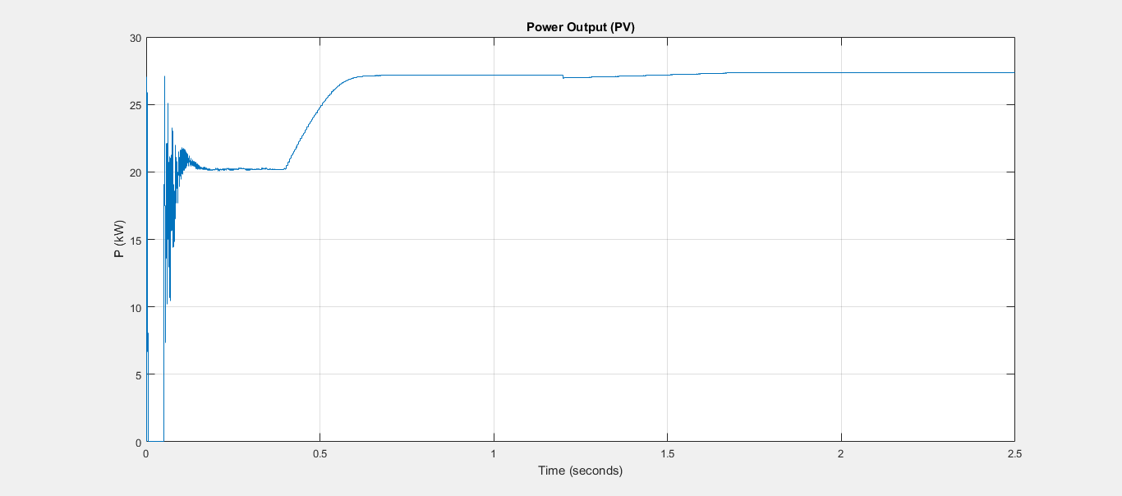
Fig. 6. PV output power (700 W / m², 25 ⁰C).
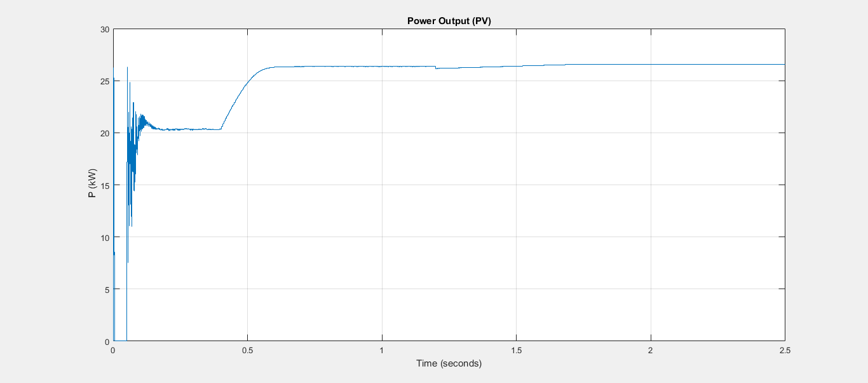
Fig. 7. PV output power (700 W / m², 35 ⁰C).
If the temperature rises to 35 ⁰C does not cause too much change in PV output power, this is shown in figure 8. The DC voltage generated by the boost converter and is the input voltage of the inverter shown in figure 9, which is 350 V DC.
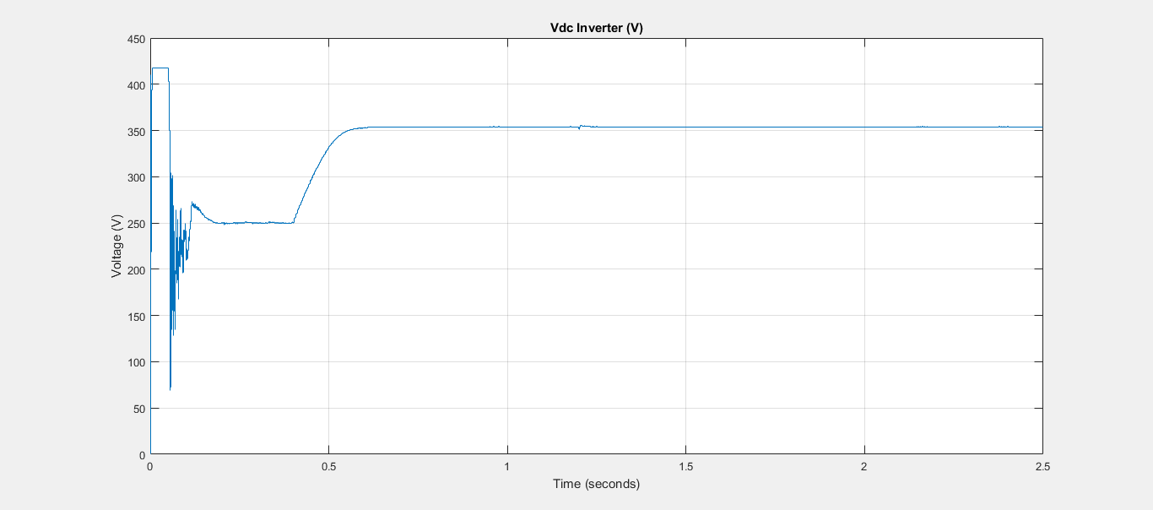
Fig. 9. Input inverter voltage.
The DC voltage from the boost converter is converted to a three phase inverter into AC voltage with 380 V AC amplitude. The output voltage of the inverter is connected to a three phase grid, shown in figure 10, while the load current is shown in figure 11.
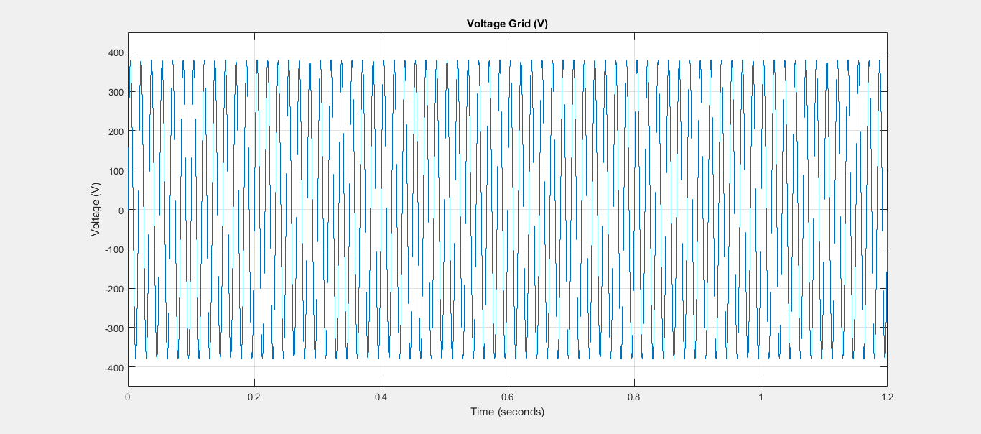
Fig. 10. The inverter's output voltage is connected to the grid.
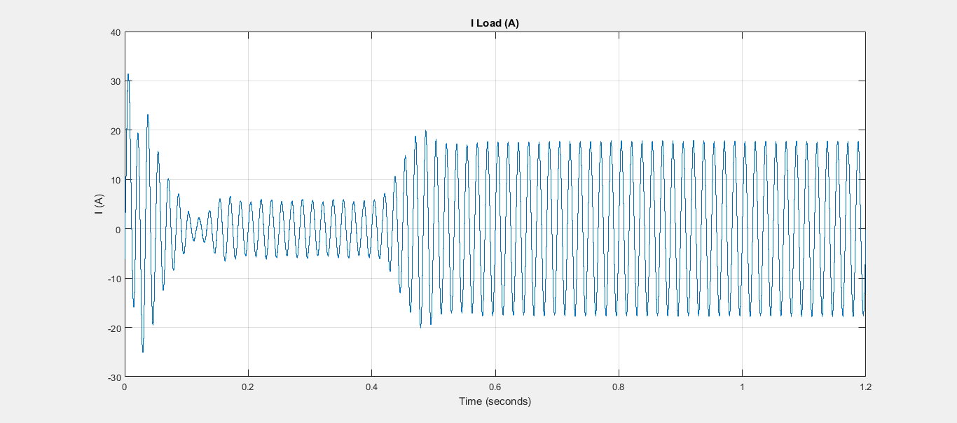
Fig. 11. Load current connected to the grid.

Conclusion
The design of a photovoltaic power generation system using on-grid inverters can only be used during the day, while this system can reduce electricity loads and PLN electricity payments. Based on the four building load data of the University of PGRI Semarang, it can be planned that the capacity of 200 Wp monocrystaline solar panels is 166 solar panels connected in series and parallel. In planning it is divided into three strings. Based on the calculation of the PV area, a value of 254.19 m² was obtained. The number of solar panels needed is 166 which will be divided into 3 strings with each string having 55 solar panels which will be arranged in series and parallel. Each planned string will produce power of 11,05 KWP, if 3 strings are arranged then the total power generated by the PV area is 33,15 KWP. The maximum solar slope angle is 17.45⁰ and the slope is facing north. The location of this solar panel placement plan covers the large area of ​​PV area of ​​254.91 m². Based on the simulation results, the PV output output is in accordance with the plan output voltage and load current on the grid.

Acknowledgment
The authors would like to thank LPPM University Of PGRI Semarang, who has provided funding for research and development of renewable energy.

References
- Chitra L., “Analysis And Simulation Of Standalone,”, International Conference on Innovations in information Embedded and Communication Systems (ICIIECS), 2017.
- Lawrence K. Lettinga, “Dynamic performance analysis of an integrated windphotovoltaic microgrid with storage”, International Journal of Smart Grid and Clean Energy, 2013.
- Junkai Zhao, H. H. C. Iu, and T. Fernando, “A Design of Single-Switch Two-Stage DC-DC Converters With PWM And PFM for Off-Grid Solar Power System,” vol. 3, no. 3, 2017.
- Monaaf D. A. Al-falahi, M. Zamri, and C. Wanik, “Modeling and Performance Analysis of Hybrid Power System for Residential Application,”, IEEE, 2015.
- Manxin Chen, H. Tan, J. H. F. Ho, and E. K. W. Cheng, “A Simple and Useful Three-Port Converter for Integrating Renewable Energy Sources in Stand-Alone Systems,” pp. 1–6, 2016.
- Pervez Hameed Shaikh H. Shaikh, T. Jan, and A. A. Baloch, “Performance Analysis of Wind – Photovoltaic – Battery based DC Microgrid Setup for off – grid Applications.”, IEEE, 2017.
- P. Janiga, M. Liška, A. B. E. L. Áň, V. Volčko, and M. Ivanič, “Power quality measurement of small solar off-grid system,”, Wseas Transactions on Enviroment and Development, vol. 11, pp. 49–56, 2015.
- Rajib Baran . Roy, E. Basher, and R. Yasmin, “Fuzzy Logic Based MPPT Approach In A Grid Connected Photovoltaic System,”, IEEE vol. 1, no. 1.
- Ranjini. B.R., I. Omsekhar, G. Nayak, “Design and Control of Power Converter for LED Lighting Driven from the PV Module,”, International Conference on Intelligent Computing,Instrumentation and Control Technologies (ICICICT), pp. 61–67, 2017.
- Saeed yousofi-Darmian, "A New Compact On And Off-Grid Inverter For Photovoltaic Applications, IEEE, 2017.
- Stefanos Saridakis, “Optimal Design of Modern Transformerless,”, IEEE Transactions On Energy Conversion, vol. 28, no. 2, pp. 394–404, 2013.
- Shohei Mita and H. Sekiya, “Analysis of class-D ZVS inverter with asymmetrical duty-cycle control for wireless power transfer applications,”, IEEE, pp. 0–4, 2018.
- Vishnu C. Syamkumar, “Time Shared Buck and Boost Converter based H-Bridge Inverter for Grid Tied and Standalone Applications,”, IEEE, pp. 1259–1264, 2017.

