Smart Parking System using Android and QR Code for Widyatama University

Yuqbal Faza Aula Dipa
Information System Department
Widyatama University
Bandung, Indonesia
yuqbal.faza@widyatama.ac.id
Dani Hamdani
Information System Department
Widyatama University
Bandung, Indonesia
dani.hamdani@widyatama.ac.id

Abstract—With so many vehicle users, a new problem arises, namely the unorganized parking lot with the lack of a proper parking management system. These create various problems for vehicle users who want to park their vehicles, such as losing much time to find an empty parking space, besides that a manual parking payment system can result in long queues at payment counters and this happened at Widyatama University because it needs the right solution to overcome these problems. With the concept of a smart parking system that uses the QR Code for user convenience. This system can run on cellular platforms with a visual display that makes it easy for users. Besides, users can reserve a parking space before parking their vehicle. With additional features of the automatic payment system (E-money). This system can streamline time and efficiency. The research method was carried out using a prototype method in the method of making the system a structured process and has several stages that must be passed. Therefore this method aims to design cellular applications, "Parkirin Aja!".
Keywords— Smart Parking, Android, QR Code, E-money.

Introduction
Transportation is an essential requirement for human life. The development of transportation every day is very rapid, especially an increase in the number of private vehicles that are increasingly in line with population growth. Data from the Indonesian National Police Traffic Corps noted that the number of vehicles that were still operating throughout Indonesia in 2013 reached 104,211 million units, up 11% from the previous year (2012) of 94,299 million units[1].
The increasing population of each city in Indonesia has an impact on the high frequency of activities in the city center, such as places of study or school and university education, as well as higher demand for transportation services. With the increasing number and development of land transportation facilities as well as the increasing number of locations of activities of the population, which are scattered in various places, the need for more extensive parking places. The reason is that most people use vehicles. Besides congestion, problems also arise in the provision of parking lots. The problem with parking is that many vehicle users park their vehicles, not at the designated place. This causes the narrowing of the road so that it often causes congestion, a specified event.
The problem of parking is critical to be studied more deeply because almost all activities in open space activities require parking facilities. The required parking space must be adequately available. Because the more significant the volume of traffic that has a good activity leaving or going to the center of activity, the higher the need for parking spaces, this vehicle is one of the causes. Therefore parking lots must be available at various centers of activity. Besides that, a suitable arrangement of parking lots is significant to apply because a chaotic parking arrangement will cause various problems. For example, finding a parking space at Widyatama University on weekdays is very difficult. Drivers lose time searching for empty parking spaces. This can be very frustrating for all drivers, especially drivers who are in a hurry. Vehicle owners sometimes forget where the vehicle is parked, and the parking system does not use useful parking mapping or even use a parking identity. These conditions can have an impact on the wasted time of the vehicle owner. Besides other problems, the parking ticket payment system that is manual uses tickets and regular payments — resulting in long queues at the payment counter that also took up a considerable amount of time.
This problem can be avoided if there is a parking system that can help drivers such as proper parking mapping, so that drivers no longer search for parking spaces and can help drivers who forget where their vehicles are parked. Also, an automatic payment system is needed so that no longer long queues take up time.
In previous studies, there have been several journals that use the Android application as a Smart Parking application to solve the solution. Among these are "IoT based Smart Parking System," "Android Based Smart Parking System Using Slot Allocation & Reservations."
However, the authors developed the previous research by using the QR Code system on the application of the system with digital payment features and hoping to help the driver save time and create a well-organized parking system.
Following the stated research objectives, the suitable method for use is the prototyping method in the process, so that it is expected to be an alternative in the design and development of applications. By using the prototyping method, there are several advantages of the method, if the scope of the research is not based on direct user experience, so enter according to what is needed from the user. With this method, there is reciprocity to help in the process of future development.
Therefore in this study, the author took the title, namely "Smart Parking System Using Android and QR Code for Widyatama."

Literature Review

2.1 Discussion of Relevant Research Theory Results
In previous studies, there have been several journals that use the android application as a Smart Parking application. Among these are:
1. Research by Dony Susandi, Wawan Nugra-ha, and Sandi Fajar Rodiansyah, entitled "Perancangan Smart Parking System pada Prototype Smart Office Berbasis Internet of Things" in this study, is more focused on designing smart parking on pro smart offices by relying on the Internet of things (IoT). Part of the IoT technology used is the Arduino Mega 2560 microcontroller and raspberry pi. in this study, in making its application using the teaching method used is the waterfall method. While what distinguishes the research they do with researchers is that there is no QR code mapping on the parking lot provided for scanning the QR code to do the parking transaction [2].
2. Research by Dikki Zulkarnain and Engelin Shintadewi Julian entitled "Perancangan Sistem Parkir Dengan Rekomendasi Lokasi Parkir" in the study, researchers gave a recommendation for parking locations using a microcontroller and sensors as information providers. This research system does not apply to public facilities because this research is more applicable to private or registered parking. What makes the difference between their researchers is that in their study, there is no application as information for users, while the researchers used an android application-based parking system [3].
3. Research by Arfan, Sumardi, and Munawar Agus Riyadi entitled "Sistem Smart Parking Terdistribusi Dengan Menggunakan Mobile Cloud Computing" in the research they were working on, they chose a parking system with a mobile cloud computing research method. In their research, the designed application can see the parking bag in the office area mapping in the form of the Dijkstra algorithm by providing recommendations for the parking bag to the user. What distinguishes it from researchers is the parking system used is for the Widyatama university campus by using the QR code as a parking ticket. Moreover, using Android-based applications as a medium [4].
4. Research by Dody Ichwana, Ratna Aisu-Warya, Styviandra Ardopa, and Indah Purna-ma, entitled "Sistem Cerdas Reservasi dan Pemantauan Parkir pada Lokasi Kampus Berbasis Konsep Internet of Things." in this study applying the IoT technology method by developing a parking reservation and monitoring system using NFC. Moreover, what distinguishes between their research with researchers is that in their research, the smart parking system used is for parking reservation bookings. While what the researchers are doing is smart parking systems with QRcode parking tickets with automatic parking spot selection [5].
5. Research by Ridho Rinaldi Erpa, Wiwik Wiharti & Ihsan Lumasa Rimra, entitled "Sistem Parkir Pintar (Menuju Smart Campus Dengan Internet of Things)" in their research, the system is made in the form of a website-based system. The system uses IoT technology using a raspberry pi micro-controller, and camera sensor. While the difference is that the system created by researchers is an android-based system using QRcode [6].

Literature Review

Android
Android is a software operating system for mobile devices, which includes middleware¸ and the core application released by Android is a mobile operating system. Android licenses are Open Source. This android operation gets full support from Google. The journey of Android began in October 2003 when 4 IT experts, Andi Rubin, Rich Minner, Nick Sears, and Chris White, founded Android.Inc, in California, US. Android's vision is to realize mobile devices that are more sensitive and understand their owners[7].

Smart Parking
Smart Parking is a vehicle parking management and management system that is applied in parking lots by providing information in real-time by integrating on a system that can be accessed through networks and platforms in the hope that the system will become one of the solutions to help parking problems.

Android Studio
Android Studio is an Integrated Development Environment (IDE) specifically for developing android applications that are open source. This Android studio has developed Intellij IDEA, an IDE for the Java programming language. Android studio is integrated with (SDK) or Android Software Development Kit to distribute to Android devices. The programming language used by Android Studio is Java [8].

XML
XML stands for eXtensible Markup Language, which is used as a language markup language for exchanging data between diverse systems. The XML describes the arrangement of information and focuses on how information looks. XML can store data both in attributes and contents as elements that are placed between the opening and closing tags [9].

JSON
JSON is an abbreviation of (JavaScript Object Notation) in the form of a data exchange language format that is easy to read and write by humans, with made and made it easy to translate by computer. JSON is a text format that does not depend on any programming language because it uses the style of language commonly used by programmers. JSON provides better performance compared to XML [10].

API
Application Programming Interface (API) is a liaison application with other applications that allow programmers to use system functions that can interact and relate to each other. The API consists of interfaces, functions, classes, structures, and so on to build and develop software [11].

REST Representational State Transfer)
REST (Representational State Transfer) is one type of architecture that is often applied in web-based development. This REST can be used as an API interface to process all resources. HTTP commands that can be used in REST are Get, Post, Put, and Delete functions. Rest is more widely used in resource-oriented web services [12].

Google Firebase
Firebase is a realtime database with backend infrastructure services as a service (BaaS) that facilitates device developers who build better applications. Firebase has several features such as Analytics, Cloud Messaging, Authentication, Realtime Database, Storage, Hosting, Test Labs, Accident Reporting, Notifications, Remote Configuration, Application Indexing, Dynamic Links, Invitations, Adwords, and Admob[13].

UML
UML is a language that visualizes and analyzes from an OO (Object-Oriented) software development system. It is also modeling used to determine or describe a software system. The primary purpose of UML diagrams is to help the project team communicate, export potential de-design, and validate the design of the software architecture [14].

QR Code
QR Code (Quick Response Code) is a two-dimensional barcode that can store data. Bigger compared to Barcodes. By using QR Code, data that can be stored can be in the form of numbers, letters, binaries, and kanji. QR Codes can be used free of charge, even for commercial purposes. The Qr Code was first introduced by the Japanese company Denso Wave in 1994. The QR code was intended to be translated quickly. Qr code is also one type of barcode that can be read with a mobile camera [15].

methodology
This method explains the research and data collection techniques to design an application that is "Parking." At this stage, the system development process method is carried out in a structured manner and has several stages that must be passed, such as data collection techniques and software development methods.

Data Collection Technique
Data collection techniques used by authors are:
1. Literature Study
At this stage, the researcher looks for relevant theory references and collects several journals with issues related to the author's title.
2. Observation
The author makes direct observations of the activities related to the problem taken by aiming to obtain complete data.

Software Development Method
At this stage, the researcher uses the prototype method used to get an overview of the application that will be designed and will be evaluated by the user. With that, the author can get a complete picture of the display system or system engineering procedures that will be built.
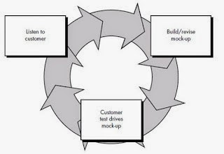
Fig. 1. Prototype Paradigm Model

Listen to Customer
Developers and customers together determine the general objectives and identify all the needs and description of the parts needed and desired in the application or system to be made.

Build/revise mockup
The design is done quickly, and the design represents all aspects as needed, and this design is the basis for making a prototype.

Customer Test Drives Mockup
In this process, the customer will evaluate and evaluate the prototype created to clarify the needs of the application following the primary purpose.

Discussion

Listen to Customer
At this stage, the researcher collects needs using a study of literature, which is by looking for theoretical references that are relevant to the problems found. Researchers look for references through journals and sites on the internet. The aim is to strengthen the problem as a theoretical basis for designing an application, "Parkirin Aja!". In addition to the study of literature, researchers also conducted observation by direct observation of the smart parking system in the city of Bandung, especially in shopping centers such as Mall Paskal 21 and Istana Plaza Bandung Mall, intending to obtain more complete information data.

Build/Revise Mockup
From observations and results see references that have been
done, researchers make a temporary picture of the application to be made. At this stage includes the decryption of actors, the design of use case diagrams, the design of activity diagrams, the design of sequence diagrams, the design of class diagrams, and the design of the user interface "Parkirin Aja!".

Actor Description
The actor's description is an explanation of what is involved in a system that will be built. The following is a description of the actors involved:
TABLE 1. Actor Description
No | Actor | Description
1 | User | The user is the person who will use the application. Users can book parking and view information about parking. Besides, users can make automatic payments using e-money, can add e-money balances. Users can also scan QR code tickets.
2 | Admin | Manage user data and parking data on Firebase.

Use Case Diagram
Use case diagram is an interaction between one or more actors with the system to be created. Moreover, to find out the functions that are in the application, "Parkirin Aja!".

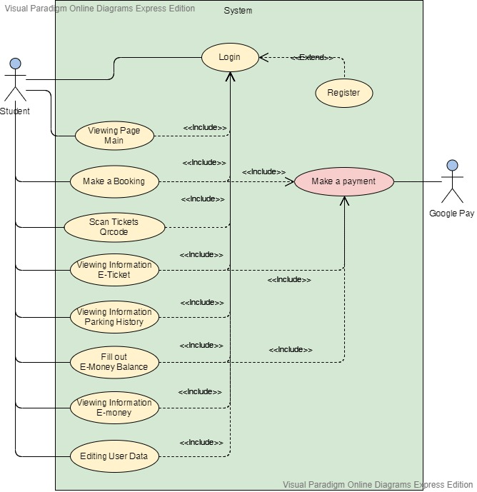
Fig. 2. Use Case

Activity Diagram
After the use case diagram is created, the next step is to describe the process that occurs, namely, to make the activity diagram as follows:
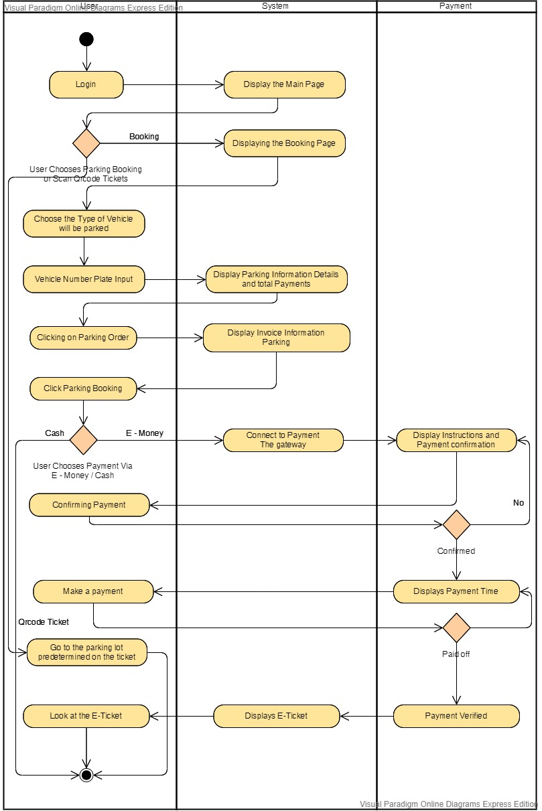
Fig. 3. Activity Diagram

Sequence Diagram
In this sequence diagram illustrates the interaction between objects and indicates communication between these objects. 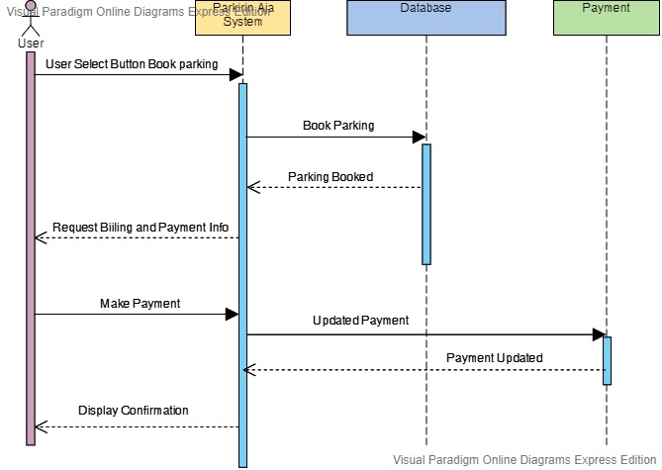
Fig. 4. Sequence Diagram

Class Diagram
In this class, the diagram illustrates the classes in a system and the relationship between one another.

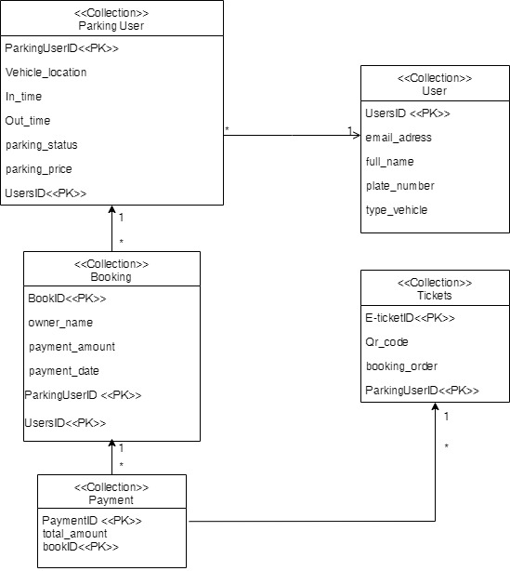
Fig. 5. Class Diagram

User Interface
Here are some pictures of the user interface display in the application "Parkirin Aja!"

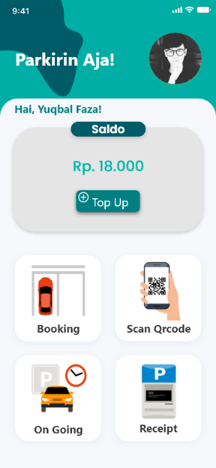
Fig. 6. Home Screen

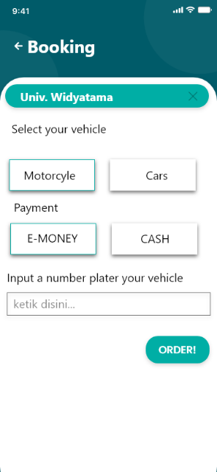
Fig. 7. Booking

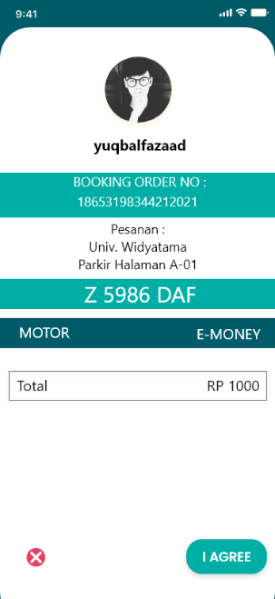
Fig. 8. Booking Order

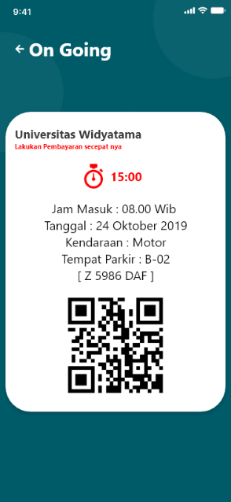
Fig. 9. E-Ticket Parking

Customer Test drives Mockup
Mock-ups that were designed are following user needs. However, some things need to be added to the design, such as the addition of the booking feature according to the slot where the user wants it because the system created by the user cannot book the place according to the user's wishes.

V. Conclusion
The conclusion that can be drawn from the results of research that has been done is that the application of "Parkirin Aja!" It can streamline time and efficiency for vehicle drivers, especially Widyatama universities. Besides that, it can maximize the parking space with useful mapping and can provide parking information for the driver. With the addition of the system features, automatic payment methods or e-money also adds to the ease of the driver to pay for parking. With the use of the mobile system in the application "Parkirin Aja! It can provide convenience for drivers to park their vehicles.

References

[1] Kurniawan, “Jumlah Kendaraan di Indonesia Capai 104.211,” tribunnews, Indonesia, Nov-2014.
[2] D. Susandi, W. Nugraha, and S. F. Rodiyansyah, “Perancangan Smart Parking System pada Prototype Smart Office Berbasis Internet of Things,” Tek. Ind. dan Tek. Inform. Univ. Majalengka, no. November, pp. 1–2, 2017.
[3] D. Zulkarnain and E. S. Julian, “Perancangan Sistem Parkir Dengan Rekomendasi Lokasi Parkir,” JETri J. Ilm. Tek. Elektro, vol. 14, no. 2, pp. 17–28, 2017.
[4] M. Arfan, Sumardi, and M. A. Riyadi, “Sistem Smart Parking Terdistribusi dengan Menggunakan Mobile Cloud Computing,” JTET (Jurnal Tek. Elektro Ter. Polines, vol. 6, no. 3, pp. 95–99, 2017.
[5] D. I. Putra, R. Aisuwarya, S. Ardopa, and I. Purnama, “Sistem Cerdas Reservasi dan Pemantauan Parkir pada Lokasi Kampus Berbasis Konsep Internet of Things,” J. Teknol. dan Sist. Komput., vol. 6, no. 2, p. 57, 2018, doi: 10.14710/jtsiskom.6.2.2018.57-63.
[6] R. R. Erpa, W. W. -, and I. L. Rimra, “Sistem Parkir Pintar (Menuju Smart Campus dengan Internet of Things),” J. Ilm. Poli Rekayasa, vol. 14, no. 1, p. 66, 2018, doi: 10.30630/jipr.14.1.112.
[7] H. N. Lengkong, A. A. E. Sinsuw, and A. S. M. Lumenta, “Perancangan Penunjuk Rute Pada Kendaraan Pribadi Menggunakan Aplikasi Mobile GIS Berbasis Android Yang Terintegrasi Pada Google Maps,” E-Journal Tek. Elektro Dan Komput., vol. 4, no. 2, pp. 18–25, 2015.
[8] A. Juansyah, “Pembangunan Aplikasi Child Tracker Berbasis Assisted – Global Positioning System ( A-GPS ) Dengan Platform Android,” J. Ilm. Komput. dan Inform., vol. 1, no. 1, pp. 1–8, 2015.
[9] M. Junaedi, “Penghantar XML,” Anonymouse, pp. 1–16, 2003.
[10] Y. Herdiana, “Aplikasi Rumus Matematika Sma Berbasis Mobile,” J. Ilm. Komput. dan Inform. ( KOMPUTA ), 2014.
[11] M. Fajar Ramdani, “Pembangunan Aplikasi Informasi, Pengaduan, Kritik, Dan Saran Seputar Kota Cimahi Pada Platform Android,” J. Ilm. Komput. dan Inform., p. 9, 2016.
[12] M. A. Rahman, I. Kuswardayan, and R. R. Hariadi, “Perancangan dan Implementasi RESTful Web Service untuk Game Sosial Food Merchant Saga pada Perangkat Android,” J. Tek. POMITS, vol. 2, no. 1, pp. 2–5, 2013.
[13] F. A. Leo Tiofan Justicia, Herman Tolle, “Rancang Bangun Aplikasi Messaging Berbasis Voice Interaction Bagi Penderita Tunanetra Pada Sistem Operasi Android,” J. Pengemb. Teknol. Inf. dan Ilmu Komput., vol. 1, no. 7, pp. 620–627, 2017.
[14] Haviluddin, “Memahami Penggunaan UML ( Unified Modelling Language ),” Memahami Pengguna. UML (Unified Model. Lang., vol. 6, no. 1, pp. 1–15, 2011.
[15] J. D. Irawan and E. Adriantantri, “Pemanfaatan QR-Code Sebagai Media Promosi Toko,” Mnemon. ITN Malang, vol. 1, no. 2, pp. 56–61, 2018.

