Mathematical Formulas Application For Elementary School Students Using Framework Codeigniter

Rizky Parlika, S.Kom, M.Kom ¹
Department of Informatics
University of Pembangunan “Veteran” East Java
Surabaya, Indonesia
rizkyparlika.if@upnjatim.ac.id

M. Diky Setiawahyudi³
Department of Informatics
University of Pembangunan “Veteran” East Java
Surabaya, Indonesia
mdikys.if@gmail.com
Agam Syahputra⁵
Department of Informatics
University of Pembangunan “Veteran” East Java
Surabaya, Indonesia
agamsyahputra.if@gmail.com

Rayhan Aulia N. ²
Department of Informatics
University of Pembangunan “Veteran” East Java
Surabaya, Indonesia
rayhanaulia.n.if@gmail.com

Dwi Darma Ardiansyah⁴
Department of Informatics
University of Pembangunan “Veteran” East Java
Surabaya, Indonesia
dwidarmaardiansyah.if@gmail.com

Abstract— Mathematics is one of the many sciences that are utilized in everyday life. Both in general and specifically. By using a basic mathematical formula, here, the author tries to review the formulas that have been studied by students from elementary school through high school. This web-based application uses codeigniter which contains 30 basic mathematical formulas.
Keywords—codeigniter, math, formulas

Introduction
Mathematics its existence to help humans in understanding and mastering social, economic and natural problems (Morris Klein dalam Alan Woods dan Ted grant, 2010)[6]. Math now, experience shift. Reasoning based on, among others, on differentiation of meaning or definition between praxis and theoretical symbols. Moreover general assumption that states mathematics is the basis of knowledge[6].
Nowadays various learning methods are developing rapidly, one of them is through internet platfom. Using a codeigniter framework as a foundation for creating this application, going forward this application will be useful as a method of learning mathematics, specifically basic, which is easily accessible for everyone.

Literature Review

Codeigniter
CI or codeigniter is a framework for the web created in PHP format. The advantage of CI is that it can be used to create complex web application systems, it can speed up the web creation process because all the required classes and modules already exist and the programmer only needs to reuse the applications created (Prabowo, D. 2015) [4].

MVC Concept
According to Betha Sidik (2012) CodeIgniter is: "A php framework that is open source and uses the MVC (Model, View, Controller) method to facilitate developers or programmers in building a web-based application without having to make it from scratch"[5].
A little explanation Model-View-Controller (MVC) itself is a concept introduced by Smalltalk (Trygve Reenskaug) aimed to hide a process or data along with processing (model), isolate from the manipulation process (controller), and view (view) to be represented on the interface.
Each has its parts:

- Model, as a data source related to data processing, is usually used as a dynamic information processor[3].

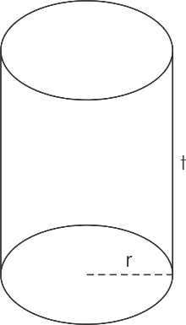
- View, as a view that later the user or user will see[3].

- Controller, receive input from the user and move to the model (if needed) to take action based on input. the results will be displayed in the view, so the controller is responsible for mapping end-user action to the application's response[3].

Bootstrap
Is a framework that can solve a problems in web designing[2]. The slogan of this framework is “Sleek, intuitive, and powerful front- end framework for faster and easier web development”, which means we can design a website more neatly, quickly and easily.
Bootstrap already provides CSS classes and integrates with JQuery. Responsive layout on css bootstrap with 12 column grid system produces a website layout that automatically adjusts to the width of the user's browser[1].
This, later we use to create the fromtend

Method

Formula Classification
Have you ever played a game on your smartphone. and have you ever felt, when you are getting good at a certain level then when you proceeded to another level. Do you feel the game is getting more intense.
Cases like this that the author try to take. Because just like the game on a smartphone, mathematics has a certain formula level.
Speaking about formulas the author took 30 elementary school level mathematical formulas. Consists of :

Addition, divide, multipicaton, subtrac, beam volume, tube volume, tube surface area, prism volume, pyramid volume, diamond volume, cube surfacee, actual distance on map, distance on map, scale on map, cone surface area, cone volume, rhombus area, area of triangle, parallegoram area, parallegoram perimeter, kite area, kite perimeter, triangle perimeter, circle area, rectangle perimeter, beam surface area, prism surface area, trapezoid perimeter, rectangular perimeter, ball surface area.

Pic The Formula
For the record, author does not write all the formulas in a coding format, but only writes one. the author's purpose is only to exemplify how it is developed through MVC, the use of a codeigniter framework, wich also the main basic of this aplication.

This is the author pic, tube volum :

Fig1. Tube

Tube volum = area of base x tall =
r = radius
t = tall

Arranging controller and view

After classifying the formula and determining what is chosen the author will describe the design of this application work. Basically this design is a reference for how this application is run.
With welcome.php as the main page landing that calls the homepage (beranda).
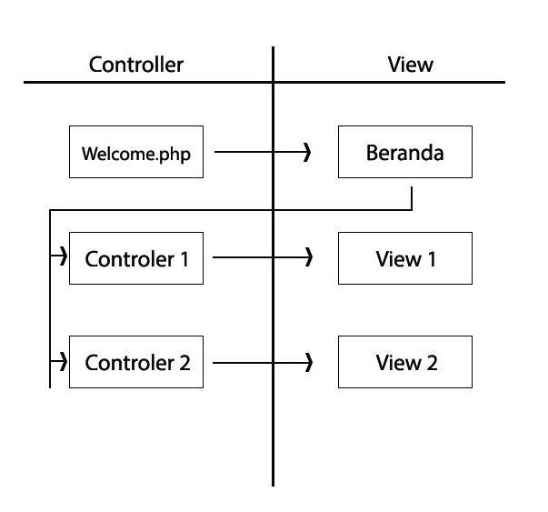
Fig2. Work design

Controller 1 and controller 2 represent the formulas as also the view itself.
The model here is not needed why? because in one controller can already process the formula
Here the author gives an example of the source code of controller 1 (tube volume),

function hitung_voltabung()
{
$data['r']=(int)$this->input->post('r',true);
Nbn $data['tinggi']=(int)$this->input->post('tinggi',true);
$data['hasil']=3.14 *($data['r']*$data['r'])*$data['tinggi'];
$this->load->view('viewkel1/Vol_tabung',$data);
}

As we can see, user input will be processed immediately without passing to the model.

Building the controller
As explained before, this controller are divided into two :
- Homepage
- Formulas
Each controller later can call their own view, but if a formula want to be call it need access via homepage

class Welcome extends CI_Controller
{
public function __construct()
{
parent::__construct();
$this->load->helper('url');
}
public function index()
{
$this->load->view('beranda');
}
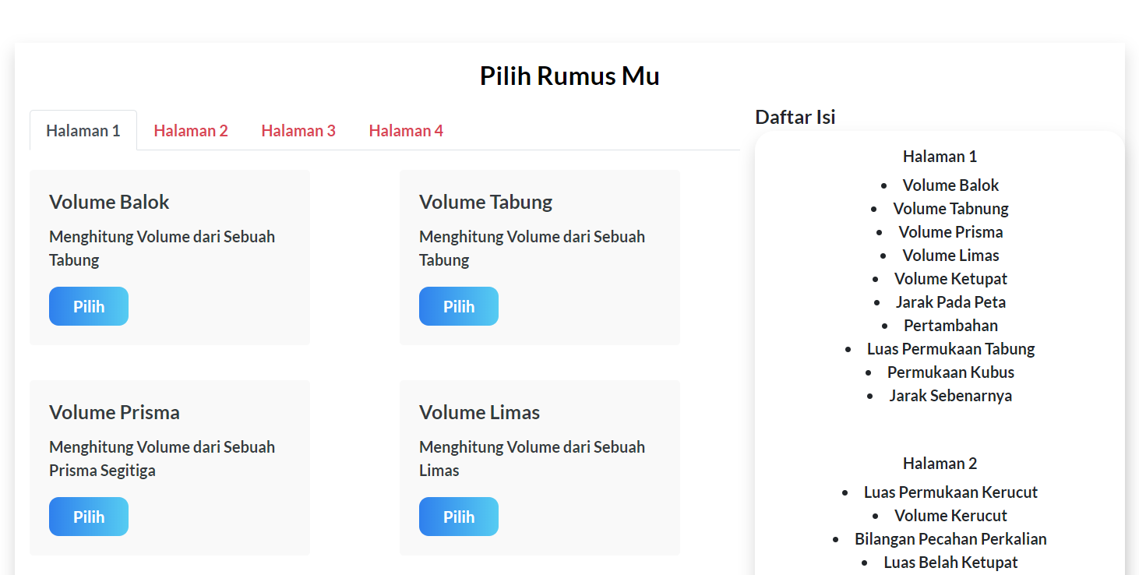
}

Sorcecode above is a homepage, with welcome.php file name This case the author access through the localhost. With folder’s name matematika. It should be like this :

Localhost/matematika/

For the formula, the author has given the previous example

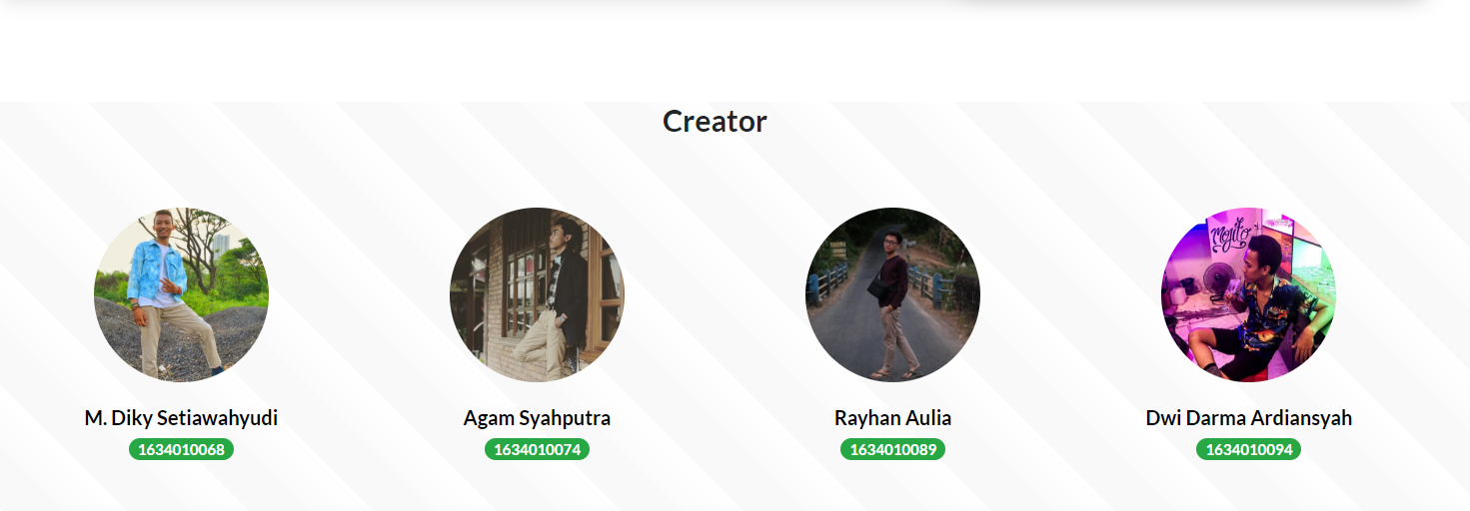
Building the view
This explanation is almost the same as the controller, divided into two :
- Home page
- formulas
This home page is built with bootstrap, visit the getbootstrap.com page. look at the bootstrapCDN section. there are two things needed.
- copy the CSS only section
- copy JS, Popper.js, and jQuery section
each put it on head and script

Result
This stage is done after classifying the formula, selecting an example, creating a controller and a view. The next step is results.
Complete design will later be implemented into the chosen programming language, codeigniter.

After implementation the new system is tested, which will be seen deficiencies in new applications for further system development.

- The Main
The main homepage are include all the formulas and the creator of this application.

Fig3. Homepage

- Formulas section
This section are divide into two :
- All the formulas
- Table of contents
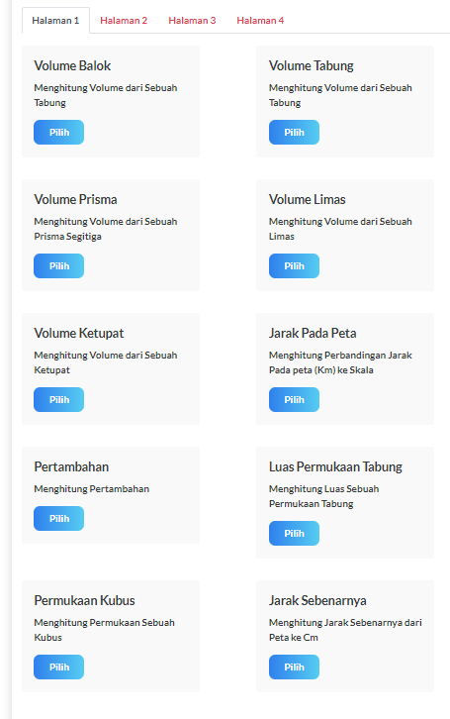
Fig4. Formulas

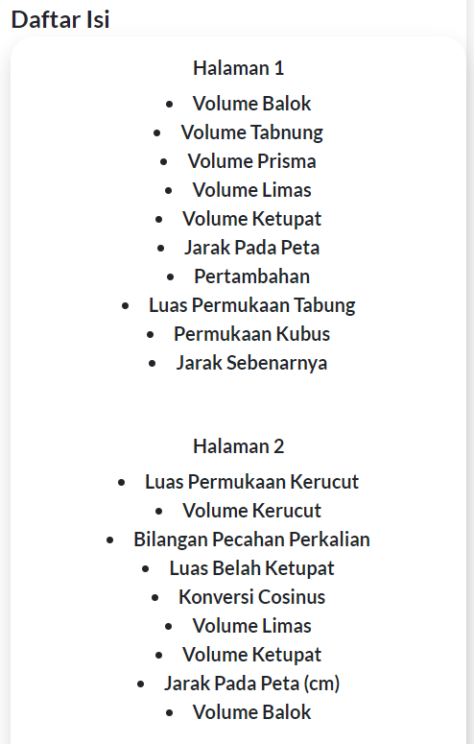
Each formulas divide into 4 pages and each pages contain 10 formulas. Execpt for the last page only contain 8 formulas
Fig5. Table of content 1

Fig6. Table of content 2
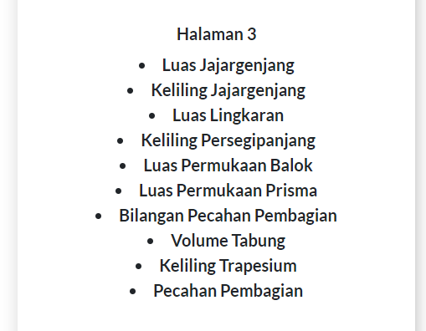

Fig7. Table of content 3
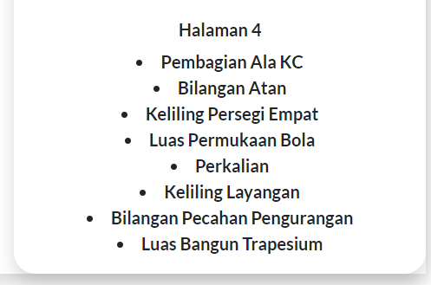
Fig8. Table of content 4

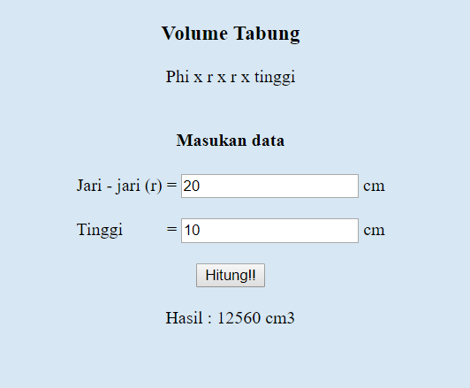
- Counting section

Fig8. Example of counting

This section explains how the controller runs, according to the figure in Fig.8 is a calculation of the tube volume.

Conclusion
Based on existing results, this application basically works in the same method. where in working out the formula each formula has its own controller. the execution of this application also becomes an alternative new learning method which elementary school students can access on a 24 hour basis. This application can be accessed on the rumusmatematikaku.000webhostapp.com

REFERENCES

[1] Try Viananda Nova Megariani, 2017 “Aplikasi Forum Pajak Menggunakan Framework Bootstrap.” “Technologia” Vol 8, No.2.

[2] Roberto Kaban, Fajrillah, 2017 “Pengembangan Sistem Informasi Perpustakaan Denganframework Css Bootstrapdan Web Development Life Cycle” Jurnal Ilmiah InformatikaVolume 2No. 1.

[3] Donni Prabowo, 2015 “Website E-Commerce Menggunakan Model View Controller ( Mvc ) Dengan Framework Codeigniter” Jurnal Ilmiah DASI Vol. 16 No. 1

[4] Asroni, 2018 “Penerapan Model View Controller (MVC) Dengan Framework Codeigniter Pada Sistem Informasi Booking Wisata Klangon” Vol 6, No 2

[5] Mara Destiningrum, Qadhli Jafar Adrian, 2017 “Sistem Informasi Penjadwalan Dokter Berbassis Web Dengan Menggunakan Framework Codeigniter (Studi Kasus: Rumah Sakit Yukum Medical Centre)” Jurnal TEKNOINFO, Vol. 11, No. 2

[6] RR. Imamul Muttakhidah, 2015 “Logika Matematika, Dialektika Dan Teknik Pengambilan Simpulan” AdMathEdu Vol.5 No.2

