DESIGN AND BUILDING OF ANDROID BASED ROOM FACILITY LENDING APPLICATION

Dicky Giancini Arwindo Kurniawan1 Department of Informatics Engineering, Faculty of Computer

Science

University of Pembangunan Nasional “Veteran” Jawa Timur Surabaya, Indonesia

[**dicky.giancini.123@gmail.com**](mailto:dicky.giancini.123@gmail.com)

Guntur Adhi Prasetya2

Department of Informatics Engineering, Faculty of Computer Science

University of Pembangunan Nasional “Veteran” Jawa Timur Surabaya, Indonesia

[**gunturadhip06@gmail.com**](mailto:gunturadhip06@gmail.com)

Sandy Rizkyando3

Department of Informatics Engineering, Faculty of Computer Science University of Pembangunan Nasional “Veteran” Jawa Timur Surabaya, Indonesia

[**sandyrizkyando@gmail.com**](mailto:sandyrizkyando@gmail.com)

***Abstract*— *Android* is a platform that is currently used by many users, so that almost every application created uses the Android platform because it is easy to use and also effective. The Faculty of Computer Science UPN "Veteran" East Java has 2 buildings and lots of rooms and other facilities such as laboratories, seminar rooms, and there are loans for equipment that can help the course of events whether in lectures or non- academics. Until now, the process of borrowing rooms and facilities at the Faculty of Computer Science is still done manually, such as using letters and several other processes. This also causes waste of paper and time because it is not necessarily the space or equipment that will be borrowed first by someone else. The purpose of designing and building a room facility loan application is to improve or optimize TU (Administration) services to room borrowers. The research methodology was carried out by collecting data such as interviews, literature study, observation and system design using the waterfall model. The results of this study are to facilitate services, be comfortable and safe in borrowing space.**

**Keywords—component; Design, Android, JavaMail, loan**

I. PRELIMINARY

The Faculty of Computer Science UPN “Veteran” East Java has 2 buildings, each of which has facilities such as classrooms, laboratories, equipment such as sound systems, mic, projectors, and of course the Seminar Room. Every time there is an activity outside the lecture agenda, of course there is an empty room that is always borrowed, either from ormawa, the community or from lecturers to conduct additional lectures. Until now, borrowing space at the FIK Building is still done manual borrowing such as using letters, and several other routes. This is also a waste of paper and time because not necessarily the space or equipment has been ordered by someone else. For self-borrowing requirements, a

KTM and a loan license signed by the borrowing party and approved by the Deputy Dean 3 are required.

Nowadays, those who have used online technology as part of our daily life certainly facilitate our activities. With this online technology, an innovation is needed to facilitate sending letter requests with the help of applications, such as the android application (Diana, 2019). In this case the writer also wants to make a prototype application for borrowing the facilities of the Faculty of Computer Science UPN "Veteran" East Java with the Android platform.

Research conducted by Ardhini Warih Utami, Prisma Wahyu Pradana (2015) uses the web as a platform to build an information system for correspondence with the title web- based correspondence information system for students (Case Study: Informatics Engineering Department, Surabaya State University). In this study the authors used PHP and MySQL for the database of the information system. This information system has several benefits and uses, namely computerized archiving, quick searches, making it easier for administrators to take care of students who want to take care of correspondence activities, and making it easier for students to deal with correspondence so that they don't need to go to TU to take care of it.

The second research conducted by Nanda Lutfian Gunawan, Antok Supriyanto, Yoppy Mirza Maulana (2016) with the title design and build a web-based mail management application at the Surabaya city transportation department. This study also uses a web platform for mail management because the web is easily accessible. From this research, there are several uses and benefits obtained, namely providing convenience in filing, checking incoming or outgoing mail, giving letter numbers.

Reza Benarivo (2018) conducted a study entitled the design of a web-based new student admission information

system. This paper describes the design of an information system for new student admissions, which uses the web as a platform. The author also explains that this website was created using the SDLC (System Development Life Cycle) method. From making this web there are various benefits and conveniences, namely providing information in the form of registering new student candidates, verifying registration requirements and announcing the written test results of all prospective new students who register.

The last research related to this research is research conducted by Galuh Fandatiar, Supriyono, Fajar Nugraha (2015). In this study, the authors designed an information system about KKN at Muria Kudus University.The purpose of this research is to produce an information system that is useful in handling the KKN registration process, the division of KKN groups, knowing the time and place for the implementation of KKN, knowing the field supervisors and seeing the assessment of KKN results and as a means of publishing information related to KKN activities through an information system. . This system is designed using UML (Unified Modeling Language) modeling, while the programming languages used are PHP and MySQL database.

From several related studies that have been mentioned, this research has several similarities, including creating an information system that facilitates the performance of related parties. There is also a difference, namely the platform we use is the android platform (Susrama, 2019), while from the related research that has been mentioned most of them use the web platform.

# SCOPE

In this study, the problem that will be covered is how as a borrower can borrow a room easily, simply by opening the Android device that is owned, then only by sending a message containing the files needed for borrowing in general, the message will be sent to Tata. The business or destination of the recipient which will be confirmed later.

The limitation that we will cover is simple scope such as the environment of the Faculty of Computer Science, University of National Development “Veteran” East Java, as well as other faculties around UPN “Veteran” East Java, because it is very common to encounter correspondence problems using manual systems.

The result that we want to achieve is a prototype application for lending facilities based on android which later can be further developed, both in the form of research and research related to this research.

# MATERIALS AND METHODS

In conducting this research the author has several methods used in implementing the building facility lending system, with the input we examined is the user or sender of a letter, for example from the learning community wants to borrow building facilities in room 301, then the input entered is email TU, then the subject of the letter, plus a description of the letter, and an attachment for reinforcing evidence.

P45L2#yIS1

**Image 1**. Design Process Diagram

In this study, the stages to be explained are how letters are made manually, which is then followed by a flowchart of the stages for submitting an android-based system design letter, then how this research designs a system for submitting letters, and implementing android-based mailing.

The programming used in this study is Object Oriented Programming (OOP), because in Android mobile programming, the paradigm used is object-based paradigm. So that by using OOP, the system flow works properly and makes writing programs easier. Objects that will be used in this system include email destinations, borrower names, letter descriptions, and letter attachments

# Manual room borrowing

In general, borrowing room facilities is still done manually. With this step, the applicant designs the letter and prints it, then the applicant must ask for approval from the Deputy Dean III, after which it can be submitted to the Administration. That, too, is not necessarily accepted, because the schedule sometimes on that day has already been used by other activities. Of course, the applicant must rewrite the letter and ask for the Vice Dean III's signature again.

# System Flowchart

In a process flow diagram the stages of using the program to send email and attachments are described in Figure 2.

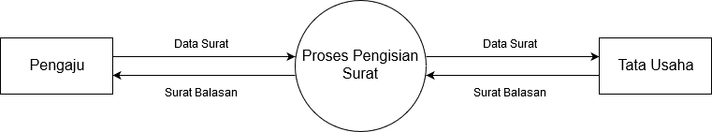

# P56#yIS1Figure 2. System Flowchart

In a flow chart, the initial process is that the applicant must fill in the data from the layout provided, then in the layout provided the applicant inputs the TU Email, then the applicant inputs the subject or title of the letter, for example "Submission of New Building Room Borrowing", then the applicant enters a description of the letter explanation . Then the applicant will press the attachment to retrieve the letter files because the borrowing rules must include documents. After that the submitter presses SEND to send. If successful, it will display the message "Sent!

As shown, that the right given to the user by the system is that the user can send an email containing the subject and description along with attachments, while TU can do both by additionally sending replies and confirmations to the user.

# Data Flow Diagram

At level 0, the data flow diagram, basically, starts with the borrower filling in the letter data which will be processed later, then the letter reaches the administration, which then replies will be sent back to the applicant, as in Figure 3.

# Figure 3. Data Flow Diagram Level 0

At level 0, the mail filling process will be carried out by the JavaMail API. In short, the JavaMail API is an abstract set that models the mailing system using the Java language. Because the android system uses the Java language, the JavaMail API is very beneficial for the system. For details on how the JavaMail API works, see DFD level 1 Figure 4.

First, the applicant will input the required letter data, then when the letter data is completed, the next step is to take the attachment that is on the applicant's internal android database, which is described by the Internal Database. After pressing "Send", the mail and attachment data will be handled by the JavaMail API so that the letter will be accepted by the Administration. Then the applicant only needs to wait for a reply letter from the Administration whether the loan letter is accepted or rejected.

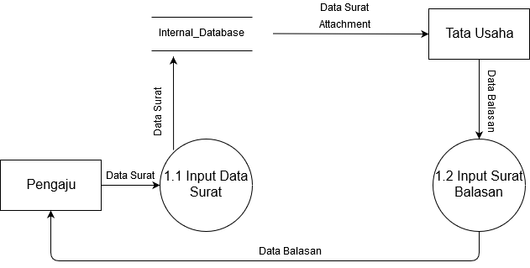

# Figure 4. Data Flow Diagram Level 1

1. **DISCUSSION**

In implementing correspondence to the Administration, it is often encountered that they still use printed paper letters to borrow space at the UPN "Veteran" Faculty of Computer Science Building, East Java. So with the formation of a prototype of this android-based facility lending system, several results were found.

# Implementation

In this form, the user will later write several letter formats as in general but in the form of mailing. When viewed from the top down, the steps the user will take to borrow, namely by writing a TU email, followed by the subject and content of the email to be sent. When finished, the next step is to send the link containing the original letter. when the user has pressed the ATTACHMENT button on the initial display, the user will be led to retrieve the original letter file contained in the user's Android folder.

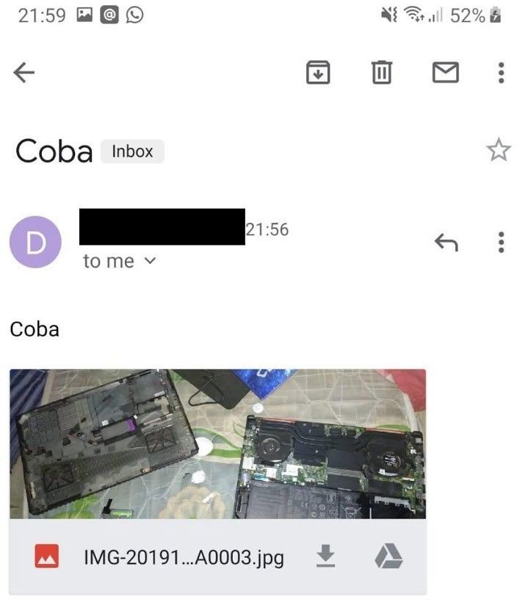

# P79#yIS1Figure 6. Menu Prototype

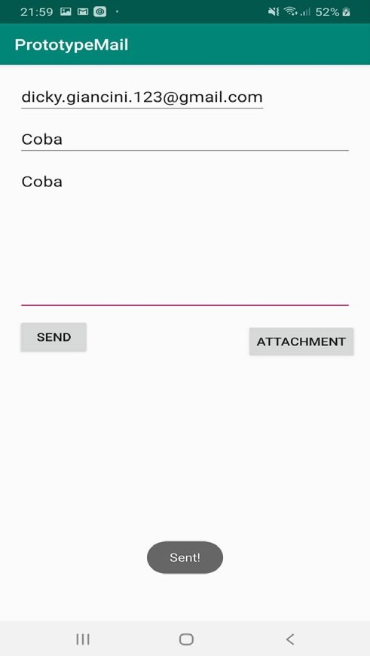

**Figure 7. Filling in Letters and Sending Letters**

When finished fetching the link in the andorid user folder, the user presses the SEND button. Which then when sending successfully the android will display a short message, namely "Sent!"

# Figure 8. Example if the letter is sent

When it is finished, the faculty administration staff only needs to check the email whether the sender has sent an email containing a letter and loan request which will be sent a confirmation to the sender's email.

# Black Box Testing

Table 1. Android Application Testing

|  |  |  |
| --- | --- | --- |
| **Features tested** | **The results are Expected** | **Result** |
| Login menu | Enter Login Menu | Corresponding |
| Menu Prototype | Sign in Menu  Prototype | Corresponding |
| Filling in  Letters and Sending Letters | Sign in Filling in Letters and Sending  Letters | Corresponding |
| Room Menu | Sign in Room Menu | Corresponding |
| Logout menu | Sign in Logout menu | Corresponding |

# CONCLUSION

After analyzing and designing, as well as implementing the Android-Based Facility Loan Application Design, the following conclusions can be drawn: Applications made with the Android platform will make it easier for those who will borrow room facilities, because with the Android platform the facility borrower can borrow where anytime and anywhere without having to waste time going to TU in person. And with this application TU will run more effectively and efficiently because TU can perform other tasks. Also, this application can also help to reduce costs incurred and use of excess paper

# SUGGESTION

There is a need for further research on JavaMail on Android but using the Kotlin programming language, because globally the use of the Java language has started to seem "outdated" and many systems are not used or can be called "deprecated". Then there needs to be extras such as the appearance to make it look more attractive

# REFERENCES

Benarivo, Reza. 2018. Design of WEB-Based Information Systems and New Student Admissions[http://eprints.ums.ac.id/59993/6/NASKAH%20]](http://eprints.ums.ac.id/59993/6/NASKAH).pdf (accessed on 18 November 2019)

Fandatiar, Galuh. 2015. Design of Information System for Real Work Lecture (Kkn) at Muria Kudus Universityhttps://jurnal.umk.ac.id/index.php/simet/article/view/247 (accessed on 18 November 2019)

Gunawan, Nanda Lutfian. 2016. The Design of Web-Based Mail Management Application at the Surabaya City Transportation Agencyhttps://[www.neliti.com/publications/244722/rancang-bangun-](http://www.neliti.com/publications/244722/rancang-bangun-) aplikasi-mana Manajemen-surat-berbasis-web-pada-dinas- perhektronik-kota (accessed November 20, 2019)

Ilvi Nur Diana, M Miftachul Anwar, I Gede Susrama, 2019. Analysis of Archiving Information System Design and Letter Disposition Based on

the Chronological Filling System, Proceedings of the 1st SANTIKA National Seminar, pp. 27-32

I Gede Susrama and Ariyono Setiawan, 2019, Designing "W-Mass (Weight Monitor Assistant)" Application Based on Android Stu-dio with Native Java Language, Journal of Poltekbang, Vol. 4 (2), p. 78-96.

Riandy, Khodijah Huliyah, A'ang Subiyakto, Design and Construction of Goods Sales Information System (Case Study: UD Cendana Depok Townsquare). Journal of Information Systems, 4 (1), 1979-0767.

Rintiasti, Aneke and Adhe Rama Febrianto, Design of Abstract and Full Paper Selection Applications. National Seminar. Journal of Process Technology and Industrial Innovation, VOL. 3, 1.

Utami, Ardhini Warih. 2015. Web-Based Information System for Student Correspondence (Case Study: Department of Informatics, State University of

Surabaya)https://jurnalmahasiswa.unesa.ac.id/index.php/jurnal-mana Management-informatika/article/view/13589 (accessed November 20, 2019)