my requirement is convert html css template into react vite template then integration. how to do

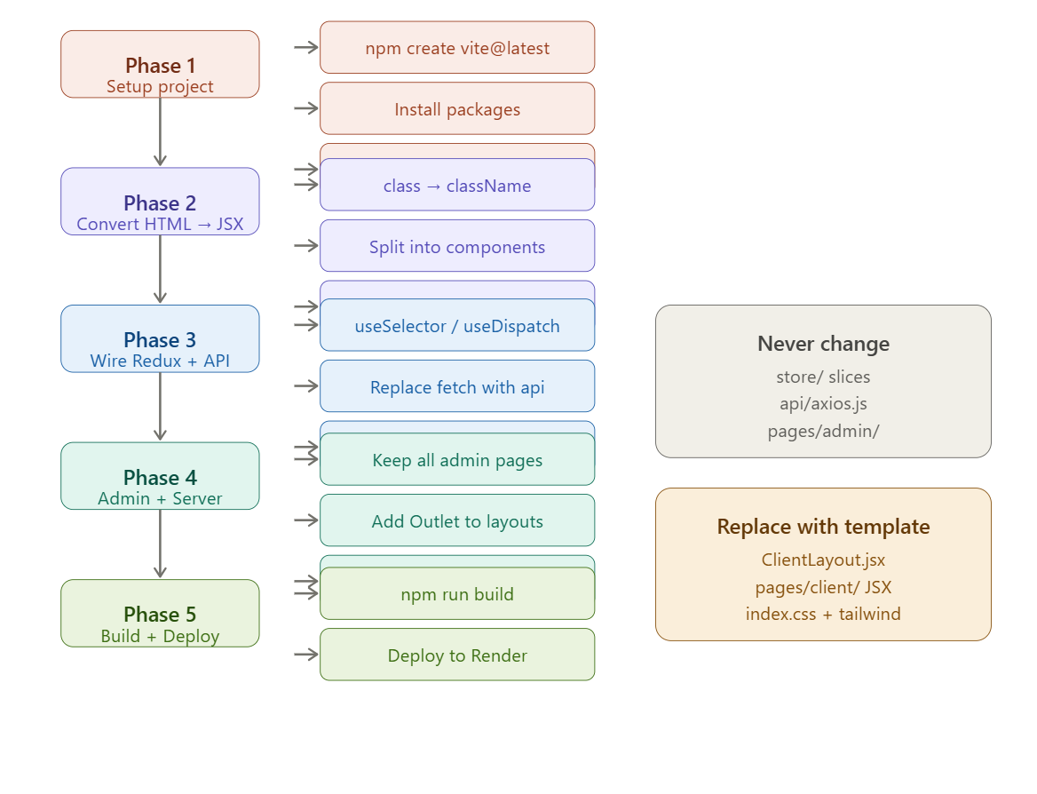

Now let me write the complete, visual step-by-step guide:Here is the complete step-by-step guide to convert your HTML/CSS template and integrate it:

Phase 1 — Project Setup
Step 1: Create a fresh Vite project
npm create vite@latest marketpro-client -- --template react
cd marketpro-client
Step 2: Install all required packages
# Core (required — do not skip any)
npm install @reduxjs/toolkit react-redux react-router-dom axios react-hot-toast

# Add your template's dependencies
npm install swiper # if template uses sliders
npm install framer-motion # if template uses animations
npm install lucide-react # for icons
Step 3: Copy the data layer from the existing project — never rewrite these
# Copy these folders exactly as-is into your new src/
cp -r old-project/src/store src/store
cp -r old-project/src/api src/api
cp -r old-project/src/pages/admin src/pages/admin
cp old-project/src/App.jsx src/App.jsx
cp old-project/src/main.jsx src/main.jsx
Step 4: Create vite.config.js
import { defineConfig } from 'vite'
import react from '@vitejs/plugin-react'
import path from 'path'

export default defineConfig({
plugins: [react()],
resolve: {
alias: { '@': path.resolve(__dirname, './src') } // ← must keep
},
server: {
proxy: { '/api': { target: 'http://localhost:8000', changeOrigin: true } }
}
})
Step 5: Create .env.local
VITE_API_URL=http://localhost:8000/api

Phase 2 — Convert HTML Template to JSX
This is where you do the actual template conversion. Go file by file.
Step 6: Identify your template's structure
Open your HTML template and map every section to a file:
HTML template structure → React file to create
─────────────────────────────────────────────────────────
<header> ... </header> → part of ClientLayout.jsx
<footer> ... </footer> → part of ClientLayout.jsx
index.html (homepage content) → pages/client/HomePage.jsx
products.html → pages/client/ProductsPage.jsx
product-detail.html → pages/client/ProductDetail.jsx
cart.html → pages/client/CartPage.jsx
wishlist.html → pages/client/WishlistPage.jsx
checkout.html → pages/client/CheckoutPage.jsx
orders.html → pages/client/OrdersPage.jsx
profile.html → pages/client/ProfilePage.jsx
login.html → pages/client/LoginPage.jsx
register.html → pages/client/RegisterPage.jsx

Repeated card/product snippet → components/product/ProductCard.jsx
Cart slide-in panel → components/cart/CartDrawer.jsx
Step 7: The 8 HTML → JSX conversion rules
Take each HTML section and make these replacements:
HTML → JSX
──────────────────────────────────────────────────────────
class="..." → className="..."
for="..." (label) → htmlFor="..."
<img src="..."> → <img src="..." alt="..." /> (self-close)
<input> <br> <hr> → <input /> <br /> <hr />
onclick="fn()" → onClick={() => fn()}
onchange="fn()" → onChange={(e) => fn(e)}
style="color:red" → style={{ color: 'red' }}
<!-- comment --> → {/* comment */}
Step 8: Convert <head> content
Move everything from <head> into index.html in your Vite project:
<!-- index.html (Vite entry) -->
<!DOCTYPE html>
<html lang="en">
<head>
<meta charset="UTF-8" />
<meta name="viewport" content="width=device-width, initial-scale=1.0" />
<title>MarketPro</title>

<!-- Paste your template's Google Fonts link here -->
<link href="https://fonts.googleapis.com/css2?family=..." rel="stylesheet" />

<!-- Any template CDN CSS (Bootstrap, etc.) -->
<link rel="stylesheet" href="https://..." />
</head>
<body>
<div id="root"></div>
<script type="module" src="/src/main.jsx"></script>
</body>
</html>
Step 9: Move CSS into src/index.css
Copy all your template's CSS into src/index.css. If using Tailwind keep the directives at top:
/* src/index.css */
@tailwind base;
@tailwind components;
@tailwind utilities;

/* ↓ Paste all your template's custom CSS below ↓ */
:root {
--primary: #f97316;
--font-main: 'Your Template Font', sans-serif;
}

/* your template's .navbar, .card, .btn styles etc. */
If your template uses a separate CSS file instead of Tailwind, import it in main.jsx:
// src/main.jsx
import './index.css'
import './your-template.css' // ← add this line

Phase 3 — Wire Redux + API into Each Component
Step 10: Build ClientLayout.jsx — the shell that wraps all pages
Take your template's <header> and <footer> HTML, convert to JSX, then add these 5 wires:
// src/components/layout/ClientLayout.jsx
import { Outlet } from 'react-router-dom' // WIRE 1 — renders pages
import { Link, useNavigate } from 'react-router-dom'
import { useSelector, useDispatch } from 'react-redux'
import { logout } from '@/store/slices/authSlice'
import { toggleCart } from '@/store/slices/uiSlice'
import CartDrawer from '@/components/cart/CartDrawer' // WIRE 2 — cart drawer

export default function ClientLayout() {
const dispatch = useDispatch()
const { user } = useSelector(s => s.auth) // WIRE 3 — user
const { item_count } = useSelector(s => s.cart) // WIRE 4 — cart badge
const { ids: wishIds } = useSelector(s => s.wishlist) // WIRE 5 — wishlist badge

return (
<>
{/* ── Paste your template's header JSX here ── */}
<header className="your-template-header-class">
<Link to="/">Logo</Link>

{/* Cart button → dispatch(toggleCart()) */}
<button onClick={() => dispatch(toggleCart())}>
Cart <span>{item_count}</span>
</button>

{/* Wishlist */}
<Link to="/wishlist">
Wishlist <span>{wishIds.length}</span>
</Link>

{/* User menu */}
{user ? (
<>
<Link to="/profile">{user.name}</Link>
<Link to="/orders">Orders</Link>
{(user.role === 'admin') && <Link to="/admin">Admin</Link>}
<button onClick={() => dispatch(logout())}>Logout</button>
</>
) : (
<Link to="/login">Sign In</Link>
)}
</header>

<CartDrawer /> {/* ← must be here, hidden until cart opens */}

<main>
<Outlet /> {/* ← renders current page here */}
</main>

{/* ── Paste your template's footer JSX here ── */}
<footer className="your-template-footer-class">
Footer content...
</footer>
</>
)
}
Step 11: Convert each page — replace static HTML with live data
For every client page, the pattern is the same:
1. Take the page's HTML from your template
2. Wrap it in a React function component
3. Add the data hook at the top
4. Replace hardcoded text with {variables}
5. Replace hardcoded links with <Link to="...">
6. Replace onclick with onClick dispatching the right action
Here is every page with its exact hook:
HomePage.jsx
import { useEffect } from 'react'
import { useDispatch, useSelector } from 'react-redux'
import { fetchProducts } from '@/store/slices/productSlice'

export default function HomePage() {
const dispatch = useDispatch()
const { list: products, categories, loading } = useSelector(s => s.products)

useEffect(() => {
dispatch(fetchProducts({ featured: true, limit: 8 }))
}, [dispatch])

return (
<>
{/* Your template's homepage HTML converted to JSX */}
{/* Replace hardcoded product cards with: */}
{loading
? <p>Loading...</p>
: products.map(p => <ProductCard key={p.id} product={p} />)
}
{/* Replace hardcoded category grid with: */}
{categories.map(cat => (
<Link key={cat.id} to={`/products?category=${cat.id}`}>
{cat.name}
</Link>
))}
</>
)
}
ProductsPage.jsx
import { useEffect } from 'react'
import { useDispatch, useSelector } from 'react-redux'
import { useSearchParams } from 'react-router-dom'
import { fetchProducts } from '@/store/slices/productSlice'

export default function ProductsPage() {
const dispatch = useDispatch()
const [searchParams, setSearchParams] = useSearchParams()
const { list, pagination, categories, brands, loading } = useSelector(s => s.products)

useEffect(() => {
dispatch(fetchProducts(Object.fromEntries(searchParams.entries())))
}, [searchParams, dispatch])

const filter = (key, val) => {
const p = new URLSearchParams(searchParams)
val ? p.set(key, val) : p.delete(key)
p.set('page', '1')
setSearchParams(p)
}

return (
<>
{/* Your template's filter sidebar — wire each filter input: */}
<select onChange={e => filter('category', e.target.value)}>
<option value="">All Categories</option>
{categories.map(c => <option key={c.id} value={c.id}>{c.name}</option>)}
</select>

{/* Sort dropdown */}
<select onChange={e => filter('sort', e.target.value)}>
<option value="createdAt">Latest</option>
<option value="price_asc">Price: Low to High</option>
<option value="price_desc">Price: High to Low</option>
</select>

{/* Product grid */}
{list.map(p => <ProductCard key={p.id} product={p} />)}

{/* Pagination */}
{Array.from({ length: pagination.pages || 1 }, (_, i) => (
<button key={i} onClick={() => filter('page', i + 1)}>{i + 1}</button>
))}
</>
)
}
ProductDetail.jsx
import { useEffect, useState } from 'react'
import { useParams } from 'react-router-dom'
import { useDispatch, useSelector } from 'react-redux'
import { fetchProduct, clearCurrentProduct } from '@/store/slices/productSlice'
import { addToCart } from '@/store/slices/cartSlice'
import { toggleWishlist } from '@/store/slices/wishlistSlice'

export default function ProductDetail() {
const { id } = useParams()
const dispatch = useDispatch()
const [qty, setQty] = useState(1)
const { currentProduct: p, productLoading } = useSelector(s => s.products)
const { ids: wishIds } = useSelector(s => s.wishlist)

useEffect(() => {
dispatch(fetchProduct(id))
return () => dispatch(clearCurrentProduct())
}, [id, dispatch])

if (productLoading) return <p>Loading...</p>
if (!p) return <p>Not found</p>

return (
<>
{/* Template's product gallery — use p.images[] array */}
{p.images.map((url, i) => <img key={i} src={url} alt={p.name} />)}

{/* YouTube video embed — only show if p.youtube_url exists */}
{p.youtube_url && (
<iframe
src={p.youtube_url.replace('watch?v=', 'embed/')}
allowFullScreen
/>
)}

<h1>{p.name}</h1>
<p>{p.price}</p>

{/* Variants */}
{p.variants?.map(v => (
<button key={v.name}>{v.name} — ₹{v.price}</button>
))}

{/* Add to cart */}
<input type="number" value={qty} onChange={e => setQty(Number(e.target.value))} min="1" />
<button onClick={() => dispatch(addToCart({ product_id: p.id, quantity: qty }))}>
Add to Cart
</button>

{/* Wishlist */}
<button onClick={() => dispatch(toggleWishlist(p.id))}>
{wishIds.includes(p.id) ? '♥ Remove' : '♡ Wishlist'}
</button>
</>
)
}
LoginPage.jsx
import { useState } from 'react'
import { useDispatch, useSelector } from 'react-redux'
import { useNavigate } from 'react-router-dom'
import { login } from '@/store/slices/authSlice'

export default function LoginPage() {
const dispatch = useDispatch()
const navigate = useNavigate()
const { loading } = useSelector(s => s.auth)
const [email, setEmail] = useState('')
const [password, setPassword] = useState('')

const handleSubmit = async (e) => {
e.preventDefault()
const result = await dispatch(login({ email, password }))
if (!result.error) navigate('/')
}

return (
<form onSubmit={handleSubmit}>
{/* Your template's login form HTML → JSX */}
<input type="email" value={email} onChange={e => setEmail(e.target.value)} />
<input type="password" value={password} onChange={e => setPassword(e.target.value)} />
<button type="submit" disabled={loading}>
{loading ? 'Signing in...' : 'Sign In'}
</button>
</form>
)
}
CartPage.jsx
import { useSelector, useDispatch } from 'react-redux'
import { updateCartItem, clearCart } from '@/store/slices/cartSlice'
import { Link } from 'react-router-dom'

export default function CartPage() {
const dispatch = useDispatch()
const { items, total } = useSelector(s => s.cart)

return (
<>
{items.map(item => (
<div key={item.product_id}>
<img src={item.product?.images?.[0]} alt={item.product?.name} />
<span>{item.product?.name}</span>
{/* Decrease — if qty becomes 0, item is removed */}
<button onClick={() =>
dispatch(updateCartItem({ productId: item.product_id, quantity: item.quantity - 1 }))
}>−</button>
<span>{item.quantity}</span>
<button onClick={() =>
dispatch(updateCartItem({ productId: item.product_id, quantity: item.quantity + 1 }))
}>+</button>
<span>₹{item.product?.price * item.quantity}</span>
</div>
))}
<div>Total: ₹{total}</div>
<Link to="/checkout">Proceed to Checkout</Link>
</>
)
}
WishlistPage.jsx
import { useSelector, useDispatch } from 'react-redux'
import { toggleWishlist } from '@/store/slices/wishlistSlice'
import { addToCart } from '@/store/slices/cartSlice'
import { Link } from 'react-router-dom'

export default function WishlistPage() {
const dispatch = useDispatch()
const { items } = useSelector(s => s.wishlist)

return (
<>
{items.map(item => (
<div key={item.product_id}>
<Link to={`/products/${item.product_id}`}>
<img src={item.product?.images?.[0]} alt={item.product?.name} />
<span>{item.product?.name}</span>
<span>₹{item.product?.price}</span>
</Link>
<button onClick={() => dispatch(addToCart({ product_id: item.product_id, quantity: 1 }))}>
Add to Cart
</button>
<button onClick={() => dispatch(toggleWishlist(item.product_id))}>
Remove
</button>
</div>
))}
</>
)
}
CheckoutPage.jsx
import { useState } from 'react'
import { useSelector, useDispatch } from 'react-redux'
import { useNavigate } from 'react-router-dom'
import { fetchCart } from '@/store/slices/cartSlice'
import api from '@/api/axios'
import toast from 'react-hot-toast'

export default function CheckoutPage() {
const dispatch = useDispatch()
const navigate = useNavigate()
const { items, total } = useSelector(s => s.cart)
const [address, setAddress] = useState({ street:'', city:'', state:'', country:'India', zip_code:'' })
const [payment, setPayment] = useState('cod')
const [loading, setLoading] = useState(false)

const placeOrder = async (e) => {
e.preventDefault()
setLoading(true)
try {
const res = await api.post('/orders', {
shipping_address: { ...address, label: 'Home', is_default: false },
payment_method: payment
})
dispatch(fetchCart()) // clears cart
navigate(`/orders/${res.data.data.id}`)
toast.success('Order placed!')
} catch (err) {
toast.error(err.response?.data?.message || 'Failed')
}
setLoading(false)
}

return (
<form onSubmit={placeOrder}>
{/* Template's address form fields — bind each to address state */}
<input value={address.street} onChange={e => setAddress(a => ({...a, street: e.target.value}))} />
<input value={address.city} onChange={e => setAddress(a => ({...a, city: e.target.value}))} />
<input value={address.state} onChange={e => setAddress(a => ({...a, state: e.target.value}))} />
<input value={address.zip_code} onChange={e => setAddress(a => ({...a, zip_code: e.target.value}))} />

{/* Payment method radio buttons */}
{['cod','upi','card'].map(m => (
<label key={m}>
<input type="radio" value={m} checked={payment === m} onChange={() => setPayment(m)} />
{m.toUpperCase()}
</label>
))}

<div>Total: ₹{total}</div>
<button type="submit" disabled={loading}>{loading ? 'Placing...' : 'Place Order'}</button>
</form>
)
}
OrdersPage.jsx
import { useEffect, useState } from 'react'
import { Link } from 'react-router-dom'
import api from '@/api/axios'

export default function OrdersPage() {
const [orders, setOrders] = useState([])
const [loading, setLoading] = useState(true)

useEffect(() => {
api.get('/orders').then(r => setOrders(r.data.data)).finally(() => setLoading(false))
}, [])

return (
<>
{orders.map(order => (
<Link key={order.id} to={`/orders/${order.id}`}>
#{order.id.slice(-6)} {order.status} ₹{order.total}
</Link>
))}
</>
)
}
Step 12: Build ProductCard.jsx
Take the single product card HTML from your template and convert it:
import { Link } from 'react-router-dom'
import { useDispatch, useSelector } from 'react-redux'
import { addToCart } from '@/store/slices/cartSlice'
import { toggleWishlist } from '@/store/slices/wishlistSlice'

export default function ProductCard({ product }) {
const dispatch = useDispatch()
const { ids: wishIds } = useSelector(s => s.wishlist)
const isWished = wishIds.includes(product.id)

const discount = product.compare_price > product.price
? Math.round(((product.compare_price - product.price) / product.compare_price) * 100)
: 0

return (
// Your template's card HTML → JSX
// Replace static values with these variables:
// product.images?.[0] → main image URL
// product.name → product title
// product.price → sale price
// product.compare_price → original price (show only if > price)
// discount → "20% off" badge
// product.is_new_arrival → "NEW" badge
// product.is_on_sale → "SALE" badge
// product.stock === 0 → show "Out of Stock"
// product.avg_rating → star rating (0–5)
// product.brand?.name → brand name above title
// isWished → filled vs outline heart icon
//
// Replace static hrefs/onclick with:
// <Link to={`/products/${product.id}`}> → card click
// onClick={() => dispatch(addToCart({product_id: product.id, quantity: 1}))
// onClick={() => dispatch(toggleWishlist(product.id))}
<div className="your-card-class">
<Link to={`/products/${product.id}`}>
<img src={product.images?.[0]} alt={product.name} />
</Link>
{discount > 0 && <span>{discount}% OFF</span>}
<h3>{product.name}</h3>
<span>₹{product.price}</span>
{product.compare_price > product.price && <del>₹{product.compare_price}</del>}
<button onClick={() => dispatch(addToCart({ product_id: product.id, quantity: 1 }))}>
Add to Cart
</button>
<button onClick={() => dispatch(toggleWishlist(product.id))}>
{isWished ? '♥' : '♡'}
</button>
</div>
)
}
Step 13: Build CartDrawer.jsx
Take your template's slide-in cart panel HTML, convert to JSX, add these:
import { useSelector, useDispatch } from 'react-redux'
import { closeCart } from '@/store/slices/uiSlice'
import { updateCartItem } from '@/store/slices/cartSlice'
import { Link } from 'react-router-dom'

export default function CartDrawer() {
const dispatch = useDispatch()
const { cartOpen } = useSelector(s => s.ui) // controls open/close
const { items, total } = useSelector(s => s.cart) // live cart data

return (
// Your template's cart panel HTML → JSX
// Show/hide using cartOpen:
<div className={`cart-panel ${cartOpen ? 'open' : ''}`}>
<button onClick={() => dispatch(closeCart())}>✕</button>

{items.map(item => (
<div key={item.product_id}>
<img src={item.product?.images?.[0]} alt={item.product?.name} />
<span>{item.product?.name}</span>
<button onClick={() => dispatch(updateCartItem({
productId: item.product_id, quantity: item.quantity - 1
}))}>−</button>
<span>{item.quantity}</span>
<button onClick={() => dispatch(updateCartItem({
productId: item.product_id, quantity: item.quantity + 1
}))}>+</button>
</div>
))}

<div>Total: ₹{total}</div>
<Link to="/checkout" onClick={() => dispatch(closeCart())}>
Checkout
</Link>
</div>
)
}

Phase 4 — Admin & Server Stay Untouched
Step 14: Keep admin pages as-is
All files in src/pages/admin/ were already copied in Step 3. Do not modify them. Just make sure AdminLayout.jsx still has <Outlet />:
// src/components/layout/AdminLayout.jsx
// You can restyle this sidebar with your template's admin design
// But these 3 things must stay:

import { Outlet } from 'react-router-dom' // renders admin page content
import { useDispatch, useSelector } from 'react-redux'
import { logout } from '@/store/slices/authSlice'

// Keep all 7 nav links pointing to these exact paths:
const NAV = [
{ label: 'Dashboard', to: '/admin' },
{ label: 'Products', to: '/admin/products' },
{ label: 'Categories', to: '/admin/categories' },
{ label: 'Brands', to: '/admin/brands' },
{ label: 'Orders', to: '/admin/orders' },
{ label: 'Customers', to: '/admin/customers' },
{ label: 'Wishlist Stats', to: '/admin/wishlist-stats' },
]

export default function AdminLayout() {
const dispatch = useDispatch()
const { user } = useSelector(s => s.auth)

return (
<div style={{ display: 'flex' }}>
<aside>
{/* Your new admin sidebar design here */}
{NAV.map(n => <Link key={n.to} to={n.to}>{n.label}</Link>)}
<button onClick={() => dispatch(logout())}>Logout</button>
</aside>
<main style={{ flex: 1 }}>
<Outlet /> {/* ← required */}
</main>
</div>
)
}

Phase 5 — Build & Deploy
Step 15: Test locally
# Terminal 1 — start the Python server
cd server
uvicorn main:app --reload

# Terminal 2 — start the React client
cd client
npm run dev
Visit http://localhost:5173 for the store and http://localhost:5173/admin for the dashboard.
Step 16: Build for production
cd client
npm run build # outputs to dist/ folder
Step 17: Deploy to Render
Create a render.yaml in the client folder:
services:
- type: web
name: marketpro-client
runtime: static
buildCommand: npm install && npm run build
staticPublishPath: dist
envVars:
- key: VITE_API_URL
value: https://your-server.onrender.com/api
routes:
- type: rewrite
source: /*
destination: /index.html

Quick Reference — What Each File Does
File | Your job
store/ and api/axios.js | Copy as-is, never edit
App.jsx | Copy as-is, only change import paths if you rename files
main.jsx | Copy as-is, only add your CSS import
index.html | Paste your template's font links and CDN CSS here
index.css | Paste your template's CSS here
ClientLayout.jsx | Replace with template header/footer + add 5 wires
AdminLayout.jsx | Replace sidebar design + keep <Outlet /> and 7 nav links
CartDrawer.jsx | Replace design + keep cartOpen, items, updateCartItem
ProductCard.jsx | Replace card design + keep addToCart, toggleWishlist
pages/client/*.jsx | Replace with template page HTML + add data hook per page
pages/admin/*.jsx | Copy as-is, never edit

