1.Introduction
Chapter 1

1.1 Introduction-
Quality Software is reasonably bug-free, delivered on time and within budget, meets requirements and/or expectations and is maintainable. It will depend on the who the ‘customer’ is and their overall influence. The ‘customers’ of software development project might include end users, customer acceptance testers, stockholders, magazine columnists etc.
So, we must consider the customer and the degree to which the product or service meets the needs of all stakeholders. We can say about the quality of a product or service that this is “poor”, or “good” or “excellent”, but this must be in accordance with something, we must have a reference to give such a description.
Quality definition may differ from person to person. The accounting department may define quality in terms of profits while and end user may define quality as user-friendly. But there are some standards of quality defined as-
- Degree of excellence
- Fitness for purpose
- Best for customer’s use and selling price

  - Importance of Quality-
- A customer’s idea of quality may cover some features-conformance to specifications, good performance on platforms/configurations, completely meets operational requirements, compatibility to all end users.
- If software has few defects, this saves time during testing and maintenance phase.
- Greater reliability contributes to an immeasurable increase in customer satisfaction as well as lower maintenance costs.
- Maintenance represents large portion of all software costs.
- Produces less customer complaints and returns.
- The product’s ability to save the customers money, help the environment.

1.3 What is SQA?
SQA-It Stands for Software Quality Assurance.
Software Quality Assurance is defined as a planned and systematic approach to the evaluation of quality and adherence to software product standards, processes and procedures.
SQA includes the process of assuring that standards and procedures are established and are followed throughout the software acquisition life cycle. It consists of a means of monitoring the software engineering processes and methods used to ensure quality. The methods by which this is accomplished are many and varied, and may include ensuring conformance to one or more standards, such as ISO 9000 or a model such as CMMI.
SQA such as requirements definition, software design, coding source, code reviews, software configuration management, testing, release management, and product integration. SQA is organized into goals, commitments, abilities, activities, measurements, and verifications. encompasses the entire software development process, which includes processes

1.4 Need of SQA:
- To ensure the software being developed meet the desired goals of the customers.
- To ensure the software/application does what it supposed to do.
- To demonstrate that there are no errors/bugs/defects in the software product being developed hindering user functionalities.
- To reduce cost of development and maintenance.

  - Benefits of SQA:
- Reduced Cost of Development-There are two benefits of this concept; first when developers are working with SQA team, they are most likely monitored every way. From planning to implementation stage, every aspect of application and its development is monitored, hence there’s lesser chance of errors coming up in the last minute during completion. This approach helps to identify problems, since everything is checked before application is released; manpower, time and ultimately, cost will be reduced.
- Product overall quality improved-The overall quality is improved by following the defined standards, procedures, actions and their implementation timings.
- Improved Customer Satisfaction-Customer satisfaction is most important factor for which quality assurance is done. Improved customer satisfaction means longer, more profitable customer relationships, positive customer testimonials.
- Timely Completion of Project-With SQA, all further testing and development including user testing and customer deployments will go more smoothly and of course more quickly-which means the software development project will consistently reach completion on time and within budget.
- New User’s Reaction- Unbiased software quality assurance specialists come to a project fresh, with a clear outlook, so serve as the first line of defense against unintuitive user interfaces and broken application functionality.

1.6 SQA Principles: -
1. Feedback-Faster the feedback, faster the application development will move forward. SQA uses rapid feedback is assured of success.
2. Focus on critical factor- This means that some of factors of software being M developed are not as critical as compared to other. That means SQA should be focus on more critical factors.
3. Multiple Objective - At the start of SQA planning, the team should have more than one objective. As much as possible a matrix should be built by SQA so that it could track the actual actions that relates to objective.
4. Motivation- There is no substitute to having the right people who having the willingness to do their jobs at all times. When they have right mindset and willingness to do, everything will just go through.
5. Process Improvement-Every project of SQA team should be a learning experience. Of course each project will give a chance to increase the experience.
6. Result Focused-SQA should not only look at the process nut ultimately its effect to the clients and users. The SQA process should always look for results whenever a phase is set.

1.7 SQA Standards:
- Capability Maturity Model-
- This model describes the principles and practices underlying software process maturity.
- It is intended to help software organizations improve the maturity of their software processes in terms of an evolutionary path from ad-hoc to mature, disciplined software processes.
- Six Sigma-
- Six sigma is quality management program to achieve “six sigma” levels of quality. It was pioneered by Motorola in mid 1980’s and has spread too many manufacturing companies.
- Six sigma is rigorous and disciplined methodology that uses data and statistical analysis and improves companies operational performance by identifying eliminating “defects” from manufacturing to transactional and from product to service.
- ISO-
ISO-International Organization of Standardization is a network of the national standards institutes of 150 countries, on the basis of one member per country, with a Central Secretariat.
ISO is non-governmental organization and has developed over 13,000 International Standards on a variety of subjects.

TESTING
CHAPTER 2

2.1 Introduction:
- Testing is about finding the bugs or “It’s a process of executing a program with the intent of finding error.”
- “Testing is process of exercising or evaluating a system or system component by manual or automated means to verify that it satisfies the specified requirements, or to identify differences between expected and actual results.”

Software testing is about testing a feature with varying test data to get a result and then comparing the actual result with expected result. It is not merely finding defects or bugs in the software; it is completely dedicated discipline of evaluating the quality of the software.
The primary role of software testing is of two fold:
- Determine whether system meets specifications (producer view).
- Determine whether system meets business and user needs (customer view).

2.2 Principles of Testing:
- Testing must be done by an independent party- Testing should not be performed by the person or team that developed the software since they tend to defend the correctness of the program
- Assign best personnel to the task- Because testing require high creativity and responsibility only the best personnel must be assign to design, implement and analyze test cases, test data and test results.
- Test for invalid and unexpected input conditions as well as valid conditions- The program should generate correct messages when an invalid test is encountered and should generate correct results when the test is valid.

2.3 Objectives of Testing:
- To ensure the application works as specified in requirements document.
- To achieve the customer satisfaction.

2.4 Quality Assurance and Quality Control:
Quality Assurance-
- All actions are taken to ensure that standards and procedures are adhered to and that delivered products or services meet performance requirements.
- Data integrity and accuracy throughout the life cycle of data, which includes input, update, manipulation and output.
Examples of Quality Assurance-
- Methodology and standards development.
- Following ISO standards.

Quality Control:
- Quality control is a procedure or set of procedures intended to ensure that a manufactured product or performed services adheres to a defined set of quality criteria or meets the requirements of the client or customer.
- In order to implement an effective QC program, an enterprise must first decide which specific standards the product or service must meet.
- QC actions must be determined, real world data must be collected and results are reported to management personnel.
- Finally QC process must be ongoing to ensure that remedial efforts, if required, have produced satisfactory results and to immediately detect recurrences or new trouble.
2.5 SDLC –Software Development Life Cycle-
The software development life cycle (SDLC) is a framework defining tasks performed at each step in the software development process. SDLC is a structure followed by a development team within the software organization. It consists of a detailed plan describing how to develop, maintain and replace specific software. The life cycle defines a methodology for improving the quality of software and the overall development process.

Phases of Life Cycle-

.

Software Development Life Cycle Models-

2.6 Levels of Testing-

2.7 Categories for Testing Types-
- White Box Testing/Structural Testing: White box is an internal view of the test object and verifies the failures in the code by writing test code against it.
- Black Box Testing/Functional Testing: It is an external view of the test object and verifies the functional behaviour of the test object in the software product to ensure that system does what its “Expected” to do.
- Non Functional Testing: Describes the tests used to measure the software characterstics such as Response times, Page Load times, Peak Load limit, Threshold limit for optimum performance of the software product on varying scale.

2.8 Agile and SCRUM Testing-
Agile Scrum Methodology is one of the popular Agile software development method. There are some other Agile software development methods but the popular one which is using widely is Agile Scrum Methodology. The Agile Scrum Methodology is a combination of both Incremental and Iterative model for managing product development.

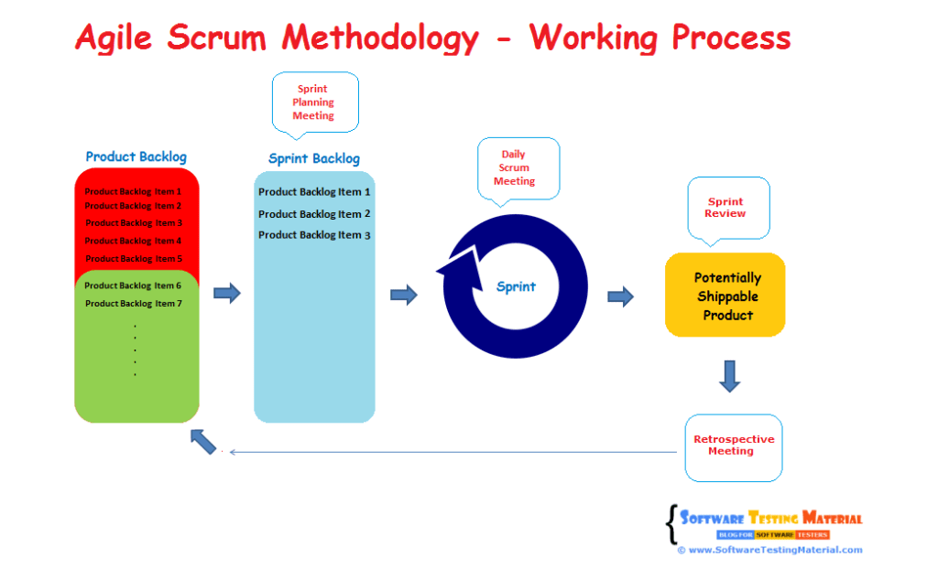

In Scrum, the project is divided into Sprints.
Sprint: Each Sprint has a specified time line (2 weeks to 1 month). This time line will be agreed by a Scrum Team during the Sprint Planning Meeting. Here, User Stories are split in to different modules. End result of every Sprint should be potentially shippable product.

Roles in Agile Scrum Methodology-
Product Owner:
Product Owner usually represents the Client and acts as a point of contact from Client side. The one who prioritizes the list of Product Backlogs which Scrum Team should finish and release.
ScrumMaster:
Scrum Master acts as a facilitator to the Scrum Development Team. Clarifies the queries and organizes the team from distractions and teach team how to use scrum and also concentrates on Return on Investment (ROI).
Scrum Development Team:
Developer’s, QA’s. Who develops the product. Scrum development team decides the effort estimation to complete a Product Backlog Item.
Scrum Team:
.A cross-functional, self-organizing group of dedicated people (Group of Product Owner, Business Analyst, Developer’s and QA’s). Recommended size of a scrum team is 7 plus or minus 2 (i.e, between 5 to 9 members in a team).

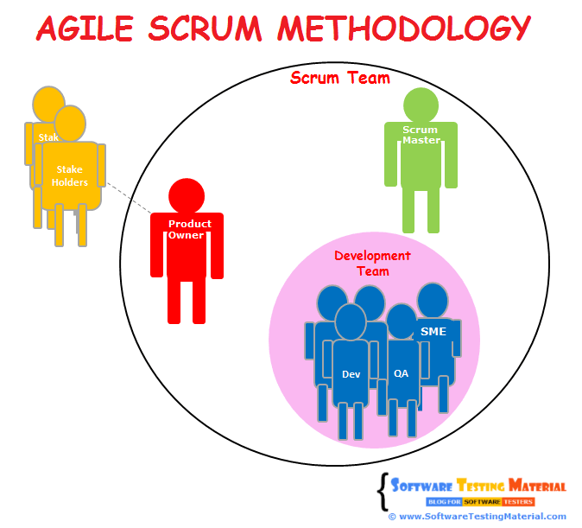

CHAPTER-3
TOURISM MANAGEMENT-

  - Introduction
Tourism Management is a website used for managing the tourism places for the visitors in India only. Tourism comprises a multitude of activities which together form one of the fastest growing international sectors. The journal takes an interdisciplinary approach and planning and policy aspects of international, national and regional tourism.
Under this project we are checking the Availability, Enability and Functionality of all the panels and modules by performing various testing strategies and techniques. At very first stage testing is performed manually by testing each sub module to check its availability, enability and functionality. Test cases are designed and executed accordingly.

3.2 Various Modules of Tourism Management page:
- Home
- User Management
- Places Management
- Category Management
- Sub category Management
- Gallery Management
- Home:
Home module is also called as Tourism Dashboard which displays the entire home page.

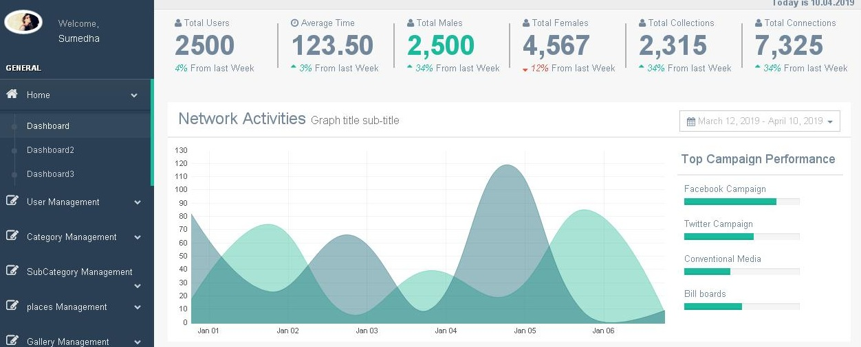

2. User Management-
This module is used to fill the user details and other management facilities which are being provided to user.
It contains two more sub-modules-
- Add user- Add user is used to add the multiple users entry.
- User listing- It provides the list of the added users.
Add user-
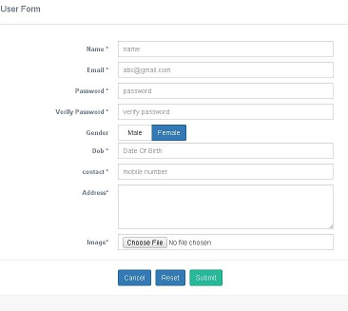
User listing-
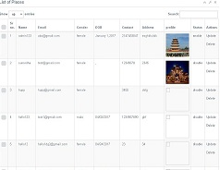

3. Places Management-
This module is used to fill the places details and other mandatory requirements to travel to different places.
It contains two more sub-modules-
- Add places- Add places is used to add the multiple places details.
- Place listing- It provides the list of the added places.
Add places-
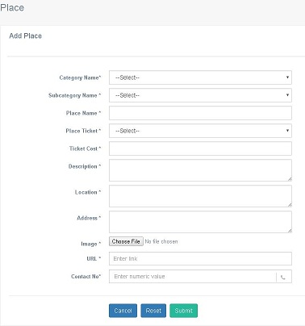
Place listing-
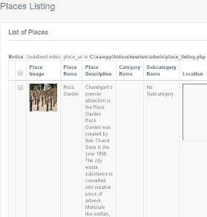
4. Category Management-
This module is used to fill the category details and other mandatory requirements to travel to different places.
It contains two more sub-modules-
- Add category- Add category is used to add the multiple categories details.
- Category listing- It provides the list of the added categories.
.Add categories-
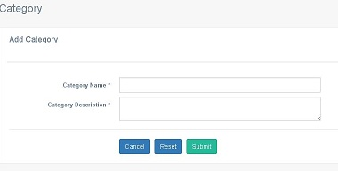

Category listing-
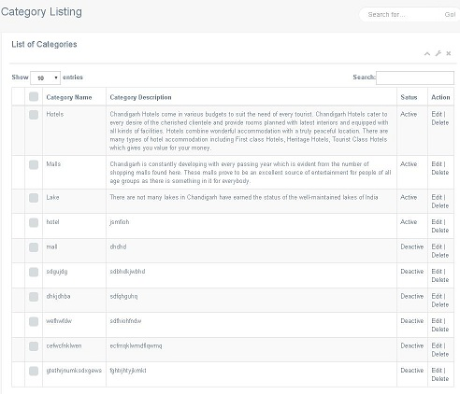

5. Sub-category Management-
This module is used to fill the sub-categories of different places details and other mandatory requirements to travel to different places.
It contains two more sub-modules-
- Add sub-category- Add sub-category is used to add the multiple sub-categories details.
- Sub-category listing- It provides the list of the added sub-categories.

Add Sub-category-
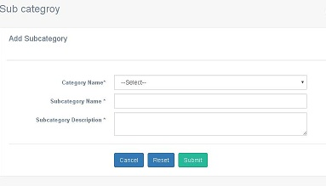

Sub-category listing-
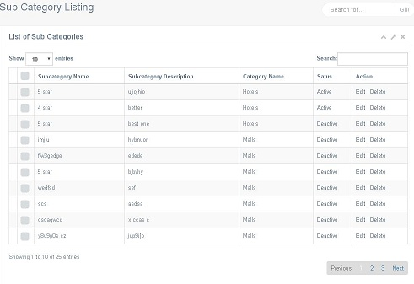
6. Gallery Management-
This module is used to add the images of different places where the user want to travel and other mandatory requirements
It contains two more sub-modules-
- Add gallery- Add gallery is used to add the multiple images.
- Gallery listing- It provides the list of the added images.

Add gallery-
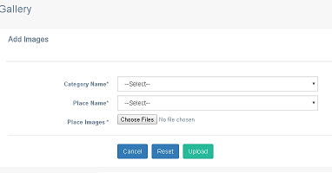

Gallery listing-
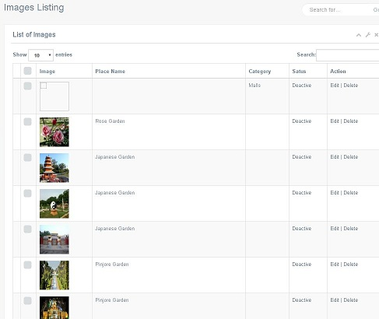
CHAPTER-4
TEST CASES

4.1 Introduction-
What is Test Case-
A test case is a set of conditions or variables under which a tester will determine whether a system under test satisfies requirements or works correctly.
The process of developing test cases can also help find problems in the requirements or design of an application.

4.2 Test Case Template-

A test case can have the following elements. Note, however, a test management tool is normally used by companies and the format is determined by tool used.
Test Suite ID: The ID of the test suite to which this test case belongs.
Test Case ID: The ID of the test case.
Test Case Summary: The summary / objective of the test case.
Related Requirement: The ID of the requirement this test case relates/traces to.
Prerequisites: Any prerequisites or preconditions that must be fulfilled prior to executing the test.

Procedure: Step-by-step procedure to execute the test.
Test Data: The test data, or links to the test data, that are to be used while conducting the test.
Expected Result: The expected result of the test.
Actual Result: The actual result of the test; to be filled after executing the test.
Status: Pass or Fail. Other statuses can be ‘Not Executed’ if testing is not performed and ‘Blocked’ if testing is blocked.
Remarks: Any comments on the test case or test execution.
Created By: The name of the author of the test case.
Date of Creation: The date of creation of the test case.
Executed By: The name of the person who executed the test.
Date of Execution: The date of execution of the test.
Test Environment: The environment (Hardware/Software/Network) in which the test was executed.

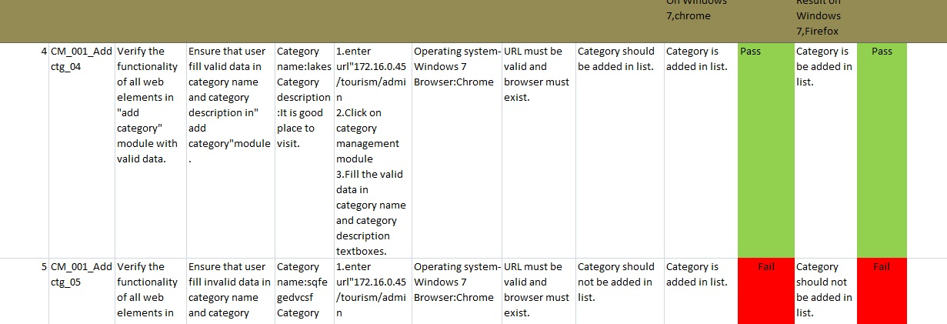

4.3 Best Practice for writing good Test Case Example.
1. Test Cases need to be simple and transparent:
Create test cases that are as simple as possible. They must be clear and concise as the author of the test case may not execute them.
Use assertive language like go to the home page, enter data, click on this and so on. This makes the understanding the test steps easy and tests execution faster.
2. Create Test Case with End User in Mind:
The ultimate goal of any software project is to create test cases that meet customer requirements and is easy to use and operate. A tester must create test cases keeping in mind the end user perspective
3. Avoid test case repetition:
Do not repeat test cases. If a test case is needed for executing some other test case, call the test case by its test case id in the pre-condition column
4. Do not Assume:
Do not assume functionality and features of your software application while preparing test case. Stick to the Specification Documents.

5. Ensure 100% Coverage:Make sure you write test cases to check all software requirements mentioned in the specification document. Use Traceability Matrix to ensure no functions/conditions is left untested.
6. Test Cases must be identifiable:
Name the test case id such that they are identified easily while tracking defects or identifying a software requirement at a later stage.
7. Implement Testing Techniques:
It's not possible to check every possible condition in your software application. Software Testing techniques help you select a few test cases with the maximum possibility of finding a defect.
- Boundary Value Analysis (BVA): As the name suggests it's the technique that defines the testing of boundaries for a specified range of values.
- Equivalence Partition (EP): This technique partitions the range into equal parts/groups that tend to have the same behavior.
- State Transition Technique: This method is used when software behavior changes from one state to another following particular action.
- Error Guessing Technique: This is guessing/anticipating the error that may arise while doing manual testing. This is not a formal method and takes advantages of a tester's experience with the application
8. Self-cleaning
The test case you create must return the Test Environment to the pre-test state and should not render the test environment unusable. This is especially true for configuration testing.
9. Repeatable and self-standing
The test case should generate the same results every time no matter who tests it
10. Peer Review.
After creating test cases, get them reviewed by your colleagues. Your peers can uncover defects in your test case design, which you may easily miss.

CHAPTER-5
TEST CASE MANAGEMENT TOOL
5.1 Introduction-
Test case Management System is most widely used web based open source test management tool. User can create test project and document test cases using this tool. With Test case Management System you can create an account for multiple users and assign different user roles. Admin user can manage test cases assignment task.
It supports both automated and manual execution of Test cases. The testers can generate Test plan and Test Report in a fraction of the time with this tool. Since it is a web based tool, multiple users can access its functionality at the same time with their credentials and assigned roles.

We will learn about:
- Advantages of Test case Management System.
- Login to Test case Management System.
- Creating a Test Project
- Creating Keyword and Platform.
- Creating a Test Plan
- Build Creation
- Creating Testsuite
- Creating a Testcase
- Assigning test case to test plan
- Creating Users and Assigning Roles in Testcase Management System.
- Executing a test case
- Generating Test Reports
- Export Test case/ Test Suite
- Importing Test case/ Test suite

Advantages of Testcase Management System:
- It supports multiple projects
- Easy export and import of test cases
- Easy filtration of test cases with version, keywords, test case ID and version
- Easy to assign test cases to multiple users
- Easy to generate test plan and test reports in various formats
- Provide credentials to multiple users and assign roles to them

5.2 Login to Test case Management System:
Step 1: Open the Test case Management System home-page and enter the login details
- Enter the user ID – admin
- Enter the password
- Click on login tab.
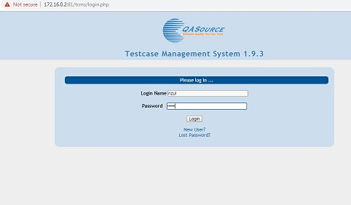
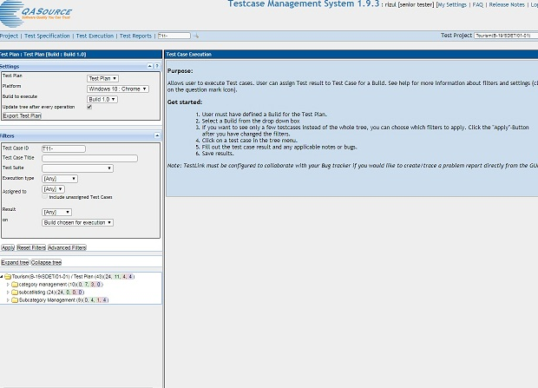

5.3 Creating a Test Project
Step 1: In the main window click on Test Project Management, it will open another window
Step 2: Click on the tab "create" to create a new project.
Step 3: Enter all the required fields in the window like a category for a test project, name of the project, prefix, description, etc. After filling all necessary details, click on tab "Create" at the end of the window.

Creating Keywords by Keyword Management
Step 1: Click on Project -> Keyword Management.
Step 2: Click on Create Keyword.

Step 3: Enter Keyword and Description.

Step 4: Click on Save button to save the keyword.

5.4 Creating Platform by Platform Management
Step 1: Click on Project -> Platform Management.
Step 2: Click on Create Platform.
Step 3: Enter Platform and Description.

Step 4: Click on Save button to save the Platform.

5.5 Creating a Test Plan
Test plan holds the complete information like the scope of Software testing, milestone, test suites and test cases. Once you have created a Test Project, next step is to create Test plan.
Step 1: From the home-page, click on Test Plan Management from home-page
Step 2: It will open another page, at the bottom of the page click on a tab "Create"
Step 3: Fill out all the necessary information like name, description, create from existing test plan, etc. in the open window, and click on "create tab"

Build Creation
A build is a specific release of a software
Step 1: Click on Builds/Releases under Test Plan from the home page
Step 2: In the next window, fill all necessary details for a software release and click on create to save your release
- Enter the title name
- Enter the description about the software release
- Mark the check-box for status- Active
- Mark the check-box for status- Open
- Choose the date of release
- Click on create a button

5.6 Creating Test suite
Test suite is a collection of test cases which may be testing or validating the same component. Following steps will explain how to create test suite for your project.
Step 1: Click on test specification option from the home page.
Step 2: Click on Project name and will display a series of test operation.
Step 3: Click on the "create" tab for the test suite
Step 4: Fill-up all the details for test-suite and click on save it tab.
- Enter the test suite name
- Enter the details about your test suite
- Select the keywords
- Click on Create Test Suite

5.7 Creating a Test case
Test case holds a sequence of test steps to test a specific scenario with an expected result. Below steps will explain how to create a test-case along with test steps.
Step 1: Click on the test suite folder on the left side of the panel under a folder tree structure
Step 2: Click on the Created Test Suite.
Step 3: New window will open, to create test cases click on create button in test-case operations
Step 4: Fill-up all the details for test case creation.
- Enter the test case title.
- Enter the test case summary.
- Enter precondition.
- Select keywords related to the test case
- Click on Create button
Step 5: Click on test-case from the folder, as shown above, it will open a window. Click on "create steps" button in a test case. It will open a test case step editor
Step 6: It will open another window on the same page, in that window you have to enter the following details
- Enter the step-action for your test case
- Enter the Expected results.
- Click save it and add another step action OR click save and exit tab if there is no more test step to add.

5.8 Executing a test case
In TCMS, we can run a test case and change execution status of a test case. Status of a test-case can be set to "blocked" "Passed", or "failed". Initially, it will be in "not run" status but once you have updated it, it cannot be altered to "not run" status again.
Step 1: From the navigation bar click on the "Test Execution" link. It will direct you to the Test Execution Panel.
Step 2: Pick the Test case you want to run from the left side panel
Step 3: Once you have selected the test cases, it will open a window.
Step 4: Follow the following steps
- Enter the notes related to test case executed
- Select its status

Step 5: On the same page, you have to fill similar detail about the execution of test-case. Fill the details, select the status and then click on "save execution".

Generating Test Reports
TCMS supports various test report formats like
- HTML
- MS Word
- MS Excel
- Open Office Writer
- Open Office Calc

Step 1: From the navigation bar, click on Test Reports option
Step 2: From the left side panel, select "Test Report" link
Step 3: To generate a report follow the following steps
- Mark and unmark the option you want to highlight in your test report
- click on your project folder

CHAPTER-6

BUGZILLA

  - Introduction:
Bugzilla is an open-source issue/bug tracking system that allows developers to keep track of outstanding problems with their product. It is written in Perl and uses MYSQL database.
Bugzilla is a Defect tracking tool, however, it can be used as a test management tool as such it can be easily linked with other Test Case management tools like Quality Center, Testlink etc.
This open bug-tracker enables users to stay connected with their clients or employees, to communicate about problems effectively throughout the data-management chain.
Key features of Bugzilla includes
- Advanced search capabilities
- E-mail Notifications
- Modify/file Bugs by e-mail
- Time tracking
- Strong security
- Customization
- Localization

6.2 How to log-in to Bugzilla
Step 1: Use the following link for your handons. To create an account in Bugzilla tool or to login into the existing account go to New Account or Log in option in the main menu.
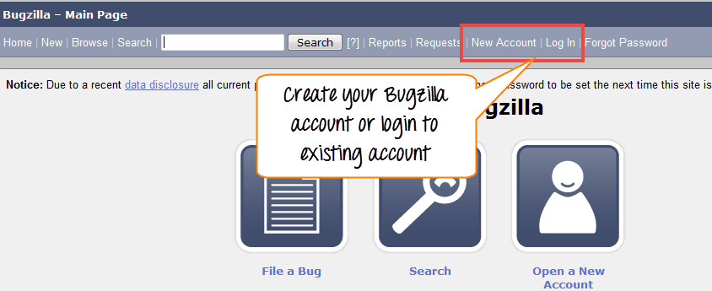
Step 2: Now, enter your personal details to log into Bugzilla
- User ID
- Password
- And then click on "Log in"
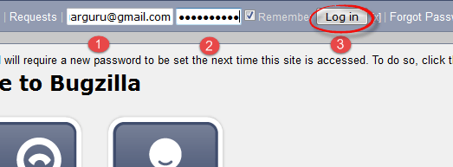
Step 3: You are successfully logged into Bugzilla system

6.3 Creating a Bug-report in Bugzilla:
To create a new bug in Bugzilla, visit the home-page of Bugzilla and click on NEW tab from the main menu .In the next window
- Enter Product
- Enter Component
- Give Component description
- Select version,
- Select severity
- Select Hardware
- Select OS
- Enter Summary
- Enter Description
- Attach Attachment
- Submit
NOTE: The above fields will vary as per your customization of Bugzilla

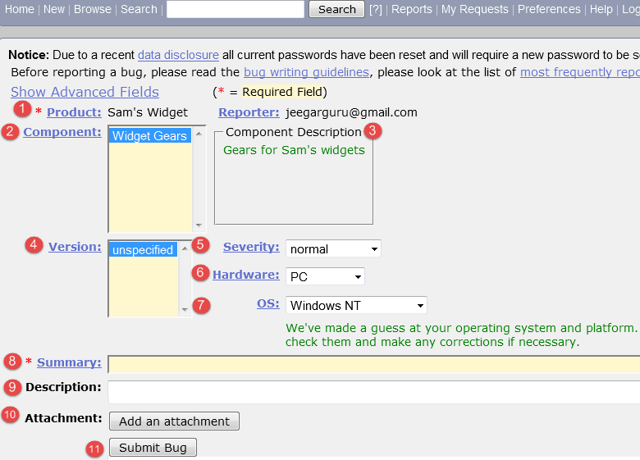
NOTE: The mandatory fields are marked with *.
In our case field's
- Summary
- Description
Are mandatory
If you do not fill them you will get a screen like below
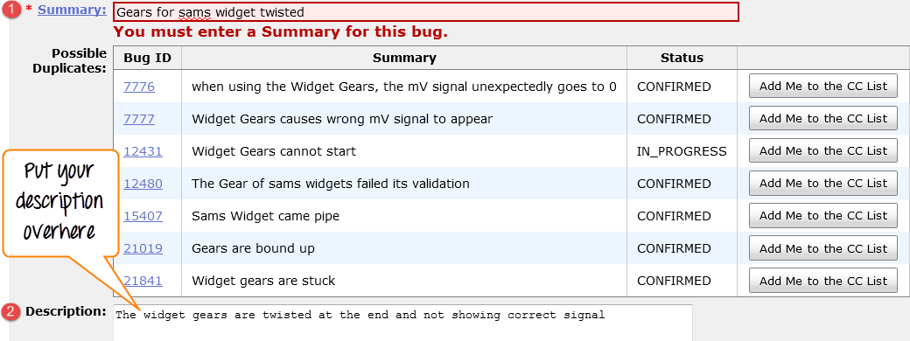

Bug is created ID# 26320 is assigned to our Bug. You can also add additional information to the assigned bug like URL, keywords, whiteboard, tags, etc. This extra-information is helpful to give more detail about the Bug you have created.
In the same window if you scroll down further. You can select deadline date and also status of the bug. Deadline in Bugzilla usually gives the time-limit to resolve the bug in given time frame.

CHAPTER-7
AUTOMATION TESTING

7.1 Introduction:
What is automation testing -
Manual testing is performed by human sitting in front of carefully executing the test steps. Automation Testing means using an automation tool to execute your test case suite.
The automation software can also enter test data into the System Under Test, compare expected and actual results and generate detailed test reports. Test Automation demands considerable investments of money and resources.
Successive development cycles will require execution of same test suite repeatedly. Using a test automation tool, it's possible to record this test suite and re-play it as required. Once the test suite is automated, no human intervention is required. This improved ROI of Test Automation. The goal of Automation is to reduce the number of test cases to be run manually and not to eliminate Manual Testing altogether.

Goal of automation Testing-
- Goal of automation testing is to reduce number of test cases to be run manually and do not eliminate manual testing.
- It must improve efficiency, reduce testing cost.
- It should give consistent and accurate results and track all the test runs.

Why Automated tests-
Automated software testing is important due to the following reasons:
- Manual Testing of all workflows, all fields, all negative scenarios is time and money consuming
- It is difficult to test for multilingual sites manually
- Automation does not require Human intervention. You can run automated test unattended (overnight)
- Automation increases the speed of test execution
- Automation helps increase Test Coverage
- Manual Testing can become boring and hence error-prone.

Which Test Cases to Automate-
Test cases to be automated can be selected using the following criterion to increase the automation ROI
- High Risk - Business Critical test cases
- Test cases that are repeatedly executed
- Test Cases that are very tedious or difficult to perform manually
- Test Cases which are time-consuming

The following category of test cases are not suitable for automation:
- Test Cases that are newly designed and not executed manually at least once
- Test Cases for which the requirements are frequently changing
- Test cases which are executed on an ad-hoc basis.

When to start Automation-
- To optimize speed and efficiency.
- The cases need to run for every build.
- To increase quality and decrease cost
- Cases that require execution of multiple data called parameterized.
- When application under manual is stable.
- To increase test coverage.
- The identical test cases which are to be executed on different h/w configuration.

When not to automate-
- Test cases that are newly designed and manual testing is not done.
- Test cases for which requirement are changing frequently.
- Test cases which are executed on ad-hoc basis.
- Test cases that are not in usability type of testing.
- when project does not have enough time.
- Test cases with unknown results can not be automated.
- Test cases which has manual interaction like enter authorization code, captcha code.

7.2 Automated Testing Process:
Following steps are followed in an Automation Process-
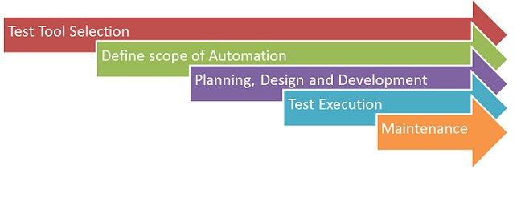
Test Tool Selection-
Test Tool selection largely depends on the technology the Application under Test is built on.
- Tool which supports different platforms and technology.
- Tool which is easy to use.
- Tool which supports multiple testing framework
- Tool which has good debugging facilities.
- Tool which has flexibility for testers of all skill levels.
- Tool which supports various types of test include functional, test management, mobile.
- Tool which is feature rich but also easy to create automated tests.
- Tool which minimize training cost of selected tools.
- Tool which create automated test that are reusable, maintainable and resistant to changes in applications UI.

Define the Scope of automation-
The scope of automation is the area of your Application Under Test which will be automated. Following points help determine scope:
- The features that are important for the business
- Scenarios which have a large amount of data
- Common functionalities across applications
- Technical feasibility
- The extent to which business components are reused
- The complexity of test cases
- Ability to use the same test cases for cross-browser testing.

Planning, Design and Development-
During this phase, you create an Automation strategy & plan, which contains the following details-
- Automation tools selected
- Framework design and its features
- In-Scope and Out-of-scope items of automation
- Automation testbed preparation
- Schedule and Timeline of scripting and execution
- Deliverables of Automation Testing

Test Execution-
Automation Scripts are executed during this phase. The scripts need input test data before there are set to run. Once executed they provide detailed test reports.
Execution can be performed using the automation tool directly or through the Test Management tool which will invoke the automation tool.
Example: Quality center is the Test Management tool which in turn it will invoke QTP for execution of automation scripts. Scripts can be executed in a single machine or a group of machines. The execution can be done during the night, to save time.

Maintainance-
As new functionalities are added to the System Under Test with successive cycles, Automation Scripts need to be added, reviewed and maintained for each release cycle. Maintenance becomes necessary to improve the effectiveness of Automation Scripts.

7.3 FrameWork for Automation:
A framework is set of automation guidelines which help in-
- Maintaining consistency of Testing
- Improves test structuring
- Minimum usage of code
- Less Maintenance of code
- Improve re-usability
- Non Technical testers can be involved in code
- The training period of using the tool can be reduced
- Involves Data wherever appropriate

There are four types of frameworks used in automation software testing-
- Data Driven Automation Framework
- Keyword Driven Automation Framework
- Modular Automation Framework
- Hybrid Automation Framework

