Create Table Employee
Query:
Create table Emp(empid int, name varchar(10), dept varchar(10), salary int, city varchar(10));
insert into Emp values(101,'Ravi','IT',50000,'Chennai');
insert into Emp values(102,'Meena','HR',45000,'Bangalore');
insert into Emp values(103,'Arun','IT',60000,'NULL');
insert into Emp values(104,'Kavya','Finance',55000,'Chennai');
insert into Emp values(105,'John','HR',40000,'Coimbatore');

Questions:
- Display all records from the Employee table
Query:
SELECT *FROM emp;
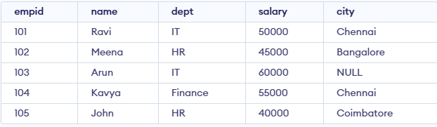
- Display only the Name and Salary of employees.
Query:
SELECT name, salary FROM emp;
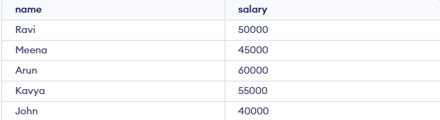

- Display employees whose salary is greater than 50,000.
Query:
SELECT *FROM emp WHERE salary>50000;
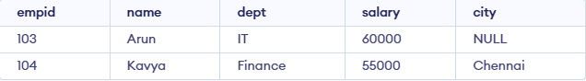
- Display employees who belong to the IT department.
Query:
SELECT *FROM emp WHERE dept=’IT’;
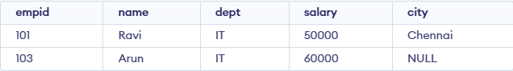
- Display employees whose city is Chennai.
Query:
SELECT *FROM emp WHERE city=’Chennai’;
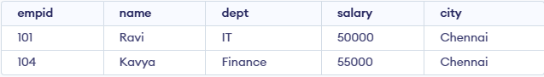
- Display employees whose salary is between 40,000 and 60,000.
Query:
SELECT *FROM emp WHERE salary BETWEEN 40000 AND 60000;
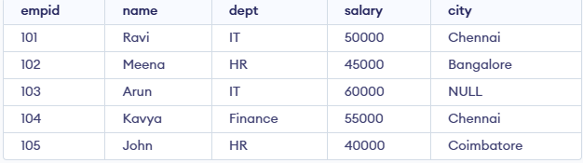

- Display employee names that start with the letter 'A' using the LIKE operator.
Query:
SELECT name FROM emp WHERE name LIKE 'A%';
- Display distinct departments from the Employee table.
Query:
SELECT DISTINCT dept FROM emp;
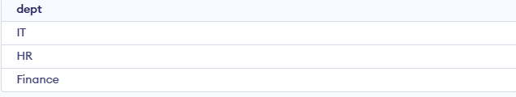
- Display employees whose City value is NULL.
Query:
SELECT *FROM emp WHERE city IS NULL;
- Find the total salary paid to all employees.
Query:
SELECT SUM(salary) AS Total_Salary FROM emp;
- Find the average salary of employees in the IT department.
Query:
SELECT AVG(salary) AS Average_Salary FROM emp WHERE dept = 'IT';

- Count the number of employees in each department using GROUP BY
Query:
SELECT dept, COUNT(*) AS Employee_CountFROM emp GROUP BY dept;
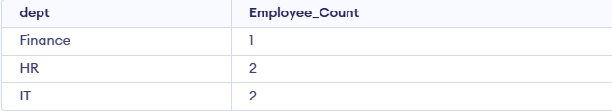
- Display employees whose salary is greater than the average salary (Nested Subquery)
Query:
SELECT *FROM emp WHERE salary > (SELECT AVG(salary)FROM emp);
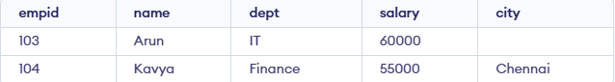
- Insert a new employee record
Query:
INSERT INTO Emp (empid, name, dept, salary, city)
VALUES (106, 'Priya', 'IT', 52000, 'Madurai');
- Update the salary of employee with EmpID = 105 to 48000
Query:
UPDATE Emp
SET salary = 48000
WHERE empid = 105;

Final Table:
