Heuristic Analysis

Project 2: Build an Adversarial Search Agent

Rizwaan Adil

**Objective**

The project attempts to devise an AI agent for the game of Isolation. The agent relies on Minimax algorithm with iterative deepening and alpha beta pruning to return best moves for a player within a given time constraint. The agent tests the below 3 heuristics against a few other AI agents and will eventually select a heuristic function which provides the best win rate

**Heuristic 1**

Custom Score 1: my_moves – 2* opponent’s moves

This simple yet elegant function emphasizes aggressive play against the opponent by evaluating the margin of moves between 2 players. This is based on the thumb rule that the player with more available moves generally wins.

**Heuristic 2**

Custom Score 2: my moves – 2* minimum of opponent’s moves for the next ply

An improvement over the first function, this function maximizes the move margin between the two players by choosing the game tree node which provides least moves to the opponent on his next turn. This is possible by utilizing the forecast move function of the board class.

**Heuristic 3**

Custom Score 3: (my moves – 2* opponent moves) + blank spaces/2

This is another take on the first function where we try to give a leg up to our agent in the early game. In the early game there are more blank spots to occupy, hence combined with the logic of function 1, this AI agent will maximize the move margin more aggressively during the beginning. The scarce but extremely valuable blank space will provide an extra edge throughout the game

**Conclusion**

The below figure shows the final result of a tournament where agens played 5 matches each

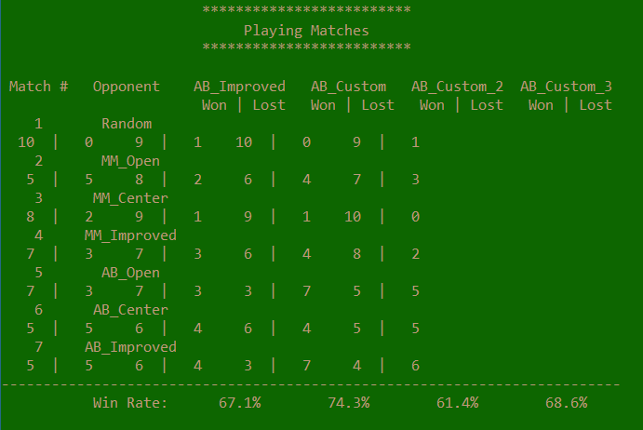

We notice that all custom heuristics were able to perform better than the baseline agent by a significant margin. Heuristic 1 stands out as the clear winner due to the significant winning margin over the baseline agent. Heuristic 3 (AB_Custom_3) which was an improvement over Heuristic 1 did not fare well as expected. This implies that the addition of blank space count to the original heuristic 1 logic had little or no impact in the final score. Heuristic 2 which searched the next ply for the opponent’s moves performed worst hinting at further refinement in logic.

Based on these results, we can safely conclude that heuristic 1 is the best choice due to its simplicity and demonstrated results. It can be further improvised by considering the centrality of the moves during initial gameplay.