1. Click on Intercept Menu

You should get the following page which displays previously stored rates which have been stored

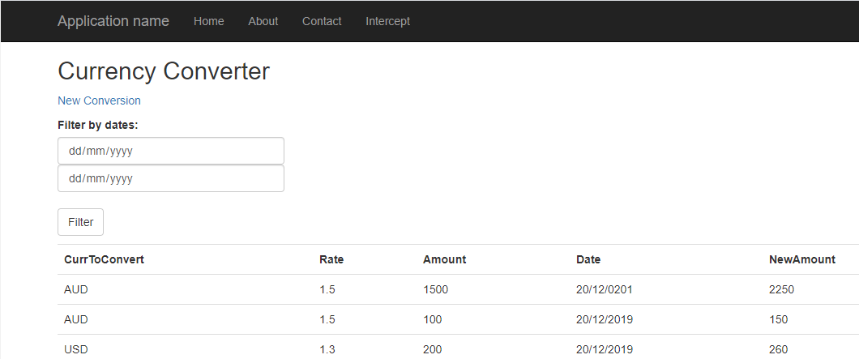

You can enter dates in the filter section which allows you to filter the list by dates the conversion rates were searched.

2. Click on ‘New Conversion’ and you should get the following page

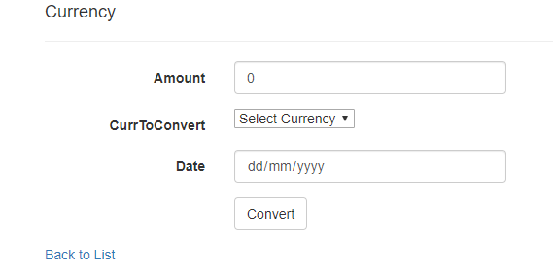

3. Filling in the values and clicking the ‘Convert’ button will take you to the following page displaying the conversion rate and the total amount you would get in the new currency.

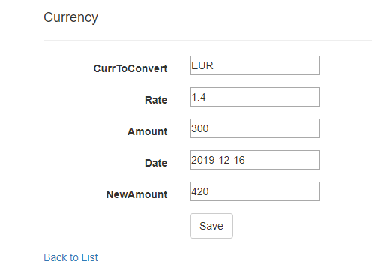

Clicking the ‘Save’ button saves the dates and conversion details to the list.