**ShipNet: Post CNN Model-based Ship Extraction from High Resolution Optical Remotely Sensed Images**

This project describes the concept to detect ships from sea images taken from satellites and these images are called as ‘Synthetic aperture radar (SAR)’. Ships can be detected from SAR images using Post CNN Algorithm. It will be trained with ship images from VGG ImageNet Network, while training it extract features from images using its height, width and image colour channel. CNN filter train images features map from multiple layers of convolution neural network. All object detection from image will be maintained in train vector with value 1 and other background features marked as 0. Whenever new SAR test image uploaded then proposed algorithm will apply train vector on SAR test image to detect objects with ships features.

All existing algorithms required manual sea segmentation images from hands to detect ships, if segmentation is not accurate or blur is capture in test images then ships will be detected falsely or no detection will happen. To overcome from this issue, we are using post CNN algorithm with Squeeze and Excitation concept.

Squeeze and Excitation concept is used to increase detection performance. Post CNN extract features from train images and then Excitation vector take relevant object detection features and ranked them, and then only top K-values will be preserved with 1. Other values will be set to 0. Then, the redundant sub-feature maps are suppressed using squeeze technique. In simple terms Excitation will identify top K features and accept them and squeeze technique remove all irrelevant features. After applying Squeeze and Excitation, post CNN will have train model with important relevant features. When we give new test image then that model apply on test image to detect ships.

Post CNN Working Procedure

After extracting shared feature maps from train images with a CNN, the first stage Region Proposal Network (RPN) takes shared feature maps as input and generates a set of rectangular candidate object locations named anchors, each with an objectness score. The size of each anchor depends on hyper parameters named scales and aspect ratios. A small network is slid over the shared feature maps and mapping each sliding window to lower dimensional feature. After two sibling fully connected layers, the 2A-dimensional vector box-classification and 4A-dimensional vector box-regression are generated for A anchors of each point on the feature map.

**Modules Information**

This project consists of following modules:

Generate post CNN Model: In this module a train post CNN model will be generated using Squeeze and Excitation. Input data to this module is given from ‘VGGImageNet.h5py’ file. Post CNN extract all features from this file and build a train model, while building model it will read all data from file and then using Squeeze and Excitation technique accept top K features and squeeze irrelevant features. Post CNN internally uses CNN pooling technique to build mode. Below code describe model generation for train images and use five convolution layers.

Upload Test Image & Detect Ship: In this module we will upload test image and then application extract features from this test image and then apply post CNN train model on that test image to detect ships.

**Screen shots**

To run this project double click on ‘run.bat’ file to get below screen

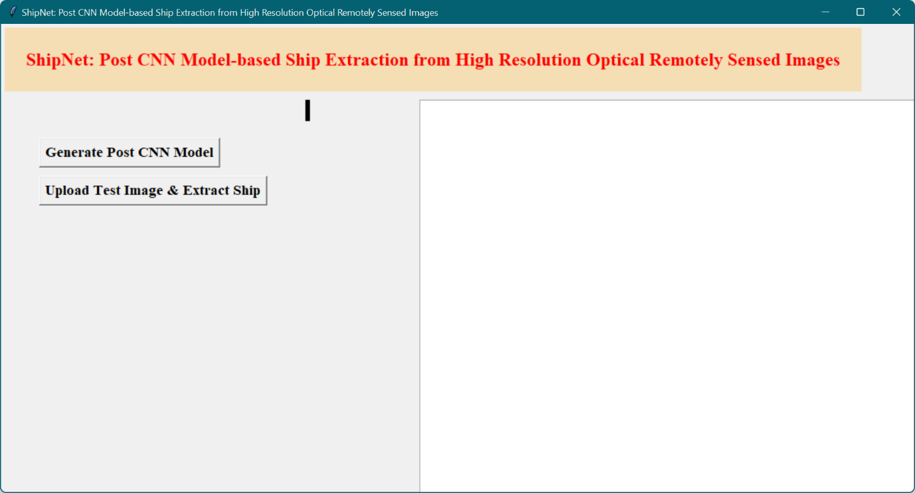

In above screen click on ‘Generate post CNN Model’ button to train CNN model

After generating model we will get above screen and if we want to see Model details then see black console screen below

From above screen we can see total numbers of layers generated by proposed post CNN model from images to build train model and in bottom we can see from VGG ImageNet it has used how many numbers of train images. Now click on ‘Upload Test Image & Detect Ship’ button to upload test image and then application will detect ship from input image.

In above screen uploading one sea image which has some ships and now click on ‘Open’ button and wait for few seconds to get below screen

After getting above screen just close image screen and backside screen to allow image to extract features from uploaded image and then to detects ship.

(Note: Please close above both screens only not black screens, once we close above both screens then in black console we can see features extraction process and once it detect ships then it will display detected ship)

In above black console in bottom X and Y features you can see and it will keep on processing till it detect ship, you just wait till you get below screen

In above screen we can see one ship is detected and then you close above ship screen to get another screen

In above screen we can see one ship is detected and one rectangle bounding box is surrounded around that ship.