
WHAMI
Where Am I? Verified by the real world.
Project Work Document: Market Positioning, Product Architecture, Roadmap, Hardware Strategy, and Development Plan
whami.global | whami.world
Confidential working draft | Prepared for Bastiaan van Gent & Timur Mukminov | 2026-06-14

Table of Contents
1. Executive Summary
2. Product Definition and Core Philosophy
3. Market Need and Timing
4. Market Positioning: Unique or Not?
5. Competitive Landscape
6. Target Markets and Beachhead Strategy
7. Product Architecture
8. One-View Position Opinions UI
9. Offline Region Packs and Data Moat
10. Phone App Roadmap and Work Packages
11. Hardware Device Phase
12. Magnetic Anomaly and Quantum Magnetometer Strategy
13. Business Model
14. Risk, Liability, and Compliance
15. Development Timeline and Team Plan
16. Investor Narrative and Go-to-Market
17. Appendices and Source Notes

1. Executive Summary
WHAMI stands for "Where Am I?" The core product is a resilient, offline-first navigation verification system. It does not simply ask GPS where the user is. It compares multiple independent physical-world indicators and shows their position opinions on one screen.
The strongest positioning is not as a replacement for Google Maps, Garmin, Navionics, or OpenCPN. WHAMI should be positioned as a Verified Navigation / Position Trust Engine: a system that tells the user whether GPS is believable and what the physical world says instead.
- Primary trust anchor: landmark and seamap reality matching.
- Secondary witness: GPS/GNSS, useful but vulnerable to spoofing, jamming, jumps, or loss of signal.
- Third physical layer: magnetic field heading, fingerprinting, and later magnetic anomaly matching.
- Stable independent layer: sextant / sky checks, shown with wide error circles rather than false precision.
- Short-term sanity layer: IMU dead reckoning and movement consistency.
- User experience: show all position opinions in one view using color-coded markers and uncertainty circles.
Bottom line: WHAMI is not unique because each component is new. WHAMI can become unique by combining those components into a visible, understandable, physical-world verification layer where GPS is only one witness.

2. Product Definition and Core Philosophy
Brand: WHAMI - Where Am I?
Domains: whami.global and whami.world.
Tagline options:
- Where Am I? Verified by the real world.
- Navigation you can verify.
- One screen. All position opinions. One trusted output.
- GPS is only one witness.

2.1 The WHAMI Rule
The WHAMI rule is the operating logic behind the app:
Indicator | Question / opinion | WHAMI interpretation
GPS | I am here. | Fast but vulnerable. Useful, but never absolute authority.
Landmark / seamap | Does that match the real world? | Highest-trust physical-world anchor when visible or available.
Camera / ARCore / vision | Do buildings, coastline, mountains, bridges, or harbor features match the offline map? | Visual confirmation and local feature matching.
Magnetometer / magnetic map | Does the magnetic fingerprint or heading fit this area? | Passive physical field check, hard to spoof at scale.
IMU | Did the physical movement path make sense? | Short-term movement sanity and impossible-jump detection.
Sextant / sky | Do sun, moon, or stars roughly confirm this area? | Stable independent validator; not meter-accurate, but very valuable.

2.2 Important correction: sextant is stable, not precise
The sextant / celestial layer should always be taken into account, but it should not be represented as highly accurate. In the WHAMI UI it should be shown in green with a wider uncertainty circle. Its value is independence and stability, not meter-level accuracy. This prevents false confidence while still using the sky as a powerful anti-spoofing witness.

2.3 Position opinion colors
Opinion | Color | Purpose
WHAMI trusted position | Amber | The output position the system currently trusts most.
Landmark / seamap | Black | Primary physical-world anchor.
GPS | Blue | Fast electronic/radio position witness.
Magnetic | Red | Physical magnetic field / fingerprint opinion.
Sextant / sky | Green | Stable independent sky validator.
IMU movement | Purple | Dead-reckoning and movement consistency witness.

3. Market Need and Timing
Modern navigation is highly dependent on GNSS/GPS. GNSS is powerful, but it is still a radio signal and can be jammed, spoofed, obstructed, degraded, or unavailable. This creates a clear market need for complementary positioning, navigation, and timing systems that verify GPS rather than blindly trusting it.
Source note: FAA guidance treats interruptions to GPS/GNSS signal-in-space as GNSS interference and includes jamming and spoofing [S1]. CISA identifies PNT as necessary for U.S. critical infrastructure [S2]. U.S. DOT is developing and testing backup GPS and complementary PNT services [S3].

3.1 Why WHAMI now?
- Consumers and professionals increasingly use phones as their primary navigation device.
- Offline maps already prove users understand the need to download data before entering low-signal areas.
- Marine and outdoor users already pay for navigation data, charts, and hardware.
- GPS interference, spoofing, and jamming are no longer niche concerns.
- Magnetic and geophysical navigation are being validated by high-end systems, which supports WHAMI’s future hardware thesis.

3.2 The key market insight
People trust GPS too much. WHAMI teaches the device not to trust GPS blindly. That is the emotional, technical, and commercial hook.

4. Market Positioning: Unique or Not?
WHAMI should create its own product category: Verified Navigation / Physical-World Position Trust.
The realistic uniqueness assessment is: components are not unique; the combination, trust hierarchy, and one-view position-opinion user experience can be unique.

4.1 What is not unique
- Offline maps exist in Google Maps and other apps [S4].
- AR/visual localization exists through ARCore Geospatial and VPS where coverage is available [S5].
- Marine charting exists through Navionics, OpenCPN, NOAA ENCs, and OpenSeaMap [S8-S11].
- Open-source Android map rendering and offline tiles exist through MapLibre and osmdroid [S6-S7].
- Magnetic anomaly navigation exists in research and high-end systems such as MIT MagNav.jl, SandboxAQ AQNav, and Q-CTRL Ironstone Opal [S13-S15].

4.2 What can be unique
- The visible courtroom model: every source gives a position opinion, and WHAMI shows disagreement rather than hiding it.
- Landmark/seamap first: the real physical world has priority over GPS.
- Sextant/sky always counted as stable but approximate.
- Offline Region Packs combining land, ocean, lake, magnetic, celestial, visual, and route-trust data.
- A hardware path that turns WHAMI from an app into a rugged physical-world atlas and sensor platform.
Recommended category statement:
WHAMI is a Verified Navigation system: a position trust engine that compares GPS against landmarks, seamaps, magnetic fields, IMU movement, celestial checks, and offline region packs.

5. Competitive Landscape
Competitor / category | Strength | WHAMI position
Google Maps / Apple Maps | Normal navigation, traffic, business search, route planning, offline areas. | Not transparent as a multi-witness anti-spoofing trust engine.
Garmin handheld GPS | Rugged outdoor devices, battery life, GNSS, maps, SOS in some models. | Still mainly gives navigation output, not a visible GPS-vs-physical-world courtroom.
Navionics / OpenCPN | Marine charting, offline charts, boat navigation, chart plotting. | Strong charting competitors; WHAMI should first become a verification layer, not a certified chart replacement.
ARCore Geospatial | Visual Positioning System using recognizable surroundings in supported coverage. | Useful input layer, but not WHAMI’s offline-first core and depends on coverage/model availability.
SandboxAQ / Q-CTRL | High-end magnetic/geophysical/quantum navigation for GPS-denied environments. | They validate the thesis, but they are not consumer app competitors.
Traditional sextant / compass | Independent physical-world navigation tools. | WHAMI digitizes and fuses these ideas into a modern UI.

Source note: Google Maps offline areas [S4], ARCore Geospatial [S5], MapLibre and osmdroid mapping [S6-S7], NOAA/OpenSeaMap/OpenCPN/Navionics marine data [S8-S11], and magnetic/geophysical navigation companies/tools [S13-S15] show that individual pieces exist. WHAMI’s opening is the fused trust layer.

6. Target Markets and Beachhead Strategy
WHAMI should not launch as a mass-market replacement for Google Maps. The best beachhead is users who already understand failure, redundancy, and offline navigation.

6.1 Target market ranking
Rank | Market | Why it matters
1 | Sailors, small boat owners, coastal/lake users | High need, willingness to pay, understands charts/compass/redundancy. Sea and Lake Mode should be an early premium wedge.
2 | Hikers, expeditions, off-grid travelers | Clear offline navigation pain, mountain/terrain/sky/compass familiarity, lower certification burden than marine.
3 | Emergency responders / disaster zones | Strong mission value but more complex B2B/B2G sales and procurement.
4 | Ports, logistics, offshore energy | Good fit for GPS integrity and landmark-rich environments. Needs enterprise workflow.
5 | Defense / security | Excellent strategic fit but slow procurement and export/control complexity.
6 | Autonomous robots / drones / vehicles | Long-term API/hardware module opportunity after core sensor fusion matures.

6.2 Beachhead recommendation
Start with GPS Truth Checker + Offline Region Pack for marine/lake/hiking users. This gives immediate value before perfect visual positioning exists. The market message is simple: "See whether GPS is believable."

7. Product Architecture
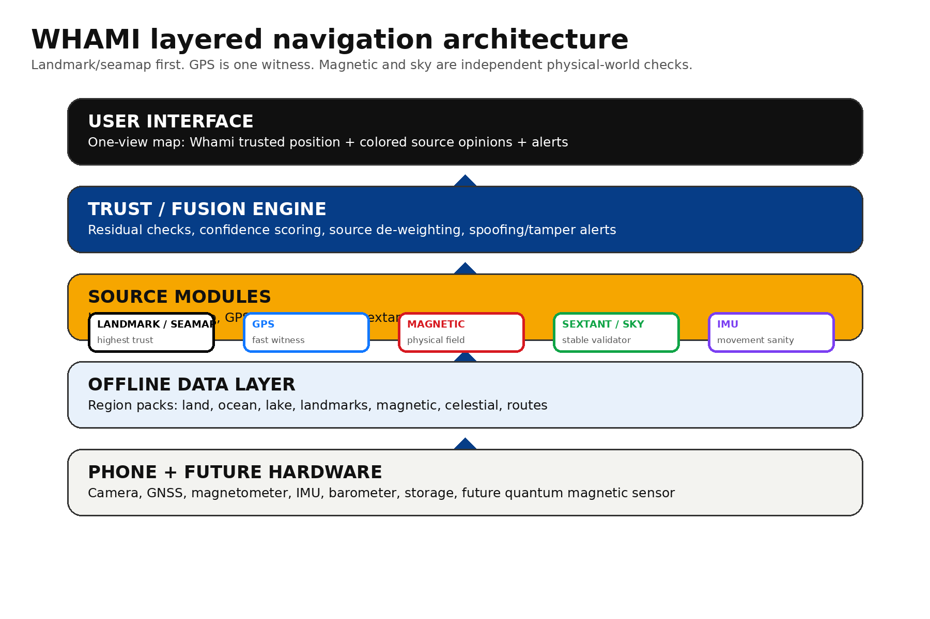
Figure 1 - WHAMI layered architecture. Landmark/seamap is primary; GPS, magnetic, IMU, and sextant are witnesses.

7.1 Core modules
Component | Responsibility
RegionPackManager | Downloads and verifies offline area packs: maps, seamap, landmarks, magnetic, celestial, routes.
SensorHub | Collects GPS/GNSS, IMU, gyroscope, magnetometer, barometer, and sensor availability.
LandmarkMappingModule | CameraX / ARCore / OpenCV visual feature extraction and landmark/seamap confirmation.
MagneticModule | Magnetic heading, field stability, fingerprinting, and future anomaly map matching.
CelestialModule | Sun/moon/star/sextant-style approximate position opinion and sky stability scoring.
TrustFusionEngine | Combines source opinions, checks residuals, de-weights suspicious sources, outputs trusted estimate.
UI Layer | One-view position opinions, trust score, alerts, map screen, sensor screen, region pack screen.

7.2 Trust scoring principle
A simple starting formula can be used before a full Extended Kalman Filter:
Trust = 0.45 x LandmarkMatch + 0.20 x GPSConfidence + 0.15 x MagneticFit + 0.10 x IMUPath + 0.10 x SkyStability
This is not fixed forever. The weightings should be dynamic: if landmarks are unavailable at sea or at night, magnetic and sky indicators gain more importance; if the phone is indoors near metal, magnetic trust drops; if GPS jumps impossibly, GPS trust drops sharply.

7.3 Full EKF / residual logic later
The long-term fusion engine should use an Extended Kalman Filter or factor-graph approach. Each source submits a measurement with covariance/uncertainty. The innovation residual tells WHAMI whether a source agrees with the current physical-world estimate. A large residual from GPS while landmark, IMU, magnetic, and sky remain stable triggers a GPS de-weighting event and clear alert.

8. One-View Position Opinions UI
The one-view map is the product’s most important interface. It makes the invisible disagreement between sensors visible to the user.
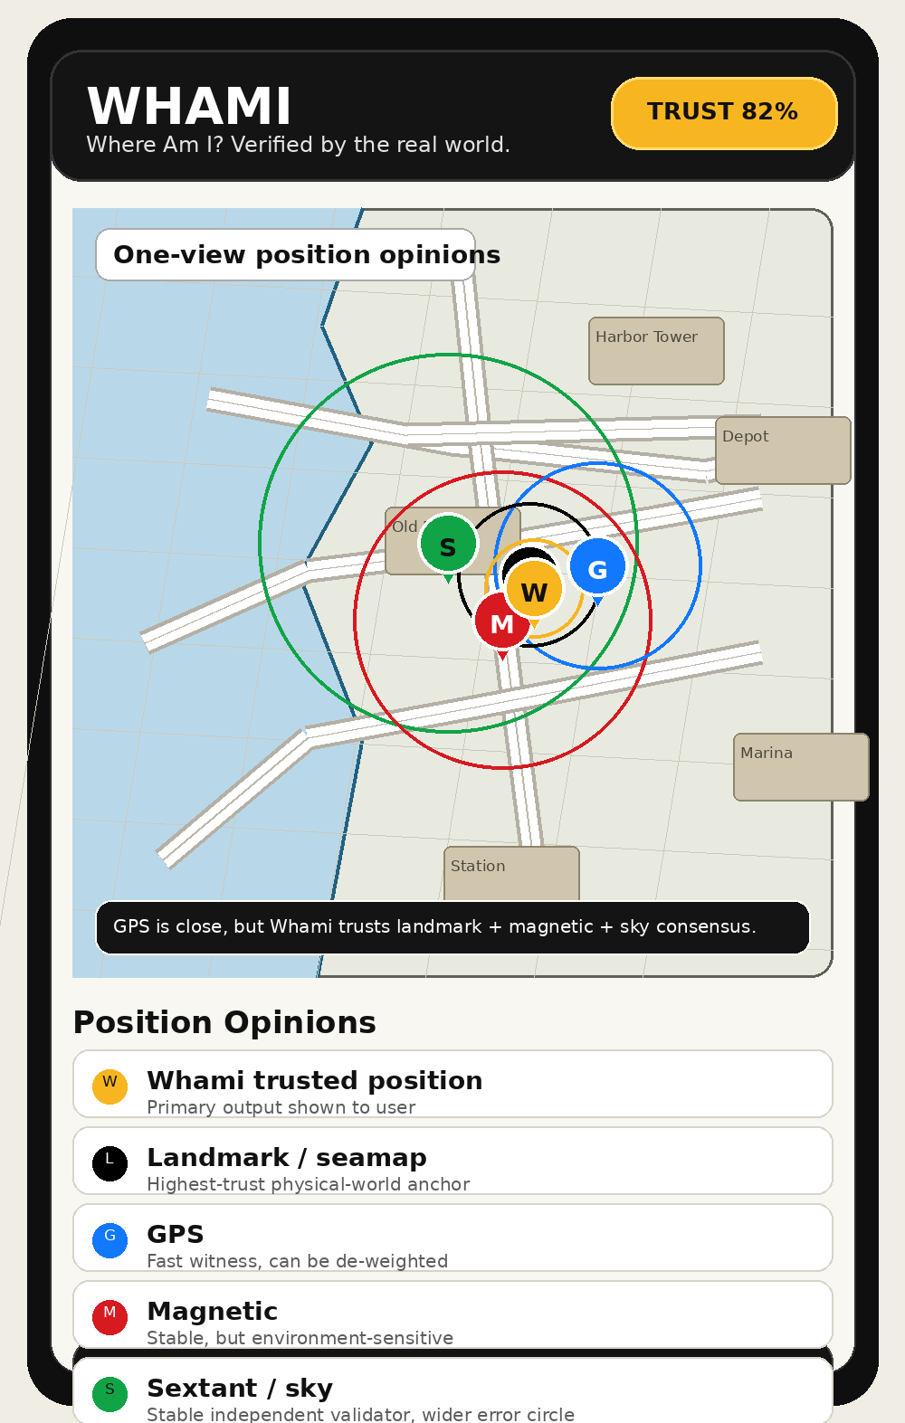
Figure 2 - Map page showing colored position opinions and error circles.

8.1 Page set from current starter concept
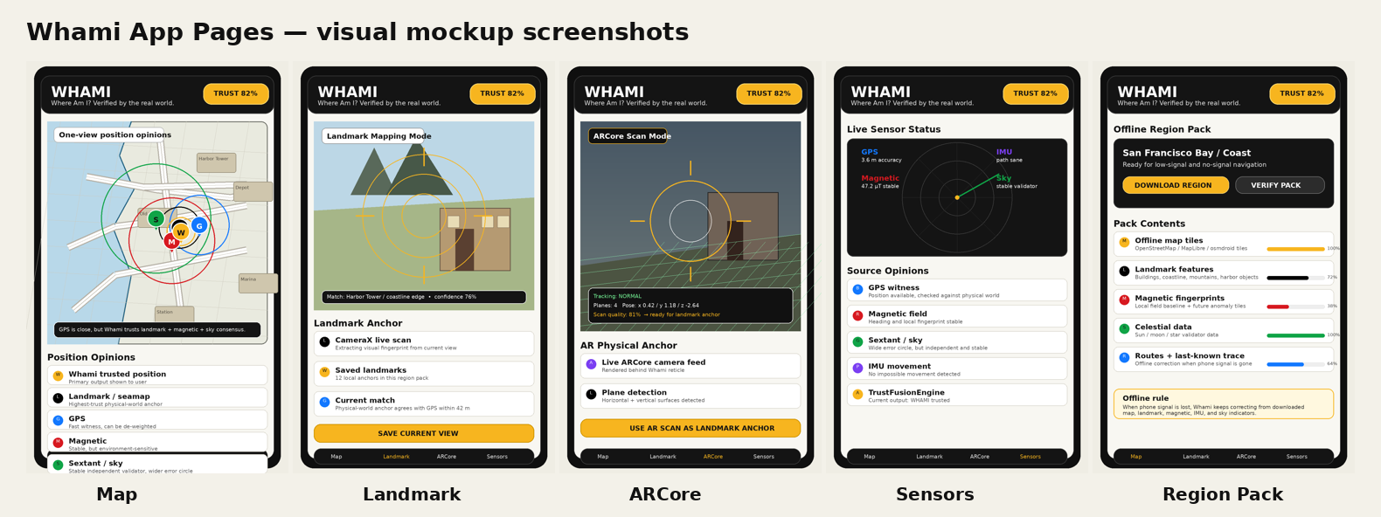
Figure 3 - WHAMI app page mockups: Map, Landmark scan, ARCore scan, Sensors, and Region Pack.

8.2 Core UI pages
Page | Role
Map | Primary user page: trusted position, GPS witness, magnetic opinion, sky opinion, landmark/seamap anchor.
Landmark Scan | CameraX-based visual capture and saved landmark matching.
ARCore Scan | Separate ARCore mode with camera feed behind the reticle and plane/pose/quality status.
Sensors | GPS, magnetic, IMU, sky, and TrustFusionEngine status.
Region Pack | Download, verify, update, and audit offline region data.

9. Offline Region Packs and Data Moat
The Region Pack is WHAMI’s most important long-term data asset. It converts WHAMI from a simple app into a portable physical-world atlas.
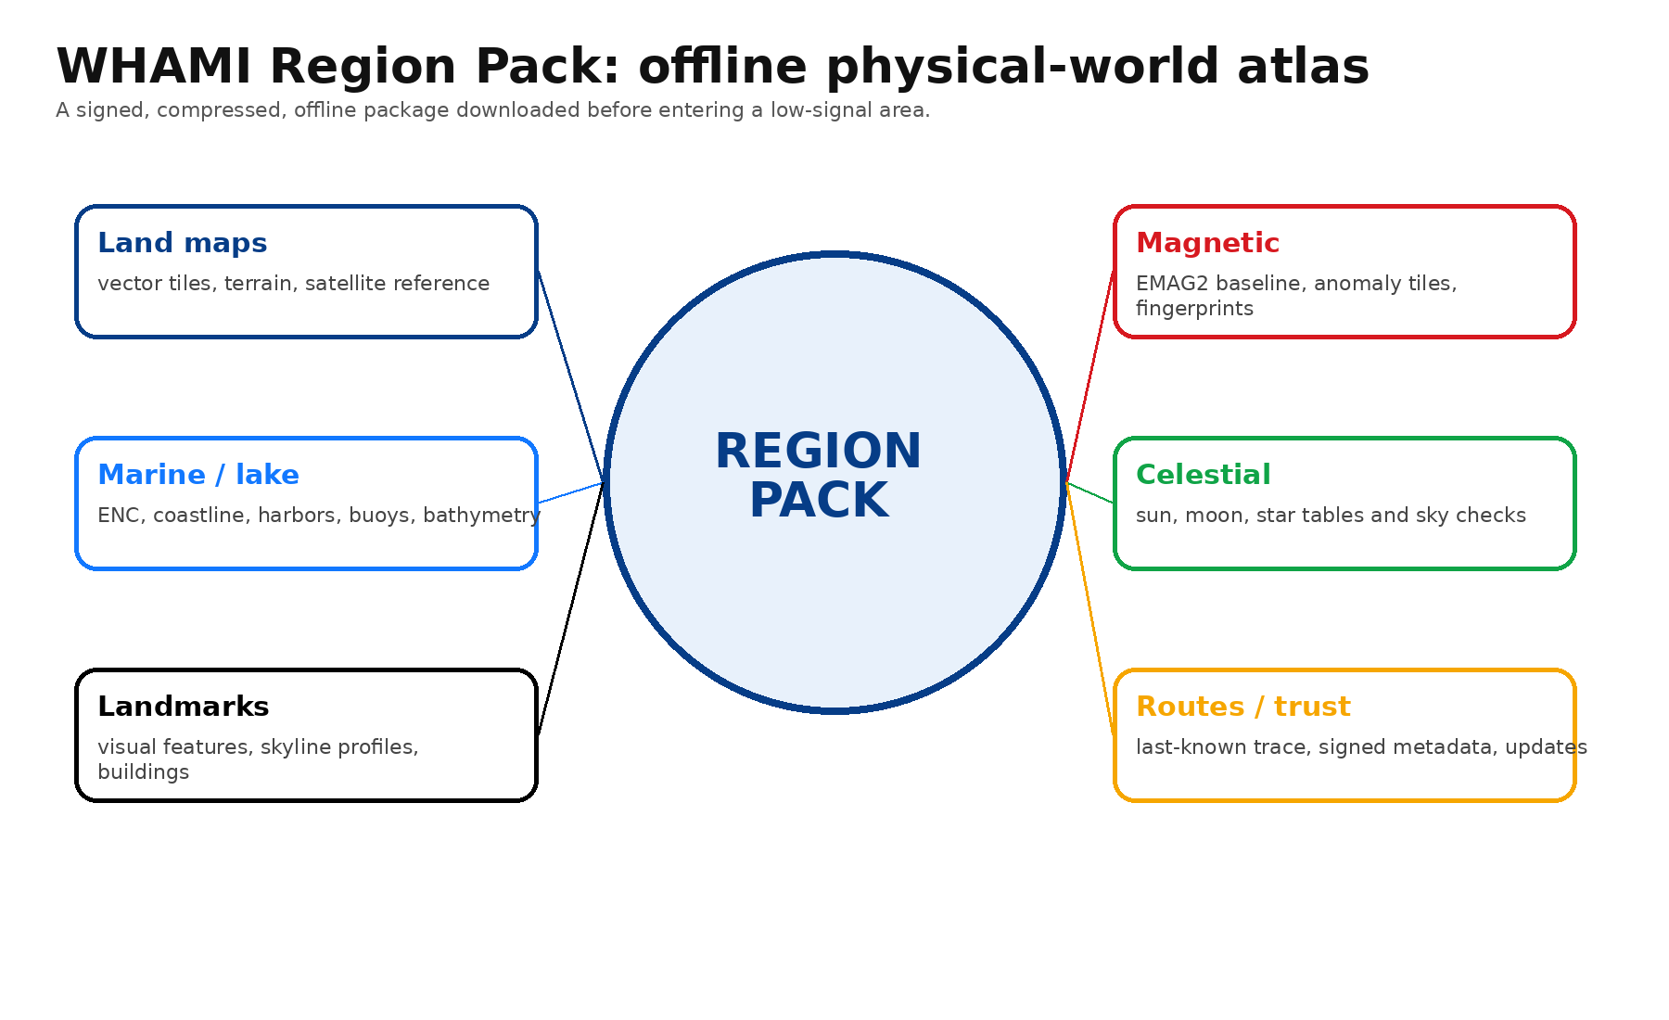
Figure 4 - WHAMI Region Pack structure: offline land, ocean, lake, magnetic, celestial, landmark, and trust data.

9.1 Region pack file structure
/whami-region-pack
/maps: land vector tiles, terrain tiles, satellite reference tiles
/marine: ENC data, OpenSeaMap layers, bathymetry, buoys, lights, harbors, coastline geometry
/landmarks: visual feature descriptors, building edges, skyline profiles, bridges, towers, mountains
/magnetic: EMAG2 baseline, regional aeromagnetic tiles, local crowd fingerprints
/celestial: almanac, sun/moon/star tables, sky validator data
/imu: route history, movement models, dead-reckoning aids
/trust: signed metadata, source quality scores, version history, update history

9.2 Data sources
- Land: OpenStreetMap, MapLibre-compatible vector tiles, elevation models, local landmark scans.
- Sea/lakes: NOAA ENC where available, OpenSeaMap, bathymetry, coastline geometry, buoys, harbors, lights.
- Magnetic: NOAA EMAG2 baseline, regional aeromagnetic surveys, local magnetic fingerprints.
- Celestial: almanac and sun/moon/star position tables.
- User contributions: consented visual landmarks, magnetic route recordings, coastline confirmations, known GPS anomaly zones.
Source note: NOAA ENCs can be downloaded free from NOAA Coast Survey websites [S8]. OpenSeaMap provides free nautical chart layers including sea marks, harbors, coordinate grid, and depth-related overlays [S9]. NOAA EMAG2 is a global magnetic anomaly grid used for navigation where GPS is unavailable [S12].

9.3 Data moat
The defensibility is not just the app code. The moat should become: signed region packs + source quality scoring + landmark/magnetic/celestial trust evidence + user-contributed physical-world corrections.

10. Phone App Roadmap and Work Packages
Current coded starter status: a WHAMI Android starter project has already been iterated through multiple versions in this workspace, including SensorHub, TrustFusionEngine, map screen with colored position opinions, CameraX landmark mode, ARCore scan mode, ARCore camera feed behind reticle, Sensors screen, and Region Pack screen. This should be treated as a prototype foundation, not a production-certified navigation app.

10.1 Recommended phases
Phase | Name | Estimate | Deliverable
Phase 0 | Foundations and sensors | 1-2 weeks | Android project, permissions, SensorHub, GPS, IMU, magnetometer, basic dashboard.
Phase 1 | GPS Truth Checker | 3-5 weeks | GPS jump detection, IMU movement sanity, magnetic stability, trust score, offline map base.
Phase 2 | Landmark / seamap first | 5-8 weeks | CameraX landmarks, ARCore scan mode, feature storage, local landmark matching, coastline/harbor/mountain anchors.
Phase 3 | Magnetic fingerprint layer | 3-5 weeks | Magnetic recording, local fingerprint map, coarse anomaly reference, magnetic confidence model.
Phase 4 | Sextant / sky validator | 4-6 weeks | Sun/moon/star checks, wide uncertainty circles, sky stability scoring, GPS disagreement alerts.
Phase 5 | Polish and field testing | ongoing | Battery optimization, offline region UX, warning language, reliability testing, pilot users.

10.2 Team plan
Team size | Realistic outcome
1 skilled Android developer | Solid working prototype in 4-6 months if focused full-time and using existing libraries.
2-3 people | Production-ready MVP in 3-4 months if one person is strong in Android/Compose, one in computer vision/maps, and one in backend/data/QA.
4+ people | Faster delivery, but only if product architecture is tightly managed; otherwise sensor-fusion projects can become fragmented.

10.3 Build order recommendation
- Make the one-view position opinions map work cleanly.
- Make offline region packs real, even if the first packs are basic.
- Make GPS truth-checker reliable and easy to understand.
- Add landmark/seamap anchor mode with CameraX and separate ARCore scan mode.
- Add magnetic fingerprint recording and local map building.
- Add sextant/sky validator with wide uncertainty circle.
- Only then upgrade the fusion engine into a full EKF / factor graph.

11. Hardware Device Phase
A dedicated WHAMI device is strongly recommended after the app proves demand. The phone proves the concept, but the hardware makes WHAMI serious for sea, expedition, emergency, and professional markets.
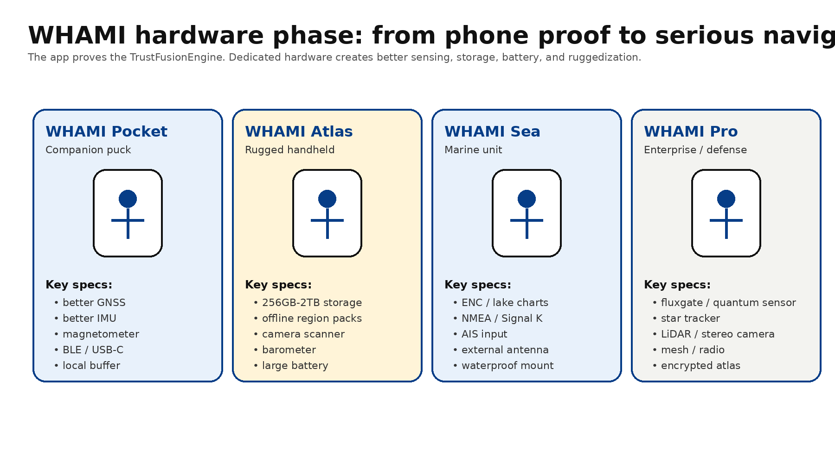
Figure 5 - WHAMI hardware line: Pocket, Atlas, Sea, and Pro.

11.1 Why hardware matters
- Phone magnetometers are noisy and affected by cases, mounts, cars, boats, and nearby metal.
- Phones have limited ruggedization, battery life, waterproofing, and sensor placement control.
- A dedicated unit can store large region packs and keep them signed, encrypted, and updateable.
- A marine or expedition device can include external antennas and better sensor isolation.
- A pro device can support fluxgate or quantum-grade magnetometers and a sky/star-tracker camera.

11.2 Product line
Hardware | Form factor | Main purpose
WHAMI Pocket | Small phone companion puck | Better GNSS, IMU, magnetometer, local buffer, BLE/USB-C, battery extension.
WHAMI Atlas | Rugged handheld | Offline atlas, camera/AR scanner, barometer, large battery, water resistance, 256GB-2TB storage.
WHAMI Sea | Marine mountable unit | ENC/lake charts, coastline matching, NMEA/Signal K integration, AIS input, external GNSS antenna, waterproof housing.
WHAMI Pro | Enterprise/defense/expedition | Fluxgate/quantum sensor support, star tracker, LiDAR/stereo camera, mesh/radio, encrypted region packs, high-capacity NVMe.

11.3 Storage strategy
Device | Suggested storage | Reason
Base app / phone | 10-50GB practical working cache | Local packs for one city, coastal region, hiking area, or lake.
WHAMI Pocket | 64-256GB | Sensor history, local magnetic routes, small offline packs.
WHAMI Atlas | 256GB-2TB | Large land/ocean/lake atlas, landmark features, offline visual descriptors.
WHAMI Sea | 1-2TB + removable media | Marine/lake chart libraries, bathymetry, harbor features, route evidence.
WHAMI Pro | 2-4TB+ encrypted NVMe | Enterprise region packs, magnetic/visual datasets, audit trails, mission data.

This is not just storage for maps. It is storage for trust evidence: landmark signatures, magnetic fingerprints, source quality, route history, sky checks, and updates.

12. Magnetic Anomaly and Quantum Magnetometer Strategy
The magnetic layer is one of WHAMI’s most defensible long-term ideas, but the phone version should start modestly. Phone magnetometers are useful for heading, stability, and local fingerprinting. High-grade magnetic anomaly navigation requires better sensors, better compensation, and quality maps.

12.1 Magnetic anomaly mapping
The total magnetic field can be understood as a smooth core field plus local crustal anomaly field. WHAMI can subtract a core model and compare the remaining magnetic signature against a regional anomaly map or local fingerprint map. This is useful in GPS-denied environments and can support sea, land, and professional use cases.
Source note: NOAA’s EMAG2 is a global Earth Magnetic Anomaly Grid compiled from satellite, ship, and airborne magnetic measurements; NOAA describes global magnetic anomaly grids as useful for navigation where GPS is unavailable [S12]. MIT MagNav.jl provides tools for airborne magnetic anomaly navigation, including mapping, compensation, and navigation workflows [S15].

12.2 Quantum magnetometer path
Quantum magnetometers are not a Phase 1 phone feature. They are a future hardware option. However, WHAMI should architect MagneticModule with a clean interface so that future external sensors can feed higher-quality magnetic readings without rewriting the whole app.
- Phase 1: phone magnetometer for heading and simple fingerprinting.
- Phase 2: better classical magnetometer in WHAMI Pocket/Atlas hardware.
- Phase 3: fluxgate or optically pumped / NV-center quantum sensor support in WHAMI Pro.
- Always include platform compensation, calibration, sensor health, and environment warnings.
Source note: SandboxAQ positions AQNav as assured navigation using quantum sensors, AI, and Earth’s magnetic field when GPS fails due to jamming, spoofing, or denial [S13]. Q-CTRL’s Ironstone Opal describes GPS-free navigation using quantum sensors and AI-powered software [S14]. NIST describes NV-center diamond magnetometers as compact, robust quantum magnetic-field sensors [S16].

13. Business Model

13.1 Free app
- Basic GPS Truth Checker.
- Small offline region pack.
- One-view position opinions.
- Simple GPS jump / spoof warning.
- Manual landmark save and basic sensor status.

13.2 WHAMI Plus
- Larger region packs.
- More saved landmarks.
- Magnetic recording and local fingerprinting.
- Trust history export.
- Better offline storage and advanced alerts.

13.3 WHAMI Marine / Expedition
- Sea/lake/coastline packs.
- Harbor, lighthouse, buoy, and coastline layers.
- Offline emergency mode.
- Route confidence history.
- Long-trip storage.

13.4 Hardware and data licensing
- WHAMI Pocket companion hardware.
- WHAMI Atlas rugged handheld.
- WHAMI Sea marine unit.
- WHAMI Pro enterprise/defense platform.
- Long-term verified region pack marketplace and API licensing.

14. Risk, Liability, and Compliance
Risk | Mitigation
Navigation liability | Do not call WHAMI a certified sole-source navigation system. Use "trusted estimate", "verification layer", and "position opinion" language.
Marine certification | At first, position WHAMI as companion verification, not ECDIS replacement or official chartplotter replacement.
Phone sensor quality | Magnetometers and IMUs are noisy; add calibration and source health warnings.
Visual matching limitations | Weather, lighting, seasons, crowds, fog, night, construction, and reflections can degrade landmark matching.
Crowdsourced data quality | Require signatures, source scoring, cross-validation, rollback, and versioning.
Battery drain | Always-on camera/sensors consume power; add scan modes and hardware path.
Privacy | Landmark and route contributions must be consented and privacy-safe.

14.1 Suggested disclaimer language
WHAMI provides a verified position estimate based on multiple device sensors and offline data sources. It is intended as a navigation confidence and redundancy layer. It should not be used as the sole source of navigation in safety-critical marine, aviation, rescue, or vehicle operations unless certified for that specific use case.

15. Development Timeline and Team Plan

15.1 One-developer estimate
For one experienced Android developer working full-time and reusing existing libraries, a solid working prototype is realistic in 4-6 months. A small team with one Android/Compose person, one vision/maps person, and one data/backend/QA person could compress a production-ready MVP to roughly 3-4 months, assuming tight scope control.

15.2 Weekly working plan for the next 10 weeks
Week | Deliverable
1 | Project setup, permissions, UI shell, map dependency, SensorHub.
2 | GPS, IMU, magnetometer streaming, sensor health panel.
3 | TrustFusionEngine v1: jump detection, confidence score, source opinions.
4 | Map screen with colored markers and uncertainty circles.
5 | RegionPackManager v1: folder structure, local pack manifest, sample pack.
6 | CameraX landmark scan mode and manual landmark saving.
7 | Landmark matching v1 and landmark fix input to fusion engine.
8 | Separate ARCore scan mode and plane/pose/quality status.
9 | Magnetic fingerprint recording and route comparison.
10 | Sextant/sky validator v1 and field test bundle.

16. Investor Narrative and Go-to-Market

16.1 Short narrative
The world is over-dependent on GPS. WHAMI creates a physical-world verification layer that continues working when GPS, cellular signal, or cloud maps become unreliable. The phone app proves the trust engine; the hardware device becomes the resilient navigation platform for sea, land, emergency, expedition, and professional use.

16.2 Proof points
- Government and infrastructure bodies are actively discussing resilient PNT and complementary GPS backup systems [S1-S3].
- Existing apps prove demand for offline maps and marine charts [S4, S8-S11].
- High-end magnetic/geophysical systems validate the GPS-denied navigation thesis [S13-S15].
- WHAMI’s one-view position-opinion UI makes a complex sensor-fusion problem understandable for ordinary users.

16.3 Go-to-market sequence
- Launch demo app with one-view GPS truth checker and offline region packs.
- Recruit marine/lake/hiking beta users who understand navigation redundancy.
- Add landmark/seamap and magnetic data contributions to improve selected pilot regions.
- Package WHAMI Plus and WHAMI Marine/Expedition subscriptions.
- Prototype WHAMI Pocket/Atlas hardware for selected pilots.
- Approach emergency, port, offshore, and enterprise partners once field evidence exists.

17. Appendices and Source Notes

17.1 Source references
ID | Title | Organization | URL
S1 | FAA GPS/GNSS Interference Resource Guide | FAA | https://www.faa.gov/about/office_org/headquarters_offices/avs/offices/afx/afs/afs400/afs410/GNSS/GPS_GNSS_Interference_Resource_Guide.pdf
S2 | Positioning, Navigation, and Timing | CISA | https://www.cisa.gov/topics/risk-management/positioning-navigation-and-timing
S3 | GPS Backup/Complementary PNT Demonstration | U.S. Department of Transportation | https://www.transportation.gov/pnt/gps-backupcomplementary-pnt-demonstration
S4 | Download areas and navigate offline in Google Maps | Google Maps Help | https://support.google.com/maps/answer/6291838?co=GENIE.Platform%3DAndroid&hl=en
S5 | ARCore Geospatial API | Google Developers | https://developers.google.com/ar/develop/geospatial
S6 | MapLibre Native Android API and OfflineRegion | MapLibre | https://maplibre.org/maplibre-native/android/api/
S7 | osmdroid OpenStreetMap tools for Android | osmdroid GitHub | https://github.com/osmdroid/osmdroid
S8 | NOAA ENC Electronic Navigational Charts | NOAA Coast Survey | https://nauticalcharts.noaa.gov/charts/noaa-enc.html
S9 | OpenSeaMap - the free nautical chart | OpenSeaMap | https://map.openseamap.org/
S10 | OpenCPN Chart Plotter Navigation | OpenCPN | https://opencpn.org/
S11 | Navionics Boating app - offline charts | Garmin/Navionics via Google Play | https://play.google.com/store/apps/details?hl=en_US&id=it.navionics.singleAppMarineLakesHD
S12 | Earth Magnetic Anomaly Grid (EMAG2) | NOAA NCEI | https://www.ncei.noaa.gov/products/earth-magnetic-model-anomaly-grid-2
S13 | AQNav assured navigation using quantum sensors, AI, and Earth magnetic field | SandboxAQ | https://www.sandboxaq.com/solutions/aqnav
S14 | Ironstone Opal GPS-free quantum navigation | Q-CTRL | https://q-ctrl.com/ironstone-opal
S15 | MagNav.jl airborne magnetic anomaly navigation toolkit | MIT AI Accelerator GitHub | https://github.com/MIT-AI-Accelerator/MagNav.jl
S16 | NV-center magnetometry | NIST | https://www.nist.gov/noac/technology/magnetic-and-electric-fields/nv-center-magnetometry

17.2 Internal project assets used
Asset | Use in project
WHAMI Logo.png | Logo concept with human silhouette inside Earth circle.
global_navigation_icon_with_human_figure.png | App icon concept derived from WHAMI logo.
whami_screens/whami_01_map.png | Map screen mockup with colored position opinions.
whami_screens/whami_pages_overview.png | Overview of app pages.
WhamiAndroidStarter_v6.zip | Current Android starter code package with map, landmark, ARCore, sensors, and region pack screens.
WhAmI.txt / Pasted text.txt | Original WHAMI project notes and magnetic/quantum navigation research notes provided in conversation.

17.3 Immediate next actions
- Open WhamiAndroidStarter_v6.zip in Android Studio and run it on Samsung Fold 5.
- Confirm the Map, Landmark, ARCore, Sensors, and Region Pack screens launch without camera/resource conflicts.
- Replace simple landmark fingerprinting with a robust feature extractor and local database strategy.
- Add a sample region pack for one real test area: Mountain View / SF Bay / harbor or lake area.
- Run first field tests: normal GPS, low-signal area, camera landmark scan, magnetic recording, sky check.
- Create a short investor/demo video showing GPS blue, landmark black, magnetic red, sky green, and WHAMI amber.

