LANS-RISK: Queue-Aware Supervision of Learned Driving Policies under Actuation Delay
Rizwan Ali and Jie Tian
School of Automotive and Traffic Engineering
Nanjing Forestry University, Nanjing, China
Abstract
Delayed commands can become inappropriate before execution. We evaluate LANS-RISK, a queue-aware supervisor that incorporates a frozen PPO proposal and a retained trajectory into sampled planning. Candidate ranking prioritizes collision-free duration, corridor retention and tracking cost. The complete main-confirmation grid contains 44,000 records, 12 controllers, four synthetic traffic scenarios and five command delays. LANS-RISK and nominal MPC attain identical observed contiguous passing thresholds: 1,000 ms on Highway and Intersection, 700 ms on Merge and 500 ms on Roundabout. Removing queue prediction reduces corridor completion in 45 of 60 paired actor/scenario/delay contrasts, all significant after study-wide Holm correction. Removing the actor leaves completion rates unchanged. Tracking differences against MPC are scenario-dependent. The results support queue compensation within this implementation, without establishing a general learned-proposal advantage, superiority over MPC or a formal safety guarantee.
autonomous driving, actuation delay, predictive supervision, learned control, model predictive control, reproducible evaluation

Introduction
Delayed actuation requires a driving controller to account for pending commands and traffic evolution before a correction arrives. Evaluation must therefore combine collision outcomes, completion and tracking. Delay-aware MPC [1] and predictive supervision [2] are established; queue prediction or guarding a learned policy alone is not a new contribution.
Earlier LANS [3] studies analytical path tracking with PPO steering residuals and packet-age handling. Here LANS-RISK combines queue rollout, a frozen PPO proposal, retained trajectories and collision-first sampled selection under a common physical FIFO. The contribution is an executable design, a resource/information-matched nominal MPC comparison, and matched removals of prediction and actor use. The central empirical finding is that queue compensation matters while the actor adds no observed completion benefit. All 12 main-confirmation controllers are reported. Plant/traffic robustness, observation-delay and dedicated runtime studies remain outside this conference article.

Related Work and State-of-the-Art Positioning

Predictive Safety Filtering and Delayed Shielding
Learning-based MPC combines prediction and optimization with learned components [4]; safe-learning surveys distinguish empirical performance from assumption-dependent guarantees [5]. Nonlinear predictive safety filtering [2] uses uncertainty descriptions and safe backups. Racing PSF [6] adds an invariant terminal set and demonstrates track-boundary protection on a 1:28-scale vehicle. System-level-synthesis filters [7] address linear systems with bounded disturbances.
Sampled-data barrier functions address input delay [8]; Cano Córdoba et al. [9] synthesize safety-game shields under bounded observation delay, with CARLA/gridworld demonstrations. LANS-RISK ranks sampled forecasts without their formal certificates or terminal-safe sets.

Delay-Aware Driving and Reinforcement Learning
Kalaria et al. [1] study adaptive delay estimation, robust tube MPC and protection of a learned controller. Our known fixed FIFO isolates command delay without reproducing their estimator or tube construction. Signal-delay RL [10], direct belief forecasting [11] and random-delay RL [12] change representation or training; our actors remain frozen.
DAROM’s supplied May 2026 version [13] combines an encoder of delayed observations, masked action histories and delay magnitude with a stopping-distance controller. Its SUMO/NGSIM-derived merging tests use stochastic V2I observation delays up to 2 s; that success endpoint is not comparable with corridor completion under our action FIFO. Other merging studies combine RL with MPC [14] or probabilistic barriers [15].

Scope of the Comparison
Table I compares mechanisms qualitatively; external methods were not rerun. Following unified benchmarking principles [16], nominal LANS–MPC matches plant, structured observations, action limits and planning resources. Other baselines’ information interfaces differ. The benchmark and failure metrics differ from earlier LANS [3]; this article reports unpenalized episode RMSE.
Table I. Qualitative literature comparison across different settings; external methods were not rerun. Guarantees depend on the cited assumptions.
Approach / source | Delay or information setting | Supervision and safety basis | Evaluation / distinction
Nonlinear PSF [2] (2021) | Model uncertainty; not our fixed FIFO protocol | Predictive constraints and safe backup under stated uncertainty assumptions | Nonlinear constrained systems; certificate differs from sampled ranking
Racing PSF [6] (2021) | State-feedback racing control | Invariant terminal set; backup trajectories; track constraints | Physical miniature vehicle; no matched traffic/FIFO experiment
Delay-aware tube MPC [1] (2022 preprint) | Estimated computation/processing delay; steering dynamics | Adaptive delay estimator and robust tube MPC | Driving/racing; richer delay model than a known queue
Delayed shielding [9] (2023) | Worst-case bounded observation delay | Safety-game synthesis and delay-resilient winning strategies | CARLA and gridworld; discrete formal abstraction
Signal-delay RL [10] (2024); DFBT [11] (2025) | Delayed observations / delayed RL information | Delay-aware representation/training or belief forecasting | Continuous robotic control; not a matched driving safety comparison
DAROM [13] (2026 version) | Stochastic V2I observation delay | Learned encoder plus stopping-distance intervention | SUMO/NGSIM-based merging; task success differs from corridor completion
LANS-RISK (this work) | Known physical FIFO, 0–1,000 ms | Queue rollout, frozen PPO prior, retained plans, lexicographic forecast ranking; no certificate | Four synthetic scenarios; paired main confirmation and component removals

Problem Formulation and Delay Model

State, Commands, and Reference Geometry
At control time $t$, the ego state is $x_{t}=\left(X_{t},Y_{t},ψ_{t},v_{t}\right)$, containing planar position, heading, and speed. Surrounding-vehicle observations are $z_{t}=\{\left(X_{t}^{i},Y_{t}^{i},ψ_{t}^{i},v_{t}^{i}\right)\}_{i=1}^{n_{t}}$. The model-based supervisor receives structured state and the pending command queue, but not hidden NPC desired speeds. A frozen PPO policy [17] proposes $u_{t}^{π}=π_{θ}\left(o_{t}\right)$ from its policy observation $o_{t}$. No actor parameters change during confirmation. The legacy 18-dimensional $o_{t}$ contains clipped tracking errors, a critical-NPC summary, synthetic latency/gain context and LQR advice; it omits the full NPC state and FIFO. Its synthetic timing feature is not the imposed command delay. The frozen actor is deployed directly with the inherited fusion gain forced to one and the legacy safety layer disabled. Thus PPO-only is a transferred-policy baseline with a different information representation, not an information-matched planner.
The normalized command $u_{t}=\left(η_{t},α_{t}\right)∈{\left[−1,1\right]}^{2}$ scales to steering angle $δ_{t}=0.5η_{t}$ rad and acceleration $a_{t}=3.5α_{t}$ m/s$​^{2}$. The prediction model uses wheelbase $L=2.6$ m and step $Δt=0.1$ s. For an applied command $\left(η,α\right)$, its explicit update is
$$\begin{matrix}v^{+} & =clip\left(v+3.5αΔt,0,25\right), \\ ψ^{+} & =wrap\left(ψ+v^{+}tan\left(0.5η\right)Δt/L\right), \\ X^{+} & =X+v^{+}cos\left(ψ^{+}\right)Δt, Y^{+}=Y+v^{+}sin\left(ψ^{+}\right)Δt.\end{matrix}$$
These equations describe the implemented ego rollout. The synthetic plant also evolves interacting NPCs, whose true future actions need not match the predictor.
Highway and Intersection use a straight reference. Merge uses a quintic lateral transition, $Y_{r}=−3.5+3.5\left(10ξ^{3}−15ξ^{4}+6ξ^{5}\right)$ with $ξ=clip\left(X/25,0,1\right)$. Roundabout uses a circle of radius 8 m. Let $e_{y}$, $e_{ψ}$ and $κ$ denote the implemented lateral error, wrapped reference-heading error and reference curvature. The geometric steering prior is
$$\begin{matrix}δ_{g}\left(x\right) & =arctan\left(Lκ\right)−0.4e_{y}−1.2\left(e_{ψ}+0.05vκ\right), \\ η_{g}\left(x\right) & =clip\left(δ_{g}\left(x\right)/0.5,−1,1\right).\end{matrix}$$
The lateral error is $Y−Y_{r}\left(X\right)$ on noncircular references and $8−\sqrt{X^{2}+Y^{2}}$ on the circle.

Physical FIFO and Available Control Authority
For $d>0$, write the commands awaiting execution as $q_{t}=\left(q_{t}^{0},…,q_{t}^{d−1}\right)$, oldest first. The plant applies $q_{t}^{0}$ and appends the newly selected $u_{t}$:
$$\begin{matrix}x_{t+1} & =F\left(x_{t},z_{t},q_{t}^{0}\right), \\ q_{t+1} & =\left(q_{t}^{1},…,q_{t}^{d−1},u_{t}\right).\end{matrix}$$
For $d=0$, $u_{t}$ acts immediately. All methods use the same zero-filled initial FIFO, so the first $d$ applied commands are initialization commands. The tested $d∈\{0,2,5,7,10\}$ corresponds to 0, 200, 500, 700, and 1,000 ms. A supervisory correction also enters the FIFO; it cannot replace already queued commands. This physical restriction differs from a delay-free safety override.

Queue Rollout and Observable Traffic Prediction
The observer estimates NPC acceleration from consecutive observed speeds:
$${\hat{a}}_{t}^{i}=clip\left(\left(v_{t}^{i}−v_{t−1}^{i}\right)/Δt,−6,1.5\right),$$
using zero on the first observation. During rollout, predicted NPC speed is clipped to $\left[0,20\right]$ m/s, and its acceleration estimate is multiplied by 0.85 after each step. NPC heading remains fixed outside the roundabout; on the roundabout, predicted motion follows the 8 m circle. This is an observable forecast, not access to the traffic simulator’s hidden intentions.
Starting from $\left({\hat{x}}^{0},{\hat{z}}^{0}\right)=\left(x_{t},z_{t}\right)$, the supervisor propagates every pending command:
$$\left({\hat{x}}^{j+1},{\hat{z}}^{j+1}\right)=\hat{F}\left({\hat{x}}^{j},{\hat{z}}^{j},q_{t}^{j}\right), 0≤j<d.$$
The resulting $\left({\overset{‾}{x}}_{t},{\overset{‾}{z}}_{t}\right)=\left({\hat{x}}^{d},{\hat{z}}^{d}\right)$ initializes the future-action search. At each predicted step, minimum disc clearance is $c=\min_{i}∥\left(X,Y\right)−\left(X^{i},Y^{i}\right)∥_{2}−4.846$ m. The queue prefix is flagged if $c<0.25$ m or $\left|e_{y}\right|>1.75$ m. A prefix violation is a diagnostic of already committed commands, not a proof that the next action can recover safety.
Episodes last at most 160 steps (16 s). Highway, Merge, Intersection and Roundabout contain 5, 6, 1 and 4 NPCs, with reference speeds 15, 12, 8 and 9 m/s. Proposed initial ego speeds are uniform on [11,15], [11,15], [6,7.5] and [5.5,7.5] m/s, respectively. Goals are 80, 60 and 50 m of relative longitudinal progress for the first three scenarios (Merge also requires $\left|Y\right|<1$ m), and one unwrapped lap for Roundabout. Goal attainment is nonterminal: logging continues until collision or the time limit. NPCs use bounded IDM-style interactions; the predictor only observes their acceleration. Initial scenes satisfy rejection-sampling predicates excluding specified overlaps and close-following configurations; these predicates do not certify solvability. Exact scene distributions and policy metadata are in the linked methods supplement. Roundabout is circular following, not entry/exit negotiation.
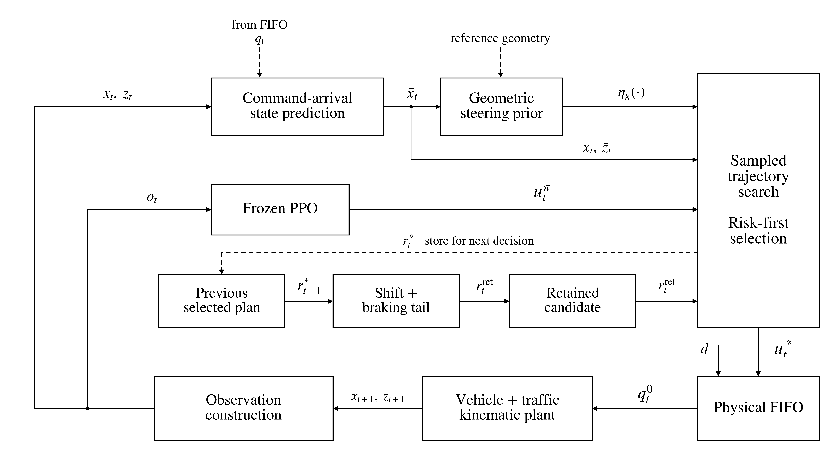
Fig. 1. LANS-RISK signal flow. Structured state and observed NPC acceleration support queue prediction; PPO receives legacy features $o_{t}$. Search uses arrival states, the geometric steering rule evaluated along each rollout, the actor prior and retained plan. Dashed paths supply queue/reference information or update memory. The selected first command enters the physical FIFO ($d=0$: immediate). No EKF or LQR–PPO actuation fusion is implemented.

Queue-Aware Trajectory Supervision

Plan Representation and Candidate Generation
A candidate $k$ is a sequence $r_{k}=\{\left(b_{k,h},α_{k,h}\right)\}_{h=0}^{H−1}$ with $H=30$. At each predicted state, it generates
$$u_{k,h}=\left(clip\left(η_{g}\left({\hat{x}}_{k,h}\right)+b_{k,h},−1,1\right),α_{k,h}\right).$$
The offset $b_{k,h}$ permits geometric steering to adapt along a trajectory. The actor provides a first-action prior; it does not increase the common desired-speed reference $v_{ref}$.
Each of three rounds samples $K=192$ plans around a per-step mean. Gaussian perturbations are shared within five-step blocks, but the mean has one value per step. All plan entries are clipped to $\left[−1,1\right]$. Six explicit candidates replace the first sampled plans: the current mean, cruise, full brake, actor prior, retained previous plan, and best-so-far plan. Cruise uses $b_{h}=0$ and $α_{h}=clip\left(\left(v_{ref}−{\overset{‾}{v}}_{t}\right)/3.5,−1,1\right)$; brake uses $\left(b_{h},α_{h}\right)=\left(0,−1\right)$. The actor-prior plan replaces the cruise plan’s first pair with $\left(clip\left(u_{t,1}^{π}−η_{g}\left({\overset{‾}{x}}_{t}\right),−1,1\right),u_{t,2}^{π}\right)$.
The first decision starts its mean at cruise and its retained candidate at brake. Later decisions use the shifted previous plan. Initial sampling standard deviations are $\left(0.18,0.65\right)$ per step; the best 24 plans update the mean and standard deviation, with floors $\left(0.015,0.08\right)$. Thus the search evaluates 576 candidate rollouts per decision, although explicit candidates may repeat. This is sampled optimization, not an exhaustive feasibility solver.

Collision-First Ranking and Performance Cost
For steps $h=0,…,H−1$, $c_{k,h}$ and $e_{k,h}$ are evaluated after propagation. Define the first forecast violations
$$\begin{matrix}h_{c}\left(k\right) & =min\left(\{h:c_{k,h}<0.25\}∪\{H\}\right), \\ h_{e}\left(k\right) & =min\left(\{h:\left|e_{k,h}\right|>1.75\}∪\{H\}\right), \\ s_{k} & =\left\{\begin{matrix}c_{k,0}, & h_{c}\left(k\right)=0, \\ h_{e}\left(k\right), & h_{c}\left(k\right)>0.\end{matrix}\right.\end{matrix}$$
Selection lexicographically maximizes $\left(h_{c}\left(k\right),s_{k},−J_{k}\right)$. Collision-free duration takes precedence; if all plans violate the collision margin immediately, first-step clearance replaces corridor duration as the secondary rank.
The implemented stage cost is explicitly
$$\begin{matrix}ℓ_{k,h}=​ & 8e_{y}^{2}+2e_{ψ}^{2}+0.2{\left(v−v_{ref}\right)}^{2} \\ & +0.03\left(η^{2}+α^{2}\right)+10max{\left(0,1−c\right)}^{2} \\ & +1_{m<0}\left({10}^{6}+{10}^{5}m^{2}\right), \\ m=​ & min\left(c−0.25,1.75−\left|e_{y}\right|\right), \\ J_{k}=​ & \sum_{h=0}^{H−1}{ℓ_{k,h}}+0.5∥u_{k,0}−u_{t}^{π}∥_{2}^{2}.\end{matrix}$$
The cost uses propagated states and normalized commands with frozen weights. Its penalties and ranking express priorities, not collision probabilities or safety certificates.

Command Execution and Plan Retention
The best plan across the three rounds supplies only its first command. For the next decision, the stored candidate is
$$r_{t+1}^{retained}=\left(r_{t,1}^{*},…,r_{t,H−1}^{*},\left(0,−1\right)\right).$$
The tail applies geometric steering and full braking. Re-evaluation can replace the retained candidate; prediction error and the uncertified tail preclude importing terminal-set guarantees [2, 6]. Algorithm 1 (Table II) summarizes the decision.
Table II. Algorithm 1: one LANS-RISK control decision (frozen actor).
 | Inputs: observed state, FIFO $q_{t}$, PPO action $u_{t}^{π}$, retained plan.
1 | Estimate NPC acceleration; roll out $q_{t}$ to $\left({\overset{‾}{x}}_{t},{\overset{‾}{z}}_{t}\right)$; compute transient prefix diagnostics.
2 | Construct cruise, brake, actor-prior and retained candidates; initialize mean and dispersion.
3 | For three rounds: draw 192 plans, insert six explicit candidates, and propagate 30 steps.
4 | Compute $\left(h_{c},s,−J\right)$; retain the best plan across rounds. Refit the sampling distribution to 24 elites.
5 | Return the selected first action to the physical FIFO. Shift the selected plan and append $\left(0,−1\right)$.
6 | Update transient forecast diagnostics; repeat at the next observation.

Matched Component Removals
The no-prediction variant skips only the internal queue rollout; the real FIFO, actor and search remain active. The no-actor variant uses the analytical cruise proposal and sets the actor-distance weight to zero, retaining prediction, ranking and plan retention. PPO-only removes the complete supervisor and uses only the legacy policy features. Accordingly, the first two are component removals, whereas the PPO-only contrast tests a bundle. No removal establishes a claim about all prediction methods or all learned policies.
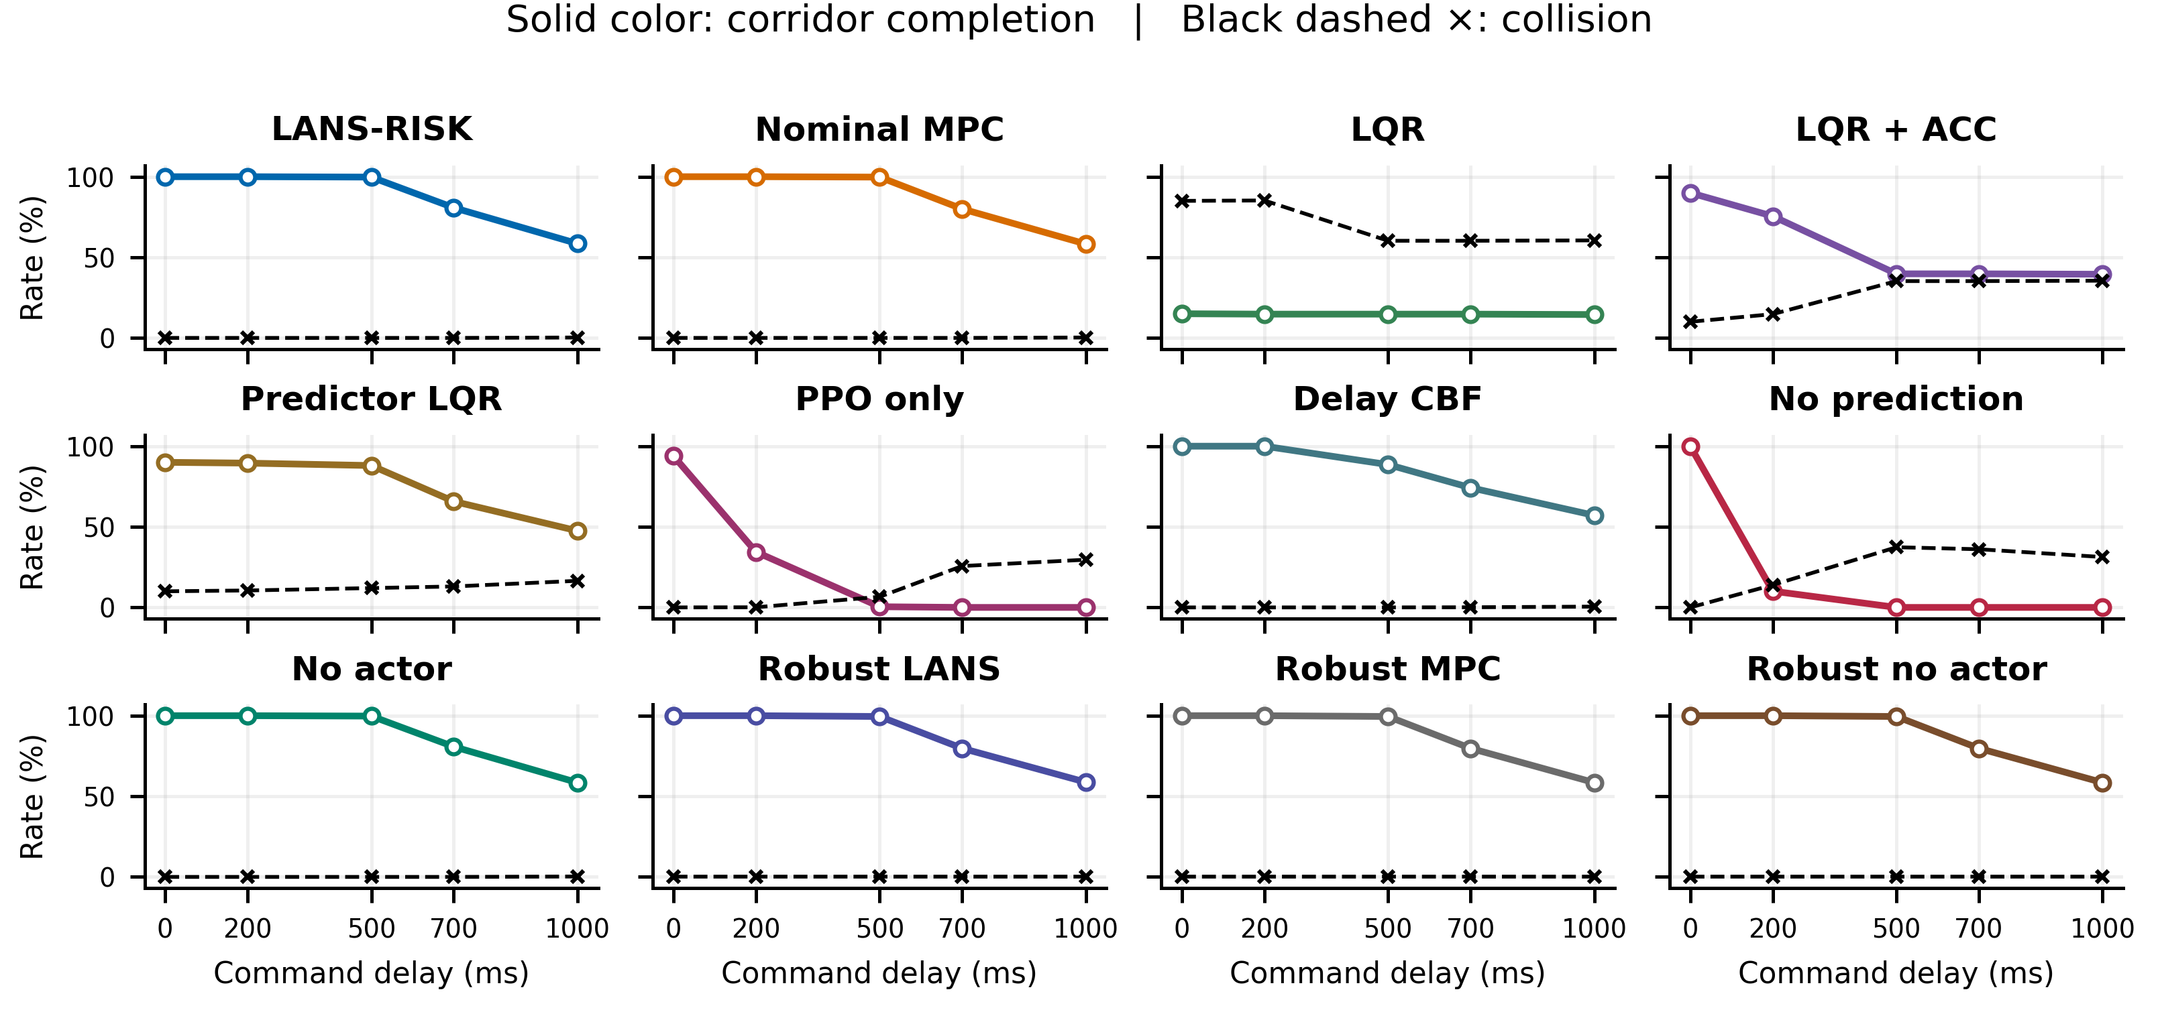
Fig. 2. All 12 controllers: colored solid curves show corridor completion; black dashed curves show collisions. Descriptive averages over scenarios/actors match Table III. Separate panels keep coincident controller curves visible.
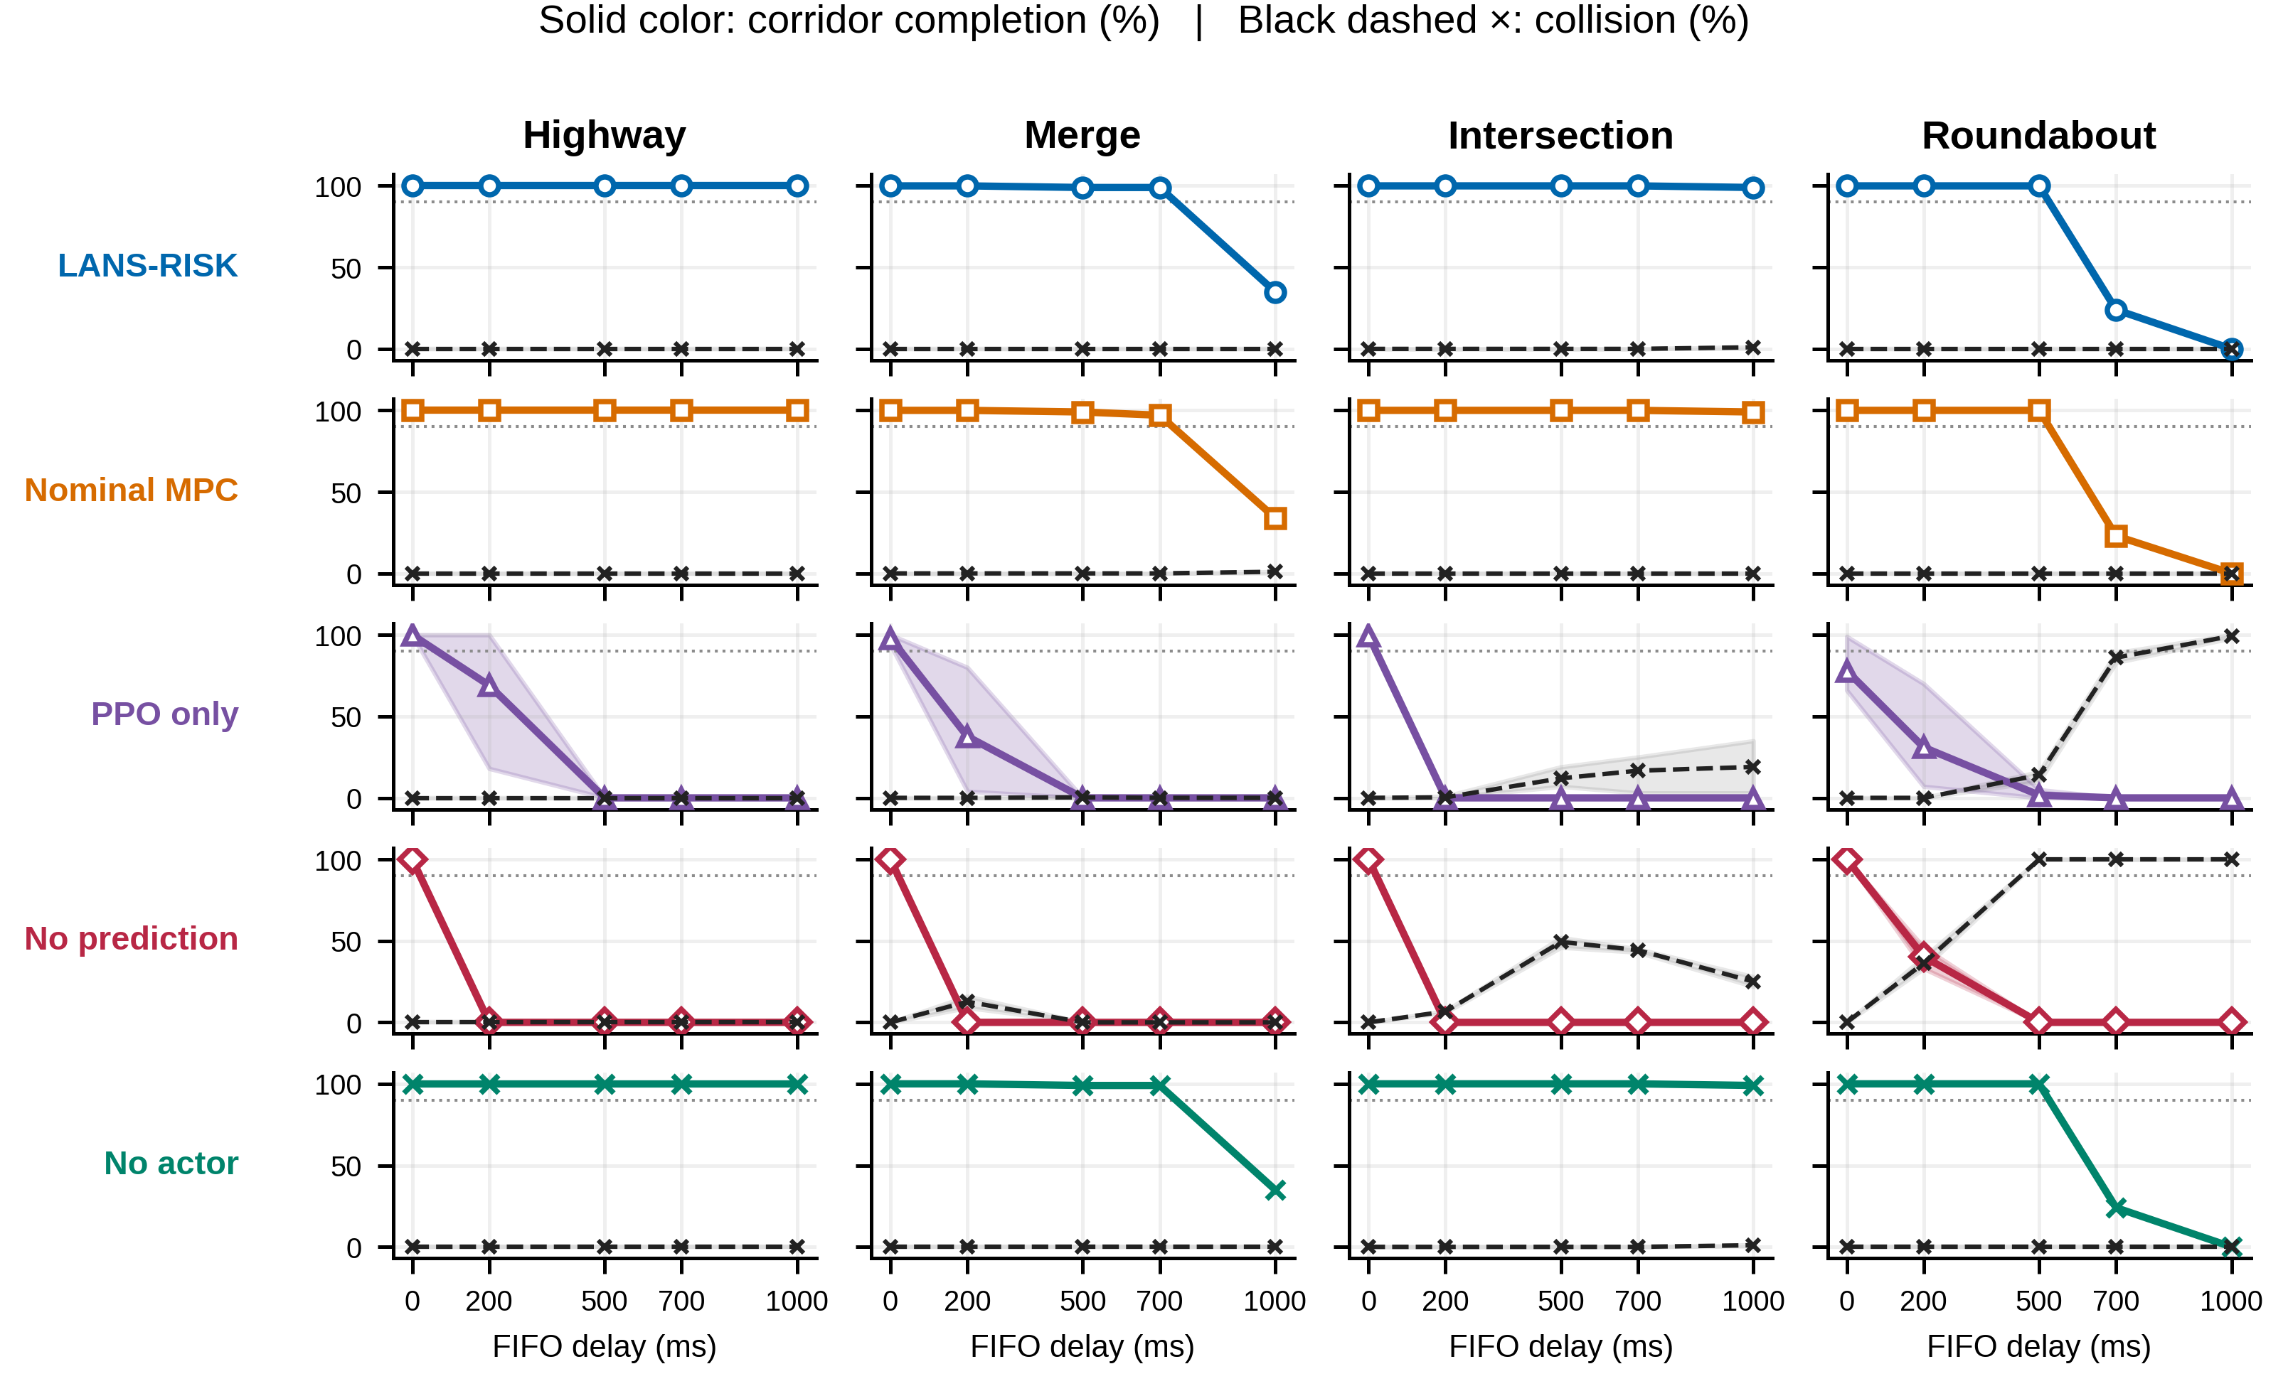
Fig. 3. Scenario-specific focused comparisons. Solid color: corridor completion; black dashed: collision. Shading spans actor minimum–maximum, not a confidence interval; dotted lines mark 90% completion. Lines connect measured points as visual guides. Separate rows expose coincident outcomes. All 12 methods’ scenario plots are supplied separately.

Experimental Protocol

Frozen Confirmation and Conference Scope
The main confirmation contains 12 controllers on four scenarios and delays of 0, 200, 500, 700 and 1,000 ms. The core comparison uses LANS-RISK, nominal MPC, PPO-only, no prediction and no actor. The full delay table also includes standalone LQR, LQR with adaptive cruise control (ACC), predictor LQR, a numerical delay-CBF filter, robust LANS, robust MPC and robust no actor. These are the project’s implemented baselines, not reproductions of the cited external algorithms.
LQR variants use analytical feedback; predictor LQR adds queue prediction. Delay CBF filters the PPO proposal using numerical braking-distance constraints. The three “robust” variants sample three NPC-acceleration forecasts (nominal and $±1$ m/s$​^{2}$ offsets before clipping), with 96 candidates per round. Robust MPC removes the actor and exact retained-trajectory handover; robust no actor preserves that handover. The label “robust” denotes this implemented scenario construction, not a formal robust-control guarantee. These variants do not share the nominal pair’s full sampling budget.
Policies are loaded with Stable-Baselines3 [18]. Five actor-dependent variants use frozen seeds 42/43/44, and seven actor-free variants run once per condition. Each uses the same 100 traffic seeds, 141000–141099, yielding $4×5×\left(5×3+7\right)×100=44,000$ records in 440 conditions. Repeated actors reuse cases; the records are not independent pooled replicates. Development seeds are disjoint. No confirmation retraining or tuning occurred. Artifacts and the methods supplement are available at https://github.com/rizwanalihasalivi/LANS-RISK/tree/integration/aris-frozen-workflow/conference_downloads/v5. This article uses only the original main protocol, not the separate dense-Merge robustness amendment. The full-table presentation and focused contrasts were selected after evaluation and are not a separately preregistered analysis.

Nominal MPC Comparison
The nominal MPC shares the plant, structured state information, physical FIFO, action bounds, reference-speed ceiling, observed-acceleration predictor, 30-step horizon, and three rounds of 192 candidates. It uses a block-parameterized plan and its own cost ranking, warm start, and fallback. LANS-RISK differs in actor use, trajectory retention/representation, and ranking/objective details. Thus, the comparison matches important resources and information but is not a one-variable algorithmic ablation. Equal candidate counts also do not establish equal runtime; no computational superiority claim is made here.

Metrics and Statistical Analysis
Collision detection tests disc overlap at sampled 0.1 s states. Route completion requires reaching the goal and remaining collision-free for the episode. Corridor completion additionally requires $\left|e_{t}\right|≤1.75$ m at every recorded step. Episode tracking error is
$$RMSE=\sqrt{\frac{1}{T}\sum_{t=1}^{T}{e_{t}^{2}}}.$$
This is conventional episode RMSE, not the failure-penalized metric in the supplied LANS path-tracking manuscript. Since collisions can shorten an episode, RMSE is interpreted together with collision and completion outcomes.
To avoid treating repeated runs or selected aggregate scores as conclusive RL evidence [19], actor-level inference and paired traffic cases are preserved. Binary rate uncertainty uses per-condition Wilson 95% intervals. Supported continuous-mean and paired-difference intervals use 5,000 traffic-case bootstrap draws. Binary comparisons use exact paired-discordance tests; RMSE uses two-sided Wilcoxon signed-rank tests with the usual symmetry assumption for a location interpretation. We retain Holm correction [20] over all 3,440 contrasts/outcomes in the parent main-confirmation analysis, including comparisons not discussed individually here. Correction is not recomputed on a favorable selected subset. Actor-seed results remain separate for inference. Aggregate displays weight scenarios equally, with 400 records per actor-free method/delay and 1,200 for actor-dependent methods. Pooling is descriptive; inference remains within actor/scenario conditions.
The empirical delay threshold is the largest tested delay for which collision rate is at most 1% and corridor completion is at least 90% at that delay and every lower grid point. It is a finite-grid endpoint, not a continuous-delay stability bound. A passing value of 1,000 ms is right-censored by the tested grid. Even zero observed collisions in 100 cases has a Wilson 95% upper bound near 3.7%, so passing does not establish a population collision probability below 1%.
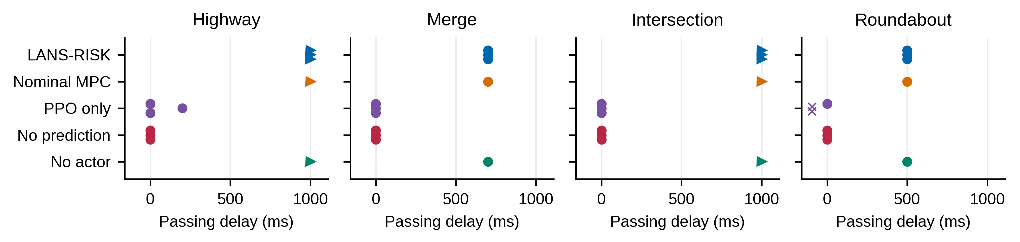
Fig. 4. Empirical passing-delay endpoints for the five focused methods. Vertically separated points denote actors without shifting delay values; right triangles mark upper-grid censoring. Crosses left of zero mean no passing grid point (NP), not negative delay. These are not runtime measurements or certified bounds.

Results

LANS-RISK versus Nominal MPC
All three LANS-RISK actors and nominal MPC attain the same observed contiguous passing thresholds: Highway 1,000 ms, Merge 700 ms, Intersection 1,000 ms, and Roundabout 500 ms. Table V and Fig. 4 summarize these endpoints; no delay-threshold advantage is established. Table III reports every tested delay, and Fig. 2 shows all controller profiles. Identical thresholds should not be read as statistical equivalence or identical episode trajectories.
At 1,000 ms (Table IV), LANS-RISK has lower mean RMSE on Merge/Roundabout and MPC on Highway/Intersection; both have poor corridor completion on Merge/Roundabout. For Merge, actor 42 has 35/100 completions (Wilson 95%: 26.4–44.7%) versus MPC’s 34/100 (25.5–43.7%). These marginal intervals do not test equivalence.
Figure 3 separates scenario-specific outcomes. The full-grid table also exposes weak baselines: LQR has only 60/400 corridor completions at zero delay despite a mean RMSE of 0.039 m. Early collision termination can produce deceptively small tracking errors; Fig. 2 therefore retains collisions alongside completion.
Across the 60 per-actor/scenario/delay LANS–MPC corridor-completion contrasts, nine have a positive LANS-minus-MPC mean difference, none has a negative mean difference, and none is significant after the retained study-wide Holm correction. Absence of significance is not a non-inferiority or equivalence result. We did not specify an equivalence margin or conduct a dedicated equivalence design.
Table III (a). Tracking performance and corridor completion over all tested command delays (0–1,000 ms). Each cell is mean episode RMSE (m); corridor-completed/total records, aggregated over four scenarios. Corridor completion requires route completion, no collision and no corridor excursion. Actor-dependent columns contain 1,200 records per delay; actor-free columns contain 400. Actor repetitions share traffic cases. No intermediate delay was measured.
Delay (ms) | LANS-RISK | Nominal MPC | LQR | LQR + ACC | Predictor LQR | PPO only
0 | 0.063; 1200/1200 | 0.028; 400/400 | 0.039; 60/400 | 0.019; 360/400 | 0.019; 360/400 | 0.402; 1127/1200
200 | 0.066; 1200/1200 | 0.031; 400/400 | 0.448; 59/400 | 0.234; 302/400 | 0.019; 358/400 | 1.787; 413/1200
500 | 0.115; 1197/1200 | 0.092; 399/400 | 1.726; 59/400 | 2.080; 159/400 | 0.093; 352/400 | 8.739; 5/1200
700 | 0.192; 969/1200 | 0.174; 320/400 | 2.261; 59/400 | 2.369; 159/400 | 0.202; 263/400 | 12.440; 0/1200
1000 | 0.357; 702/1200 | 0.353; 233/400 | 5.232; 58/400 | 5.102; 158/400 | 0.429; 190/400 | 16.136; 0/1200
Table III (b). Tracking performance and corridor completion over all tested command delays (0–1,000 ms). Each cell is mean episode RMSE (m); corridor-completed/total records, aggregated over four scenarios. Corridor completion requires route completion, no collision and no corridor excursion. Actor-dependent columns contain 1,200 records per delay; actor-free columns contain 400. Actor repetitions share traffic cases. No intermediate delay was measured.
Delay (ms) | Delay CBF | No prediction | No actor | Robust LANS | Robust MPC | Robust no actor
0 | 0.398; 1200/1200 | 0.063; 1200/1200 | 0.061; 400/400 | 0.074; 1200/1200 | 0.044; 400/400 | 0.070; 400/400
200 | 0.650; 1200/1200 | 3.586; 121/1200 | 0.064; 400/400 | 0.076; 1200/1200 | 0.046; 400/400 | 0.072; 400/400
500 | 1.000; 1063/1200 | 17.263; 0/1200 | 0.112; 399/400 | 0.126; 1194/1200 | 0.102; 398/400 | 0.123; 398/400
700 | 1.103; 891/1200 | 23.461; 0/1200 | 0.188; 323/400 | 0.207; 957/1200 | 0.189; 319/400 | 0.206; 319/400
1000 | 1.423; 685/1200 | 11.365; 0/1200 | 0.358; 234/400 | 0.405; 705/1200 | 0.384; 234/400 | 0.402; 234/400
Table IV. Main-confirmation outcomes at 1,000 ms. LANS-RISK entries are descriptive averages of three actor-condition means; MPC uses the same 100 traffic cases once. Collision (C) and corridor completion (CC) are percentages.
 | LANS-RISK |  |  | Nominal MPC
Scenario | C (%) | CC (%) | RMSE (m) | C (%) | CC (%) | RMSE (m)
Highway | 0.0 | 100.0 | 0.080 | 0.0 | 100.0 | 0.025
Merge | 0.0 | 35.0 | 0.378 | 1.0 | 34.0 | 0.416
Intersection | 1.0 | 99.0 | 0.043 | 0.0 | 99.0 | 0.031
Roundabout | 0.0 | 0.0 | 0.927 | 0.0 | 0.0 | 0.939
Table V. Empirical contiguous passing actuation delay (ms). Passing requires collision $≤1\%$ and corridor completion $≥90\%$ at every tested delay up to the endpoint. Slashes list actors 42/43/44 when they differ; otherwise all three agree. NP means no passing point, including at zero delay. $†$: 1,000 ms is the tested upper limit, not a measured failure boundary.
Controller | Highway | Merge | Intersection | Roundabout
LANS-RISK | 1000$​^{†}$ | 700 | 1000$​^{†}$ | 500
Nominal MPC | 1000$​^{†}$ | 700 | 1000$​^{†}$ | 500
PPO only | 0/200/0 | 0 | 0 | 0/NP/NP
No prediction | 0 | 0 | 0 | 0
No actor | 1000$​^{†}$ | 700 | 1000$​^{†}$ | 500

Contribution of Queue Prediction
Disabling internal queue prediction reduces corridor-completion rates in 45 of the 60 paired actor/scenario/delay contrasts; all 45 remain significant after Holm correction. No contrast has a higher corridor-completion rate for the no-prediction variant. These counts are correlated comparisons over shared cases and actors, not 60 independent replications.
At 1,000 ms, no prediction yields zero corridor completion in every scenario (Table VI). Collision-free Highway/Merge failures show why collision-only reporting is insufficient; Intersection/Roundabout also incur collisions. The physical FIFO remains active, isolating the effect of skipping internal queue rollout.

Contribution of the Actor and Supervision Bundle
Removing the actor leaves corridor-completion rates unchanged in all 60 per-actor/scenario/delay comparisons. Table VI shows mixed tracking effects at 1,000 ms: the no-actor variant has slightly lower mean RMSE on Intersection and Roundabout, but higher mean RMSE on Highway and Merge. Therefore, the present evidence does not establish a general completion benefit from the learned prior.
Against PPO-only, LANS-RISK has higher corridor-completion rates in 49 of 60 contrasts, with 45 significant after Holm correction. The improvement applies to the full supervision bundle, including its richer state/FIFO interface; it does not establish a benefit over a policy trained for the current information and actuation setting. PPO-only has zero corridor completion at the largest tested delay in every scenario and high collision rates on some scenarios. This comparison cannot isolate individual supervisory effects.
Table VI. Focused removals and PPO-only at 1,000 ms. C: collision; CC: corridor completion. Actor-seed averaging is descriptive; per-seed estimates and intervals are supplied separately.
Scenario | Variant | C (%) | CC (%) | RMSE (m)
Highway | LANS-RISK | 0.0 | 100.0 | 0.080
Highway | No prediction | 0.0 | 0.0 | 14.599
Highway | No actor | 0.0 | 100.0 | 0.082
Highway | PPO only | 0.0 | 0.0 | 11.060
Merge | LANS-RISK | 0.0 | 35.0 | 0.378
Merge | No prediction | 0.0 | 0.0 | 16.687
Merge | No actor | 0.0 | 35.0 | 0.392
Merge | PPO only | 0.0 | 0.0 | 35.224
Intersection | LANS-RISK | 1.0 | 99.0 | 0.043
Intersection | No prediction | 25.0 | 0.0 | 11.149
Intersection | No actor | 1.0 | 99.0 | 0.032
Intersection | PPO only | 19.0 | 0.0 | 14.573
Roundabout | LANS-RISK | 0.0 | 0.0 | 0.927
Roundabout | No prediction | 100.0 | 0.0 | 3.025
Roundabout | No actor | 0.0 | 0.0 | 0.927
Roundabout | PPO only | 99.3 | 0.0 | 3.687

Discussion and Limitations
The cold FIFO limits control authority: committed startup commands can cause corridor departure before a correction arrives. Passing thresholds therefore depend on initialization and scenario geometry. Retention and lexicographic ranking lack isolated nominal ablations; the multicomponent robust variants cannot establish their individual benefit.
Generalization is limited by synthetic disc vehicles, structured state access, known queues, fixed actors and finite sampling. Corridor checks concern the reference point at sampled ticks, not the vehicle footprint or continuous motion. No terminal-safe set, recovery certificate, real-road safety or real-time guarantee is established.
Saved logs contain episode metrics and flags rather than full trajectories. Aggregate statistics and tests can be recomputed, but individual RMSE, collision/corridor events and queue histories cannot be independently reconstructed. Some forecast diagnostics are transient. Intervals are marginal, repeated actors share cases, and three fixed seeds do not characterize the training-outcome population.

Conclusion
LANS-RISK provides a reproducible empirical study of queue-aware trajectory supervision. Its main grid supports queue prediction within this design, finds no actor completion benefit and no delay-threshold advantage over nominal MPC, and shows scenario-dependent tracking differences. The contribution is the specified implementation and controlled evidence, with explicit limits on novelty and safety.

References
[1] D. Kalaria, Q. Lin, and J. M. Dolan, “Delay-aware robust control for safe autonomous driving and racing,” arXiv:2208.13856v1, 2022.
[2] K. P. Wabersich and M. N. Zeilinger, “A predictive safety filter for learning-based control of constrained nonlinear dynamical systems,” Automatica, vol. 129, Art. no. 109597, 2021.
[3] R. Ali and J. Tian, “Latency-aware path-tracking control for autonomous vehicles via analytical feedback and PPO-based residual compensation,” author-supplied manuscript, undated.
[4] L. Hewing, K. P. Wabersich, M. Menner, and M. N. Zeilinger, “Learning-based model predictive control: Toward safe learning in control,” Annual Review of Control, Robotics, and Autonomous Systems, vol. 3, pp. 269–296, 2020.
[5] L. Brunke et al., “Safe learning in robotics: From learning-based control to safe reinforcement learning,” Annual Review of Control, Robotics, and Autonomous Systems, vol. 5, pp. 411–444, 2022.
[6] B. Tearle, K. P. Wabersich, A. Carron, and M. N. Zeilinger, “A predictive safety filter for learning-based racing control,” arXiv:2102.11907v1, 2021.
[7] A. P. Leeman, J. Köhler, S. Bennani, and M. N. Zeilinger, “Predictive safety filter using system level synthesis,” in Proc. Learning for Dynamics and Control, PMLR, vol. 211, pp. 1180–1192, 2023.
[8] A. Singletary, Y. Chen, and A. D. Ames, “Control barrier functions for sampled-data systems with input delays,” in Proc. IEEE Conf. Decision and Control, pp. 804–809, 2020.
[9] F. Cano Córdoba, A. Palmisano, M. Fränzle, R. Bloem, and B. Könighofer, “Safety shielding under delayed observation,” in Proc. Int. Conf. Automated Planning and Scheduling, vol. 33, pp. 80–85, 2023.
[10] W. Wang, D. Han, X. Luo, and D. Li, “Addressing signal delay in deep reinforcement learning,” in Proc. Int. Conf. Learning Representations, 2024. [Online]. Available: https://openreview.net/forum?id=Z8UfDs4J46
[11] Q. Wu et al., “Directly forecasting belief for reinforcement learning with delays,” in Proc. Int. Conf. Machine Learning, 2025.
[12] Y. Bouteiller, S. Ramstedt, G. Beltrame, C. Pal, and J. Binas, “Reinforcement learning with random delays,” in Proc. Int. Conf. Learning Representations, 2021.
[13] A. Tabrizian, Z. Huang, A. Aziz, and P. Wei, “Delay-aware reinforcement learning for highway on-ramp merging under stochastic communication latency,” arXiv:2403.11852v5, May 2026.
[14] J. Lubars et al., “Combining reinforcement learning with model predictive control for on-ramp merging,” in Proc. IEEE Int. Intelligent Transportation Systems Conf., pp. 942–947, 2021.
[15] S. Udatha, Y. Lyu, and J. Dolan, “Reinforcement learning with probabilistically safe control barrier functions for ramp merging,” in Proc. IEEE Int. Conf. Robotics and Automation, pp. 5625–5630, 2023.
[16] Z. Yuan et al., “Safe-control-gym: A unified benchmark suite for safe learning-based control and reinforcement learning in robotics,” IEEE Robotics and Automation Letters, vol. 7, no. 4, pp. 11142–11149, 2022.
[17] J. Schulman, F. Wolski, P. Dhariwal, A. Radford, and O. Klimov, “Proximal policy optimization algorithms,” arXiv:1707.06347, 2017.
[18] A. Raffin et al., “Stable-Baselines3: Reliable reinforcement learning implementations,” Journal of Machine Learning Research, vol. 22, no. 268, pp. 1–8, 2021.
[19] R. Agarwal, M. Schwarzer, P. S. Castro, A. C. Courville, and M. G. Bellemare, “Deep reinforcement learning at the edge of the statistical precipice,” in Advances in Neural Information Processing Systems, vol. 34, 2021.
[20] S. Holm, “A simple sequentially rejective multiple test procedure,” Scandinavian Journal of Statistics, vol. 6, no. 2, pp. 65–70, 1979.

