LANS-RISK: Queue-Aware Supervision of Learned Driving Policies under Actuation Delay
Rizwan Ali and Jie Tian
School of Automotive and Traffic Engineering
Nanjing Forestry University, Nanjing, China
Abstract
Commands selected from a current vehicle state can become inappropriate while waiting for delayed execution. This paper investigates a queue-aware, trajectory-retaining supervisor for frozen learned driving policies. LANS-RISK predicts the state reached after pending commands, incorporates a proximal policy optimization proposal into sampled future plans, and ranks plans by predicted collision-free duration, corridor retention, and tracking cost. We report a focused, 22,000-episode subset of a separately frozen confirmation study, covering four synthetic traffic scenarios, five command delays, a matched nominal model predictive controller, PPO-only control, and two component ablations. LANS-RISK and nominal MPC attain identical observed contiguous passing delay thresholds: 1,000 ms on Highway and Intersection, 700 ms on Merge, and 500 ms on Roundabout. Removing queue prediction reduces corridor completion in 45 of 60 paired actor/scenario/delay contrasts, all significant after the retained study-wide Holm correction. Removing the actor does not change corridor-completion rates on the evaluated grid. Tracking differences against MPC remain scenario-dependent. These findings support queue compensation within this implementation, but do not establish a general advantage of learned proposals, universal superiority over MPC, or a formal safety guarantee.
autonomous driving, actuation delay, predictive supervision, learned control, model predictive control, reproducible evaluation

Introduction
Autonomous-driving control decisions are often evaluated as if the selected action were applied immediately. With a physical command queue, the vehicle instead continues to execute previously issued commands. A corrective action based only on the measured state can therefore address a state that no longer exists when the command reaches the plant. Nearby traffic also evolves during this interval. Delay compensation must consequently be evaluated together with collision outcomes, task completion, and tracking, rather than inferred from a controller’s decision time alone.
Delay-aware control and supervision of learning-enabled controllers are established research directions. Kalaria et al. combine delay handling with robust tube MPC and discuss a protective role for a learning-enabled primary controller [1]. Predictive safety filtering also provides a principled framework for modifying a learned action under specified model and feasibility assumptions [2]. These precedents rule out a broad claim that predicting through delay or guarding a learned policy is itself new.
The author-supplied LANS path-tracking manuscript [3] studies analytical feedback with optional PPO steering residuals, packet-age handling, and implementation-specific supervision. The present study addresses a different question: how does a trajectory-level supervisor perform in interacting synthetic traffic when all commands, including corrective commands, pass through the same actuation FIFO? The current implementation combines existing model-based and learning-based elements. Its contribution is a specific design and a controlled examination of its benefits and limitations, not a new PPO optimization algorithm or a certified safety-filter theory.
We study LANS-RISK, a supervisor that rolls out the pending queue, retains a shifted previous trajectory, and includes a frozen PPO proposal as a prior in sampled trajectory search. Candidate selection first favors a longer predicted collision-free prefix, then corridor retention, and finally a weighted performance objective. This ordering is intended to distinguish collision-related recovery from a simple tracking-error penalty, while remaining an approximate forecast.
The conference contribution is deliberately focused: (i) an executable queue-aware trajectory-selection design with explicit information and actuation assumptions; (ii) a paired comparison with nominal MPC and PPO-only control; and (iii) matched removals of queue prediction and the actor proposal. We retain all four scenarios and all five command delays for the selected methods, including failures and ties. Broader controller families, plant/traffic perturbations, stochastic observation-delay evaluation, and detailed timing analyses are outside this paper’s scope.

Related Work and State-of-the-Art Positioning

Predictive Safety Filtering and Delayed Shielding
Learning-based MPC combines prediction and optimization with learned components [4]; safe-learning surveys distinguish empirical constraint handling from guarantees that depend on a model, uncertainty description, and safe backup [5]. Wabersich and Zeilinger [2] formulate a predictive safety filter for constrained nonlinear systems with state/input-dependent model uncertainty. Tearle et al. [6] specialize predictive filtering to racing: an invariant terminal set and backup trajectories support track-boundary safety, demonstrated on a 1:28-scale vehicle. Leeman et al. [7] use system-level synthesis to enlarge certified safe sets for linear systems with bounded disturbances.
Input latency is also addressed through sampled-data control barrier functions [8]. Cano Córdoba et al. [9] synthesize delay-resilient shields from safety games under worst-case observation-delay assumptions, with CARLA and gridworld demonstrations. These guarantees concern their formal abstractions and assumptions. LANS-RISK instead ranks finitely sampled forecasts and retains a candidate trajectory; it has neither a winning-strategy certificate nor a certified terminal safe set.

Delay-Aware Driving and Reinforcement Learning
Kalaria et al. [1] address computation/processing delay and steering dynamics with adaptive delay estimation and robust tube MPC, including a guard for a learning-enabled controller. Our fixed, known FIFO isolates delayed command execution and does not reproduce their adaptive estimator or robust tube construction.
Recent RL work emphasizes reconstructing useful information from delayed signals. Wang et al. [10] study delayed-observation MDPs and delay-aware training/representation strategies in continuous robotic control. Wu et al. [11] directly forecast beliefs for delayed RL. Random-delay RL [12] provides another formulation for delayed interactions. These methods change the learned representation or training process; the current LANS-RISK confirmation uses already frozen actors.
The supplied May 2026 version of DAROM [13] is particularly relevant to highway merging. It combines delayed observations, masked action histories, and observed delay magnitude in an encoder, and adds a stopping-distance safety controller. It evaluates stochastic V2I observation delays in SUMO using NGSIM-derived traffic parameters. Its reported success under delays up to 2 s is not directly comparable with our corridor-completion endpoint under a physical action FIFO. Earlier on-ramp studies combine RL with MPC [14] or probabilistic barrier functions [15]. Their existence also precludes claiming that combining learning and model-based supervision is itself new.

Scope of the Comparison
Table I compares mechanisms and evidence, not numerical rankings across incompatible benchmarks. The cited approaches were not rerun in our simulator. Nominal MPC and PPO-only are the experimentally evaluated baselines here. Following the motivation for unified safe-control benchmarking [16], we match plant, observations, action limits and important planning resources, and disclose remaining differences. Relative to the earlier LANS path-tracking manuscript [3], the present work studies steering/acceleration trajectories and surrounding-vehicle clearance under a shared physical FIFO. Its benchmark and RMSE definition differ.
Table I. Related state-of-the-art approaches and LANS-RISK: qualitative mechanism comparison. Literature results are author-reported in different settings; no external method was rerun or ranked against LANS-RISK. “Guarantee” refers to the cited model assumptions, not unconditional real-world safety.
Approach / source | Delay or information setting | Supervision and safety basis | Evaluation / distinction
Nonlinear PSF [2] (2021) | Model uncertainty; not our fixed FIFO protocol | Predictive constraints and safe backup under stated uncertainty assumptions | Nonlinear constrained systems; certificate differs from sampled ranking
Racing PSF [6] (2021) | State-feedback racing control | Invariant terminal set; backup trajectories; track constraints | Physical miniature vehicle; no matched traffic/FIFO experiment
Delay-aware tube MPC [1] (2022 preprint) | Estimated computation/processing delay; steering dynamics | Adaptive delay estimator and robust tube MPC | Driving/racing; richer delay model than a known queue
Delayed shielding [9] (2023) | Worst-case bounded observation delay | Safety-game synthesis and delay-resilient winning strategies | CARLA and gridworld; discrete formal abstraction
Signal-delay RL [10] (2024); DFBT [11] (2025) | Delayed observations / delayed RL information | Delay-aware representation/training or belief forecasting | Continuous robotic control; not a matched driving safety comparison
DAROM [13] (2026 version) | Stochastic V2I observation delay | Learned encoder plus stopping-distance intervention | SUMO/NGSIM-based merging; task success differs from corridor completion
LANS-RISK (this work) | Known physical FIFO, 0–1,000 ms | Queue rollout, frozen PPO prior, retained plans, lexicographic forecast ranking; no certificate | Four synthetic scenarios; paired main confirmation and component removals

Problem Formulation and Delay Model

State, Commands, and Reference Geometry
At control time $t$, the ego state is $x_{t}=\left(X_{t},Y_{t},ψ_{t},v_{t}\right)$, containing planar position, heading, and speed. Surrounding-vehicle observations are $z_{t}=\{\left(X_{t}^{i},Y_{t}^{i},ψ_{t}^{i},v_{t}^{i}\right)\}_{i=1}^{n_{t}}$. The controller receives structured state and the pending command queue, but not hidden NPC desired speeds. A frozen PPO policy [17] proposes $u_{t}^{π}=π_{θ}\left(o_{t}\right)$ from its policy observation $o_{t}$. No actor parameters change during confirmation.
The normalized command $u_{t}=\left(η_{t},α_{t}\right)∈{\left[−1,1\right]}^{2}$ scales to steering angle $δ_{t}=0.5η_{t}$ rad and acceleration $a_{t}=3.5α_{t}$ m/s$​^{2}$. The prediction model uses wheelbase $L=2.6$ m and step $Δt=0.1$ s. For an applied command $\left(η,α\right)$, its explicit update is
$$\begin{matrix}v^{+} & =clip\left(v+3.5αΔt,0,25\right), \\ ψ^{+} & =wrap\left(ψ+v^{+}tan\left(0.5η\right)Δt/L\right), \\ X^{+} & =X+v^{+}cos\left(ψ^{+}\right)Δt, Y^{+}=Y+v^{+}sin\left(ψ^{+}\right)Δt.\end{matrix}$$
These equations describe the implemented ego rollout. The synthetic plant also evolves interacting NPCs, whose true future actions need not match the predictor.
Highway and Intersection use a straight reference. Merge uses a quintic lateral transition, $Y_{r}=−3.5+3.5\left(10ξ^{3}−15ξ^{4}+6ξ^{5}\right)$ with $ξ=clip\left(X/25,0,1\right)$. Roundabout uses a circle of radius 8 m. Let $e_{y}$, $e_{ψ}$ and $κ$ denote the implemented lateral error, wrapped reference-heading error and reference curvature. The geometric steering prior is
$$\begin{matrix}δ_{g}\left(x\right) & =arctan\left(Lκ\right)−0.4e_{y}−1.2\left(e_{ψ}+0.05vκ\right), \\ η_{g}\left(x\right) & =clip\left(δ_{g}\left(x\right)/0.5,−1,1\right).\end{matrix}$$
The lateral error is $Y−Y_{r}\left(X\right)$ on the noncircular references and $8−\sqrt{X^{2}+Y^{2}}$ on the circle. Thus the method’s corridor test is tied to explicit reference geometry.

Physical FIFO and Available Control Authority
For $d>0$, write the commands awaiting execution as $q_{t}=\left(q_{t}^{0},…,q_{t}^{d−1}\right)$, oldest first. The plant applies $q_{t}^{0}$ and appends the newly selected $u_{t}$:
$$\begin{matrix}x_{t+1} & =F\left(x_{t},z_{t},q_{t}^{0}\right), \\ q_{t+1} & =\left(q_{t}^{1},…,q_{t}^{d−1},u_{t}\right).\end{matrix}$$
For $d=0$, $u_{t}$ acts immediately. All methods use the same zero-filled initial FIFO, so the first $d$ applied commands are initialization commands. The tested $d∈\{0,2,5,7,10\}$ corresponds to 0, 200, 500, 700, and 1,000 ms. A supervisory correction also enters the FIFO; it cannot replace already queued commands. This physical restriction differs from a delay-free safety override.

Queue Rollout and Observable Traffic Prediction
The observer estimates NPC acceleration from consecutive observed speeds:
$${\hat{a}}_{t}^{i}=clip\left(\left(v_{t}^{i}−v_{t−1}^{i}\right)/Δt,−6,1.5\right),$$
using zero on the first observation. During rollout, predicted NPC speed is clipped to $\left[0,20\right]$ m/s, and its acceleration estimate is multiplied by 0.85 after each step. NPC heading remains fixed outside the roundabout; on the roundabout, predicted motion follows the 8 m circle. This is an observable forecast, not access to the traffic simulator’s hidden intentions.
Starting from $\left({\hat{x}}^{0},{\hat{z}}^{0}\right)=\left(x_{t},z_{t}\right)$, the supervisor propagates every pending command:
$$\left({\hat{x}}^{j+1},{\hat{z}}^{j+1}\right)=\hat{F}\left({\hat{x}}^{j},{\hat{z}}^{j},q_{t}^{j}\right), 0≤j<d.$$
The resulting $\left({\overset{‾}{x}}_{t},{\overset{‾}{z}}_{t}\right)=\left({\hat{x}}^{d},{\hat{z}}^{d}\right)$ initializes the future-action search. At each predicted step, minimum disc clearance is $c=\min_{i}∥\left(X,Y\right)−\left(X^{i},Y^{i}\right)∥_{2}−4.846$ m. The queue prefix is flagged if $c<0.25$ m or $\left|e_{y}\right|>1.75$ m. A prefix violation is a diagnostic of already committed commands, not a proof that the next action can recover safety.
Episodes last at most 160 steps (16 s). Initial scenes satisfy rejection-sampling predicates excluding specified overlaps and close-following configurations; those predicates do not certify that every task is solvable. The benchmark is synthetic and does not establish road-vehicle validity.
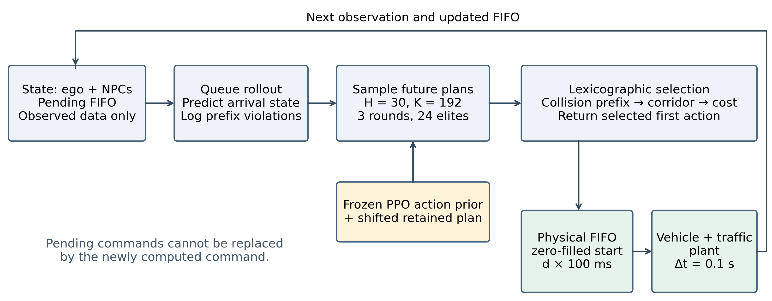
Fig. 1. LANS-RISK framework. Observation and pending-command processing feed a predicted arrival state to trajectory search. The frozen PPO prior and retained plan are candidates, while the lexicographic score determines selection. The selected command enters the same physical FIFO as every baseline. The upper feedback path returns updated state and queue information. No block implies a certified safety guarantee.

Queue-Aware Trajectory Supervision

Plan Representation and Candidate Generation
A candidate $k$ is a sequence $r_{k}=\{\left(b_{k,h},α_{k,h}\right)\}_{h=0}^{H−1}$ with $H=30$. At each predicted state, it generates
$$u_{k,h}=\left(clip\left(η_{g}\left({\hat{x}}_{k,h}\right)+b_{k,h},−1,1\right),α_{k,h}\right).$$
The offset $b_{k,h}$ permits geometric steering to adapt along a trajectory. The actor provides a first-action prior; it does not increase the common desired-speed reference $v_{ref}$.
Each of three rounds samples $K=192$ plans around a per-step mean. Gaussian perturbations are shared within five-step blocks, but the mean has one value per step. All plan entries are clipped to $\left[−1,1\right]$. Six explicit candidates replace the first sampled plans: the current mean, cruise, full brake, actor prior, retained previous plan, and best-so-far plan. Cruise uses $b_{h}=0$ and $α_{h}=clip\left(\left(v_{ref}−{\overset{‾}{v}}_{t}\right)/3.5,−1,1\right)$; brake uses $\left(b_{h},α_{h}\right)=\left(0,−1\right)$. The actor-prior plan replaces the cruise plan’s first pair with $\left(clip\left(u_{t,1}^{π}−η_{g}\left({\overset{‾}{x}}_{t}\right),−1,1\right),u_{t,2}^{π}\right)$.
The first decision starts its mean at cruise and its retained candidate at brake. Later decisions use the shifted previous plan. Initial sampling standard deviations are $\left(0.18,0.65\right)$ per step; the best 24 plans update the mean and standard deviation, with floors $\left(0.015,0.08\right)$. Thus the search evaluates 576 candidate rollouts per decision, although explicit candidates may repeat. This is sampled optimization, not an exhaustive feasibility solver.

Collision-First Ranking and Performance Cost
For steps $h=0,…,H−1$, $c_{k,h}$ and $e_{k,h}$ are evaluated after propagation. Define the first forecast violations
$$\begin{matrix}h_{c}\left(k\right) & =min\left(\{h:c_{k,h}<0.25\}∪\{H\}\right), \\ h_{e}\left(k\right) & =min\left(\{h:\left|e_{k,h}\right|>1.75\}∪\{H\}\right), \\ s_{k} & =\left\{\begin{matrix}c_{k,0}, & h_{c}\left(k\right)=0, \\ h_{e}\left(k\right), & h_{c}\left(k\right)>0.\end{matrix}\right.\end{matrix}$$
Selection lexicographically maximizes $\left(h_{c}\left(k\right),s_{k},−J_{k}\right)$. A longer predicted collision-free prefix therefore takes precedence over corridor retention and tracking cost. When every sampled plan predicts a first-step collision-margin violation, first-step clearance replaces corridor duration as the secondary rank.
The implemented stage cost is explicitly
$$\begin{matrix}ℓ_{k,h}=​ & 8e_{y}^{2}+2e_{ψ}^{2}+0.2{\left(v−v_{ref}\right)}^{2} \\ & +0.03\left(η^{2}+α^{2}\right)+10max{\left(0,1−c\right)}^{2} \\ & +1_{m<0}\left({10}^{6}+{10}^{5}m^{2}\right), \\ m=​ & min\left(c−0.25,1.75−\left|e_{y}\right|\right), \\ J_{k}=​ & \sum_{h=0}^{H−1}{ℓ_{k,h}}+0.5∥u_{k,0}−u_{t}^{π}∥_{2}^{2}.\end{matrix}$$
Variables in $ℓ_{k,h}$ refer to the propagated candidate state and normalized command. These weights are frozen implementation constants, not values selected on confirmation cases. The large penalty and lexicographic rank express operational priorities; neither turns the sampled forecast into a collision-probability estimate or a safety certificate.

Command Execution and Plan Retention
The best plan across the three rounds supplies only its first command. For the next decision, the stored candidate is
$$r_{t+1}^{retained}=\left(r_{t,1}^{*},…,r_{t,H−1}^{*},\left(0,−1\right)\right).$$
The tail means geometric steering with full braking, not zero physical steering. All returned commands pass through the physical FIFO. Re-evaluation at the next observation can select a different plan. Retention therefore preserves a candidate, not a recursively feasible backup; prediction error and the uncertified braking tail prevent importing the terminal-set guarantees of [2, 6]. Algorithm 1 (Table II) summarizes the actual decision sequence.
Table II. Algorithm 1: one LANS-RISK control decision (frozen actor).
 | Inputs: observed state, FIFO $q_{t}$, PPO action $u_{t}^{π}$, retained plan.
1 | Estimate NPC acceleration; roll out $q_{t}$ to $\left({\overset{‾}{x}}_{t},{\overset{‾}{z}}_{t}\right)$; log prefix violations.
2 | Construct cruise, brake, actor-prior and retained candidates; initialize mean and dispersion.
3 | For three rounds: draw 192 plans, insert six explicit candidates, and propagate 30 steps.
4 | Compute $\left(h_{c},s,−J\right)$; retain the best plan across rounds. Refit the sampling distribution to 24 elites.
5 | Return the selected first action to the physical FIFO. Shift the selected plan and append $\left(0,−1\right)$.
6 | Log forecast collision/corridor violations; repeat at the next observation.

Matched Component Removals
The no-prediction variant skips only the internal queue rollout; the real FIFO, actor and search remain active. The no-actor variant uses the analytical cruise proposal and sets the actor-distance weight to zero, retaining prediction, ranking and plan retention. PPO-only removes the complete supervisor. Accordingly, the first two are component removals, whereas the PPO-only contrast tests a bundle. No removal establishes a claim about all prediction methods or all learned policies.

Experimental Protocol

Frozen Confirmation and Conference Scope
The reported subset contains five controller variants: LANS-RISK, nominal MPC, PPO-only, no queue prediction, and no actor. Each is evaluated on all four scenarios and delays of 0, 200, 500, 700, and 1,000 ms. Policies are loaded with Stable-Baselines3 [18]. Learned variants use frozen actor seeds 42, 43, and 44; actor-free methods are run once for each scenario/delay. Each condition uses the same 100 traffic-case seeds, 141000–141099. This yields 220 conditions and 22,000 episode records. The repeated actor evaluations reuse traffic cases and are not 300 independent cases per condition.
These records are drawn from a completed, source-frozen 440-condition/44,000-record confirmation stage. Development used a separate seed range. No retraining or tuning was performed on the reported confirmation cases. The conference subset was chosen for its methodological scope after the full evaluation; it is not a separately preregistered experiment. All selected methods retain every scenario and delay. The expanded robustness, sensor-delay, runtime, and broader baseline studies are not reported here. In particular, this paper uses only the original main-confirmation protocol, not the separate dense-Merge robustness initialization amendment.

Nominal MPC Comparison
The nominal MPC shares the plant, structured state information, physical FIFO, action bounds, reference-speed ceiling, observed-acceleration predictor, 30-step horizon, and three rounds of 192 candidates. It uses a block-parameterized plan and its own cost ranking, warm start, and fallback. LANS-RISK differs in actor use, trajectory retention/representation, and ranking/objective details. Thus, the comparison matches important resources and information but is not a one-variable algorithmic ablation. Equal candidate counts also do not establish equal runtime; no computational superiority claim is made here.

Metrics and Statistical Analysis
A collision is an event anywhere in the recorded episode. Route completion requires reaching the goal and remaining collision-free for the episode. Corridor completion additionally requires $\left|e_{t}\right|≤1.75$ m at every recorded step. Episode tracking error is
$$RMSE=\sqrt{\frac{1}{T}\sum_{t=1}^{T}{e_{t}^{2}}}.$$
This is conventional episode RMSE, not the failure-penalized metric in the supplied LANS path-tracking manuscript. Since collisions can shorten an episode, RMSE is interpreted together with collision and completion outcomes.
To avoid treating repeated runs or selected aggregate scores as conclusive RL evidence [19], actor-level inference and paired traffic cases are preserved. Binary rate uncertainty uses per-condition Wilson 95% intervals. Supported continuous-mean and paired-difference intervals use 5,000 traffic-case bootstrap draws. Binary comparisons use exact paired-discordance tests; RMSE uses two-sided Wilcoxon signed-rank tests with the usual symmetry assumption for a location interpretation. We retain Holm correction [20] over all 3,440 contrasts/outcomes in the parent main-confirmation analysis, including comparisons outside the conference subset. Correction is not recomputed on a favorable selected subset. Actor-seed results remain separate for inference. Figure lines and endpoint tables average actor-condition estimates only for display; ranges across three actors are not confidence intervals.
The empirical delay threshold is the largest tested delay for which collision rate is at most 1% and corridor completion is at least 90% at that delay and every lower grid point. It is a finite-grid endpoint, not a continuous-delay stability bound. A passing value of 1,000 ms is right-censored by the tested grid. Even zero observed collisions in 100 cases has a Wilson 95% upper bound near 3.7%, so passing does not establish a population collision probability below 1%.
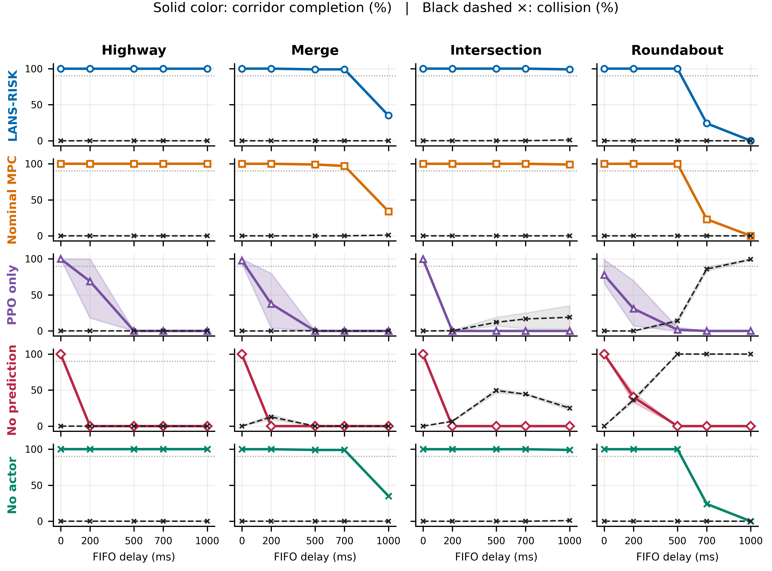
Fig. 2. All four scenarios and five main-confirmation delays. Each controller has a separate row, so coincident LANS-RISK, MPC and no-actor curves remain visible. Solid colored lines and colored markers show corridor completion; black dashed lines and crosses show collisions. Values are percentages. Lines are actor-seed means; shading is the corresponding actor minimum–maximum range, not a confidence interval. Dotted lines mark 90% completion. No horizontal or vertical offsets are applied to outcomes.

Results

LANS-RISK versus Nominal MPC
All three LANS-RISK actors and nominal MPC attain the same observed contiguous passing thresholds: Highway 1,000 ms, Merge 700 ms, Intersection 1,000 ms, and Roundabout 500 ms. Figure 2 shows the full completion grid. Table IV and Fig. 3 summarize the latency endpoint; no delay-threshold advantage is established. Identical thresholds should not be read as statistical equivalence or identical episode trajectories.
At 1,000 ms, both methods complete the corridor in all Highway cases, while their actor-mean corridor rates are 35% versus 34% on Merge, 99% versus 99% on Intersection, and zero for both on Roundabout (Table III). LANS-RISK has lower mean RMSE on Merge and Roundabout, while MPC has lower mean RMSE on Highway and Intersection. These descriptive differences do not support a universal tracking winner. In particular, a small RMSE advantage on a scenario with poor corridor completion is not evidence that the task was successfully solved.
Across the 60 per-actor/scenario/delay LANS–MPC corridor-completion contrasts, nine have a positive LANS-minus-MPC mean difference, none has a negative mean difference, and none is significant after the retained study-wide Holm correction. Absence of significance is not a non-inferiority or equivalence result. We did not specify an equivalence margin or conduct a dedicated equivalence design.
Table III. Main-confirmation outcomes at 1,000 ms. LANS-RISK entries are descriptive averages of three actor-condition means; MPC uses the same 100 traffic cases once. Collision (C) and corridor completion (CC) are percentages.
 | LANS-RISK |  |  | Nominal MPC
Scenario | C (%) | CC (%) | RMSE (m) | C (%) | CC (%) | RMSE (m)
Highway | 0.0 | 100.0 | 0.080 | 0.0 | 100.0 | 0.025
Merge | 0.0 | 35.0 | 0.378 | 1.0 | 34.0 | 0.416
Intersection | 1.0 | 99.0 | 0.043 | 0.0 | 99.0 | 0.031
Roundabout | 0.0 | 0.0 | 0.927 | 0.0 | 0.0 | 0.939
Table IV. Empirical contiguous passing actuation delay (ms). Passing requires collision $≤1\%$ and corridor completion $≥90\%$ at every tested delay up to the endpoint. Slashes list actors 42/43/44 when they differ; otherwise all three agree. NP means no passing point, including at zero delay. $†$: 1,000 ms is the tested upper limit, not a measured failure boundary.
Controller | Highway | Merge | Intersection | Roundabout
LANS-RISK | 1000$​^{†}$ | 700 | 1000$​^{†}$ | 500
Nominal MPC | 1000$​^{†}$ | 700 | 1000$​^{†}$ | 500
PPO only | 0/200/0 | 0 | 0 | 0/NP/NP
No prediction | 0 | 0 | 0 | 0
No actor | 1000$​^{†}$ | 700 | 1000$​^{†}$ | 500
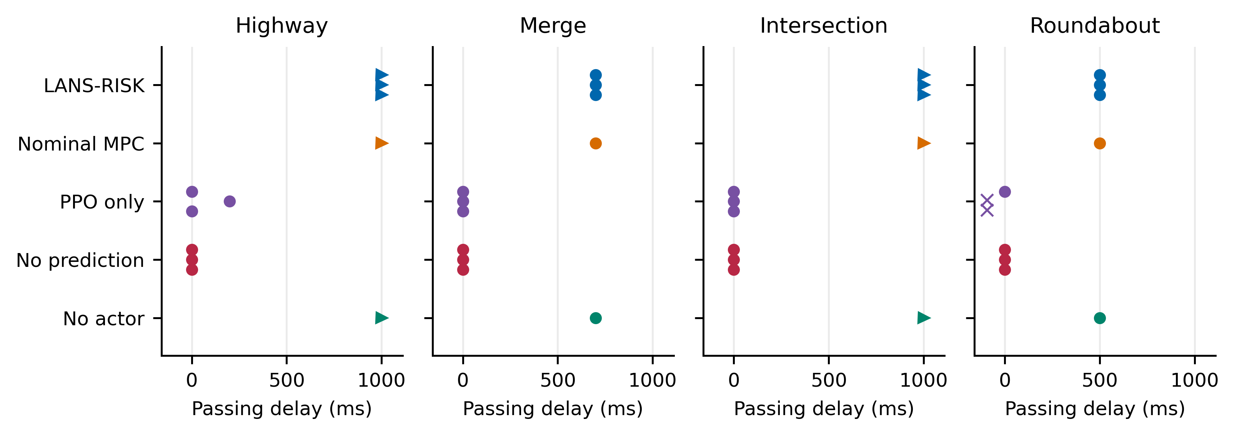
Fig. 3. Empirical latency endpoints for every method and scenario. Separate method rows prevent inter-controller occlusion. Three vertically separated points represent actor seeds; the horizontal value is unchanged. Right-pointing triangles denote an upper-grid-censored endpoint. A cross left of zero denotes NP, not negative tolerated delay. These are finite-sample endpoints, not certified latency bounds or measured controller execution times.

Contribution of Queue Prediction
Disabling internal queue prediction reduces corridor-completion rates in 45 of the 60 paired actor/scenario/delay contrasts; all 45 remain significant after Holm correction. No contrast has a higher corridor-completion rate for the no-prediction variant. These counts are correlated comparisons over shared cases and actors, not 60 independent replications.
The endpoint behavior illustrates the mechanism’s limitations and value. At 1,000 ms, removing prediction yields zero corridor completion in every scenario. Mean collision rates rise to 25% on Intersection and 100% on Roundabout, while Highway and Merge can have zero collisions yet still fail corridor completion. This combination explains why collision-only reporting would be misleading. The physical queue remains active in the ablation; the degradation concerns planning from the wrong effective initial state within this implementation.

Contribution of the Actor and Supervision Bundle
Removing the actor leaves corridor-completion rates unchanged in all 60 per-actor/scenario/delay comparisons. Table V shows mixed tracking effects at 1,000 ms: the no-actor variant has slightly lower mean RMSE on Intersection and Roundabout, but higher mean RMSE on Highway and Merge. Therefore, the present evidence does not establish a general completion benefit from the learned prior. This finding is retained rather than interpreting the presence of PPO as evidence of its usefulness.
Against PPO-only, LANS-RISK has higher corridor-completion rates in 49 of 60 contrasts, with 45 significant after Holm correction. The improvement applies to the full supervision bundle. PPO-only has zero corridor completion at the largest tested delay in every scenario and high collision rates on some scenarios. Nevertheless, comparing a supervised trajectory planner with an unsupervised policy cannot isolate which individual supervisory element causes every observed improvement.
Table V. Focused removals and PPO-only at 1,000 ms. C: collision; CC: corridor completion. Actor-seed averaging is descriptive; per-seed estimates and intervals are supplied separately.
Scenario | Variant | C (%) | CC (%) | RMSE (m)
Highway | LANS-RISK | 0.0 | 100.0 | 0.080
Highway | No queue prediction | 0.0 | 0.0 | 14.599
Highway | No actor | 0.0 | 100.0 | 0.082
Highway | PPO only | 0.0 | 0.0 | 11.060
Merge | LANS-RISK | 0.0 | 35.0 | 0.378
Merge | No queue prediction | 0.0 | 0.0 | 16.687
Merge | No actor | 0.0 | 35.0 | 0.392
Merge | PPO only | 0.0 | 0.0 | 35.224
Intersection | LANS-RISK | 1.0 | 99.0 | 0.043
Intersection | No queue prediction | 25.0 | 0.0 | 11.149
Intersection | No actor | 1.0 | 99.0 | 0.032
Intersection | PPO only | 19.0 | 0.0 | 14.573
Roundabout | LANS-RISK | 0.0 | 0.0 | 0.927
Roundabout | No queue prediction | 100.0 | 0.0 | 3.025
Roundabout | No actor | 0.0 | 0.0 | 0.927
Roundabout | PPO only | 99.3 | 0.0 | 3.687

Discussion and Limitations
The main implication is narrower than a generic learned-control superiority claim. Queue-aware planning is consequential within the tested supervisor, while the learned proposal has no observed corridor-completion advantage over its matched removal. A strong model-based baseline matches the empirical delay threshold. These results motivate treating the actor as an optional proposal mechanism whose value must be measured, rather than assumed.
The cold FIFO also imposes a control-authority limitation. Early queued commands may move the vehicle outside the reference corridor before a newly computed correction can act. Increasing search effort at the current decision cannot alter commands that have already entered the queue. The threshold is therefore partly a property of the complete protocol, initial queue, scenario, and reference geometry, not solely of the controller’s optimization quality.
Several boundaries limit generalization. The benchmark uses synthetic disc vehicles, a finite horizon, structured state access, fixed actors, and a known command queue. It does not establish real-road safety, robustness to arbitrary uncertainty, or performance with perception failures. Sampling only finitely many trajectories cannot certify feasibility; retaining a plan does not create a safe terminal set. Information about queue-prefix violations is diagnostic and should not be advertised as a guarantee of recovery.
The analysis preserves failures, paired cases, and frozen source/model hashes. Nonetheless, raw logs do not contain full per-step trajectories for independently reconstructing every recorded episode RMSE; aggregate statistics are recomputed from the saved episode-level values and the frozen metric implementation is retained. Confidence intervals are marginal, actor repetitions share traffic cases, and the fixed set of three actor seeds does not characterize all possible training outcomes. Shared-session episode timings are not evidence of real-time execution guarantees.

Conclusion
We presented and evaluated a queue-aware, trajectory-retaining supervisor for frozen learned driving policies under delayed command execution. A 22,000-record confirmation subset supports the importance of queue prediction within this design, while revealing no corridor-completion benefit from the actor prior and no observed delay-threshold advantage over matched nominal MPC. Tracking differences are scenario-dependent, and failures remain visible. The resulting contribution is an empirically characterized supervision design and a reproducible comparison, with explicit limits on novelty, safety, and generalization.

References
[1] D. Kalaria, Q. Lin, and J. M. Dolan, “Delay-aware robust control for safe autonomous driving and racing,” arXiv:2208.13856v1, 2022.
[2] K. P. Wabersich and M. N. Zeilinger, “A predictive safety filter for learning-based control of constrained nonlinear dynamical systems,” Automatica, vol. 129, Art. no. 109597, 2021.
[3] R. Ali and J. Tian, “Latency-aware path-tracking control for autonomous vehicles via analytical feedback and PPO-based residual compensation,” author-supplied manuscript, undated.
[4] L. Hewing, K. P. Wabersich, M. Menner, and M. N. Zeilinger, “Learning-based model predictive control: Toward safe learning in control,” Annual Review of Control, Robotics, and Autonomous Systems, vol. 3, pp. 269–296, 2020.
[5] L. Brunke et al., “Safe learning in robotics: From learning-based control to safe reinforcement learning,” Annual Review of Control, Robotics, and Autonomous Systems, vol. 5, pp. 411–444, 2022.
[6] B. Tearle, K. P. Wabersich, A. Carron, and M. N. Zeilinger, “A predictive safety filter for learning-based racing control,” arXiv:2102.11907v1, 2021.
[7] A. P. Leeman, J. Köhler, S. Bennani, and M. N. Zeilinger, “Predictive safety filter using system level synthesis,” in Proc. Learning for Dynamics and Control, PMLR, vol. 211, pp. 1180–1192, 2023.
[8] A. Singletary, Y. Chen, and A. D. Ames, “Control barrier functions for sampled-data systems with input delays,” in Proc. IEEE Conf. Decision and Control, pp. 804–809, 2020.
[9] F. Cano Córdoba, A. Palmisano, M. Fränzle, R. Bloem, and B. Könighofer, “Safety shielding under delayed observation,” in Proc. Int. Conf. Automated Planning and Scheduling, vol. 33, pp. 80–85, 2023.
[10] W. Wang, D. Han, X. Luo, and D. Li, “Addressing signal delay in deep reinforcement learning,” in Proc. Int. Conf. Learning Representations, 2024. [Online]. Available: https://openreview.net/forum?id=Z8UfDs4J46
[11] Q. Wu et al., “Directly forecasting belief for reinforcement learning with delays,” in Proc. Int. Conf. Machine Learning, 2025.
[12] Y. Bouteiller, S. Ramstedt, G. Beltrame, C. Pal, and J. Binas, “Reinforcement learning with random delays,” in Proc. Int. Conf. Learning Representations, 2021.
[13] A. Tabrizian, Z. Huang, A. Aziz, and P. Wei, “Delay-aware reinforcement learning for highway on-ramp merging under stochastic communication latency,” arXiv:2403.11852v5, May 2026.
[14] J. Lubars et al., “Combining reinforcement learning with model predictive control for on-ramp merging,” in Proc. IEEE Int. Intelligent Transportation Systems Conf., pp. 942–947, 2021.
[15] S. Udatha, Y. Lyu, and J. Dolan, “Reinforcement learning with probabilistically safe control barrier functions for ramp merging,” in Proc. IEEE Int. Conf. Robotics and Automation, pp. 5625–5630, 2023.
[16] Z. Yuan et al., “Safe-control-gym: A unified benchmark suite for safe learning-based control and reinforcement learning in robotics,” IEEE Robotics and Automation Letters, vol. 7, no. 4, pp. 11142–11149, 2022.
[17] J. Schulman, F. Wolski, P. Dhariwal, A. Radford, and O. Klimov, “Proximal policy optimization algorithms,” arXiv:1707.06347, 2017.
[18] A. Raffin et al., “Stable-Baselines3: Reliable reinforcement learning implementations,” Journal of Machine Learning Research, vol. 22, no. 268, pp. 1–8, 2021.
[19] R. Agarwal, M. Schwarzer, P. S. Castro, A. C. Courville, and M. G. Bellemare, “Deep reinforcement learning at the edge of the statistical precipice,” in Advances in Neural Information Processing Systems, vol. 34, 2021.
[20] S. Holm, “A simple sequentially rejective multiple test procedure,” Scandinavian Journal of Statistics, vol. 6, no. 2, pp. 65–70, 1979.

