**SQL SERVER ASSIGNMENT**

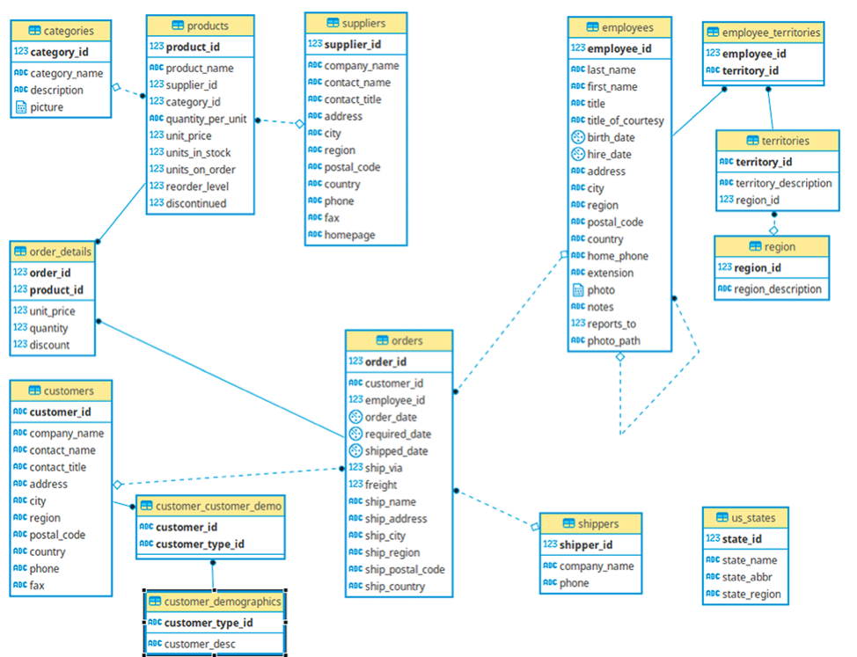

1. Develop database with the name of **Shopdb**
2. Create Two Tables as they are define in the above diagram; with name of categoies and Products
3. Insert Data in both table atleast 10 records in Products table with three catogires.
4. Create Insert Triggers that the check the data price ; should not less than 5oo/=,if less than 500 then rollback
5. Create Update Trigger that print the product_id that has been updated.
6. Create Delete Triggers that print the number of deleted records
7. Create three stroe procedure for insert update and delete.
   1. Insert Product in Products table
   2. Insert Categoy in Categories table
   3. Update in Price Products table
   4. Update in Catogery name Categories table
   5. Delete from Categories
   6. Delete from Products
8. Create Store Procedure that add Category and Products at same time.
9. Create View for that Shows Product_id,Categories Name,Product Price,unit in Stock