bizFE – Week 7 Notes
Angular front-end lab: creating the project, building a custom component, displaying data, and styling with Bootstrap.

Task 1: Create and Run the Angular Project
1. Open a terminal in the folder where the project should live and run:
ng new bizFE

- Stylesheet system: CSS
- Server-Side Rendering (SSR/SSG): No
- AI tools: select none, press Enter
- Analytics prompt (first ng serve): N
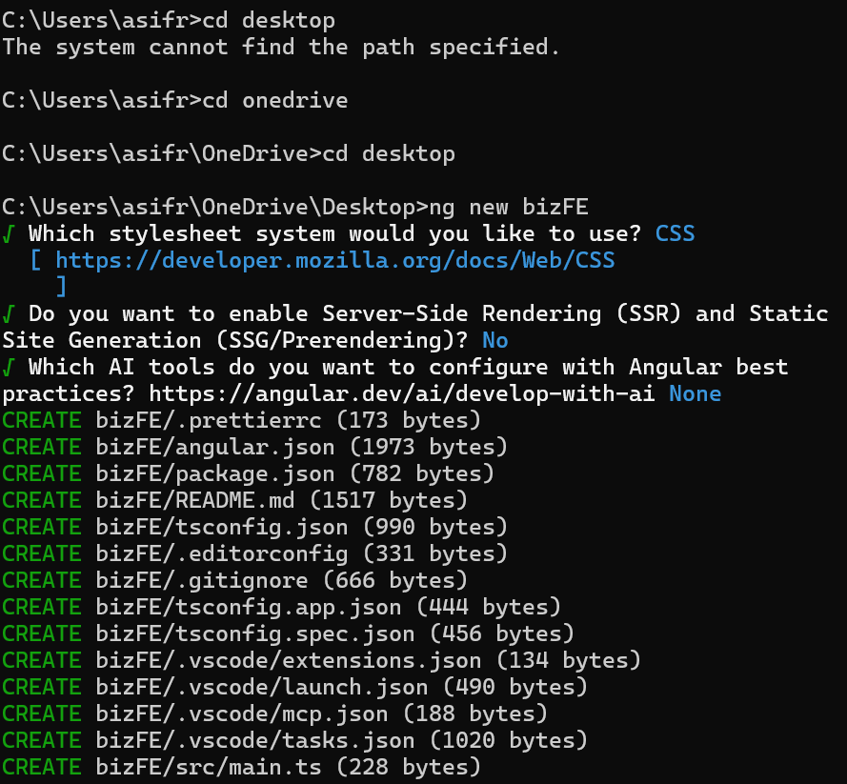
2. Move into the project and start the development server:
cd bizFE
ng serve

3. Open http://localhost:4200 in the browser.
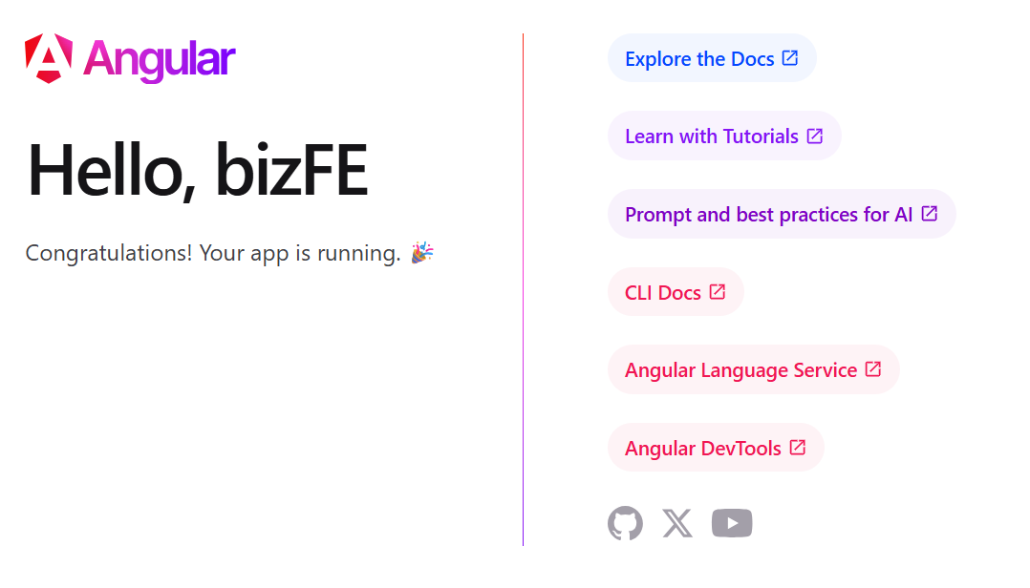
Note: If you get “Port 4200 is already in use”, an old ng serve is still running. Stop it with Ctrl+C in its terminal, or free the port with netstat -ano | findstr :4200 then taskkill /PID <pid> /F.
4. Open the project in VS Code.
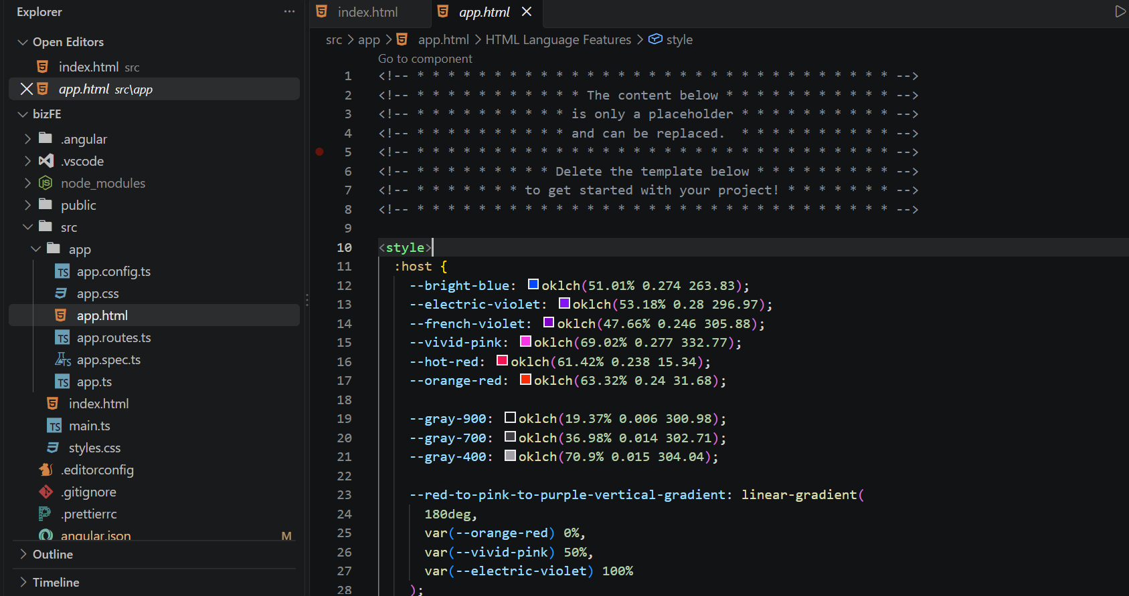
5. Open src/app/app.html, delete everything, and replace it with:
app.html
<h1>Welcome to {{ title() }}</h1>

Note: title is a signal in app.ts, so it is read with brackets: title(), not title.
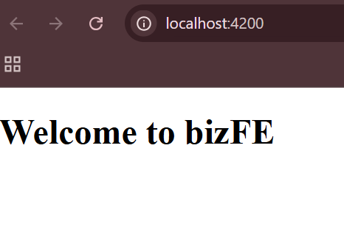
Result in the browser

Task 2: Create a Custom Component
1. In VS Code, right-click the app folder and choose Open in Integrated Terminal. Go into the components folder and generate the component:
cd src/app/components
ng generate component businesses

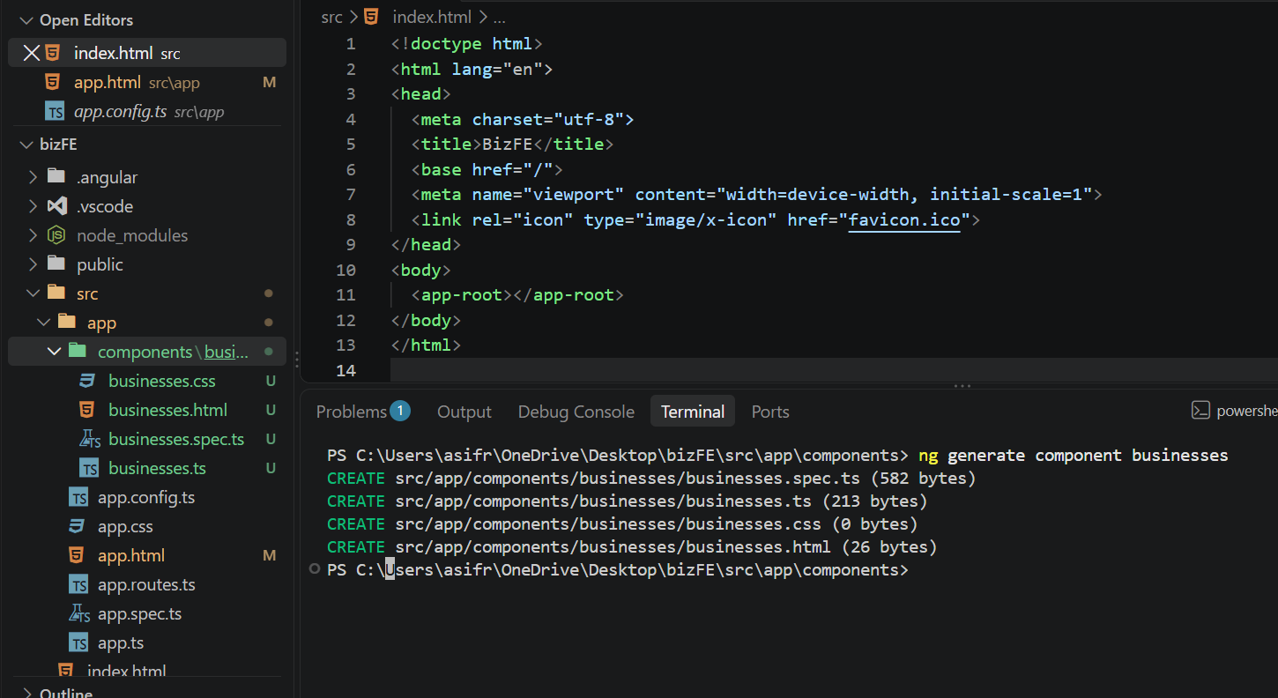
2. Edit the component template:
businesses.html
<h1>Biz Directory</h1>

3. Show the component from the root template:
app.html
delete the existing code and replace with below

<h1>Welcome to {{ title() }}</h1>
<app-businesses></app-businesses>

Common error: “app-businesses is not a known element”
A red line appears under <app-businesses> because the root component has not imported it. Add Businesses to the imports array in app.ts (and import it at the top of the file):
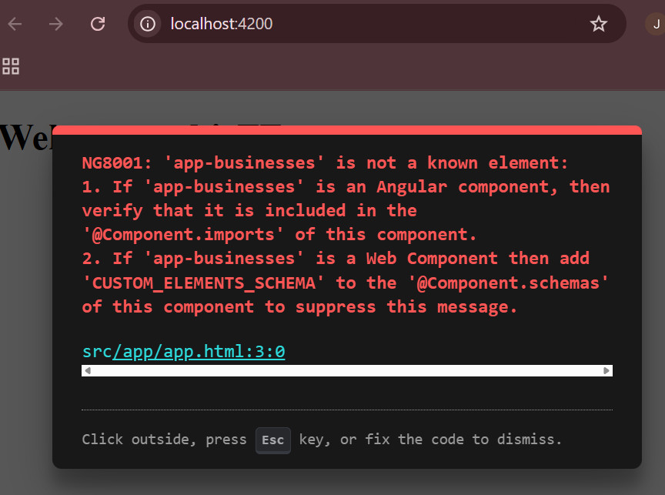
Error shown in VS Code
app.ts
import { Businesses } from './components/businesses/businesses';

@Component({
selector: 'app-root',
imports: [Businesses],
templateUrl: './app.html',
styleUrl: './app.css'
})

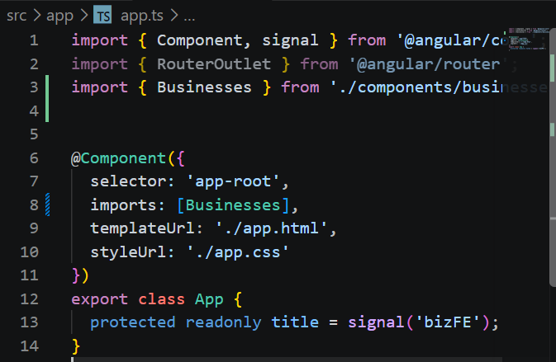
app.ts after the fix
Note: If RouterOutlet is imported but not used in app.html, Angular shows a warning. Either remove it from imports or add <router-outlet /> to the template.
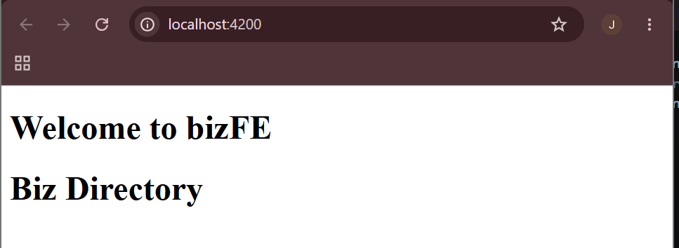
Output in the browser

Task 3: Angular Data Processing
Store the data in the component class, then display it in the template with interpolation and a @for loop.
businesses.ts
export class Businesses {
business_list = [
{name: 'Pizza Mountain',
town: 'Coleraine',
rating: 5
},

{ name: 'Wine Lake', town: 'Ballymoney', rating: 3 },
{ name: 'Sweet Desert', town: 'Ballymena', rating: 4 },
];
}

businesses.html
<h1>Biz Directory</h1>

<h2>There are {{ business_list.length }} businesses in the directory.</h2>
<h2>The first business is {{ business_list[0].name }}</h2>

@for (business of business_list; track business.name) {
<div class="card">
<h3>{{ business.name }}</h3>
<p>Town: {{ business.town }}</p>
<p>Rating: {{ business.rating }} / 5</p>
</div>
}

Key points:
- {{ ... }} interpolation prints a value from the class into the page.
- @for repeats its block once per item; track gives Angular a unique key for each item.
- Keep headings outside the loop, otherwise they repeat for every business.
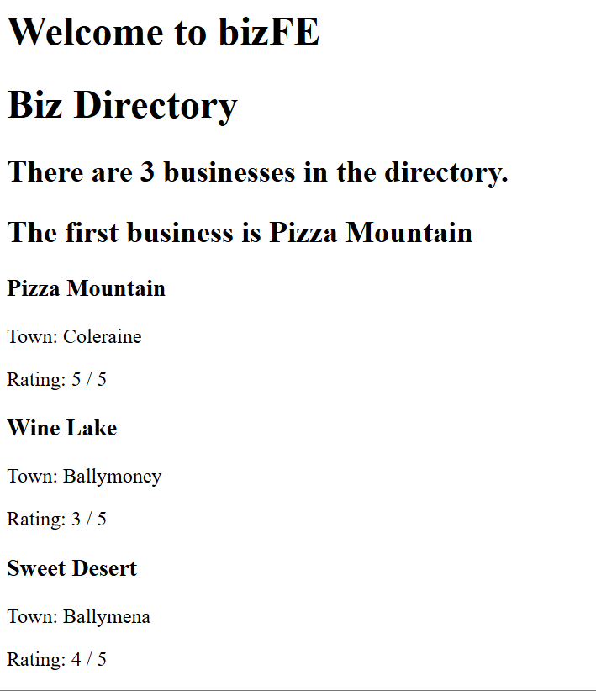
Output in the browser

Task 5: Bootstrap
1. Install Bootstrap and jQuery from the project folder:
npm install bootstrap jquery --save

Note: npm may print “allow-scripts” warnings for esbuild, lmdb and msgpackr-extract. They are harmless. To approve them: npm approve-scripts esbuild lmdb msgpackr-extract
2. Check that bootstrap and jquery now appear under node_modules, then restart the server:
ng serve

3. In angular.json, add the Bootstrap CSS under "styles" (Bootstrap first, so your own styles can override it):
"styles": [
"node_modules/bootstrap/dist/css/bootstrap.min.css",
"src/styles.css"
],

Note: Angular only reads angular.json at startup, so restart ng serve after editing it. Mind the commas: every item except the last needs one.
4. Replace the previous code in businesses.html with the Bootstrap version:
businesses.html
<div class="container mt-4">
<h1 class="mb-3">Biz Directory</h1>

<h5>There are {{ business_list.length }} businesses in the directory.</h5>
<h5 class="mb-4">The first business is {{ business_list[0].name }}</h5>

@for (business of business_list; track business.name) {
<div class="card bg-primary text-white mb-3">
<div class="card-header">{{ business.name }}</div>
<div class="card-body">
This business is based in {{ business.town }}
</div>
<div class="card-footer">Rating: {{ business.rating }}</div>
</div>
}
</div>

5. In app.html, remove the line <h1>Welcome to {{ title() }}</h1> so the heading is not shown twice.
app.html
<app-businesses></app-businesses>

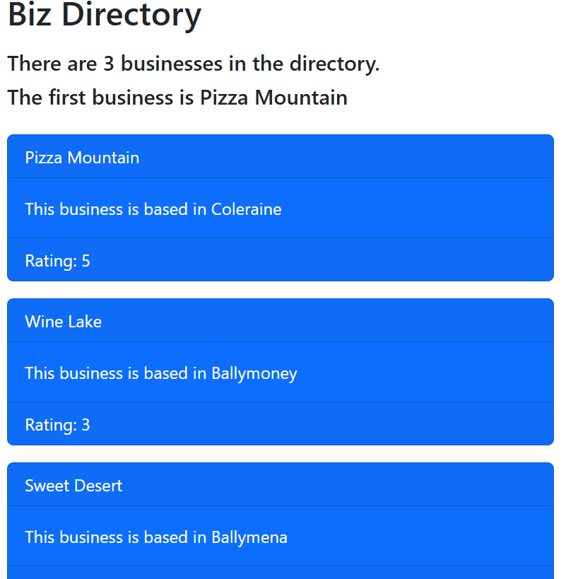
Final output with Bootstrap cards

Task 6: npm and Package Management
package.json lists the project’s dependencies (for example bootstrap and jquery after the install above). npm install --save adds a package and records it there; node_modules holds the downloaded files.
Note: This section was empty in the original notes. Add your own findings from package.json here.

