If you’re using Herd, you don’t need php artisan serve. For testing the many-to-many relationship (Students ↔ Courses), here are the exact Laravel Tinker commands you should run.

0) Make sure DB has tables + data
Run this once in terminal (recommended):
php artisan migrate:fresh –seed
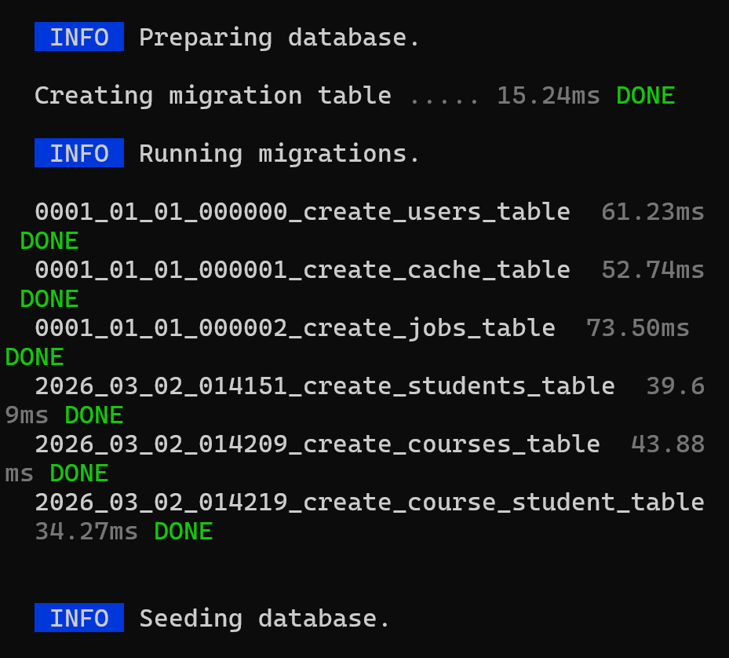

1) Open Tinker
php artisan tinker
Inside Tinker, run:
use App\Models\Student;
use App\Models\Course;
use Illuminate\Support\Facades\DB;

2) Confirm records exist
Student::count();
Course::count();
DB::table('course_student')->count();

3) Get a student and see their courses
$student = Student::first();
$student->courses; // returns courses collection
$student->courses->pluck('title','id'); // quick view
Or with eager loading (best practice):
$student = Student::with('courses')->first();
$student->courses;

4) Get a course and see its students
$course = Course::first();
$course->students;
$course->students->pluck('name','id');

5) Attach courses to a student (enroll student)
Attach by course IDs:
$student = Student::first();
$student->courses()->attach([1, 2]);
Attach 2 random courses:
$courseIds = Course::inRandomOrder()->take(2)->pluck('id');
$student->courses()->attach($courseIds);
✅ Safer (prevents duplicates):
$student->courses()->syncWithoutDetaching($courseIds);

6) Detach courses (unenroll student)
Remove specific courses:
$student->courses()->detach([1, 2]);
Remove all courses:
$student->courses()->detach();

7) Sync courses (replace enrollments)
This will remove old and keep only these:
$student->courses()->sync([1, 3]);

8) Check pivot table directly
DB::table('course_student')->where('student_id', $student->id)->get();

9) Useful relationship queries
Students who are enrolled in any course:
Student::has('courses')->get();
Students enrolled in a specific course ID:
Student::whereHas('courses', fn($q) => $q->where('courses.id', 1))->get();

Herd URL reminder
To view your /students page with Herd, open:
http://student-course-app.test/students

