Set up a Many-to-Many relationship between Students and Courses using Laravel with SQLite and the MFSC (Model, Factory, Seeder, Controller) structure. It describes in detail the entire flow of creating the project, setting up models, running migrations, seeding data, and managing relationships using Laravel's Eloquent ORM.

Here’s a breakdown of the concepts and what is happening in the project:

General Overview:

Laravel is a powerful web application framework that simplifies tasks like routing, authentication, and database management. In this tutorial, you will learn how to set up a Many-to-Many relationship between two entities (Student and Course) using SQLite as the database and the MFSC structure to organize the project.

Laravel Project Setup:

Laravel is installed using the command laravel new student-course-app, and then you navigate into the directory using cd student-course-app. This sets up the project, its folder structure, and its configuration files, ready for development.

SQLite Database Setup:

SQLite is chosen as the database, and its configuration is done in the .env file, where DB_CONNECTION=sqlite and the database file is specified as database/database.sqlite. SQLite is a self-contained database engine that stores data in a single file, and no server is required for it to run.

Creating Models with MFSC:

The command php artisan make:model Student -mfsc creates multiple necessary files at once:

Model: Represents the students table in the database.

Migration: Defines the structure of the students table.

Factory: Used to generate fake data for testing.

Seeder: Used to insert test data into the database.

Controller: Handles the logic for routes associated with the Student model.

Similarly, the Course model is also created in the same way, resulting in the same set of files.

Pivot Table for Many-to-Many Relationship:

A pivot table (course_student) is created to store the relationship between students and courses. The migration defines a table with two foreign keys, student_id and course_id, linking the two models together. This allows a student to have multiple courses and a course to have multiple students.

Defining Relationships in Models:

In Laravel, defining relationships between models is straightforward using methods like belongsToMany(). In this case:

The Student model has a method courses() that defines the many-to-many relationship between students and courses.

The Course model has a method students() that defines the inverse relationship.

These methods tell Laravel how to connect the models via the pivot table.

Running Migrations:

The php artisan migrate command runs the migrations and creates the tables in the SQLite database. This creates the students, courses, and course_student tables.

Setting Up Factories for Fake Data:

Laravel uses Faker to generate fake data for testing. Factories are set up for both Student and Course models. The StudentFactory generates fake names and emails, while the CourseFactory generates fake titles and course codes. These factories are used to populate the database with test data.

Seeding Data:

Seeder is used to populate the database with fake data. The DatabaseSeeder class creates 5 students and 3 courses and then attaches 2 random courses to each student. The attach() method is used to insert data into the pivot table (course_student), which stores the relationships.

Running Seeder:

The php artisan db:seed command runs the seeder and populates the database with the students, courses, and relationships.

Setting Up Routes and Controllers:

A route is defined in routes/web.php to display the list of students and their related courses. This route points to the index method in the StudentController. In the controller, the index() method fetches all students and their related courses using Eloquent’s with() method.

The data is then passed to the view (students.index) to display it in the browser.

Laravel Student-Course Many-to-Many Relationship (SQLite + MFSC)
This document explains step-by-step how to create a Many-to-Many relationship between Students and Courses using Laravel Herd with SQLite3 and MFSC (Model, Factory, Seeder, Controller).

STEP 1: Create Laravel Project
Run in terminal:
laravel new student-course-app
cd student-course-app
✅ Purpose:
- Creates a brand-new Laravel application.
- Sets up folder structure, dependencies, configuration files, and environment file.
- You now have a clean Laravel project ready to configure.

STEP 2: Setup SQLite Database
Create SQLite file inside database folder:
database/database.sqlite
Update .env file:
DB_CONNECTION=sqlite
DB_DATABASE=database/database.sqlite
✅ Purpose:
- Tells Laravel to use SQLite instead of MySQL.
- database/database.sqlite is the actual database file.
- SQLite stores everything in one file (no server required).
What is happening?
Laravel reads .env → connects to SQLite → uses that file to create tables during migrations.

STEP 3: Create Models with MFSC
✅ Purpose:
This single command creates:
- Model → Represents a database table
- Migration → Defines table structure
- Factory → Generates fake data
- Seeder → Inserts test data
- Controller → Handles logic for routes
What is happening?
Laravel scaffolds all required files so you can:
- Define table structure
- Generate fake records
- Control application logic

Create Student model with migration, factory, seeder, controller:

php artisan make:model Student -mfsc
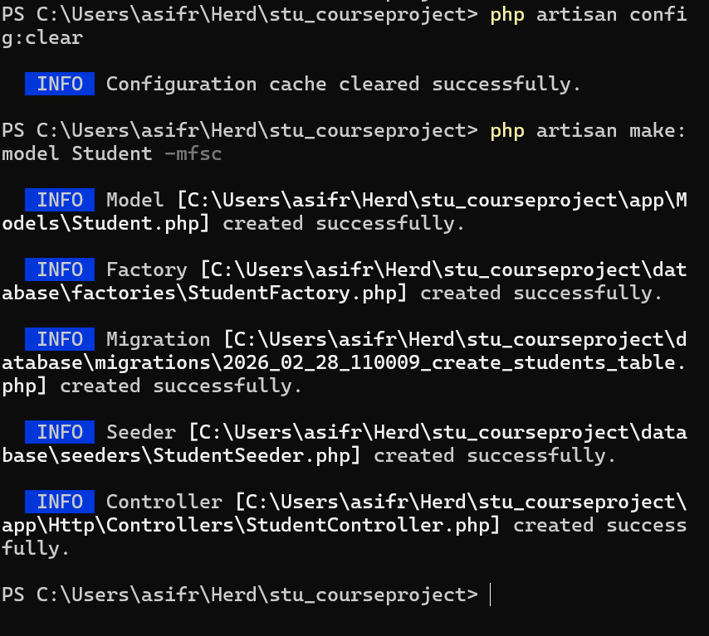
Create Course model with migration, factory, seeder, controller:
php artisan make:model Course -mfsc
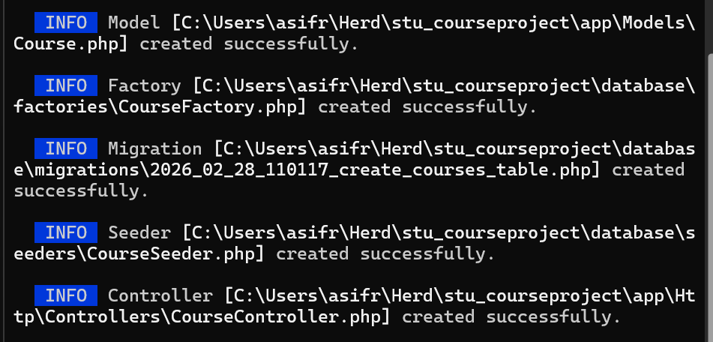

STEP 4: Create Pivot Table
php artisan make:migration create_course_student_table
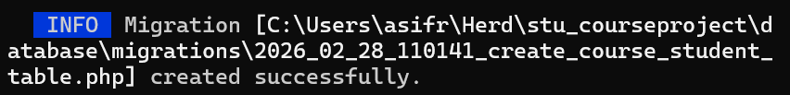
✅ Purpose:
Creates a pivot table for the many-to-many relationship.
Schema::create('course_student', function (Blueprint $table) {
$table->id();
$table->foreignId('student_id')->constrained()->onDelete('cascade');
$table->foreignId('course_id')->constrained()->onDelete('cascade');
$table->timestamps();
});
What is happening?
- student_id → links to students table
- course_id → links to courses table
- onDelete('cascade') → If a student/course is deleted, related records are automatically removed.
📌 Why needed?
Because in Many-to-Many:
- One student can have many courses
- One course can have many students
So we need a middle table to store relationships.

Final Look so Far
Now the VScode has :
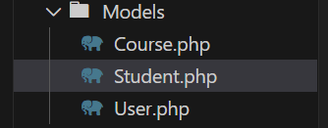
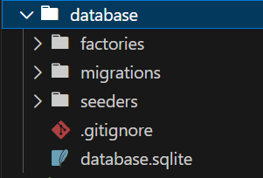
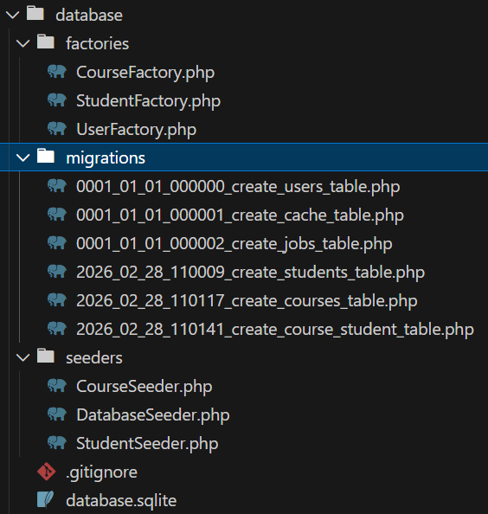

Inside migration file (Pivot Table):
Schema::create('course_student', function (Blueprint $table) {
$table->id();
$table->foreignId('student_id')->constrained()->onDelete('cascade');
$table->foreignId('course_id')->constrained()->onDelete('cascade');
$table->timestamps();
});
Run this after placing data in Course, student and pivot table.

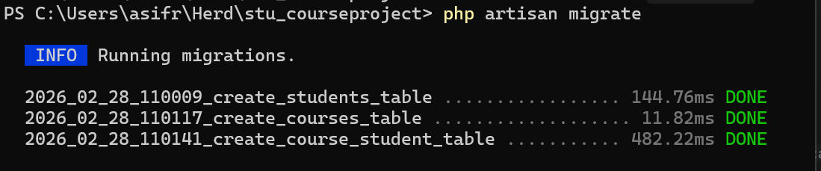

STEP 5: Define Relationships in Models
In Student model:
public function courses() {
return $this->belongsToMany(Course::class);
}
In Course model:
public function students() {
return $this->belongsToMany(Student::class);
}
✅ Purpose:
Defines how models are connected.
What is happening?
- belongsToMany() tells Laravel:
  - Look for a pivot table (course_student)
  - Use foreign keys (student_id, course_id)
- Laravel now automatically handles:
  - Attaching records
  - Detaching records
  - Syncing records
  - Fetching related data
Example:
$student->courses
Laravel automatically joins the pivot table and returns related courses.

STEP 6: Run Migrations
php artisan migrate
✅ Purpose:
Creates all tables in the database.
What is happening?
Laravel reads migration files → converts them into SQL → creates:
- students table
- courses table
- course_student pivot table
Your SQLite file now contains actual database tables.

STEP 7: Setup Factories
  - StudentFactory example:
In database/factories/StudentFactory.php, add the following code to generate fake student data:
use Faker\Generator as Faker;
use Illuminate\Database\Eloquent\Factories\Factory;
use App\Models\Student;

class StudentFactory extends Factory
{
protected $model = Student::class;

public function definition()
{
return [
'name' => $this->faker->name,
'email' => $this->faker->unique()->safeEmail,
];
}
}
  - Example: CourseFactory
In database/factories/CourseFactory.php, add the following code to generate fake course data:
use Faker\Generator as Faker;
use Illuminate\Database\Eloquent\Factories\Factory;
use App\Models\Course;
class CourseFactory extends Factory
{
protected $model = Course::class;
public function definition()
{
return [
'title' => $this->faker->word,
'code' => strtoupper($this->faker->bothify('CS###')),
];
}
}

✅ Purpose:
Automatically generate fake test data.
What is happening?
Laravel uses Faker to:
- Create realistic names
- Create emails
- Generate course titles and codes
This helps during testing without manually inserting records.

STEP 8: Setup Seeder
Open the database/seeders/DatabaseSeeder.php file and modify it to populate the database with fake data and establish relationships:
Inside DatabaseSeeder:

public function run()

{

$students = \App\Models\Student::factory(5)->create(); // Create 5 students

$courses = \App\Models\Course::factory(3)->create(); // Create 3 courses

foreach ($students as $student) {

$student->courses()->attach( // Attach random courses to each student

$courses->random(2)->pluck('id')->toArray() // Attach 2 random courses

);

}

}

✅ Purpose:

This will create 5 students, 3 courses, and randomly assign 2 courses to each student.

Populate database with sample data and relationships.

What is happening?

Creates 5 students

Creates 3 courses

For each student:

Randomly selects 2 courses

Inserts records into pivot table using attach()

So the pivot table gets entries like:

student_id | course_id
1 | 2
1 | 3
2 | 1

STEP 9: Run Seeder
- Now, run the seeder to populate the database with students, courses, and relationships:
php artisan db:seed
- This will execute the DatabaseSeeder class and populate the database with students, courses, and their relationships.
✅ Purpose:
Executes the DatabaseSeeder class.
What is happening?
Laravel runs:
- StudentFactory
- CourseFactory
- Attaches relationships
Your database is now fully populated.

STEP 10: Add Route and Test
- In routes/web.php, add a route to display the students and their courses:
Route::get('/students', [StudentController::class, 'index']);
- In StudentController.php, modify the index() method to fetch students with their related courses:
public function index()
{
$students = Student::with('courses')->get();
return view('students.index', compact('students'));
}
- Finally, run the Laravel development server:
php artisan serve

Visit http://127.0.0.1:8000/students in your browser to see the list of students and their enrolled courses.
✅ Purpose:
Creates a URL endpoint.
When visiting:
http://127.0.0.1:8000/students
What is happening?
- Browser hits /students
- Route calls StudentController@index
- Controller fetches students (possibly with courses)
- Data is returned to browser

Run server: php artisan serve
Visit: http://127.0.0.1:8000/students

Conclusion
You have successfully created a Many-to-Many relationship between Students and Courses using SQLite in Laravel Herd with MFSC structure.
🔹 Overall Concept (Big Picture)
You built:
Component | Role
Model | Represents table
Migration | Creates table
Factory | Generates fake data
Seeder | Inserts data
Pivot Table | Connects students & courses
Relationship | Defines connection logic
Route | Exposes URL
Controller | Handles request logic

🔥 What You Achieved
You implemented a Many-to-Many Relationship, which means:
- A student can enroll in multiple courses.
- A course can have multiple students.
- Laravel automatically manages the relationship using Eloquent ORM.

New Topic Eloquent ORM:
What is Eloquent ORM in Laravel?
Eloquent ORM (Object-Relational Mapping) is Laravel’s built-in system for interacting with your database using PHP objects instead of raw SQL queries.
It allows you to work with database tables as if they were regular PHP classes.
Laravel Tinker:
You can use Laravel Tinker to interact with your application's database and check relationships like the one between Student and Course. Here's how you can do it:
Step 1: Open Tinker
In your terminal, navigate to your Laravel project directory and run the following command to start Tinker:
php artisan tinker

Step 2: Check the Relationship
Once you're in Tinker, you can execute the following commands to test the relationships between Student and Course:
1. Get a Student and Its Courses
To fetch a student and their associated courses, run:
$student = App\Models\Student::find(1);
$student->courses;
This will return all the courses associated with the student with an id of 1. If the student has no courses, it will return an empty collection.
2. Get a Course and Its Students
To fetch a course and the students enrolled in it, run:
$course = App\Models\Course::find(1);
$course->students;
This will return all the students associated with the course with an id of 1. If no students are enrolled in the course, it will return an empty collection.
Step 3: Attach Courses to a Student (For Testing)
If you want to manually attach courses to a student for testing, you can do it like this:
- Get the student:
$student = App\Models\Student::find(1);
- Get the courses:
$courses = App\Models\Course::find([1, 2]); // This fetches courses with IDs 1 and 2
- Attach the courses to the student:
$student->courses()->attach($courses);
Step 4: Verify the Data
After attaching courses to the student, you can run the following command to verify the relationship:

$student->courses;
This should now show the courses that were attached to the student.
Step 5: Detach Courses from a Student
If you want to detach courses from a student, you can use:

$student->courses()->detach($courses);
Step 6: Check Pivot Table Directly
You can also check the pivot table directly to verify the data. In this case, you can do it by querying the course_student pivot table:

DB::table('course_student')->where('student_id', 1)->get();
This will show the records of the course_student pivot table for the student with id = 1.
Summary of Tinker Commands:
- Get a student and its courses:
$student = App\Models\Student::find(1);
$student->courses;
- Get a course and its students:
$course = App\Models\Course::find(1);
$course->students;
- Attach courses to a student:
$student->courses()->attach([1, 2]); // Attaches course with id 1 and 2 to the student
- Detach courses from a student:
$student->courses()->detach([1, 2]); // Detaches courses with id 1 and 2 from

🔹 1️⃣ What Does ORM Mean?
ORM = Object Relational Mapping
It maps:
Database Concept | Eloquent Equivalent
Table | Model
Row | Object
Column | Property
Foreign Key | Relationship
So instead of writing SQL like:
SELECT * FROM students;
You write:
Student::all();
Much cleaner and more readable.

🔹 2️⃣ What is Eloquent?
Eloquent is Laravel’s implementation of ORM.
Each Model in Laravel represents a database table.
Example:
php artisan make:model Student
Creates:
class Student extends Model
Now the Student model automatically connects to the students table.

🔹 3️⃣ How Eloquent Works (Behind the Scenes)
When you write:
Student::create([
'name' => 'John',
'email' => 'john@email.com'
]);
Eloquent:
- Converts this into an SQL INSERT
- Executes it in the database
- Returns a Student object
You don’t see the SQL — Eloquent handles it.

🔹 4️⃣ Basic Eloquent Operations (CRUD)
✅ Create
Student::create([...]);
✅ Read
Student::all();
Student::find(1);
Student::where('name', 'John')->get();
✅ Update
$student = Student::find(1);
$student->name = 'Mike';
$student->save();
✅ Delete
Student::find(1)->delete();

🔹 5️⃣ Relationships (Very Powerful Feature)
Eloquent makes relationships easy.
One-to-Many
return $this->hasMany(Post::class);
Many-to-Many
return $this->belongsToMany(Course::class);
Then you can do:
$student->courses;
And Laravel automatically fetches related records using JOIN queries.

🔹 6️⃣ Why Eloquent is Powerful
✔ Cleaner Code
No messy SQL strings everywhere.
✔ Automatic Table Naming
Student → students table automatically.
✔ Built-in Security
Prevents SQL injection.
✔ Easy Relationships
Handles pivot tables and foreign keys automatically.
✔ Readable & Maintainable
Code looks like natural PHP.

🔹 7️⃣ Eloquent vs Raw SQL
Raw SQL
DB::select("SELECT * FROM students WHERE id = 1");
Eloquent
Student::find(1);
Eloquent is:
- Shorter
- Cleaner
- Object-oriented

🔹 8️⃣ In Simple Words
Eloquent lets you treat your database like objects.
Instead of thinking:
"Query the students table"
You think:
"Work with the Student model"

🔥 Summary
Eloquent ORM is:
- Laravel’s database system
- Converts PHP models into database queries
- Makes CRUD operations simple
- Handles relationships automatically
- Reduces need for writing SQL manually

