Azure DevOps
Create Account in Azure DevOps
Here’s a step-by-step guide to create an organization in Azure DevOps. I’ll make it detailed so you can follow along easily.

Step 1: Sign in to Azure DevOps
- Go to Azure DevOps
- Sign in with your Microsoft account.
  - If you don’t have one, create a Microsoft account first.

Step 2: Start creating a new organization
- After signing in, you’ll see the Azure DevOps home page.
- Click “New organization” (usually a big button on the top-right or in the center of the page).

Step 3: Enter organization details
- Organization name:
  - Choose a unique name (this will appear in your Azure DevOps URL).
  - Example: rizwanaasiforg
- Location:
  - Choose a region closest to you for best performance (e.g., East US, Europe).
- Click Continue.

Step 4: Configure billing (optional)
- If you are just starting, Azure DevOps gives a free tier (up to 5 users with full features).
- You can skip billing for now if it’s a personal or test project.

Step 5: Complete setup
- Azure DevOps will create your organization.
- You’ll see a welcome screen like: “Welcome to your organization”.
- The URL of your organization will be:
https://dev.azure.com/<your-organization-name>
- Example:
https://dev.azure.com/rizwanaasiforg

Step 6: Create your first project
- Click “New Project” in your organization.
- Fill in:
  - Project name: e.g., LaravelApp
  - Visibility: Public or Private (Private is recommended)
  - Advanced: Choose version control (Git) and work item process (Agile is common)
- Click Create.

Step 7: Access your organization and project
- Once created, you can access your project:
https://dev.azure.com/<your-organization-name>/<project-name>/
- From here, you can create repos, pipelines, boards, artifacts, etc.

✅ Your organization is ready. You can now:
- Add users
- Create repositories
- Set up CI/CD pipelines
- Track work items with Boards

Commands in Laravel Herd
Select the Laravel Herd Project
Open terminal
Command: git init
Command: git remote add origin https://dev.azure.com/ORG_NAME/PROJECT_NAME/_git/REPO_NAME
PS C:\Users\asifr\Herd\firstproject> git remote add origin https://dev.azure.com/rizwanaasiforg/LaravelApp/_git/firstpro

cd C:\Users\asifr\Herd\firstproject

# Optional: remove old remote (you did this already)
git remote remove origin

# Add remote
git remote add origin https://dev.azure.com/rizwanaasiford/LaravelApp/_git/firstpro

# Make sure branch is main
git branch -M main

# Push with PAT
git push -u origin main
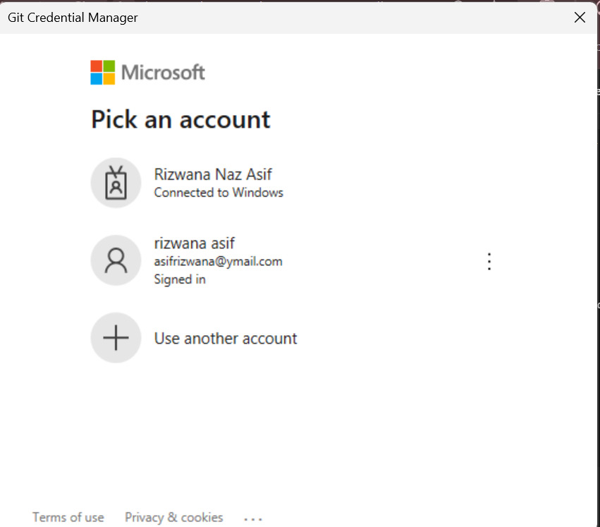
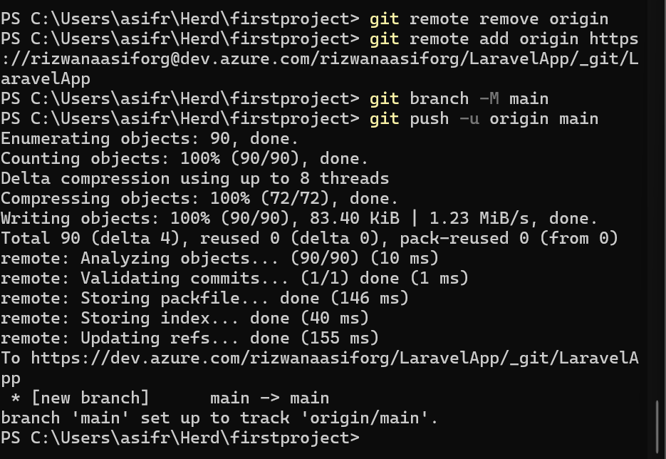
Org: rizwanaasiforg
Project: LaravelApp
Repo: firstpro
Branch: main
What you can do next
- Verify in Azure DevOps
  - Go to Repos → Files in your LaravelApp project
  - You should see all your Laravel files uploaded.
- Next steps for Laravel
  - Set up Pipelines for CI/CD (automatic build & deploy)
  - Configure .env for deployment
  - Connect a web server (like Azure App Service) if you want live hosting
  - Add Boards to track tasks if needed

Detailed Notes:
Here’s a daily Git cheat sheet for your Laravel Herd project on Windows PowerShell. You can literally copy-paste these commands every day.

1️⃣ Go to your project folder
cd C:\Users\asifr\Herd\firstproject

2️⃣ Pull the latest changes from Azure DevOps
git pull origin main
✅ Always do this first so your local project is up-to-date.

3️⃣ Stage all changes
git add .
- . → adds all modified/new files
- Optional: stage only specific files:
git add resources/views/welcome.blade.php

4️⃣ Commit your changes
git commit -m "Describe your changes here"
- Use clear, meaningful messages, e.g., "Added login validation" or "Updated routes for API"

5️⃣ Push changes to Azure DevOps
git push origin main
- This updates the Azure DevOps repository
- If prompted for credentials:
  - Username → Azure DevOps email
  - Password → Personal Access Token (PAT)
💡 Optional: cache credentials so you don’t have to enter PAT every time:
git config --global credential.helper manager-core

✅ Optional quick workflow in one block
You can copy-paste this every day:
cd C:\Users\asifr\Herd\firstproject
git pull origin main
git add .
git commit -m "YOUR COMMIT MESSAGE"
git push origin main
- Just replace "YOUR COMMIT MESSAGE" each time.

Exercise: Change the content in About File

Let’s go step by step on how to edit your Laravel Herd project file about.blade.php, commit your changes, and push them to Azure DevOps. I’ll make it easy to follow.

Step 1: Open the project folder in your editor
- Open Herd → find your project firstproject.
- Open the project in your preferred code editor, e.g., VS Code:
  - Right-click the project folder → Open with Code
OR in PowerShell:
- cd C:\Users\asifr\Herd\firstproject
- code .
- Navigate to the file path:
resources/views/about.blade.php

Step 2: Edit about.blade.php
- Open the file in the editor.
- Make your changes. For example, add a new heading:
<h1>About Our Company</h1>
<p>Welcome to our Laravel Herd project!</p>
- Save the file.

Step 3: Open Terminal / PowerShell
- Make sure your terminal is in the project folder:
cd C:\Users\asifr\Herd\firstproject

Step 4: Pull latest changes from Azure DevOps
Always pull first to avoid conflicts:
git pull origin main

Step 5: Stage the changes
Tell Git which files you want to commit:
git add resources/views/about.blade.php
Or stage all changes:
git add .

Step 6: Commit your changes
git commit -m "Updated about.blade.php with new heading and paragraph"
- Use a descriptive commit message so others (or future you) know what changed.

Step 7: Push changes to Azure DevOps
git push origin main
- This updates the remote repo.
- If prompted:
  - Username → Azure DevOps email
  - Password → Personal Access Token (PAT)

✅ Step 8: Verify
- Go to Azure DevOps → Repos → Files → about.blade.php
- Check if your new changes appear.

