Practical 1: Say "Hello" from one PC to another (email)
Aim: send a real text message, "Hello", from PC0 to PC1. Time: about 45 minutes. PCs cannot chat directly, so a server in the middle holds the message, just like real email.
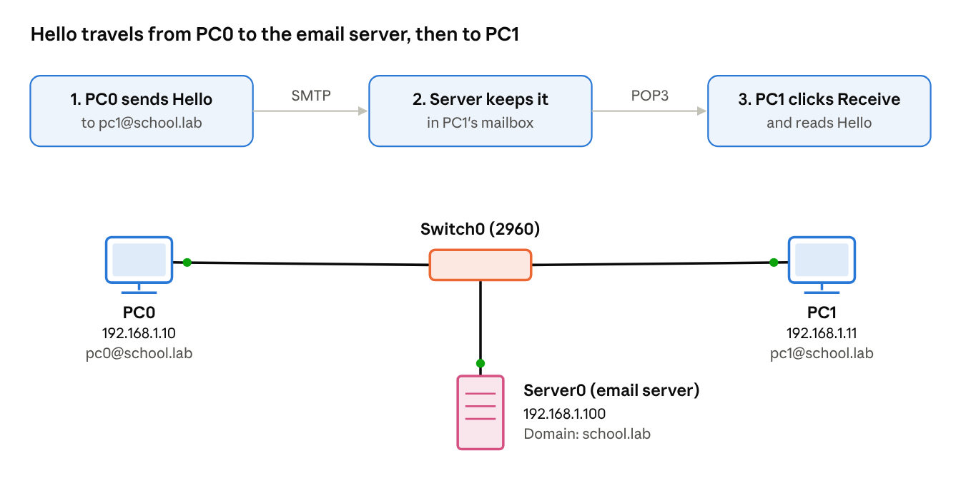
Practical 5 · two PCs and an email server on one switch
Device | IPv4 address | Subnet mask | Email address | Password
PC0 | 192.168.1.10 | 255.255.255.0 | pc0@school.lab | 1234
PC1 | 192.168.1.11 | 255.255.255.0 | pc1@school.lab | 1234
Server0 | 192.168.1.100 | 255.255.255.0 | – | –

Part A: Build the network
- Drag in a 2960 switch, two PCs (End Devices) and one Server (End Devices → Server).
- Join all three to the switch with Copper Straight-Through cables (solid black).
- Give each device its address and mask in Desktop → IP Configuration → Static, using the table.
- Wait for green dots, then ping the server from PC0 (ping 192.168.1.100) to check the network works.

Part B: Set up the email server
- Click Server0 and open Services → EMAIL.
- Make sure SMTP Service and POP3 Service are both On.
- In Domain Name, type school.lab and click Set.
- Under User Setup, type User pc0 and Password 1234, then click + to add it.
- Add a second user: pc1 with password 1234.

Part C: Set up email on each PC
- Click PC0 and open Desktop → Email. The configuration form opens the first time.
- Fill it in: Your Name PC0, Email Address pc0@school.lab, Incoming Mail Server 192.168.1.100, Outgoing Mail Server 192.168.1.100, User Name pc0, Password 1234. Click Save.
- Do the same on PC1 with PC1, pc1@school.lab, user pc1, password 1234.

Part D: Send "Hello"
- On PC0's Email window, click Compose.
- To: pc1@school.lab, Subject: Hello, message: Hello PC1, this is PC0! Click Send. The bottom bar should say the mail was sent successfully.
- On PC1's Email window, click Receive. The "Hello" message appears in the inbox; double-click to read it.
- Reply from PC1 to PC0 to say hello back.
If it fails: check that both PCs can ping the server, that the user names and passwords match what you added on the server, and that the email addresses end in exactly @school.lab.
Watch it happen: switch to Simulation, filter only SMTP and POP3, send again, and click Capture/Forward to see the message go from PC0 to the server, then from the server to PC1.

