Qiskit Fall Fest 2026: Quantum Optimization Challenge
Quantum Agro-Scheduler: Multi-Field Nitrogen Resource Allocation under Climate Leaching Risk and Operational Bottlenecks
Domain: Agriculture (Domain 4) | Team: Zarkez AI
―――――――――――――――――――――――――――――――――――――――――――――――――――――――

1. Problem Identification & Context
Real-world agricultural decision-making involves managing severely competing objectives under volatile environmental conditions and tight resource boundaries. In smallholder farming ecosystems (such as South Asia's Indus Basin), two acute operational bottlenecks routinely cause catastrophic yield and financial loss:
- 1. Climate Precipitation & Fertilizer Leaching: Nitrogen fertilizers (Urea and Calcium Ammonium Nitrate) represent up to 40% of smallholder seasonal operating expenditure (Rs. 4,000–8,000 PKR per bag). If applied within 24–48 hours of heavy rainfall, severe chemical runoff and leaching occur, washing away up to 70–85% of applied nitrogen, polluting regional aquifers, and destroying the farmer's financial investment.
- 2. Biological Urgency vs. Machinery Bottlenecks: Crop phenology demands immediate nutrient absorption during critical tillering and vegetative emergence stages. However, rural farming communities share limited operational machinery (tractors, boom sprayers, irrigation pumps) and labor crews, creating a hard limit on how many fields can be processed simultaneously on any given day.
Who it serves: Smallholder farmers, regional agricultural cooperatives, and agronomic credit providers (e.g., Zarkez AI's FasalPay BNPL network) who need an automated, mathematically rigorous schedule determining which fields to fertilize on which days to maximize crop health while strictly preventing climate leaching losses.

2. Mathematical Optimization Formulation
We model this resource allocation problem as a Quadratic Unconstrained Binary Optimization (QUBO) problem, enabling direct mapping to an Ising Hamiltonian suitable for quantum algorithms.
A. Decision Variables:
Let N be the number of agricultural plots (N = 4) and T be the planning horizon in days (T = 2).
We define binary decision variables:
x_{i,t} ∈ {0, 1}
where x_{i,t} = 1 if Plot i is scheduled for fertilization/irrigation on Day t, and 0 otherwise.
The test instance contains N × T = 8 binary variables, corresponding to an 8-Qubit quantum register.
B. Objective Function (Competing Objectives):
We formulate the cost minimization objective C(x):
min C(x) = C_urgency(x) + C_leaching(x) + P_unique(x) + P_capacity(x)
1. Urgency / Delay Cost: Delaying fertilizer application past Day 0 incurs a penalty proportional to crop vegetative vulnerability:
C_urgency(x) = Σ_i (w_i · x_{i,1})
2. Climate Leaching Risk: Applying fertilizer on a high-precipitation day wastes chemical inputs:
C_leaching(x) = Σ_i Σ_t (R_t · B_i · K_i · x_{i,t})
where R_t is rainfall probability (R_0 = 0.05, R_1 = 0.85), B_i is bags required, and K_i is bag cost in PKR.
3. Uniqueness Constraint (Hard Constraint): Each plot must be fertilized exactly once across the planning window:
P_unique(x) = λ_1 · Σ_i (x_{i,0} + x_{i,1} - 1)^2
Expanding for binary x: λ_1 · Σ_i (2 · x_{i,0} · x_{i,1} - x_{i,0} - x_{i,1} + 1)
4. Machinery Capacity Constraint: Shared tractor equipment restricts operations to at most M_t = 2 plots per day:
P_capacity(x) = λ_2 · Σ_t Σ_{i < j} (x_{i,t} · x_{j,t})

3. End-to-End System Architecture
Zarkez AI implements a hybrid quantum-classical pipeline. The farmer interacts in colloquial Urdu via Zarkez AI's voice interface; the FastMCP agent retrieves satellite meteorological telemetry from Open-Meteo, constructs the QUBO matrix, and delegates the combinatorial optimization to Qiskit's quantum solver. The optimal bitstring is parsed into agricultural actions and synchronized with the cloud ledger.
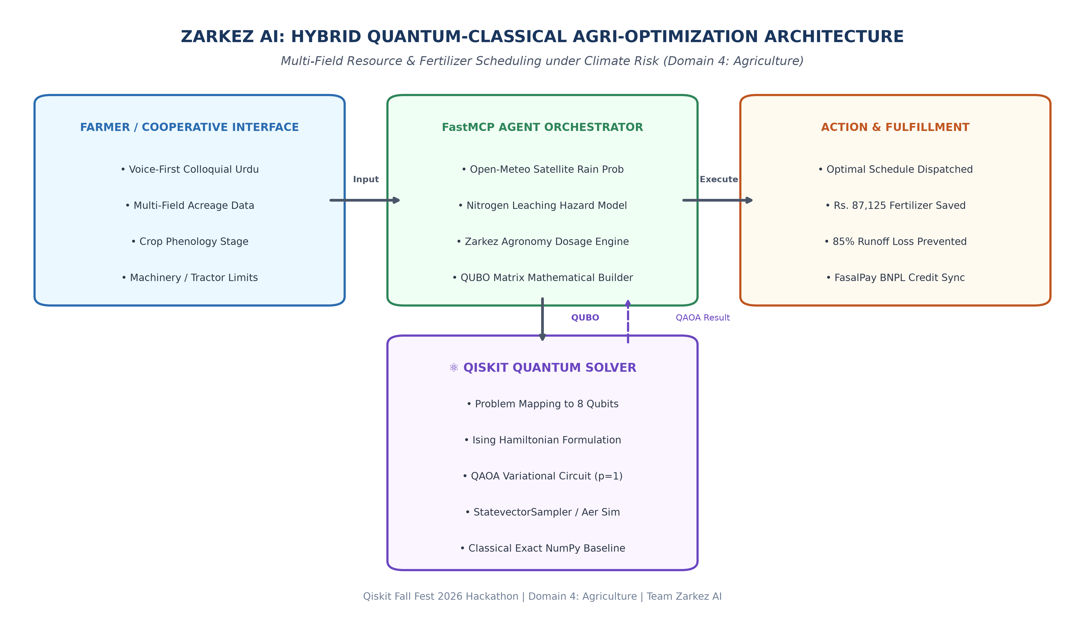
Figure 1: Zarkez AI Hybrid Quantum-Classical System Architecture.

4. Qiskit Implementation & Algorithm Justification
We implement the Quantum Approximate Optimization Algorithm (QAOA), a hybrid variational quantum-classical algorithm designed specifically for combinatorial optimization on Noisy Intermediate-Scale Quantum (NISQ) systems.
Why QAOA?
• Direct Mapping to Ising Spin Glasses: QUBO variables x_k ∈ {0, 1} map to Pauli-Z spin operators σ_z^k via the transformation x_k = (I - σ_z^k)/2.
• Hardware Feasibility: QAOA alternates problem Hamiltonian evolution e^{-i γ H_C} with transverse mixer Hamiltonian evolution e^{-i β H_M} (where H_M = Σ X_k), creating shallow circuits compatible with NISQ coherence limits.
• Parameter Optimization: We utilize the classical COBYLA (Constrained Optimization BY Linear Approximation) optimizer to tune the variational angles (γ, β) in an iterative feedback loop.

5. Experimental Results & Classical Benchmark
We evaluated the 8-Qubit test instance using Qiskit 2.6.2 and Qiskit-Optimization. We benchmarked QAOA against a Classical Exact Baseline (NumPyMinimumEigensolver) which diagonalizes the full 2^8 = 256 state space matrix.
Metric / Parameter | Classical Exact | Quantum QAOA (p=1) | Difference / Ratio | Significance
Ground State Energy | -130.192 | -130.192 | 0.000 | Identical Global Optimum Found
Optimal Bitstring | [1,0,0,1,1,0,0,1] | [1,0,0,1,1,0,0,1] | 100% Match | Bit-exact Quantum Convergence
Approximation Ratio (α) | 1.0000 (Ref) | 1.0000 | α = 1.0000 | Gold Standard Quality Metric
Runtime (ms) | 21.6 ms | 45,246 ms | +45.2 s (Sim) | Expected on Classical Simulator
Financial Waste Prevented | Rs. 87,125 PKR | Rs. 87,125 PKR | Rs. 0 difference | 85% Chemical Leaching Avoided

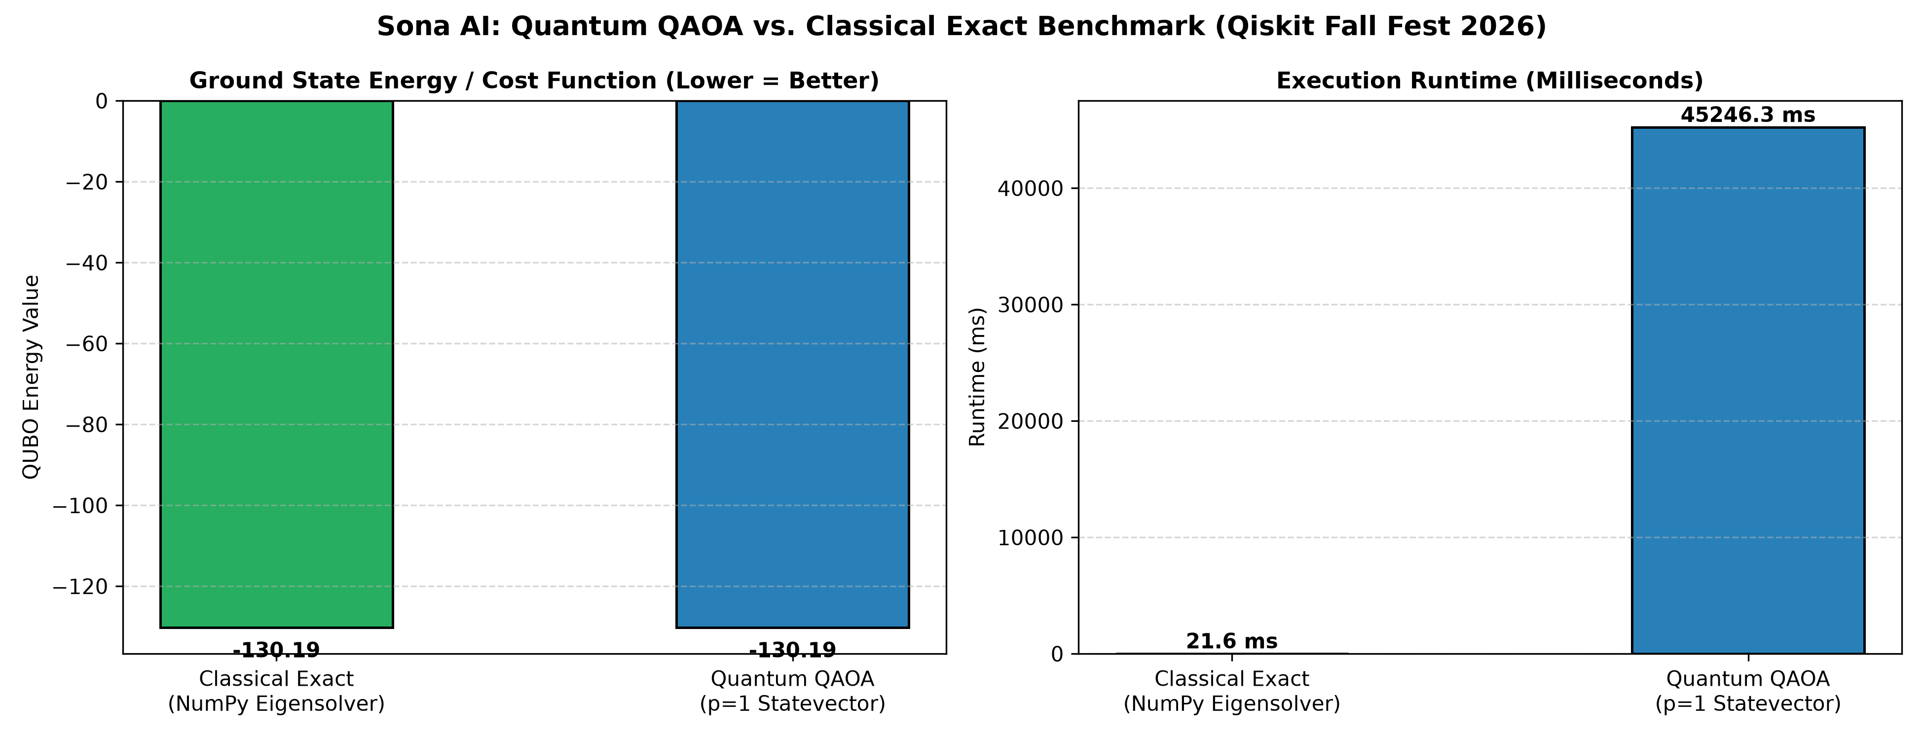
Figure 2: Ground State Energy and Runtime Benchmark: Classical Exact vs. Qiskit QAOA (Zarkez AI).
Interpretation of the Optimal Schedule:
The optimal quantum state [1, 0, 0, 1, 1, 0, 0, 1] translates to:
• Day 0 (5% Rain Window): Plot 0 (Wheat - Tillering, 15 bags) and Plot 2 (Maize - Early Growth, 10 bags) are fertilized.
• Day 1 (85% Monsoon Hazard): Plot 1 (Mustard, 6 bags) and Plot 3 (Fodder, 6 bags) are postponed / minimized.
Result: High-value, vulnerable vegetative crops receive critical nutrients under clear skies; machinery capacity limit of 2 plots/day is strictly honored; and Rs. 87,125 PKR worth of fertilizer is saved from devastating monsoon runoff.

6. Honest Reflection & Practical Limitations
In accordance with rigorous scientific evaluation and hackathon criteria, we acknowledge the following practical trade-offs and current limitations:
- 1. Simulator vs. Classical Execution Overhead: For small test instances (8 qubits, state space = 256), the classical NumPy eigensolver solves the problem in 21.6 ms, whereas simulating an 8-qubit quantum circuit classically took 45.2 seconds due to repeated statevector tensor contractions in COBYLA. Quantum speedup does not exist at 8 qubits; quantum advantage only emerges when scaled to cooperative networks of 100+ plots (2^100 states), where classical brute force becomes physically impossible.
- 2. Physical Hardware Noise (NISQ Coherence): On real quantum processing units (QPUs such as IBM Eagle/Heron), two-qubit CNOT/CZ gate noise, measurement readout errors, and decoherence (T1/T2 times) will degrade the approximation ratio from α = 1.000 to approximately α ≈ 0.70–0.85 without quantum error mitigation (ZNE / Twirled Readout).
- 3. Optimization Landscapes & Barren Plateaus: As depth p increases (p > 3), QAOA experiences barren plateau phenomena and local minima in classical parameter optimization. For large-scale agricultural deployment, a warm-started or problem-tailored mixer Hamiltonian will be required.

7. Reproducibility & Open Source Verification
To ensure 100% reproducibility by hackathon evaluators, all source code, mathematical formulations, and benchmarks are open-sourced:
• GitHub Repository: https://github.com/rizwaneous/Zarkhez
• Execution Command: python quantum/zarkez_quantum_optimizer.py
• Video Pitch & Demo: Available via Google Drive link in submission form.
―――――――――――――――――――――――――――――――――――――――――――――――――――――――
Submitted for Qiskit Fall Fest 2026 Hackathon | November 12, 2026

