**Assignment 3**

**Name :** Rizwan Hussain **Neptun:** ULLBQG

# Task

In the hydrological cycle of the Earth, various areas affect the weather as well as areas are also affected by various weathers. Areas involved in the simulation: plain, grassland, lakes region. Each area has a name, and the amount of water stored in the certain area is also given in km3. The humidity of the air over the areas is also given in percentage.

The possible types of weather are the following**: sunny**, **cloudy, rainy**, depending on the humidity of the air. In case the humidity exceeds 70%, the weather gets rainy and the humidity decreases to 30%.

In case the humidity is between 40-70%, the calculation of the chance of rainy weather is: (humidity-30)*3,3%, otherwise the weather is cloudy. Humidity below 40% leads to sunny weather.

In the following, we declare how the certain areas respond to the different type of weathers.

First the amount of water stored by the area varies then the weather will be affected. There is no type of areas with negative amount of water stored.

In case the type is *plain*, if the weather is sunny, the amount of water will be decreased by 3 km3; if cloudy, it will be decreased by 1 km3; for rainy weather it will be increased by 20 km3. The humidity of the air is increased by 5%. If the amount of the stored water is greater than 15 km3, the plain area changes into grassland.

In case of type *grassland*: in sunny weather, the amount of water is decreased by 6 km3, for cloudy it will be decreased by 2 km3, but and for rainy, it will be increased by 15 km3. The humidity of the air is increased by 10%. The area becomes lakes region obtaining amount of water over 50 km3, whereas in case the amount of stored water goes below 16 km3, the area changes to plain.

In case of type *lakes region*: in sunny weather, the amount of water is decreased by 10 km3, for cloudy it will be decreased by 3 km3, for rainy it will be increased by 20 km3. The humidity will be increased by 15%. Beyond an amount of water of 51 km3the area changes into grassland.

The program reads data from a text file. The first line of the file contains a single integer N indicating the number of areas. Each of the following N lines contains the attributes of an area separated by spaces: the owner of the area, the type of the area, and the amount of water stored by the area. In the last line, the humidity of the air is given in percentage. The type is identified by a character: P –plain, G –grassland, L –lakes region.

***After 10 simulation rounds, determine the owner of the area which is storing the greatest amount of water. The amount of water is also required to be determined. The program should print all attributes of the certain areas by simulation rounds!***

The program should ask for a filename, then print the content of the input file. You can assume that the input file is correct. Sample input:

4

Mr Bean L 86

Mr Green G 26

Mr Dean P 12

Mr Teen G 3598

# Plan

# Four classes have been introduced for each of the Area and Weather. One is the parent class while other three are the child classes. Parent or base classes have some getter and setter functions. Area class has some virtual functions which can be overridden in its child classes. Weather has a transform function which transforms one weather into other, depending upon the amount of humidity it has. It is same as the constructor of the Weather class. Here is how different types of areas react to the different types of Weather.

# Plain:

# Plain area reacts to different weathers as follows:

|  |  |  |
| --- | --- | --- |
| Weather Type | Water Change | Humidity Change |
| Sunny | -3 | - |
| Cloudy | -1 | - |
| Rainy | 20 | 5 |

# If the amount of water exceeds 15 km3, the area changes to Grassland.

# Grassland:

# Grassland behaves as follows:

|  |  |  |
| --- | --- | --- |
| Weather Type | Water Change | Humidity Change |
| Sunny | -6 | - |
| Cloudy | -2 | - |
| Rainy | 15 | 10 |

# Grassland converts into Lake if the water amount goes beyond 50 km3. And if the water level falls below 16 km3, Grassland changes to Plain.

# Lake:

# Lake is affected by different weathers as follows:

|  |  |  |
| --- | --- | --- |
| Weather Type | Water Change | Humidity Change |
| Sunny | -10 | - |
| Cloudy | -3 | - |
| Rainy | 20 | 15 |

# Below the amount of 51 km3 of water, Lake is converted to a Grassland.

# Here is the UML class diagram of the Class Area.

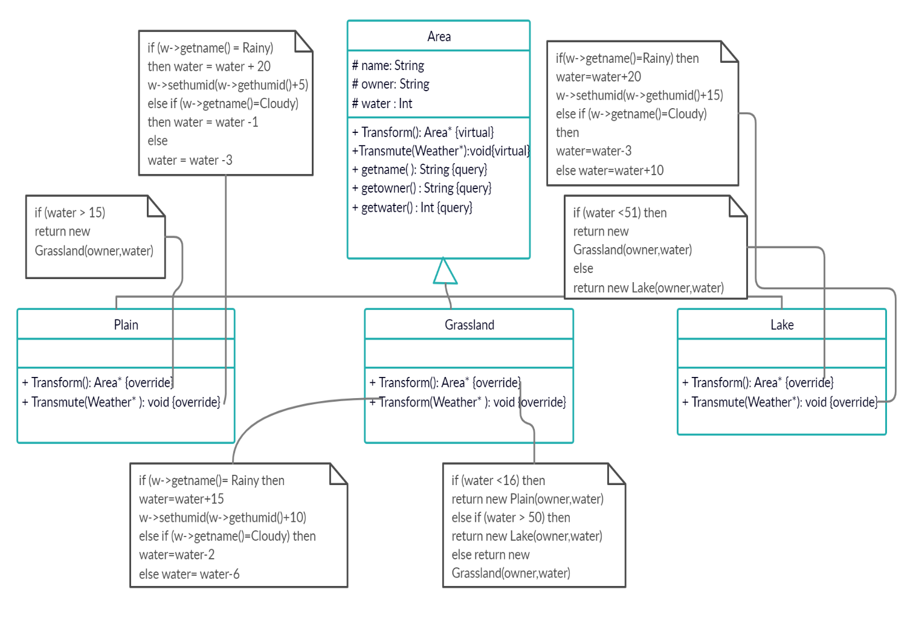

UML diagram of Weather class is as follows:

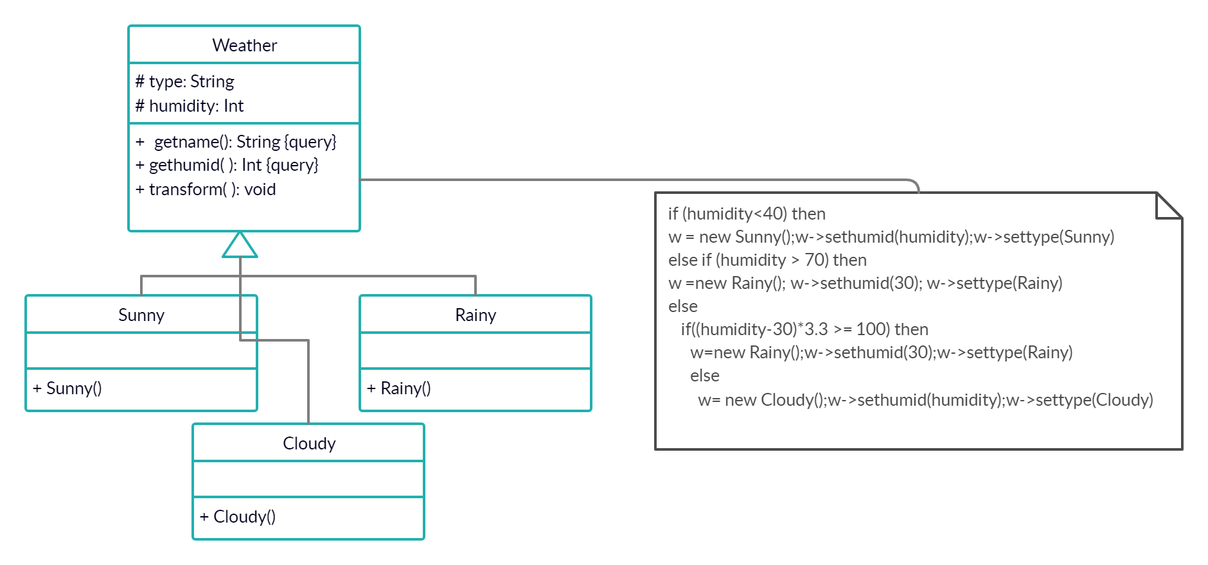

In the specification, it is necessary to calculate with the *n*+1 versions of the ground as every area transmutes the given weather. In every simulation the *transmute* function of area takes the given weather and on the basis of type of this weather, it changes its water level accordingly. Then if the water level falls below zero, it shows an exception. Otherwise the transform function changes the area according to its water level.

Then it transforms the weather as well at the end of every simulation.

Then comes the maxLand procedure, which checks the landlord who has the most water at the end of 10 simulations.

**Specification:**

A = *ground*: *Arean*, *LandLord*: *String, maxWater:Integer*

Pre = *ground = ground0*

Post = *(LandLord,maxWater) = MAXi=1..N(ground[i].water)*

Finding the landlord with most water after 10 simulations is the maximum search.

**Analogy:**

|  |  |
| --- | --- |
| enor(*E*) | *i = 1 .. n* |
| *f*(*e*) | *ground[i].water* |
| *H,<* | *Z,<* |
| H, +, 0 |  |

**Algorithm:**

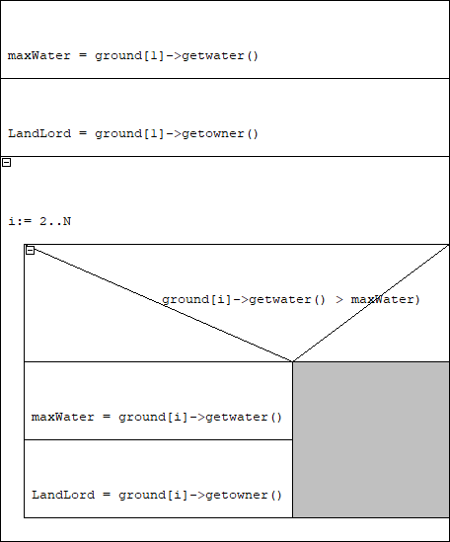

# Testing

Grey box test cases:

*Max Selection:*

1. First middle and last:
   * first Landlord has the most water
   * last Landlord has the most water
   * Landlord with most water is in middle

Simulate Function:

-Water level falls below 0 during the simulation.

*Examination of functions transform and transmute.*

Four different test cases depending on the Area and the Weather.