**Chapter 1 Tasks**

* 1. **Python.org**

Explored the site and viewed Python Standard Libraries along with tutorials and guides.

* 1. **Hello World Typos**

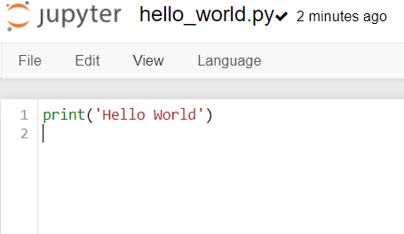

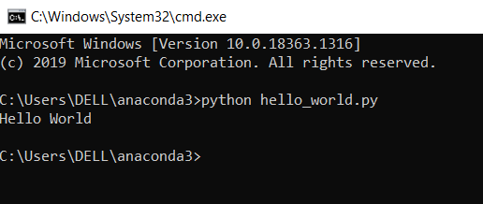

Yes, I could make a typo, which generated an error. Changed the keyword ‘Print’ to ‘Pint’.

The error message was ‘NameError: name 'python' is not defined’ which makes sense because ‘pint’ is not a keyword in python, and it was defined so python could not recognize it.

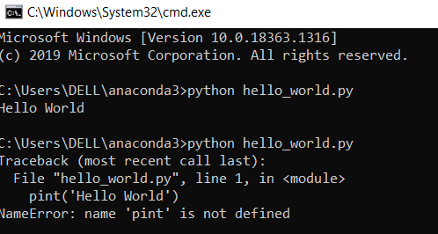

I couldn’t think of a typo which could not generate an error in python. If a keyword is mis-spelled in python it generates an error and python accepts variable names as you like except for those which start with numbers or special characters.

* 1. **Infinite Skills**

If I have infinite skills in programming, I would like to make a complete ERP or a SAP software for enterprises. Also I would like to make Artificial Intelligence based projects which could predict human behavior and reactions.

Also a face recognition program which could read someone’s face and tell that person’s mood and expected responses to any event.